**Testing and Verification**

Our application was tested against the following conditions:

|  |  |  |
| --- | --- | --- |
| **Condition** | **Verification** | **Screenshot** |
| Files are uploaded, intact, correct name | File transfers from client to server, file is present in appropriate directory with proper name. File plays without issues. |  |
| File list on server is updated accordingly | Upon connecting to the remote server or uploading a file, the list is updated. |  |
| Files are playable from the server | Played a 2.5 MB PCM WAV file and a 10 MB 44kHz 256 kbps CBR MP3 file successfully. | Not Applicable |
| Files are downloaded, intact, correct name | File transfers from server to client, file is present in appropriate directory with proper name. |  |
| Downloaded files are playable on the client (not necessarily from our application) | Upon completion of file download, the audio file is playable in any media player. |  |
| Streaming music is audible with no distortion on the client | Upon a stream being initiated, the music can be heard clearly. | Not Applicable |
| Client can drop in and listen to music with no distortion (multicast) | Client joins multicast session and hears the music clearly. | Not Applicable |
| Client/Server communicate with no distortion, no latency (microphone) | Voices can be heard on both ends with little to no latency or distortion. | Not Applicable |
| Client exits cleanly | A client, once joined, terminates at any point throughout execution without errors. |  |

**User Manual**

*System requirements:* Windows XP SP2 or later, libzplay.dll binary, FuzzyPlayer server (fuzzyserver.exe) and client (fuzzyclient.exe) binaries, TCP/IP connectivity, sound card, speakers and a microphone

**Server**

The server component of this application consists of a simple command line application. This application takes no command line arguments, and requires no user input throughout the duration of its execution.

To run this application, simply run the “*FuzzyServer.exe*” executable file, or run it from the command line using “*FuzzyServer.exe*”.

Upon execution, in its initial state, the server will look similarly to as follows:

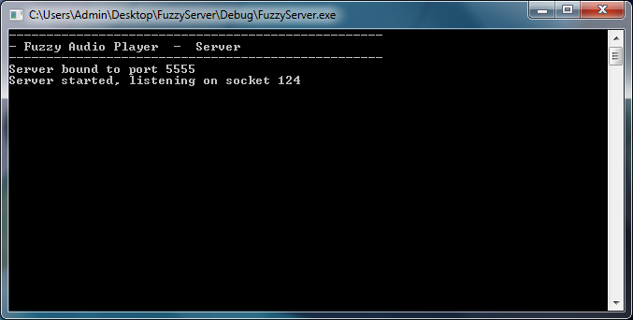

The server will look for audio files in a very particular way. In the same directory that the executable is located, (example, *C:\Users\Admin\Desktop*), there must be a directory named “*Music*” (example, *C:\Users\Admin\Desktop\Music*). It should be noted that only supported audio files should be located in this directory.

The server also supports UDP multicasting. This function is automatically started upon execution of the server. It will cast all songs in your “*Music*” subdirectory in order until all have been played. Like a radio station, clients can “tune in” to the FuzzyServer multicast at and time while it is casting.

**Client**

The FuzzyPlayer Client is used to connect to a central server that hosts music files, chat sessions and multicast sessions. The libzplay.dll must be in the same directory as your fuzzyclient.exe executable. Before starting the client, ensure that your microphone and speakers are not muted and plugged in. Ensure the server is running and be sure to know its IP.

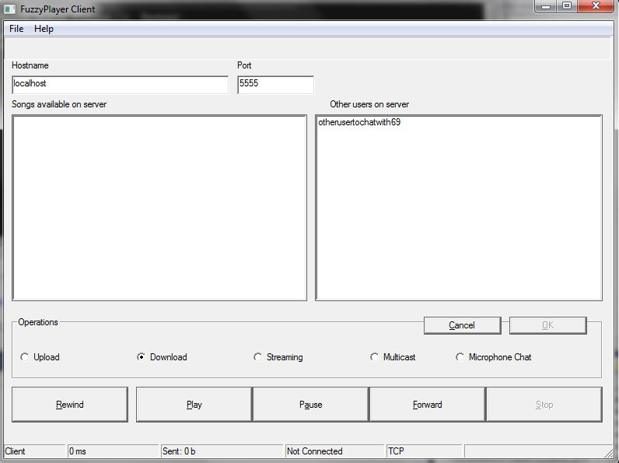

To connect to the FuzzyServer:

1. Type in the IP of the computer that is running FuzzyServer into the Hostname box
2. Type in the port of the FuzzyServer (default: 5555)
3. Click on “File”
4. Click on “Connect”

To stream or download music from the server:

1. Connect to the FuzzyServer
2. Click on the song you which to download or stream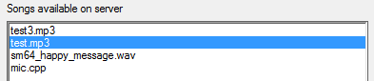
3. If you wish to save the file to your local computer, select the “Download” radio button or if you wish play the file, click on “Streaming” radio button
4. Click “OK” and music should start playing or being downloaded to your computer in the same running directory as your FuzzyClient.exe

To start a voice/microphone chat session with the server

1. Ensure that your microphone is enabled, unmuted and plugged into your computer
2. Connect to the FuzzyServer
3. Click on “Microphone Chat” radio button
4. Click OK
5. Click OK on the message box
6. Speak into your microphone to chat with the user on the server side

To upload a music file to the server

1. Connect to the FuzzyServer
2. Click on the “Upload” radio button
3. Click OK
4. On the open file dialog window, select the music file you wish to upload then click “Open”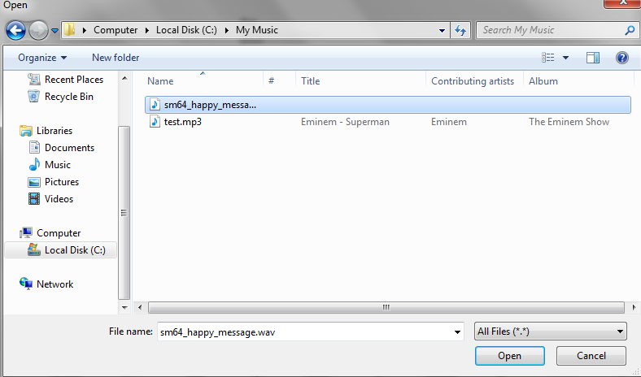
5. The file will now appear on the server for others to stream and download

To connect to the server multicast session

Note: the server will cast all songs in the song list but, given the nature of multicasting, the user cannot control what the server is now playing.

1. Connect to the FuzzyServer
2. Click on the “Multicast” radio button
3. Click OK