Data Comm 4985 – Assignment 2

Ronald Bellido

Table of Contents
Data Comm 4985 – Assignment 2 1
advanced-io 3
Important Notes & Known Bugs 3
Getting Started 3
Start a TCP Server 3
Start a TCP client: 5
Design 6
Pseudo-code 6
Testing 7
Connection established, data sent back and forth 7

advanced-io
A simple application that can create a TCP or UDP client/server. It keeps track of statistics such as packets sent and received, timing, and packet/loss ratio.

Important Notes & Known Bugs
Currently, advanced-io only has an implementation of a TCP client/server with data transferring back and forth succesfully, and very minimal statistical data collected and displayed. UDP client/server was not implemented. As such, this document will provide a getting started guide, test data, and design for advanced-io as a TCP client/server application.
Advanced-io is not a robust application. For instance, it will crash if one tries to send a file once more than once by pressing the 'Send to Server' button on the TCP client. As a result, testing data is also very minimal at this point. Testing data provided will be on connections established between a client and server, data sent and received succesfully, and a display of some of the statistical data it can provide.
Acknowledgement of data sent or received is done by outputting statistical data to let the user know the size of the packets. But the numbers are incorrect as it will be demonstrated on the testing.

Getting Started
- Launch advanced-io.exe.
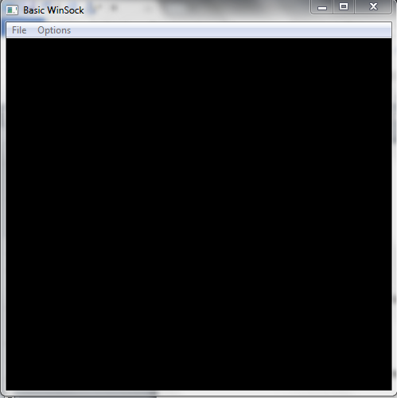
- From here, we can select what type of connection we want to do:

Start a TCP Server
- Click Connect->Server->TCP
- Enter a valid IP address on the “Type the IP or the Hostname” text box
- Enter the port number on the “Port” text box
- Specify an empty text file by clicking the Browse button
- When ready, click the “Start Server” button
- When a client request is made, the saved output will be on the file specified above

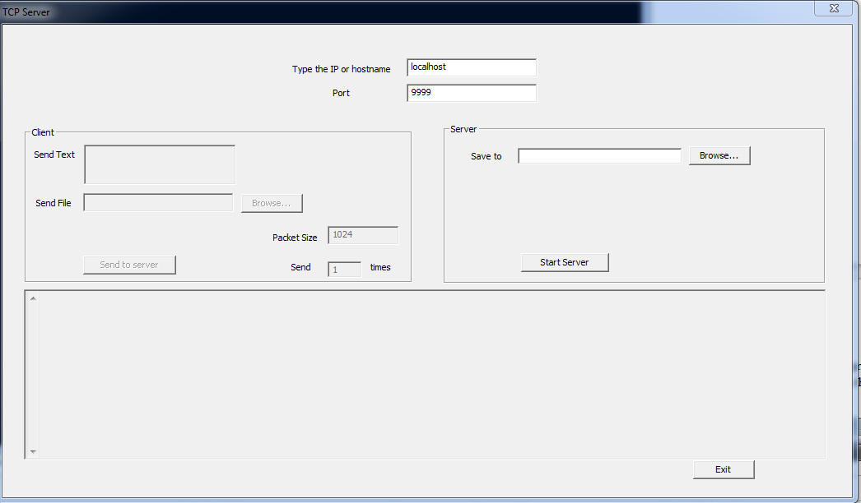

Start a TCP client:
  - Click Connect->Client->TCP
  - Enter a valid IP address on the “Type the IP or the Hostname” text box
  - Enter the port number on the “Port” text box
  - Specify a text file to send (preferrably with contents) by clicking the Browse button
  - Specify the packet size and the amount of times to send
  - When ready, click the “Send to Server” button

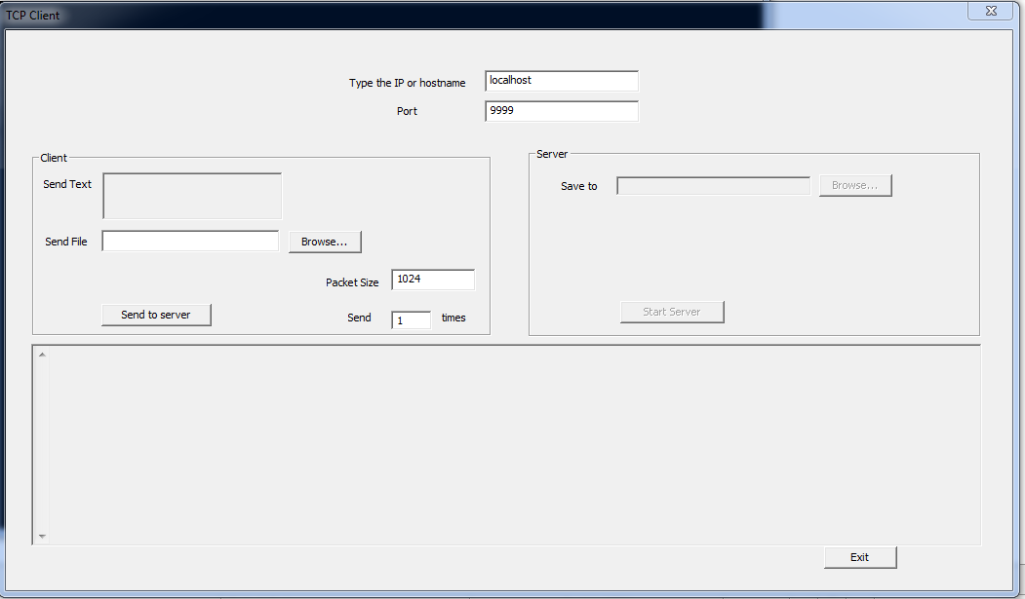

Design

Pseudo-code

StartTCPServer():
gather data from GUI
create listen socket
bind lisen socket
set event for client request
create thread to handle accept()
create thread to handle completion routine
StartTCPClient():
gather data from GUI
create connect socket
create event for succesful connection
create thread to handle connect()
create thread to handle completion routine

Testing

Connection established, data sent back and forth
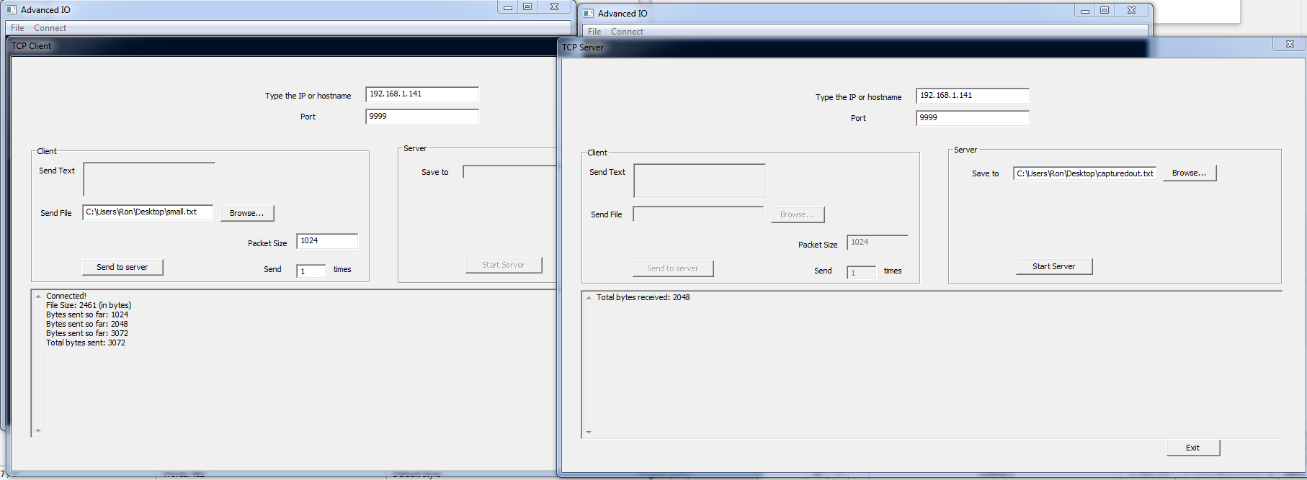
See testing.png for a closer look

