# Control Channel

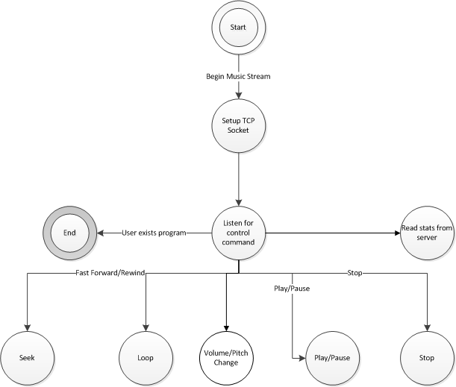

## Setup TCP Socket

1. Create socket
2. Bind

## Listen for control command

## Read stats from server

## End

1. Close TCP socket
2. Exit

## Seek

## Loop

## Volume/Pitch Change

## Play/Pause

## Stop

# GUI

Graphical user interface will similar to VLC. 2-way microphone chat mode would be invoked through the drop-down menus. The music stream would be started through the drop-down menus. Once the stream is started, the stream can be controlled through the buttons at the bottom of the window (stop, play, pause, seek, volume, pitch).

