Pipe-N-Fork
A simple Linux program that uses IPC pipes and forks to interact with the user
Ronald Bellido
Table of Contents
Getting Started 3
File listings 3
Build 3
Design 4
Pseudocode 4
Testing 7
Screenshots 7

Getting Started

File listings
- pipe-fork.cpp
- pipe-fork-utils.cpp
- pipe-fork.h
- Makefile
- documentation.odt
- pipe-n-fork

Build
On the same directory as the makefile and all the source files, type:
you@host:~/dev/pipes-n-fork$ make
To run:
you@host:~/dev/pipes-n-fork$ make run

Design

Pseudocode
main():
disable terminal
create output pipe
create translate pipe
create translate_output pipe
fork output()
fork translate()
execute input() as parent
terminate processes
enable terminal

input(input_outputpipe, input_translatepipe):
while (1):
get user input from stdin

buffer user input

if user input is 'E':
write the buffer to input_translatepipe
clear buffer
else if user input is 'T':
write user input to input_outputpipe
write buffered user input to input_translatepipe
return
else if user input is 'ctrl-k':
return
else:
write user input to input_outputpipe

output(input_outputpipe, translate_outputpipe):
start thread for reading pipe from translate_outputpipe

while (1):
read from input_outputpipe one character at a time
output the character to stdout

if user input is 'T':
wait for translate to finish
terminate

readfromtranslate(translate_outputpipe):
while (1):
read from translate_outputpipe one character at a time
output character to stdout

if user input is 'T':
flush the output
exit out of loop

translate(input_translatepipe, translate_outputpipe):
initialize translatedline

while(1):
read from input_translatepipe one character at a time
if character is 'K':
clear translatedline
else if character is 'X':
erase one character at end of translatedline
else if character is 'a':
append 'z' to translatedline
else if character is 'T':
write translatedline to translate_outpipe
return
else if character is 'E':
send translatedline to translate_outputpipe
clear translatedline
else:
append character to translatedline

Testing
Below is a summary of the tests passed. There are also screenshots provided that show the actual output for each test.
Test # | Test Description | Expected Output | Actual Output | Passed?
1. | Input abcdefE | zbcdef | zbcdef | Y
2. | Input abcdefXXE | zbcd | zbcd | Y
3. | Input abcdefKE | -empty- | -empty- | Y
4. | Input abcdefT | zbcdef #program terminates | zbcdef #program terminates | Y*
5. | Input abcCTRL-K | #program terminates | #program terminates | Y*

*Note: a program is considered terminated if it does not leave any processes behind. This can be checked using 'ps aux | grep pipe-n-fork'. The result of that command should not return a pipe-n-fork process still running.

Screenshots
Tests 1, 2, 3, and 4
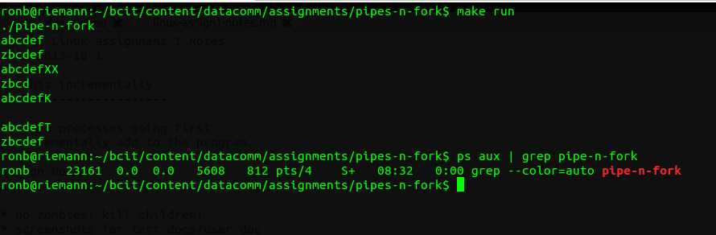
Test 5
