g04_tempo

# Description of Circuit Functions

The purpose of the tempo circuit is to provide a tempo for musical applications given an input of the desired beats-per-minute (bpm). The inputs are the bpm value, a clock and a reset toggle. The outputs include a beat signal representing the tempo, a tempo_enable which is a subdivision of the beat signal and the segment_display which allows the beat to be represented on a 7-segment LED display.

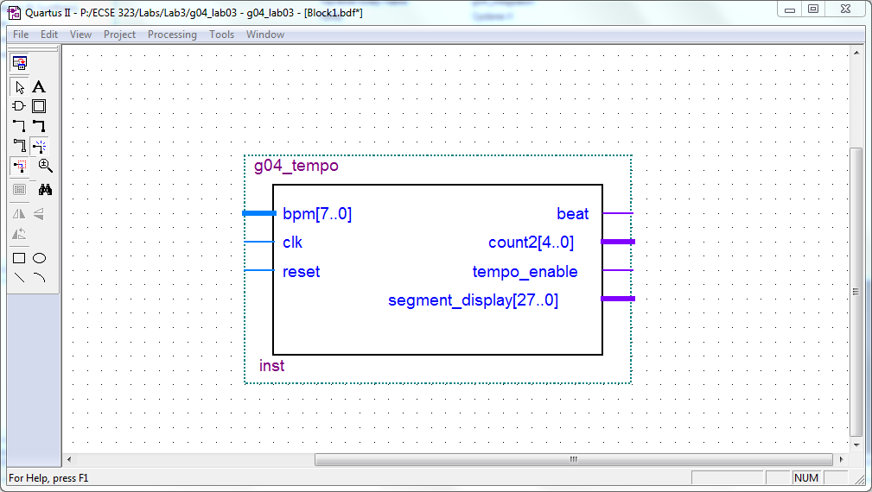

# Testing and Simulation

The tempo circuit was tested via a timing simulation. We input 4 different bpm values to check that the tempo_enable and beat signals were responding appropriately. Below are two of the values we used to test the circuit.

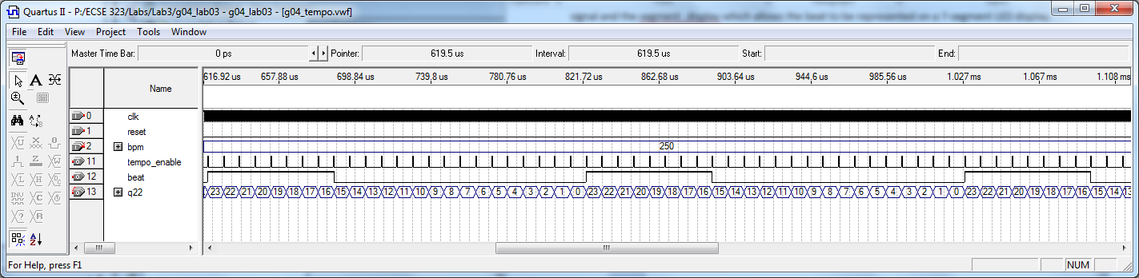

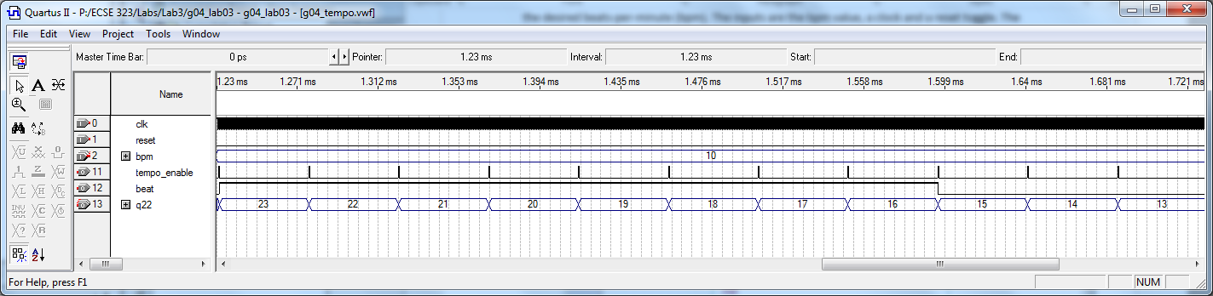

After the timing simulation, we performed a SignalTap II Logic Analysis. This would check that the circuit behaved correctly on the FPGA board. Similarly to the timing analysis results, the tempo_enable signal acts as a subdivision of the beat.

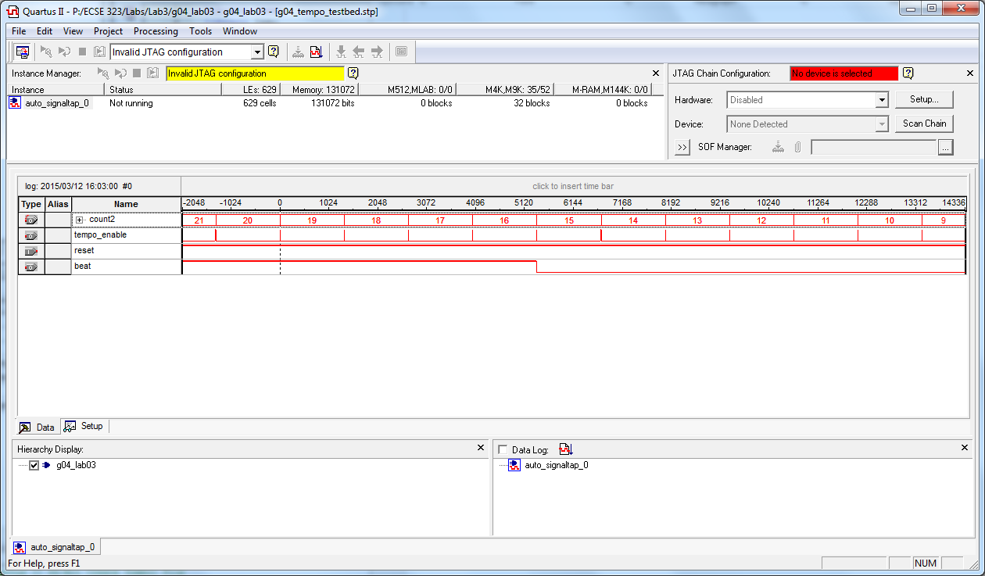

Timing performance summary –notes from in the lab: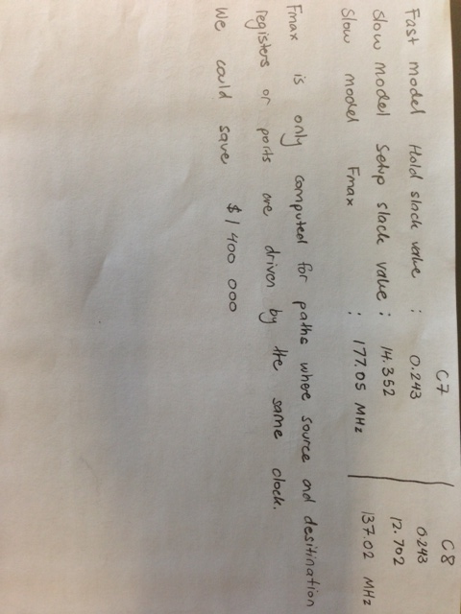

The propogation delay of the circuit was 12.5 ns.

FPGA Resource Utilisation Summary: