**Daily Scrum or Standup Meeting**

Team name: Group 5_________________________

Scrum Master: Aryan Osqueezadeh_______________________

Date: 2/22/22_______________________________

| **Team Member** | **What did you do since the last scrum?** | **What do you plan to do before the next scrum?** | **What obstacles do you have?** |
| --- | --- | --- | --- |
| Matt | Set up Django project | Set up worker home page | None |
| Bryce | Nothing | Set up database and start work on job API | None |
| Jake | Nothing | Be patient | The generic sign up page needs to be set up |
| Aryan | Nothing | Set up generic sign up page | None |
|  |  |  |  |

# Burndown

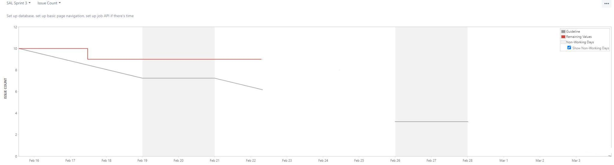

# 

# Screenshot of you project board

