**Daily Scrum or Standup Meeting**

Team name: Group 5_________________________

Scrum Master: Aryan Osqueezadeh_______________________

Date: 2/24/22_______________________________

| **Team Member** | **What did you do since the last scrum?** | **What do you plan to do before the next scrum?** | **What obstacles do you have?** |
| --- | --- | --- | --- |
| Matt | Set up worker home page | Make basic migrations.  Further testing on worker home page | None |
| Bryce | Set up database and start work on job API | Work further on job API.  Update requirements draft to reflect changes to database structure. | None |
| Jake | Was patient | Create worker sign up page. | The generic sign up page needs to be set up |
| Aryan | Set up generic sign up page | Create sign in/sign up page. | None |
|  |  |  |  |

# Burndown

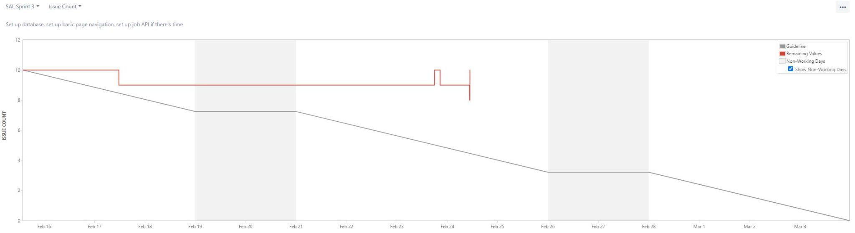

# 

# 

# 

# 

# 

# 

# 

# 

# Screenshot of you project board

