**Daily Scrum or Standup Meeting**

Team name: Group 5_________________________

Scrum Master: Aryan Osqueezadeh_______________________

Date: 3/1/22_______________________________

| **Team Member** | **What did you do since the last scrum?** | **What do you plan to do before the next scrum?** | **What obstacles do you have?** |
| --- | --- | --- | --- |
| Matt | Made migrations  Made customer home page  Made worker home page | Perform any bug fixes on migrations | The zip code is being mean |
| Bryce | Finished setting up Django job API (methods) | Defining and refining the Django methods | None |
| Jake | Created customer sign up page  Created worker sign up page | Update js files for the sign up pages | None |
| Aryan | Created front page | Create owner home page | None |
|  |  |  |  |

# Burndown

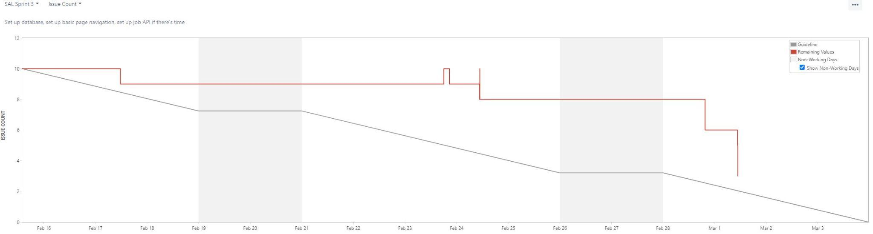

# 

# 

# 

# 

# 

# 

# 

# 

# Screenshot of you project board

