**Daily Scrum or Standup Meeting**

Team name: Group 5_________________________

Scrum Master: Aryan Osqueezadeh_______________________

Date: 3/1/22_______________________________

| **Team Member** | **What did you do since the last scrum?** | **What do you plan to do before the next scrum?** | **What obstacles do you have?** |
| --- | --- | --- | --- |
| Matt | Finished migrations  Finished worker/customer home page | Merge stylesheets between all homepages | Owner home page is incomplete |
| Bryce | Implemented majority of utility.py | Finish implementation  Begin testing of utility.py | FIguring out how to perform testing |
| Jake | Attempted javascript for sign up pages | Give up on javascript  Move on to python | Figure out input for worker available times |
| Aryan | Attempted migrations :( | Set up owner home page | None |
|  |  |  |  |

# Burndown

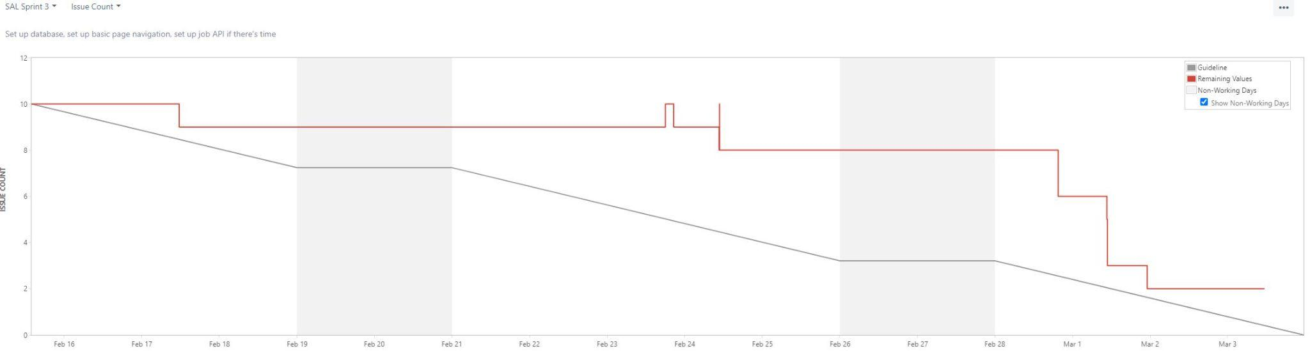

# 

# 

# 

# 

# 

# 

# 

# 

# Screenshot of you project board

