**Daily Scrum or Standup Meeting**

Team name: Group 5_______________________

Scrum Master: Bryce Flammer________________

Date: 3/14/22_____________________________

|  |  |  |  |
| --- | --- | --- | --- |
| **Team Member** | **What did you do since the last scrum?** | **What do you plan to do before the next scrum?** | **What obstacles do you have?** |
| Matt | Took Spring Break. | Customer Page Update | Refreshing after Spring Break |
| Bryce | Took Spring Break | Finish writing first draft of Job API | Testing |
| Jake | Took Spring Break |  |  |
| Aryan | Created Owner Home Page | Recover from Spring Break | Daylight Savings Time |
|  |  |  |  |

# Burndown

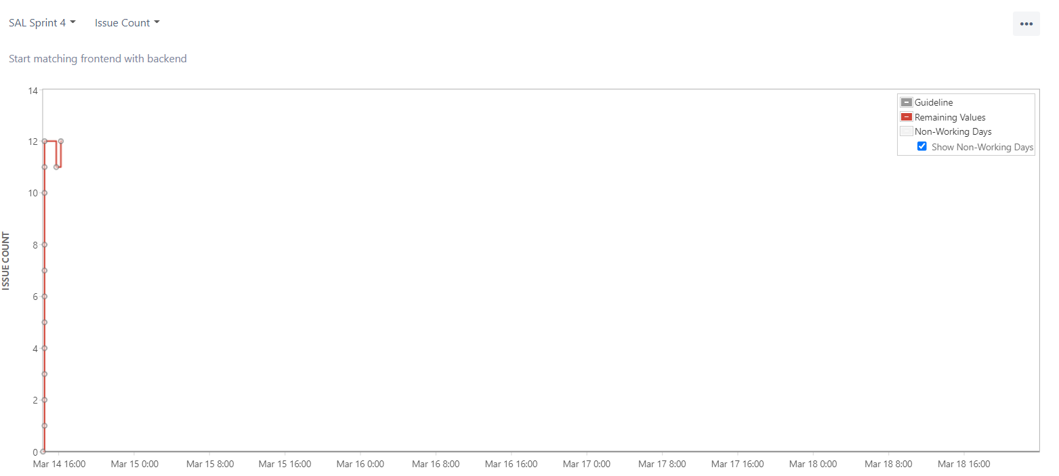

# 

# Screenshot of you project board

