Code for DAG based on author’s causal structure:

dag {

"Agricultural yield" [latent,pos="-1.037,-0.009"]

"Bat population" [latent,pos="-1.301,-0.447"]

"Infant mortality rate" [outcome,pos="0.176,-0.458"]

"Insect pest population" [latent,pos="-0.679,-0.443"]

"Insecticide Use" [outcome,pos="-0.218,-0.043"]

"Net crop revenue" [outcome,pos="-0.677,0.378"]

"White Nose Syndrome" [exposure,pos="-1.655,-0.037"]

"Agricultural yield" -> "Net crop revenue"

"Bat population" -> "Insect pest population"

"Insect pest population" -> "Agricultural yield"

"Insect pest population" -> "Insecticide Use"

"Insecticide Use" -> "Agricultural yield"

"Insecticide Use" -> "Infant mortality rate"

"White Nose Syndrome" -> "Bat population"

}

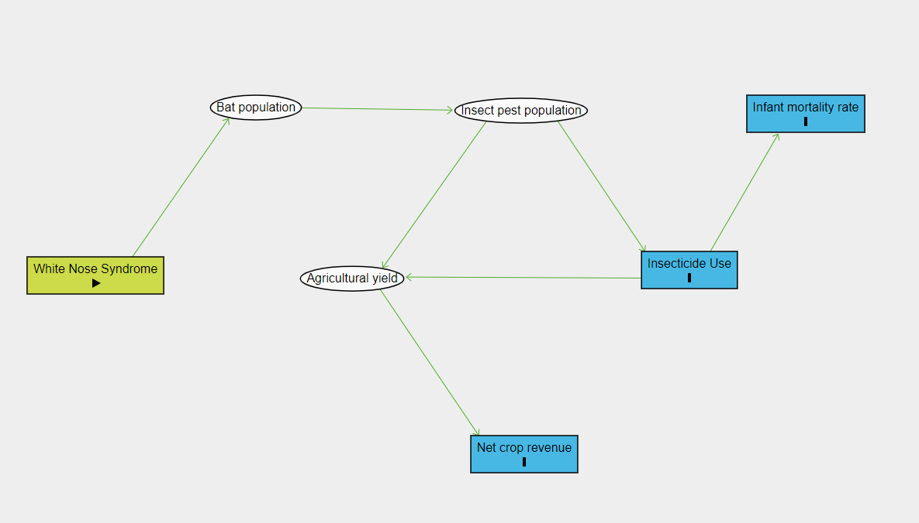

Code for DAG including a single confounder:

dag {

"Agricultural yield" [latent,pos="-1.037,-0.009"]

"Bat population" [latent,pos="-1.209,-0.257"]

"County location" [pos="-1.246,0.206"]

"Infant mortality rate" [outcome,pos="-0.400,0.243"]

"Insect pest population" [latent,pos="-0.735,-0.252"]

"Insecticide Use" [outcome,pos="-0.733,-0.087"]

"Neighborhood socioeconomic deprivation" [pos="-0.800,0.347"]

"Net crop revenue" [outcome,pos="-0.753,0.139"]

"White Nose Syndrome" [exposure,pos="-1.495,-0.023"]

"Agricultural yield" -> "Net crop revenue"

"Bat population" -> "Insect pest population"

"County location" -> "Neighborhood socioeconomic deprivation"

"County location" -> "White Nose Syndrome"

"Insect pest population" -> "Agricultural yield"

"Insect pest population" -> "Insecticide Use"

"Insecticide Use" -> "Agricultural yield"

"Insecticide Use" -> "Infant mortality rate"

"Neighborhood socioeconomic deprivation" -> "Infant mortality rate"

"White Nose Syndrome" -> "Bat population"

}

