School of Electronics Engineering

B.Tech Electronics and communication engineering

**ECE-402**

Microwave Engineering lab task

**Submitted to:**

Prof. Boopalan G.

**Submitted by**:

13BEC0576

Radhika Bhange

**Amplifier design**

**Aim:** Design an amplifier for maximum gain at 4 GHz, using single stub matching system. Calculate and plot RL and gain from 3 to 5 GHz.

Z0=50

**Calculations:**

We have h=1.6mm, thickness=0.05mm, tand=0.001

For 0.12 λ: W= 3.04378, L= 4.87244

For 0.206 λ: w=3.04378, L=8.36436

**Design:**

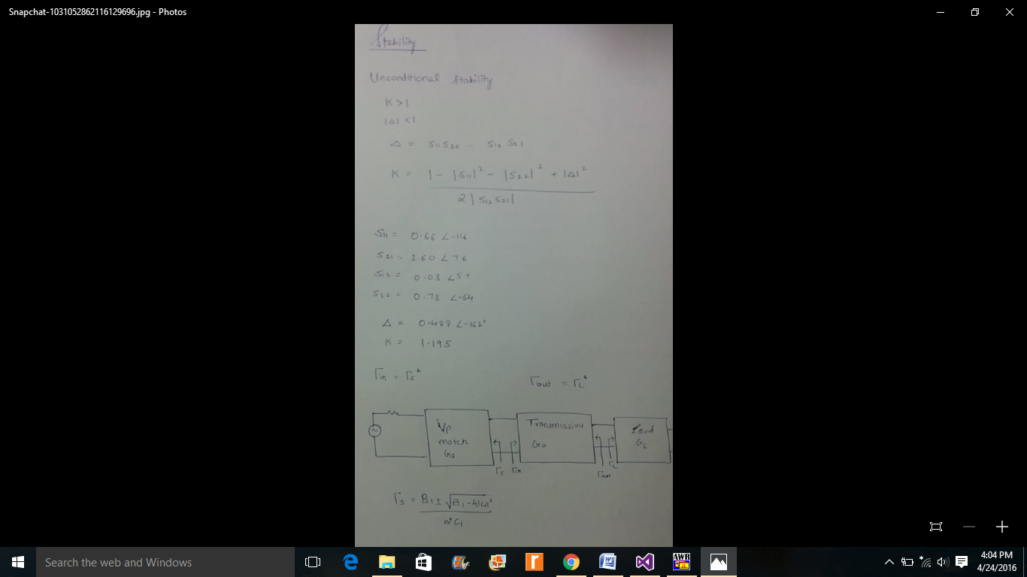

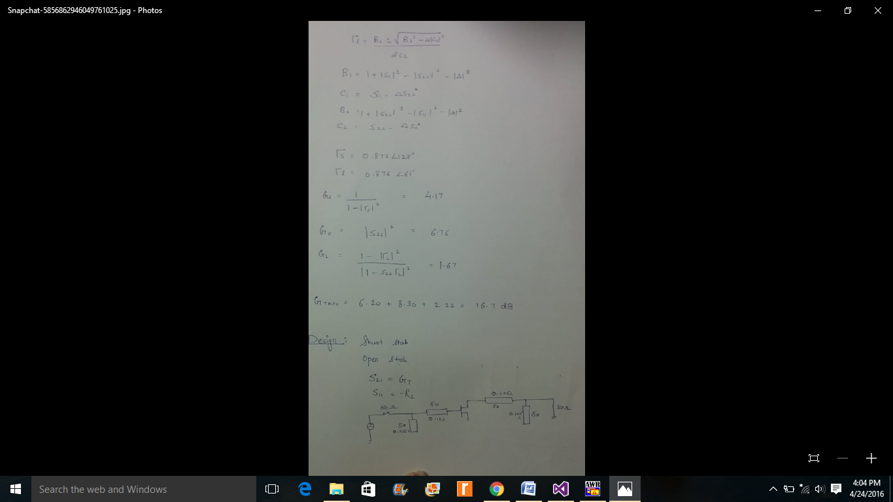

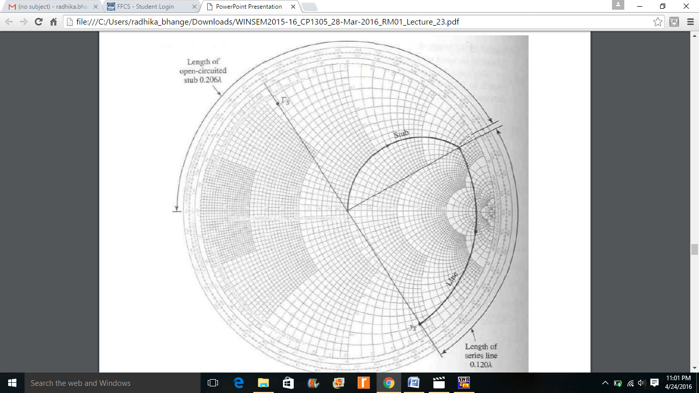

**Circuit diagram:**

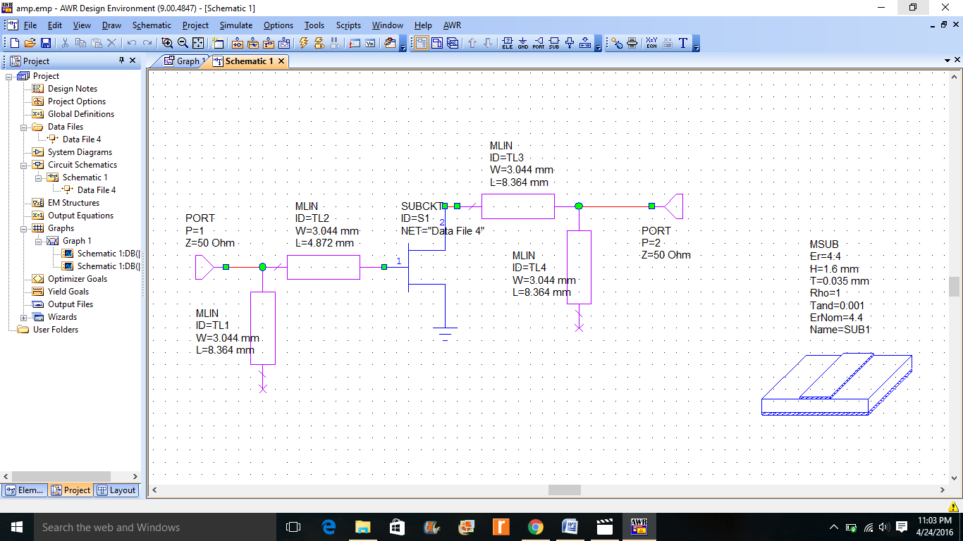

**Data file:**

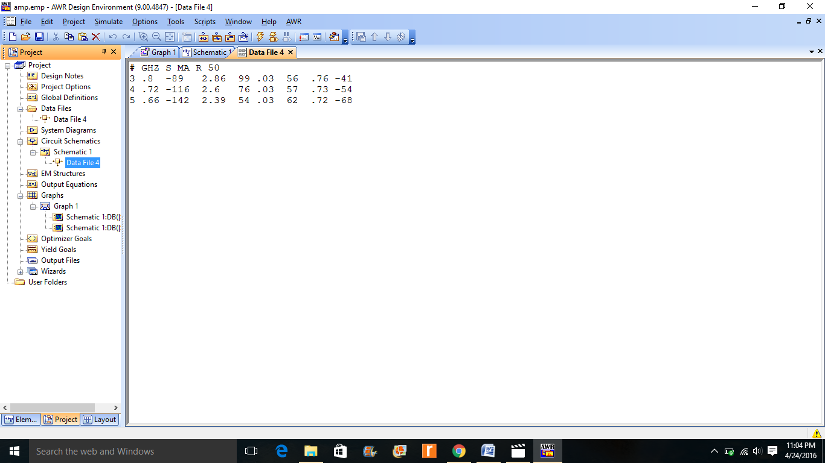

**Graph:**

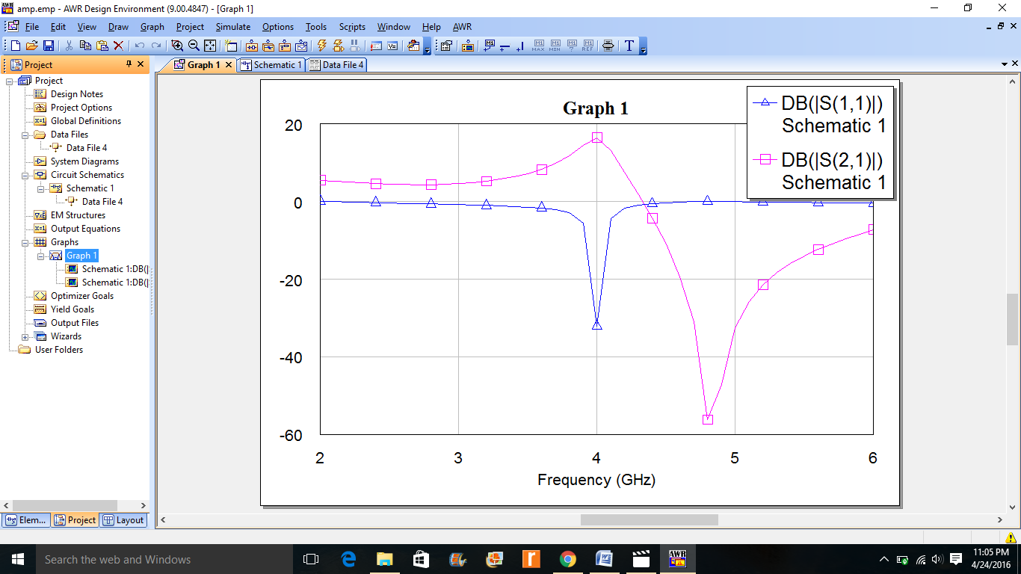

**Result:**

The graph was plotted for return loss and Gt, and the desired gain of 16.7 was attained at 4 Ghz successfully.