Exercise 1 – Regional Earthquakes North America
The first exercise determines the source parameters an Mw=5.2 earthquake in the central United States that occurred on April 18, 2008. This earthquake occurred within a seismic network that Saint Louis UnicRUSTversity operates for the U. S. Geological Survey, and provided significant information on high frequency ground motion scaling [Herrmann, R. B, M. Withers and H. Benz (2008). The April 18, 2008 Illinois earthquake – an ANSS monitoring success, Seism. Res. Letters 79, 830-843].
For the purposes of this documentation, it is assumed that you are on the CYGWIN system, and that everything was installed in the /cygdrive/c/usr directory.

Step 1 – Go to work area
Go to the work area for North American earthquakes
cd RMT/MECH.NA
Examine the contents of the directory:
rbh> ls
0XXXREG/ DOIRIS* DOQUERY* DOSOLUTION* PROTO.I/
DOCWBREG* DOISETUP* DOSETUP* mech.sh* PROTO.CWB/ RAW/

The '*' indicates that the file is executable and the '/' indicates that the file is a directory. The purpose of each entry is as follows:
0XXXREG - a directory containing prototypes for the complete processing.
DOCWBREG - the initial script for use inside the USGS
DOIRIS - the initial script for SEED datasets from IRIS/Orfeus
DOISETUP - script called by DOIRIS to setup the instrument deconvolution
DOQUERY - script called by DOCWBREG to get the NEIC data stream (for internal use)
DOSETUP - script called by DOIRIS and DOCWBREG to create an event directory and to
modify all scripts for that event
DOSOLUTION - script that performs the inversion and documentation after everything has been
properly set up and the raw data has been quality controlled.
mech.sh - a script that using the program dialog to create a simple menu that creates the
starting script
PROTO.I - a directory containing scripts for working with the SEED data sets
PROTO.CWB - a directory containing scripts for working with the NEIC data stream
RAW - a directory containing the sample data sets

Step 2 – Get the data
Normally one must get the waveform data. An easy way to accomplish this for significant earthquakes is to use the Wilbur II interface at IRIS
http://www.iris.edu/cgi-bin/wilberII_page1.pl
or at Orfeus
http://www.orfeus-eu.org/cgi-bin/wilberII/wilberII_page1.pl
The IRIS Wilbur II interface starts by selecting the earthquake, then selecting the networks, and finally the individual stations. A SEED volume is created which provides the station coordinates, the instrument orientations and responses as well as the digital data. The result is downloaded using ftp, ( or wget).

Step 3 – Sample data sets
We will select a data set for inversion from the RAW directory.
rbh> ls RAW
00README 20080221235752.seed 20080418093700.seed

and look at the contents of the 00README file

rbh> cat RAW/00README
Year Mo Dy HR Mn Sc Lat Lon H Mag State Seed Volume
2008/04/18 09:37:00 38.45 -87.89 11.6 5.2 Illinois 20080418093700.seed
2008/02/21 23:57:52 41.053 -114.923 10.0 4.6 Nevada 20080221235752.seed

This provides the information that you need about the earthquake and also indicates the name of the SEED volume for each data set. We will first look at the 20080418093700 data set.

Step 4 – Create the DO script
The actual processing will begin by invoking the program DOIRIS, e.g.,
rbh>
DOIRIS "2008" "04" "18" "09" "37" "00" "000" "38.4500" "-87.8900" "12.0" "5.20" "CUS" "NONE" "NONE" "Illinois"

By starting DOIRIS with no arguments, an on-line help message is written to the terminal so that you know what input is required. One must enter 15 parameters after the 'DOIRIS'. Since there is a chance for error at this stage, we will use the mech.sh command.
rbh> mech.sh
This command starts the menu based input:
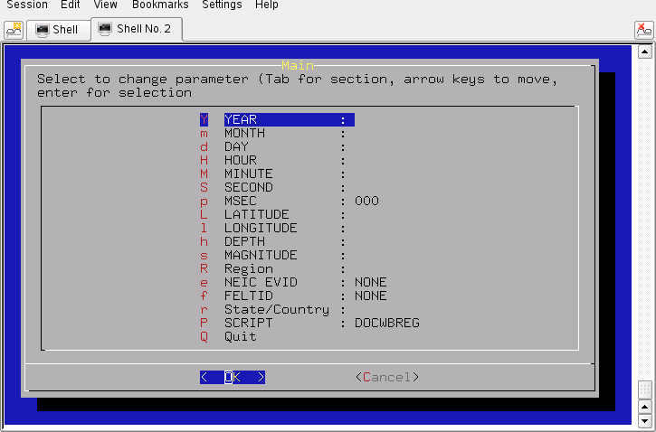
You can navigate by using the up/down arrow keys or by entering the letter on the keyboard. If you hit the 'Enter' key on the keyboard, then the highlighted item will take you to another menu, e.g.,
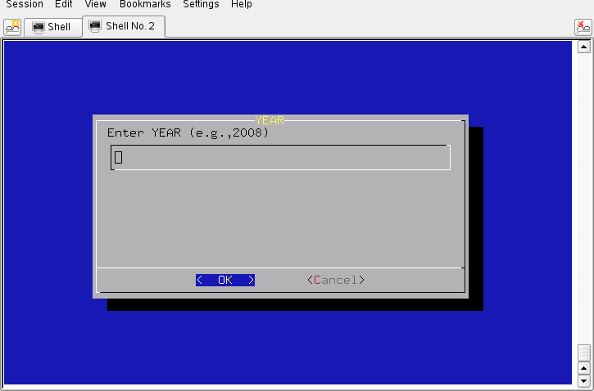
Enter the year, e.g., 2008, and continue to make entries until the main menu looks like
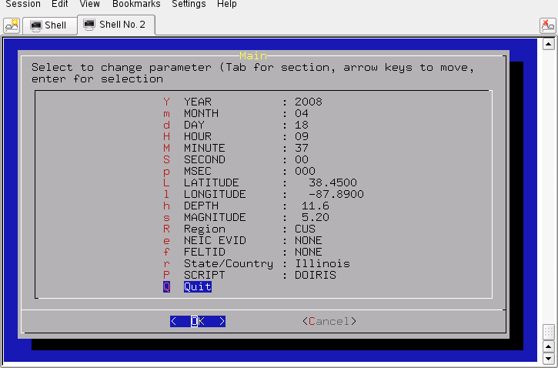
After pressing the 'Enter' key for 'Quit', you will see this on the terminal:

#!/bin/sh
#####
# valid regions
# REG Region FELTID VELOCITY_MODEL
# HI Hawaii hi [Not implemented June 23, 2007]
# SAK Alaska ak WUS (to 69 km deep)
# NAK Alaska ak CUS (in continent from Rockies -no dee p)
# CA California ca WUS
# PNW Pacific Northwestrn pnw WUS
# IMW Intermountain west imw WUS
# CUS Central US cus CUS
# NE Northeastern US ne CUS
# ECAN Eastern Canada ous CUS (in continent from Rockies)
# WCAN Western Canada ous [Not implemented June 23, 2007]
#####
# Command syntax:
#DOCWBREG YEAR MO DY HR MN SC MSC LAT LON DEP MAG REG NEIC FELTID STATE/COUNTRY
#####
DOIRIS "2008" "04" "18" "09" "37" "00" "000" " 38.4500" " -87.8900" " 11.6" "5.20" "CUS" "NONE" "NONE" "Illinois"
************************************************************
To enter the command DO to begin the moment tensor procedure
************************************************************

This shows the contents of the new command file 'DO' which was created by the menu. If you look carefully you will see that each of the required fields in the menu was provided in the 'DOIRIS' command line.
This may also be your first experience with a SHELL script. The first line tells the system that this is shell script. All other lines starting with the '#' symbol are comments. Only the last 'DOIRIS' line will be executed. Note that I have taken the time to document this script.

Step 5 – Create the event directories
Start the processing with the command:
rbh> DO
This will return the following message:
1. PLACE THE SEED_VOLUME FROM IRIS in /cygdrive/c/usr/MOMENT_TENSOR/MECH.NA/20080418093700/2008041809370
2. UNPACK the SEED_VOLUME FROM IRIS as follows
cd Sac
rdseed -f ../SEED_VOLUME -R -d -o 1
[Note use the name of the downloaded file for SEED_VOLUME, e.g., 20090116.seed]
3. Return to the top level directory where you started:
cd /cygdrive/c/usr/MOMENT_TENSOR/MECH.NA
4. enter the command:
DOFINISH

Before we continue, examine what has changed:
rbh> ls
0XXXREG/ DO* DOFINISH* DOISETUP* DOSETUP* mech.sh* PROTO.CWB/ RAW/
20080418093700/ DOCWBREG* DOIRIS* DOQUERY* DOSOLUTION* out PROTO.I/

You will now see the 'DO' script, an 'out' file that contains a detailed listing of what the script 'DO' actually did, and the event directory 20080418093700. We can look at what is in this event directory by using the 'ls -R' command to get a recursive listing:

rbh> ls -R 20080418093700
20080418093700:
20080418093700/ GRD.REG/ MAP.REG/ NEW2.REG/
DAT.REG/ HTML.REG/ MT.OTHER/ SYN.REG/

20080418093700/20080418093700:
evt.proto IDODIST* IDOGCARC* IDOQCTEL* MFT/
IDODEC* IDOEVT* IDOQC* IDOROT* Sac/

20080418093700/20080418093700/MFT:

20080418093700/20080418093700/Sac:

20080418093700/DAT.REG:
NOUSE/

20080418093700/DAT.REG/NOUSE:

20080418093700/GRD.REG:
DOCLEANUP* DOGRD* DOPLTSAC* DOSTA*

20080418093700/HTML.REG:
DOHTML* html.tmp QUALITY SHWP*

20080418093700/MAP.REG:
DOCOORD* DOMAP* na.gmt*

20080418093700/MT.OTHER:
00README

20080418093700/NEW2.REG:
DOGRID* DOPLTRAD*

20080418093700/SYN.REG:
DOCLEANUP* DOMCH* DOPLTSAC* DOSTA* DOSYN*

The directory is indicated by a line such as 20080418093799/HTML.REG:
Each directory accomplishes a different task:
20080418093700 - this is the location of the raw and deconvolved, rotated waveforms
DAT.REG - this is where the waveforms for the source inversion are stored
GRD.REG - this is the work area for the source inversion
HTML.REG - this is where the final documentation is stored
MAP.REG - this is used for the surface-wave spectral amplitude studies
MT.OTHER - this is used to document solutions by other groups
NEW2.REG - this is where the surface-wave spectral amplitude inversion is performed
SYN.REG - this is where a forward synthetic is made to verify the surface-wave solution
For sample data sets, the first four directories will be used.

Step 6 – Place data into the event processing directory and process
We now copy the data set to the work area, unpack the SEED volume into Sac files, and then start the final process.
First remember where we are:
rbh> pwd
/cygdrive/c/MOMENT_TENSOR/MECH.NA

We now follow the instructions to copy the SEED volume, which we have in the RAW directory, to the work area. Normally this would be obtained from IRIS. For the example above, this is done by the command:
rbh> cp RAW/20080418093700.seed \
/cygdrive/c/MOMENT_TENSOR/MECH.NA/20080418093700/20080418093700
rbh> cd /cygdrive/c/MOMENT_TENSOR/MECH.NA/20080418093700/20080418093700
rbh> cd Sac
rbh> rdseed -f ../*.seed -R -d -o 1

(The '\' indicates that the command continues to the next line).
The SEED volume is now unpacked and we return to the top level, e.g., :
rbh> cd /cygdrive/c/MOMENT_TENSOR/MECH.NA
and enter the last command
rbh> DOFINISH

You will see a lot of output as the instrument response is removed to convert the digital counts to ground velocity in m/s. The predicted P arrival times using the AK135 continental model are placed in the trace headers, the three-component traces are rotated to vertical (up positive), radial and transverse components, all traces at distances less than 700 km are selected, and an interactive quality control begins.
The quality control presents the waveforms in the same manner that they will be used for the inversion, e.g., the time window and filtering are the same. Placing the cursors on a trace, and clicking any mouse button will cause a red '+' symbol to be plotted to indicate that this trace should be used for inversion. A trace will not be used if you do not click or if you enter 'r', for reject, from the keyboard. You can use the Sac commands 'x' and 'x' to reposition the trace (or the gsac '+' '-' 'spacebar'). The traces are presented in increasing distance order. Use the 'n' key to go to the next set of traces.
I look for the same P-wave polarity on the vertical and radial, little or no P-wave on the transverse, and Rayleigh wave particle motion on the vertical and radial at large distance. Recall that the fundamental Rayleigh-wave motion is retrograde elliptical. The display indicates the group velocity of the arrival by the vertical blue bars with the numbers indicating the velocity. The vertical red lines indicate the origin time and the AK-135 P- and S-arrival time predictions for this distance.
The station USIN is closest. SLM is far enough away that the Love and Rayleigh waves separate out and the Rayleigh wave particle motion on the Z and R traces is seen. The TZTN horizontals are not used since the T and R traces are identical in shape, an indication of problems with the original N and E traces.

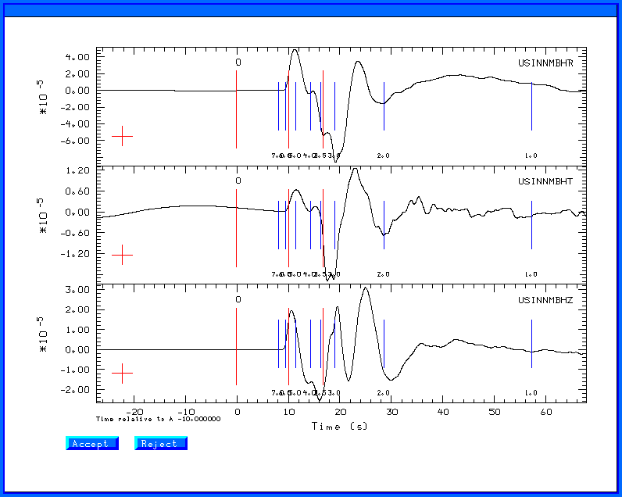

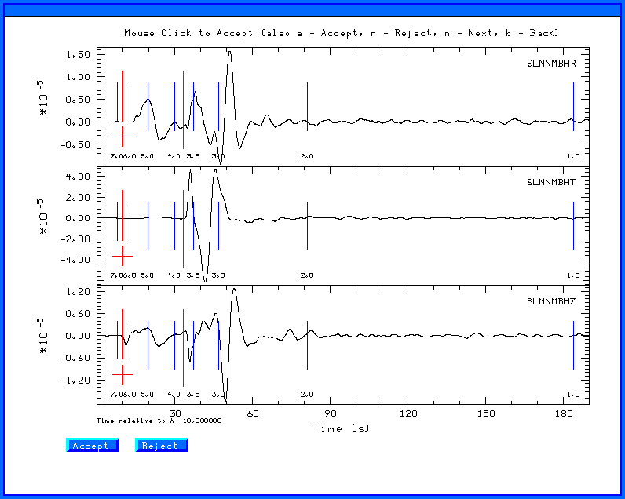
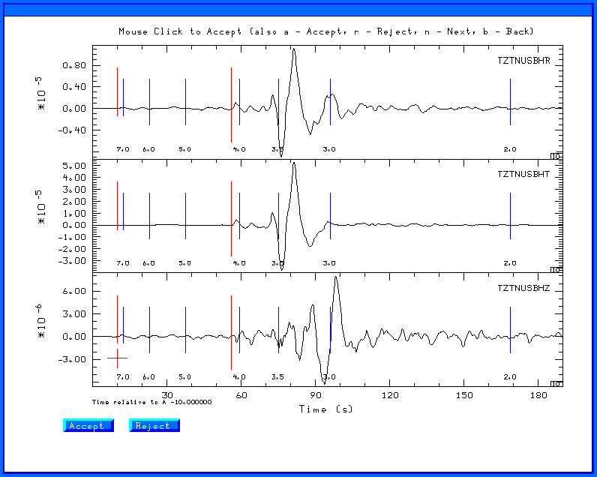

When done with the data set, either when you run out of traces to review or when you enter the 'q', the traces selected will be moved from the 20080418093700/20080418093700/FINAL.QC directory up one level to 20080418093799/DAT.REG and the processing will begin in the 20080418093700/GRD.REG directory.
As the grid-search inversion proceeds, you will see output such as
What is the input file name?
What is the output file name?
WVFGRD96 0.5 125 80 5 4.85 0.2144
What is the input file name?
What is the output file name?
WVFGRD96 1.0 305 85 10 4.89 0.2319
What is the input file name?
What is the output file name?
WVFGRD96 2.0 300 85 -5 4.96 0.2599
What is the input file name?
What is the output file name?
WVFGRD96 3.0 300 75 5 5.01 0.2681
What is the input file name?
What is the output file name?
WVFGRD96 4.0 300 70 0 5.03 0.2797
What is the input file name?
What is the output file name?
WVFGRD96 5.0 300 70 -5 5.05 0.2977
This shows the best solution for each source depth. The output gives the program name, e.g., WVFGRD96, the depth, strike, dip and rake angles, the goodness of fit. The largest value indicates the correct depth. For the stations selected, and the filter settings, the best depth is 15 km. The scripts will then select the best depth, compare synthetics for the best solution and put all graphics files in the HTML.REG directory, and finally run the DOHTML script to create the web page index.html file.
The best depth is given in the fmdfit.dat file in the GRD.REG directory. The best fits for all depths are given in the FMDSUM file, which is listed next. I indicate the final solution by the bold font.
WVFGRD96 0.5 125 80 5 4.85 0.2144
WVFGRD96 1.0 305 85 10 4.89 0.2319
WVFGRD96 2.0 300 85 -5 4.96 0.2599
WVFGRD96 3.0 300 75 5 5.01 0.2681
WVFGRD96 4.0 300 70 0 5.03 0.2797
WVFGRD96 5.0 300 70 -5 5.05 0.2977
WVFGRD96 6.0 300 75 -5 5.07 0.3165
WVFGRD96 7.0 295 75 -5 5.10 0.3342
WVFGRD96 8.0 295 75 -10 5.11 0.3520
WVFGRD96 9.0 120 90 -10 5.12 0.3686
WVFGRD96 10.0 295 75 -5 5.16 0.3887
WVFGRD96 11.0 295 85 5 5.18 0.4048
WVFGRD96 12.0 295 85 5 5.19 0.4171
WVFGRD96 13.0 295 85 5 5.20 0.4244
WVFGRD96 14.0 295 85 5 5.21 0.4289
WVFGRD96 15.0 295 85 5 5.22 0.4301
WVFGRD96 16.0 295 85 5 5.23 0.4281
WVFGRD96 17.0 295 85 0 5.23 0.4245
WVFGRD96 18.0 295 85 0 5.24 0.4196
WVFGRD96 19.0 115 90 -5 5.25 0.4116
WVFGRD96 20.0 295 85 0 5.26 0.4042
WVFGRD96 21.0 115 90 -5 5.26 0.3940
WVFGRD96 22.0 295 85 0 5.27 0.3849
WVFGRD96 23.0 115 90 -5 5.27 0.3736
WVFGRD96 24.0 295 85 -5 5.27 0.3611
WVFGRD96 25.0 115 90 -5 5.27 0.3490
WVFGRD96 26.0 295 85 -5 5.27 0.3380
WVFGRD96 27.0 295 85 -5 5.28 0.3251
WVFGRD96 28.0 120 85 0 5.26 0.3147
WVFGRD96 29.0 120 85 5 5.26 0.3061

You can review the inversion results my opening the browser (Firefox or Internet Explorer) to
RMT/MECH.NA/20080418093700/HTML.REG
and then selecting the 'index.html' file. Note on Windows, Internet Explorer or Firefox uses the Windows view of the file system and not that of CYGWIN. You will see five figures, two of which are shown here. The seismogram comparison is useful. On can justify removing traces if it seems that the instrument is not working correctly, e.g., the USIN horizontals, or the UTMT instruments. Such decisions require some experience and an understanding of seismic wave propagation.
The figures below show the stations used in the inversion (a map created using GMT), the goodness of fit with source depth, and a portion of the trace display.

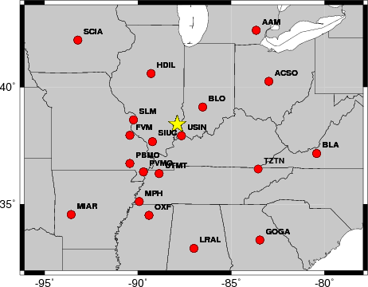
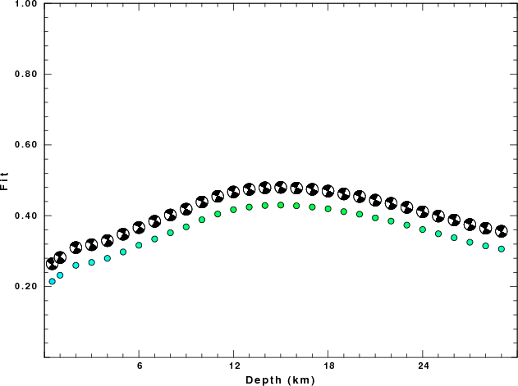

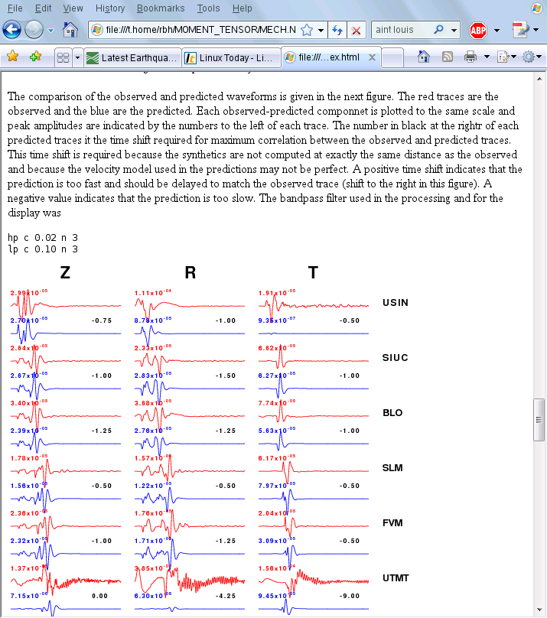
The solution for this earthquake is given at

http://www.eas.slu.edu/eqc/eqc_mt/MECH.NA/20080418093700/index.html

More things to do

Remove bad traces
To remove some traces and then to rerun, there are two steps:
First, go to the DAT.REG directory and move the unwanted traces. I place them in the NOUSE subdirectory
rbh> mv UTMT* NOUSE
rbh> mv USINBHT NOUSE
Second go to the processing directory, and cleanup
rbh> cd ../GRD.REG
rbh> DOCLEANUP

The DOCLEANUP script removes all files ending with .obs .pre Z R and T. If you wish to change the filtering bands, e.g., to change the time window, bandpass corner frequencies or apply the microseism filter, carefully modify the DOSTA script. Now restart everything and generate the revised documentation.
rbh> DOGRD; DOPLTSAC; cd ../HTML.REG; DOHTML
The ';' indicates the end of a command. This is one way to issue all of the commands at once, and then have everything run to completion.

You can also edit the DOSTA script in RMT/MECH.NA/20080418093700/GRD.REG to sue a different set of filter frequencies.

