Landing Screen- User adds the wallpaper they intend to have configured.

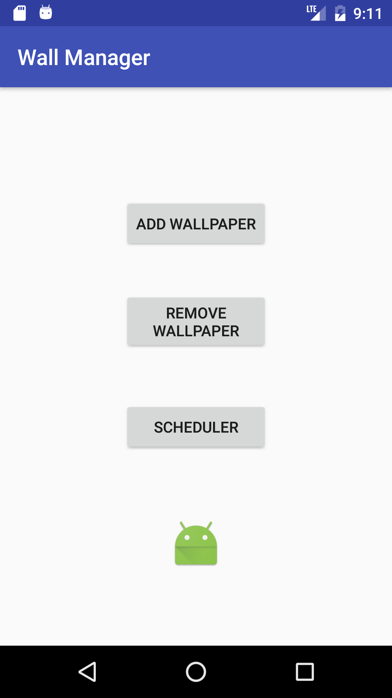

User Selects the images from the Gallery

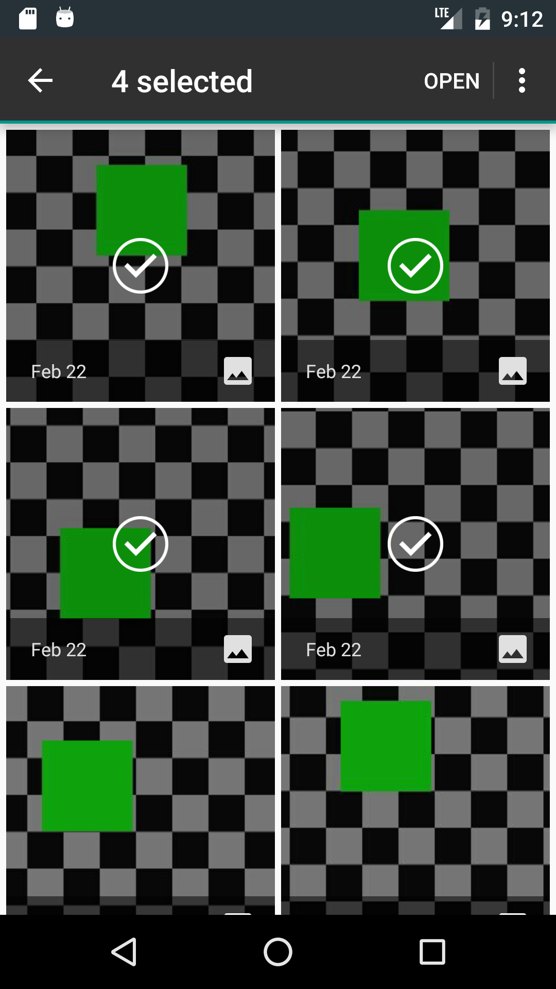

Images are add to the App

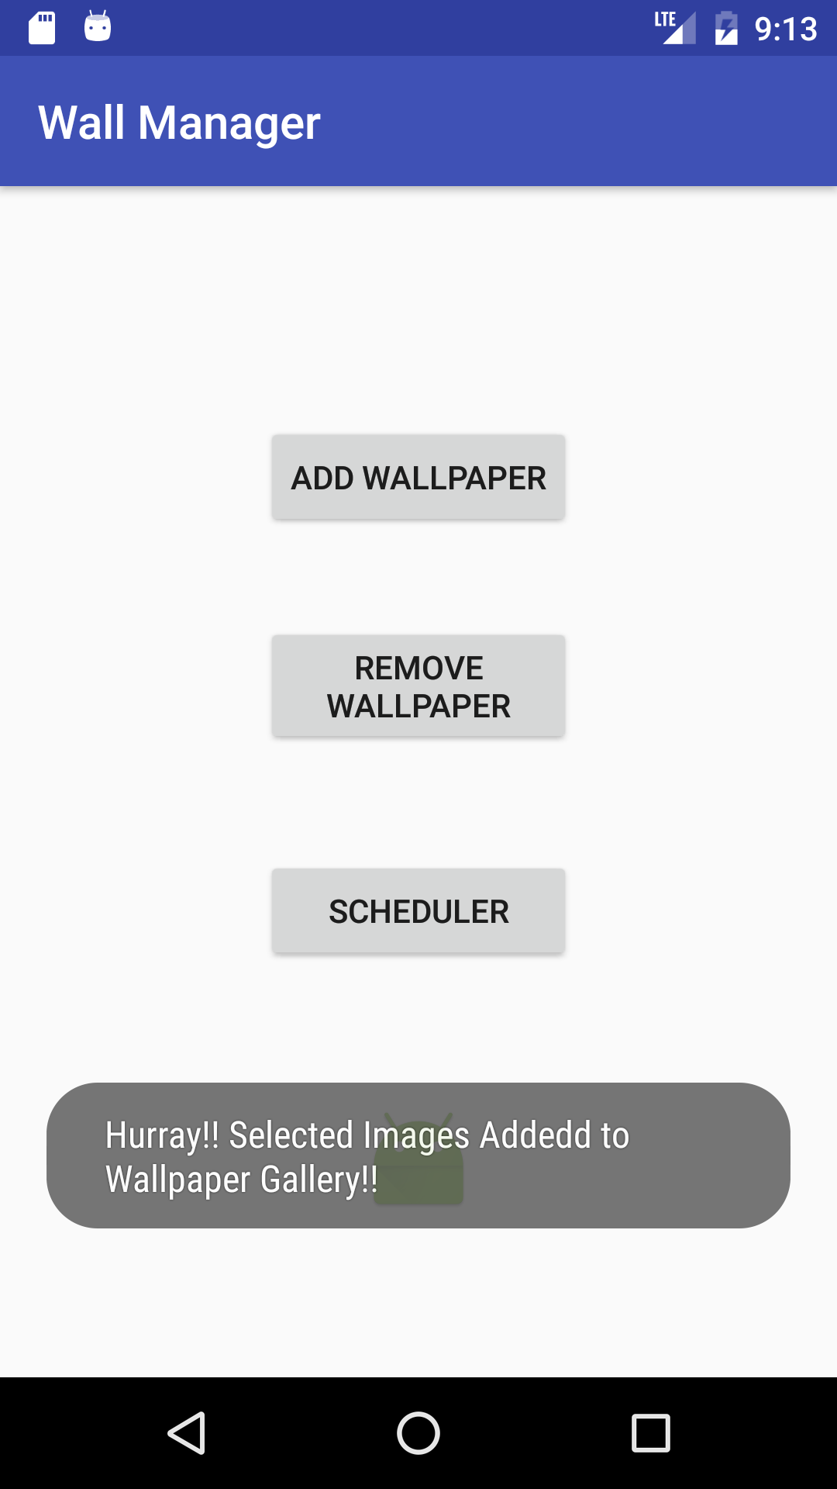

User Comes to the landing screen where he/she can choose to make modification to the list of Images by go to Remove button



User is shown a list of Images

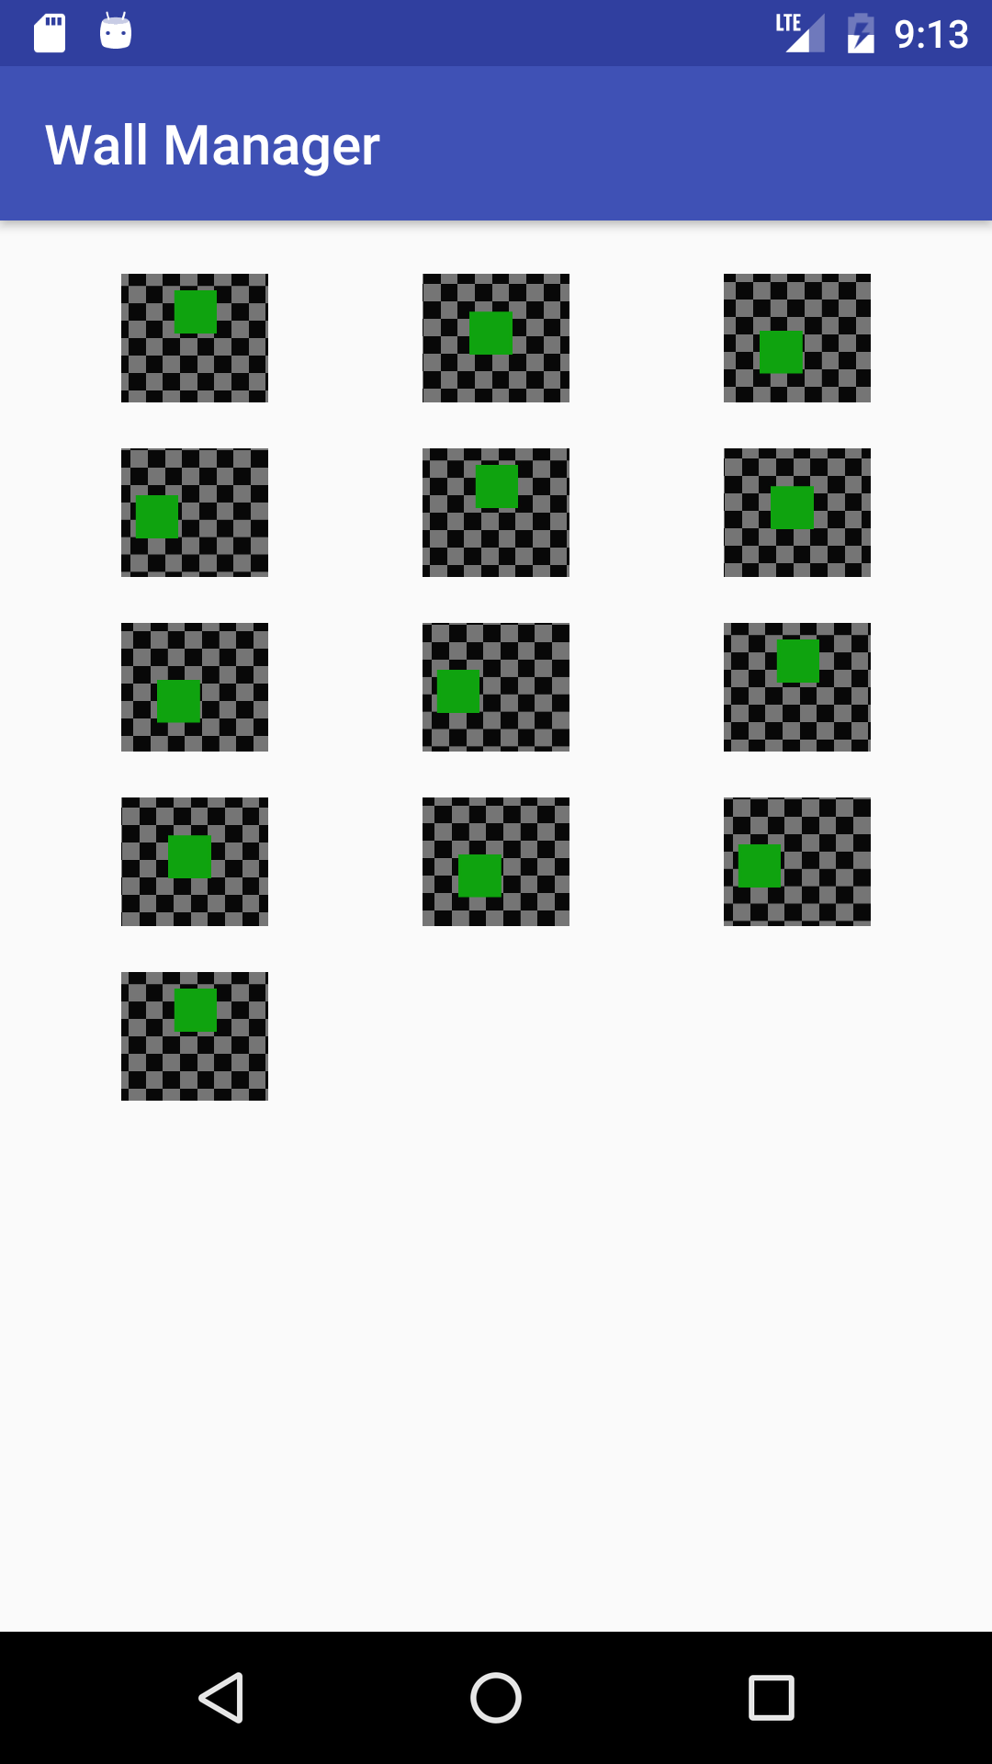

User then Comes to main screen and clicks on Scheduler to schedule the Wall paper change frequency



User sets the frequency and turns on the app

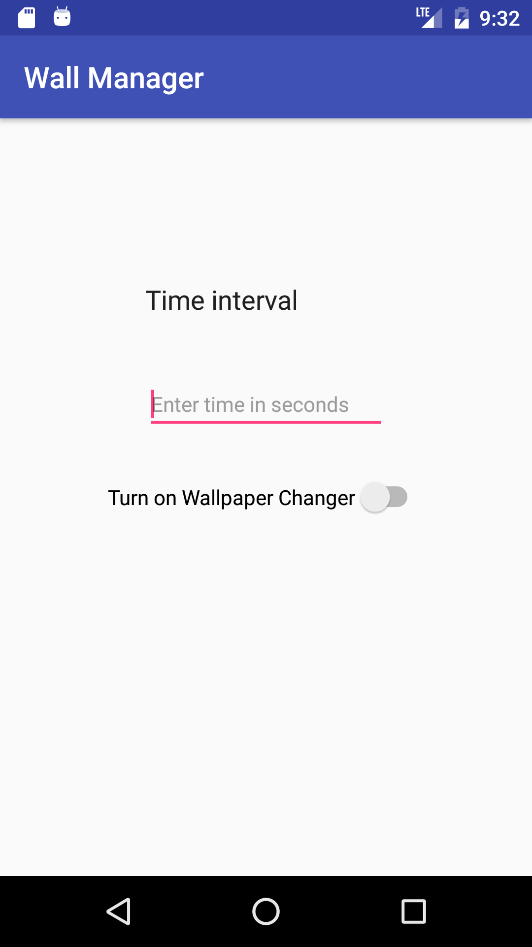

Wallpaper Changes as per the settings

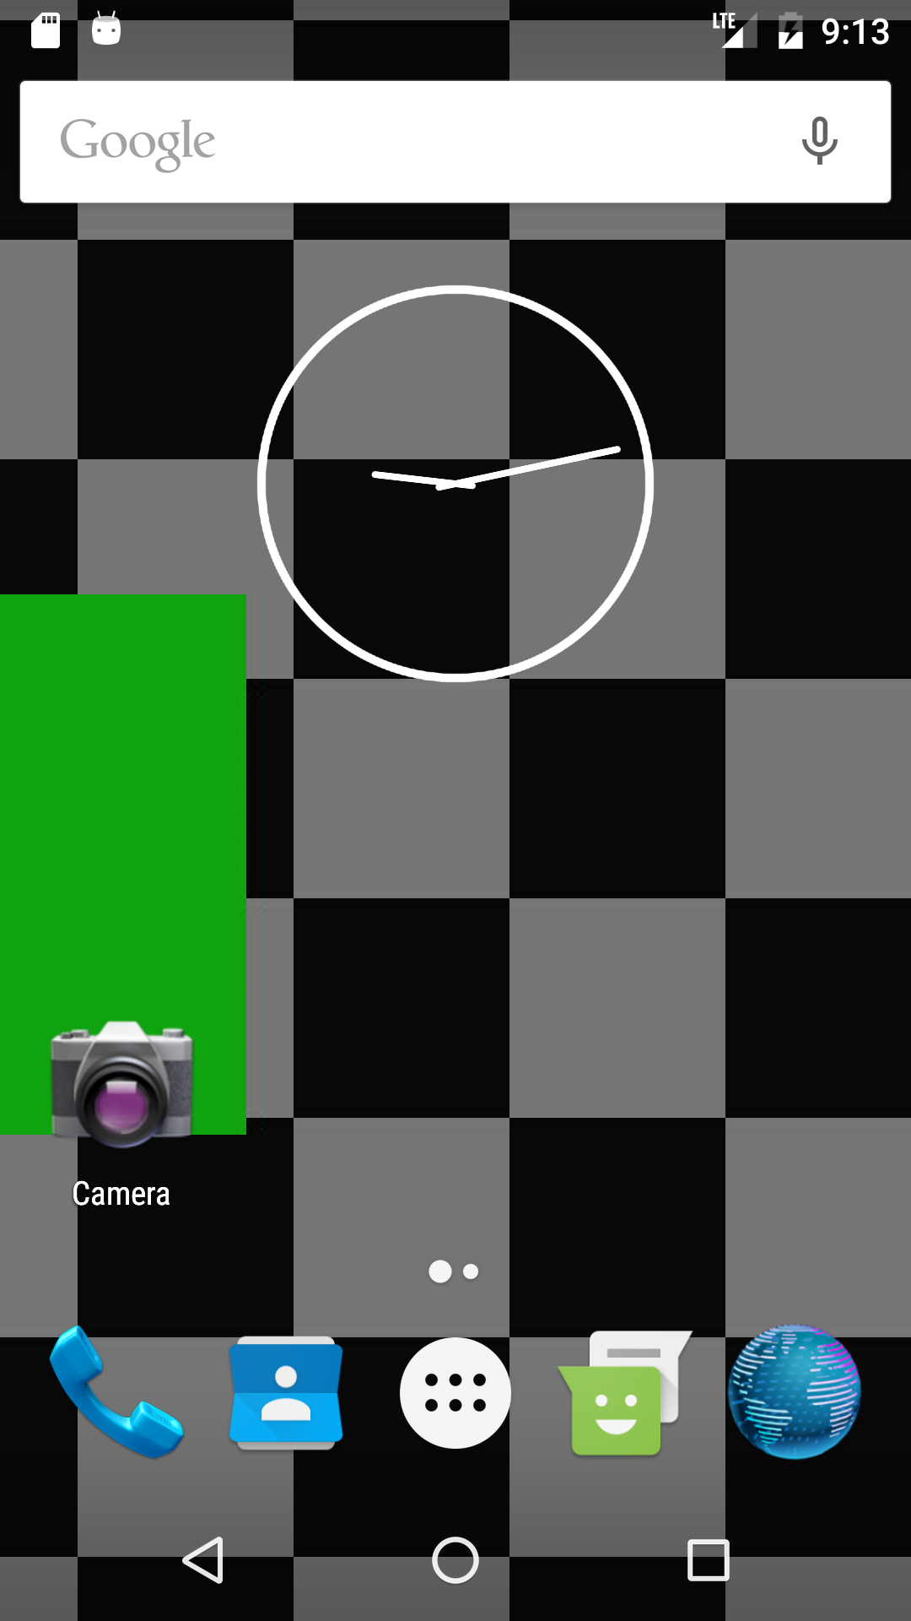

<https://github.com/rbidanta/WallManager.git>