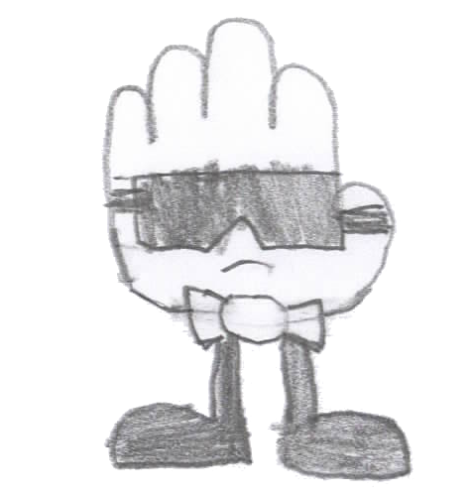

At a very young age Glove always insisted on order. Toys in the correct bins, books sorted by genre, author and title, clothes pressed and hung (never folded), bed tucked so tight you could bounce a quarter, I think you get the idea. Glove has authoritarian tendencies and wants to always be in control, keeping Fingers and Hand isolated from one another over the years has helped to mold Glove’s hard stance.

So it's no surprise the first time Glove saw the movie MiB, Glove knew which profession to pursue, secret agent! From that point on, all of Glove’s efforts were spent in pursuit of the dream to work for the CIA. Glove mimicked agents' movements and dress, how agents walk and talk and yes, even how they scowl, all in preparation for badge day, the day Glove could officially announce, “I’m CIA”!

Unfortunately, things did now work out as planned, heart broken but not deterred, Glove started a private eye business to keep the dream alive. Now, as with all stories, this is where Glove’s turned, for when Glove flipped on the "Any Case Welcome” neon sign for the very first time a distraught Mitten walked through the door forever changing Glove’s life.

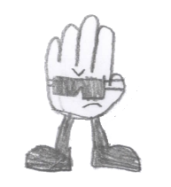 |  | 