**importETPdataAndCompareWithDataNitro.py**

What the script does:

* Extracts data from **E**mployee **T**raining **P**anel records and local Data Nitro records
* Compares data and finds discrepancies
* Accounts for and Excludes…
  + unidentified employees
  + external employees
  + temporary employees
  + interns
  + ineligible classes
  + classes not in class list
* Creates a new sheet with a list of employee/class records recorded locally but not uploaded to ETP

**IMPORTANT:** When copying the information from the original files into one workbook, follow the original formatting. See end of document for A1 reference.

Running the script:

* Script steps:

1. Open workbook within the following directory: Z:\work\training\Training\_Services\Training\_Interns\Rachael\_Projects\Data Nitro ETP

Workbook should contain sheets with HR info, ETP data, and class info

Z:\work\training\Training_Services\Training_Interns\Rachael_Projects\Data Nitro ETP WIP\v2-01.PNG

Z:\work\training\Training_Services\Training_Interns\Rachael_Projects\Data Nitro ETP WIP\v2-02.PNG

1. Load the “importETPDataAndCompareDataNitro” script using the DataNitro tab, and click “Run”

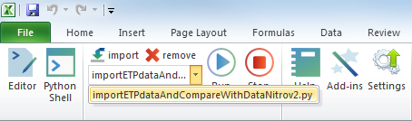

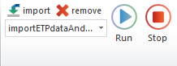

1. Enter the name of the worksheet with the HR information  
   This will create a “dictionary” that maps trainee IDs to their employment type

e.g. “hr info”

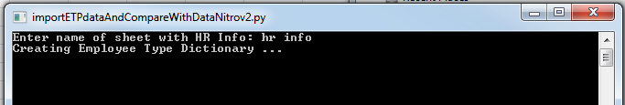

1. Enter the name of the worksheet with the class information  
   This will create a “dictionary” that maps unique IDs to the trainee name, trainee ID, class title,   
   roster ID and class date

e.g. “class info”

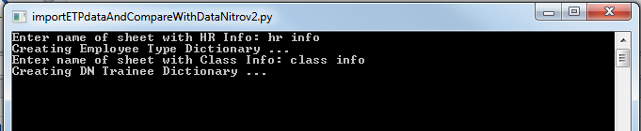

1. Enter the name of the worksheet with the downloaded ETP information

This will parse the ETP records to compare it to the local records by creating another dictionary

e.g. “etp info”

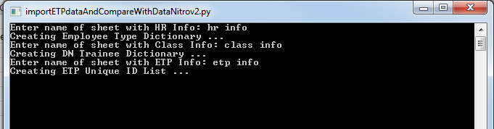

1. The script will make and open a new sheet in the workbook with the local records  
   The new sheet name will have the format “results\_#”

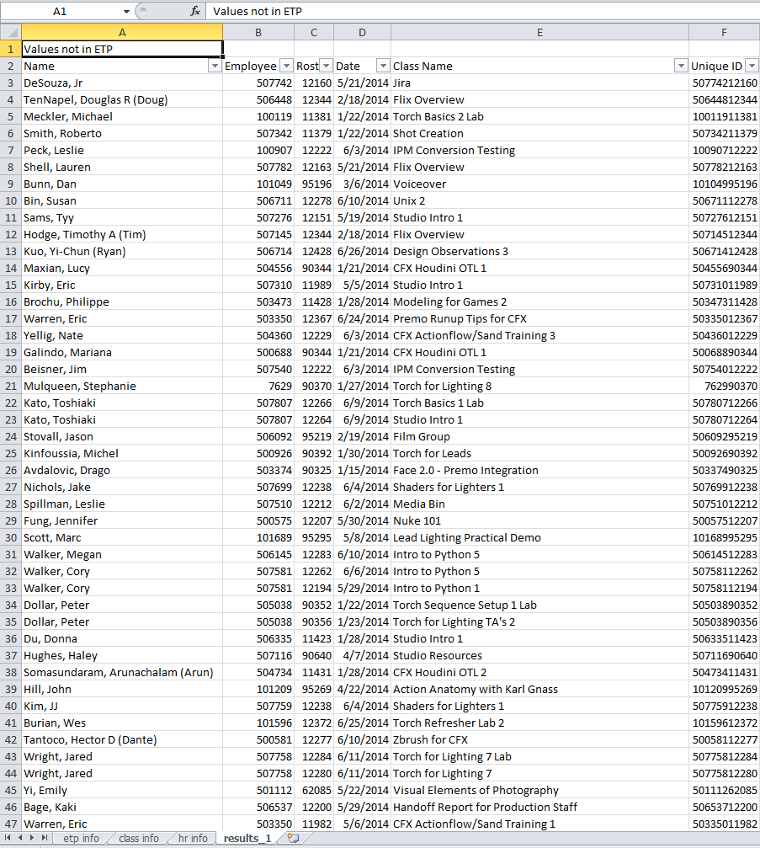



**A1 Reference**

|  |  |  |  |  |  |  |  |  |  |
| --- | --- | --- | --- | --- | --- | --- | --- | --- | --- |
| **Sheet** | **Column Header**  **On Row** | **ID** | **Roster** | **Category** | **Name** | **Date** | **Class** | **Attended** | **ETP type** |
| **HR** | 5 | C |  | G |  |  |  |  |  |
| **Class Info** | 6 | B | M |  | C | K | N | AI | AH |
| **ETP Info** | 2 | D | G |  |  |  |  |  |  |