**streamline.gs**

What the script does:

* Creates a “Custom Functions” Menu with “Get Data” and “Deleted Scheduled” functions
* Get Data
  1. Extracts data from curriculum spreadsheets in the given folders
  2. Populates a new spreadsheet with the class names, attending trainees, and week number
* Delete Scheduled
  1. Removes rows marked with anything other than “FALSE” in the “Scheduled?” column

Running the script:

* Setting Up:
  1. Navigate to Google Drive
  2. Create a new spreadsheet  
       
     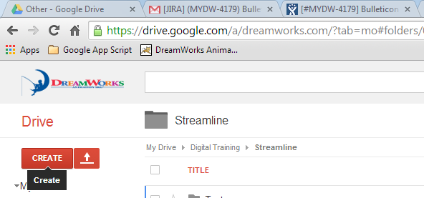
  3. Navigate to **Tools > Script Editor  
       
     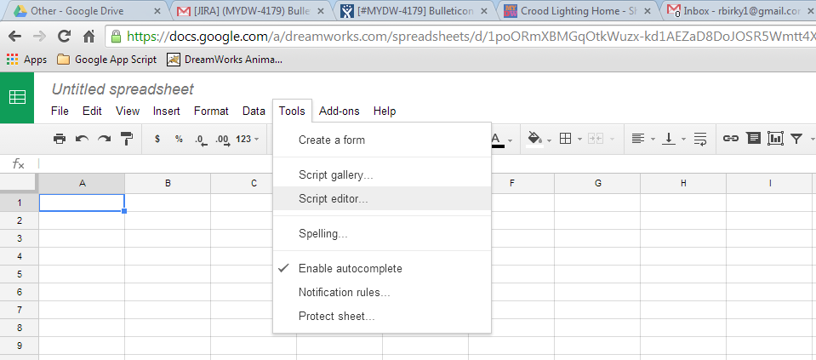**
  4. Upon prompt, click to create a new “Blank Project”  
       
     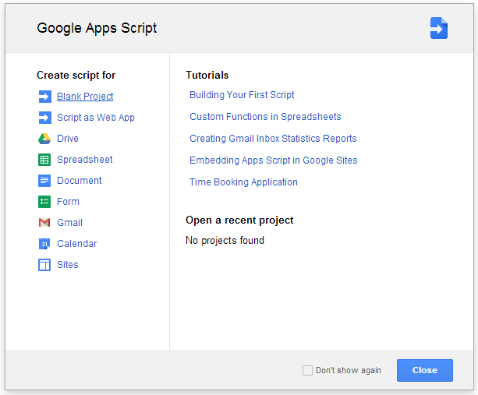
  5. Remove any existing code.
  6. Copy and paste code from

**Z:\work\training\Training_Services\Training_Interns\Rachael_Projects\Streamline\ streamlineScript.txt**

* 1. Save and enter “Project Name” upon prompt  
       
     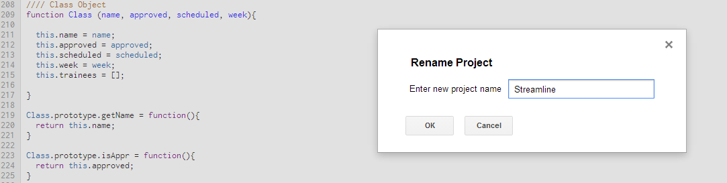
  2. **Close** Script Editor **and** Spreadsheet tabs  
     *Optional: Rename Spreadsheet before closing*  
     **Re-open** Spreadsheet  
     Note: This is required for the “Custom Functions” menu to appear
  3. The script is now ready to be used

* Script steps:
  1. “Get Data”
     + Select **Custom Functions > Get Data**Note: The **first** time you run the script, you will need to authorize it by selecting   
        “Continue” when prompted  
       Note: This might require you to select a Google account; select the account in which you   
        are using the script (@dreamworks.com)  
       Another prompt will require you to click “Accept” **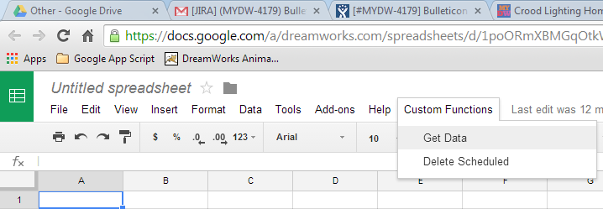  
         
        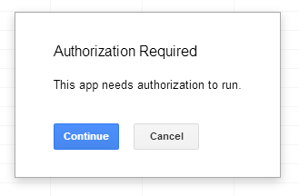  
        Select “Continue”  
         
        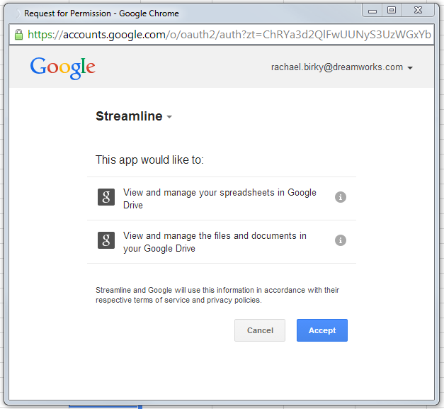  
         
        Select “Accept”**Select **Custom Functions > Get Data** again to run the script if authorization was required
     + When prompted, enter the name of the folder with the curricula spreadsheets  
       Note: Simply press “Enter” or click “Ok” without typing in the prompt text box when   
        there are no more folders to be processed  
       Note: A “Script Running” dialog box will show at the top of the page to show progress  
         
        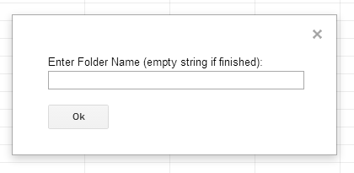  
         
        
     + The results will be input to the spreadsheet!  
       Note: You might want to auto-fit the columns manually  
       Note: The top row is frozen and the font is bold for your convenience  
        0

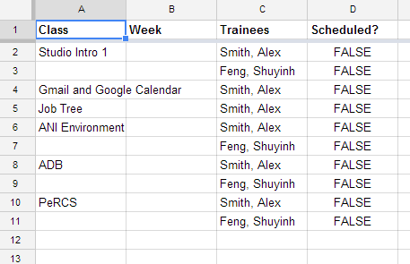

* 1. “Delete Scheduled”
     + Follow instructions for “Get Data” if authorization is required
     + Mark rows to be deleted  
       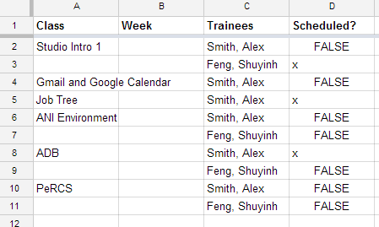
     + Run **Custom Functions > Delete Scheduled  
         
       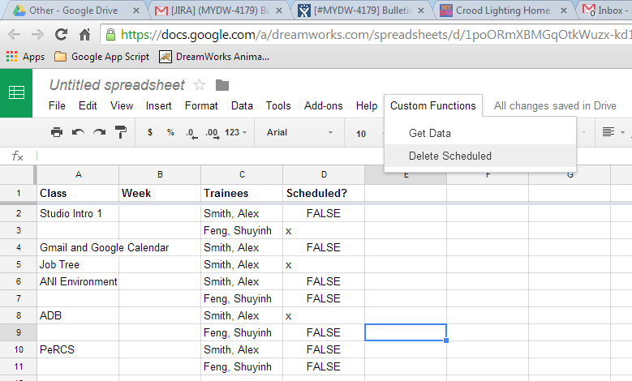**
     + Results are update!  
         
       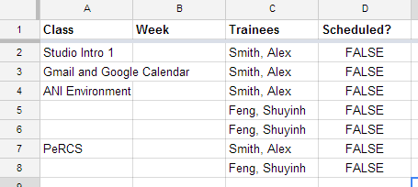
     + Note: This function is just to clean the document while working  
        The best way to keep updated content is to re-run the “Get Data” Function after   
        updating the individual curriculum spreadsheets