**Reports.xlsm**

This file is located in: **Z:\work\training\Training_Services\EducationDatabase\2014\Reports**

What the script does:

* Can access all four DataNitro training databases
* Gives a **G**raphical **U**ser **I**nterface to apply multiple filters to the databases
* Copies the filtered information to

**Important:** This document contains macros.

You must enable the content, if prompted, for the script to function properly.

Running the Script:

* Script steps:

1. Open the workbook Reports.xlsm located in the directory Z:\work\training\Training_Services\EducationDatabase\2014\Reports
2. Navigate to Sheet1 where you will find a button labeled **Get Data**

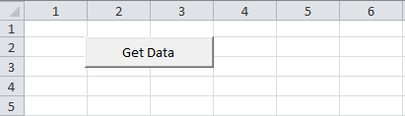

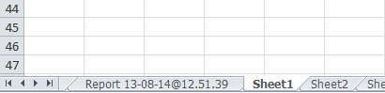

1. Click the **Get Data** button, and you will receive a GUI as seen below

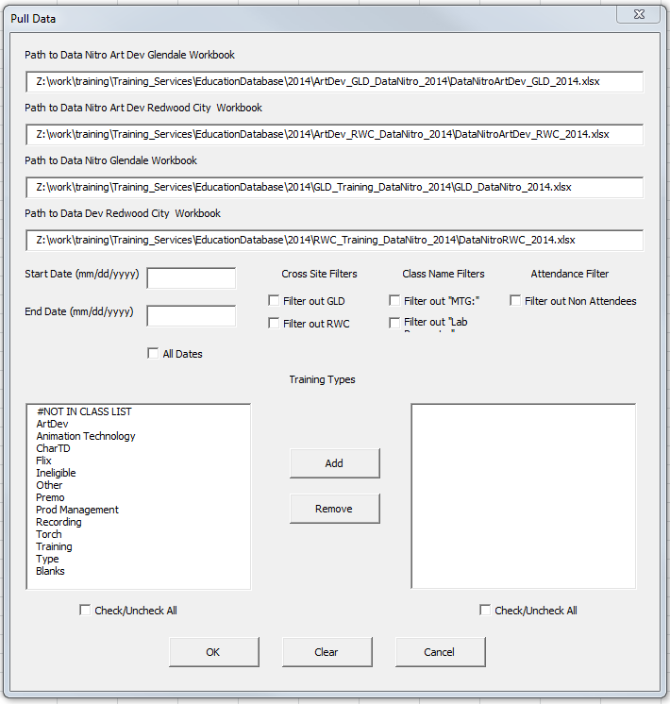

1. The first four text boxes contain the four workbooks from which to pull.  
   They have been auto-populated with the 2014 Data Nitro databases paths.   
   To exclude a database, simply delete the path and leave the text box empty

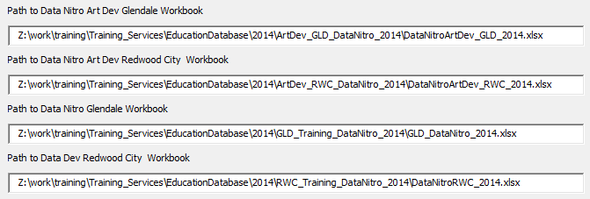

1. The next two text boxes let you specify the **Start Date** and **End Date** (inclusive) to filter  
   Check the **All Dates** check box to pull all dates (you will not be able to enter dates in the text boxes)

**Note:** The format of the date must match that of the Data Nitro databases

*ex. 12/15/2014 or 1/14/2013*

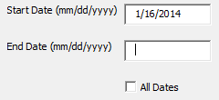 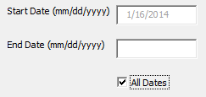

All Dates selected, date textboxes disabled (greyed out)

Example of entering dates

1. The five check boxes to the right are filtering options for **Cross Site**, **Class Name**, and **Attendance**  
   Check one to *exclude* or *filter out* that option

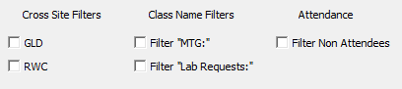

1. There are two list boxes representing **Training Types**.  
   The left one contains all the training types, the right, the types you select to *include* in the results  
   Multi-selection is supported (click, CTRL-click, SHIFT-click)  
   Click **Add** to add training types in the left box to the right box (and thus the results)  
   Select training types in the right box and click **Remove** to remove them from the results  
   **Check/Uncheck All** checkboxes have been added for convenience

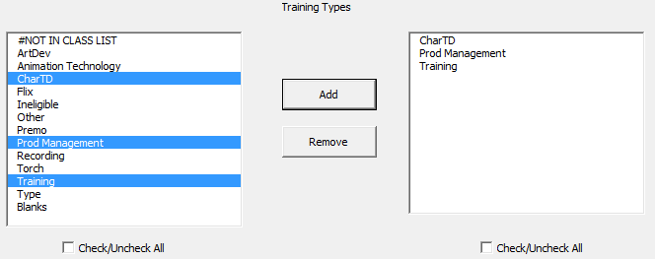

1. Instructors?
2. When you are finished selecting options, click “OK”
   1. If you wish to start over, click “Clear” and the options will reset to the default
   2. To cancel, click “Cancel”

