# **Brand name: Housing Smurfs**

# **Business transactions/processes:**

Our business aims to help UMD members to meet their perfect unit match around this area (less than 10 miles from UMD). With our services, customers can easily refer to reviews from different resources and details about the unit. Once they identify a suitable unit, the contact information we provide allows them to contact the owner and get a lease. After they become a resident, they can also rate their units to support more UMD members in finding their dream unit!

# **Mission Statement:**

To help find reviews of various units and their rental details from various online sources in one place.

# **Mission Objectives:**

1. Take A Look At All The Units That You Can Choose

* What are the unit name, rate, rent per person, number of bedrooms and bathrooms, number of reviews, and contact info for every unit near the UMD?

1. Understand Some General Conditions For These Units

* What is the average rate for the units that the UMD shuttle bus will stop by?
* What is the percentage of reviewers that left rate >=4.0 starts for Graduate Hills?

1. Search For The Unit That Meets Your Expectations

* Which apartment is less than 1 mile to the UMD, has rent equal to or lower than $1,400, and with a study room at the same time?

1. Check If The Unit Is Also Recommended By Their Residents

* Is the review content for that unit which is >=4.0?

# **ER Schema:**

## 

## **Entities, Attributes, and Primary Keys**

Unit ( **unitId**, unitName, unitAddress, -unitStreet, -unitCity, -unitState, -unitZipCode, unitType, unitDistance, unitUtilities[1..10], =avgRate, =reviewNumber)

Owner ( **ownerId**, ownerName, -ownerFName, -ownerMInit, -ownerLName, ownerPhone[1..2])

Review ( **reviewId,** reviewRate, reviewContent)

Resident( **residentId**, residentName, -residentFName, -residentMInit, -residentLName，residentGender, residentAge, residentCitizenship)

Reviewer (**reviewerId**, reviewerName, -reviewerFName, -reviewerMInit, -reviewerLName)

Lease ( **leaseId**, leaseDuration, leaseArea, leasePrice, leaseBedroom, leaseBathroom)

Response ( **responseId**, responder, responseContent)

Relationships, Attributes, Degrees, Participating Entities and Constraints

Sign[signDate]: ternary relationship

1 resident and 1 unit to 1 lease

1 resident and 1 lease to 1 unit

1 unit and 1 lease to 1 or many residents

Comment [commentDate]: ternary relationship

1 reviewer and 1 review to 1 unit

1 reviewer and 1 unit to 0 or many reviews

1 unit and 1 review to 1 reviewer

Manage: binary relationship

1 owner to 1 or many units

1 unit to 1 owner

Reply: binary relationship

1 review to 0 or many responses

1 response to 1 review

# **ER Diagram:**

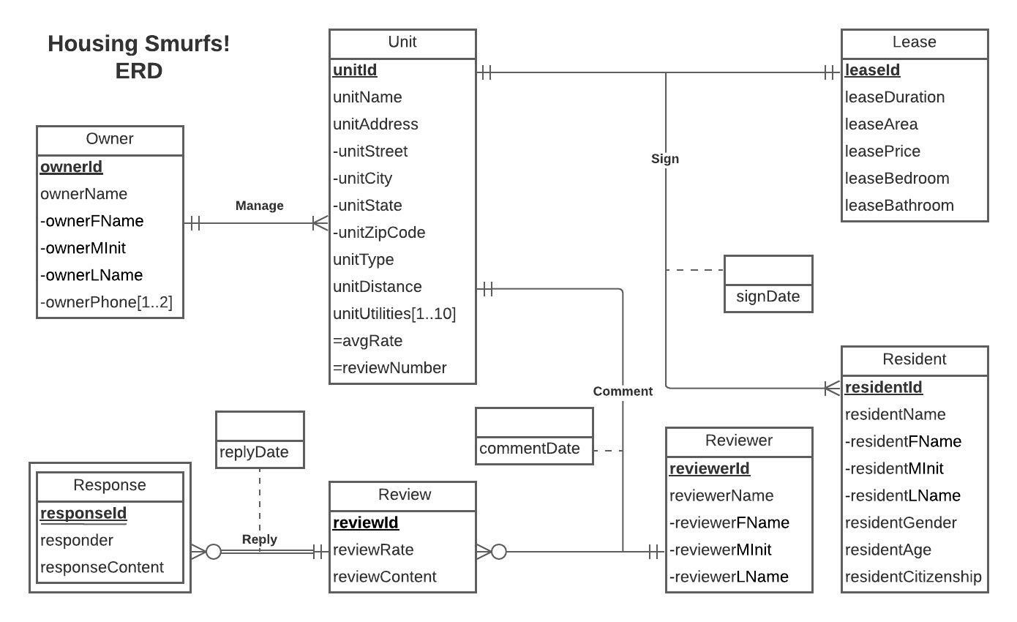

# **Relations:**

Owner (**ownerId**, ownerFName, ownerMInit, ownerLName)

Unit (**unitId**, unitName, unitStreet, unitCity, unitState, unitZipCode, unitType, unitDistance, *ownerId*)

Unit_Utilities (***unitId***, **unitUtilities**)

Owner_Phone (***ownerId***, **ownerPhone**)

Lease (**leaseId**, leaseDuration, leaseArea, leasePrice, leaseBedroom, leaseBathroom)

Resident (**residentId**, residentFName, residentMInit, residentLName, residentGender, residentAge, residentCitizenship)

Reviewer (**reviewerId**, reviewerFName, reviewerMInit, reviewerLName)

Review (**reviewId**, reviewRate, reviewContent)

Response (***reviewId***, **responseId**, responder, responseContent, replyDate)

Sign (***residentId***, *leaseId*, *unitId*, signDate)

Comment (***reviewId***, *unitId*, *reviewerId*, commentDate)

**Business rules:**

[R1] When Owner information is changed or deleted, the corresponding owned unit information should be changed or deleted accordingly

[R2] When Owner information is changed or deleted, the owner’s phone numbers should be changed or deleted accordingly

[R3] When a lease is signed by a resident, for a unit, the information of the resident cannot be deleted but can be changed accordingly

[R4] When a lease is signed by a resident, for a unit, the unit, and the lease agreement cannot be changed or deleted

[R5] When the information of the unit is changed or deleted, the information regarding the unit utilities should be changed or deleted accordingly

[R6] When the information of a review is changed or deleted, the information of the response to the review should also be changed or deleted

[R7] When the information of a review is changed or deleted, the information of the comments on the review should also be changed or deleted accordingly.

[R8] When the information of a unit is changed or deleted, the comments about the unit should also be changed or deleted

[R9] When the information of a reviewer is changed or deleted, the comments from the reviewer should also be changed or deleted

# **Referential integrities:**

|  |  |  |  |  |  |  |  |
| --- | --- | --- | --- | --- | --- | --- | --- |
| Relation | Foreign Key | Base Relation | Primary Key | Business Rule | Constraint: ON DELETE | Business Rule | Constraint: ON UPDATE |
| Unit | ownerId | Owner | ownerId | R1 | Cascade | R1 | Cascade |
| Owner_Phone | ownerId | Owner | ownerId | R2 | Cascade | R2 | Cascade |
| Sign | residentId | Resident | residentId | R3 | No action | R3 | Cascade |
| Sign | leaseId | Lease | leaseId | R4 | No action | R4 | No action |
| Sign | unitId | Unit | unitId | R4 | No action | R4 | No action |
| Unit_Utilities | unitId | Unit | unitId | R5 | Cascade | R5 | Cascade |
| Response | reviewId | Review | reviewId | R6 | Cascade | R6 | Cascade |
| Comment | reviewId | Review | reviewId | R7 | Cascade | R7 | Cascade |
| Comment | unitId | Unit | unitId | R8 | Cascade | R8 | Cascade |
| Comment | reviewerId | Reviewer | reviewerId | R9 | Cascade | R9 | Cascade |

# **Sample Data:**

Unit (

1. U01, Alloy, 4700 Berwyn Street, College Park, MD, 20740, Apartment, 0.1, *O01*

2. U02, University View, 8204 Baltimore Avenue, College Park, MD, 20740, Apartment, 0, O02)

Unit_Utilities (

1. fitness center, swimming pool, club room, study room, parking lot, courtyard, on-site maintenance, controlled access, business center, Null
2. fitness center, swimming pool, club room, study room, parking lot, UMD shuttle bus, courtyard, on-site maintenance, controlled access, business center)

Owner (

1. O01, Willow Wick Residential, Null, Null

2. O02, Scion, Null, Null)

Owner_Phone (

1. O01, 3016180990, 3016374385

2. O02, 3013046500, Null)

Lease (

1. L01, 12 months, 900, 1489, 2, 2

2. L02, 12 months, 900, 1489, 2, 2)

Resident (

1. D01, Wen, Null, Chen, F, 23, China

2. D02, Wei-Yu, Null, Jen, F, 27, Taiwan)

Reviewer (

1. C01, Shih Siang, Null, Lin

2. C02, Steve, Null, Null)

Review (

1. R01, 1.0, I’ve had experiences with various student apartment rentals in college park. In my opinion the view is the worse so far. Even though the view appears to be competitive in terms of rent, they will nickel and dime you for so many other expenses. The cost for utilities every month just adds up. Also at the end of year they will gouge you for expenses that should qualify as normal wear and tear. They tried to charge us for dust that was on the floor saying it would require significant cleaning. Give me a break! Call them and they will remove some of the charges but others such as marks on the wall they will say require a full painting of the room. Are you telling me that a mark on the wall is not considered to be normal wear and tear? It’s ridiculous. My son stayed at another apartment rental and had similar marks and was not charged at all. Save yourself some money and headache and look elsewhere.)

Response (

1. R01, S01, UV Owner, Hi Steve, we're sorry to see your negative review. We would like to reach out to you if you have the time to speak to one of our team members. You can reach out to us at live@uviewapts.com or 301-304-6500., 09/01/2021)

Sign (

1. C01, L01, U02, 5/6/2021)

Comment (

1. R01, U02, C02, 11/10/2020)