# **Project name: Housing Smurfs**

**Data Sources**

1. Websites:

We have used several websites to collect review, reviewer, utilities, review response, owner and apartment information. The data from the following websites was used to create our database

* Google Reviews: [https://www.google.com/search?gs_](https://www.google.com/search?gs_ssp=eJzj4tFP1zc0ysiNLzZOMjJgtFI1qLCwTDJPNrM0tDQwsUhKMTe1MqhITjZOTDW2tEgyMU41Mk-y8BJOyc9NzMxTSM7PyUlNT1UoSCzKBgAErBYN&q=domain+college+park&rlz=1C1OKWM_enIN914IN914&oq=domain+colle&aqs=chrome.1.35i39i355j46i39i175i199j69i57j0i512j0i20i263i512j0i512j46i175i199i512j0i512l3.3084j0j9&sourceid=chrome&ie=UTF-8#lrd=0x89b7c6919048bd75:0xcc3ae398b43e27b8,1,,,)
* Yelp : <https://www.yelp.com/nearme/apartments>
* Apartments.com:<https://www.apartments.com/>
* Apartment Ratings:<https://www.apartmentratings.com/>

1. Survey:

To collect the lease information which was not available easily on the websites, we created a survey using google forms and sent it out to umd students.

Link: [Survey link](https://docs.google.com/forms/d/1CZ24ISKj1vNgxOos1fKJn4MViVjVjggQIKqYZMVvPnM/edit)

**Testing our Project**

1. Creating Tables:

The Project_0507_DDL.sql file has the create table and insert commands which create and insert the data into tables used in our project. Running this query in the Microsoft server management studio after connecting to the rhsmith sql server will create all the required tables and insert the data into the tables. The screenshots of the tables created and the insert data commands are attached below.

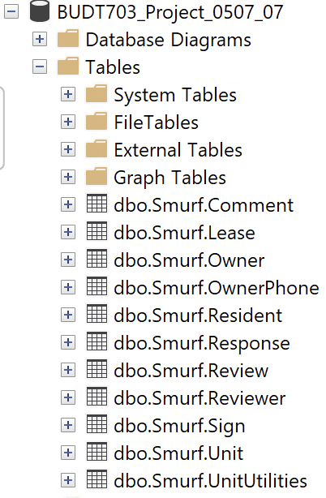

Fig.1 All the tables created

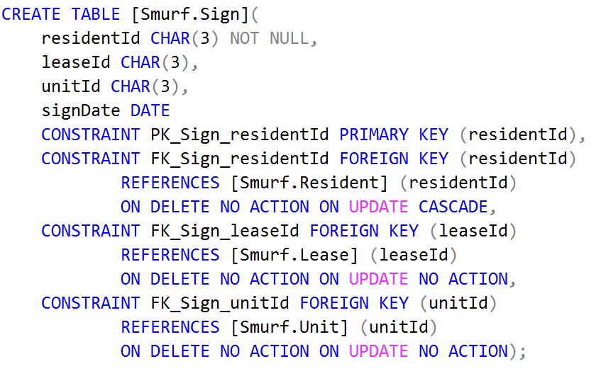

Fig.2 Create table command

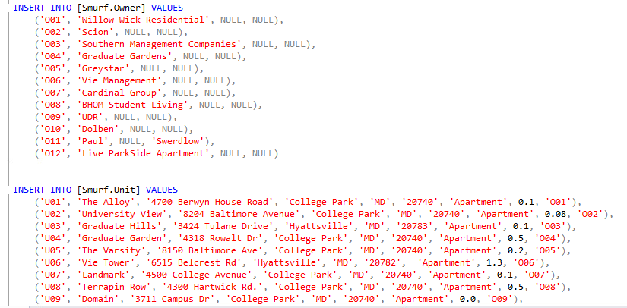

Fig.3: Data insertion Commands

1. Business Transactions in SQL:

The file Project_0507_DML.sql contains the SQL commands for all the business transactions of our project. Running this query in the Microsoft server management studio after connecting to the rhsmith sql server will give the sql table outputs for our business transactions. The screenshots of the outputs are attached below

Fig.4 Business Transaction 1

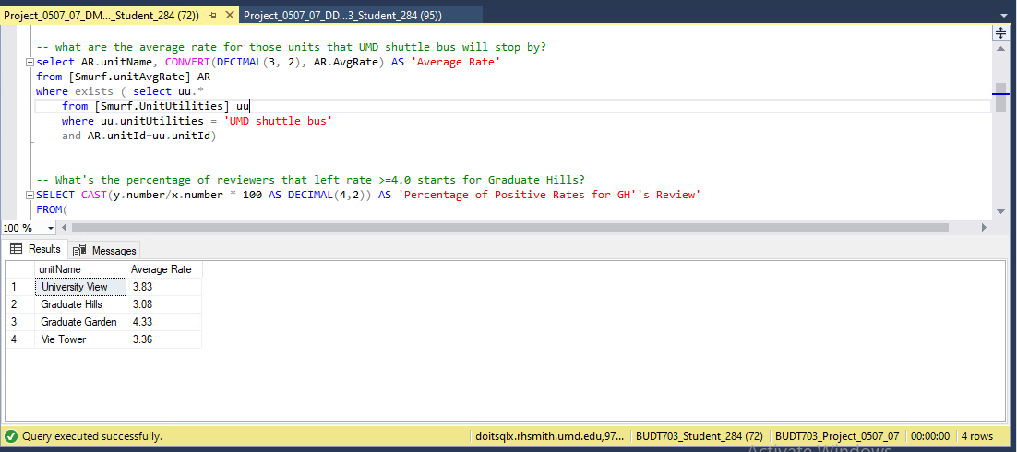

Fig.5 Business Transaction 2

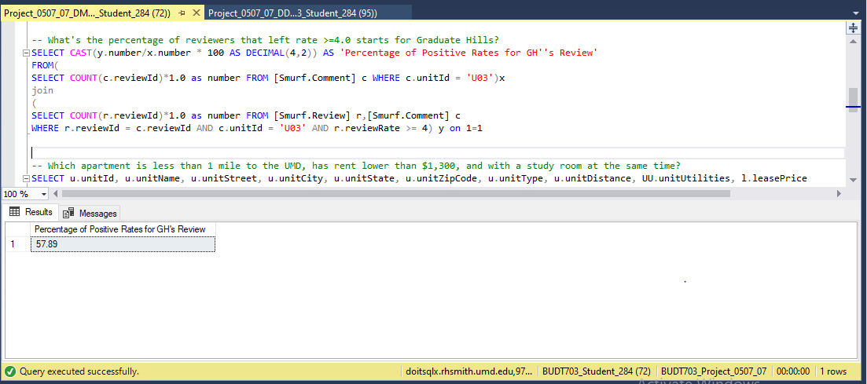

Fig.6: Business Transaction 3

Fig.7: Business Transaction 4

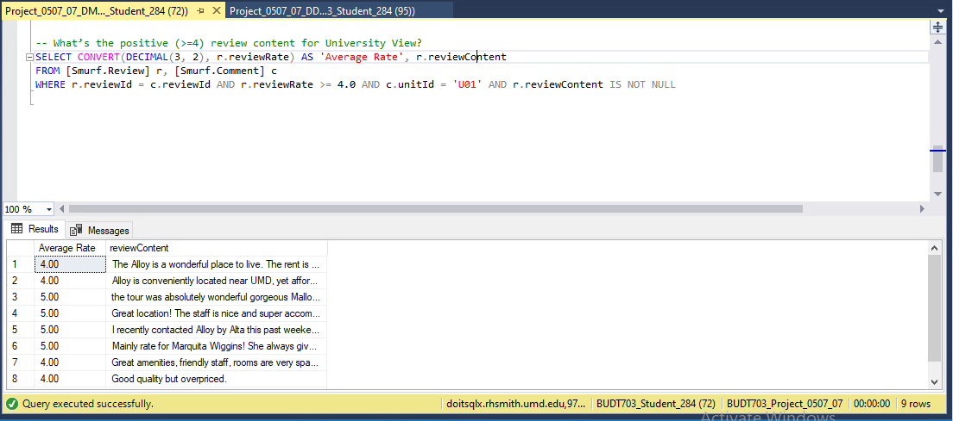

Fig.8: Business Transaction 5

3. Business Transaction Visualization in Tableau:

The Project_507_Tableau.twb file has the data connections, the business transactions visualization and dashboard of our project. Open the file in Tableau and login to the rhsmith sql server to access the data connections, visualization and the dashboard. The screenshots of the connections, visualization and dashboard are attached below.

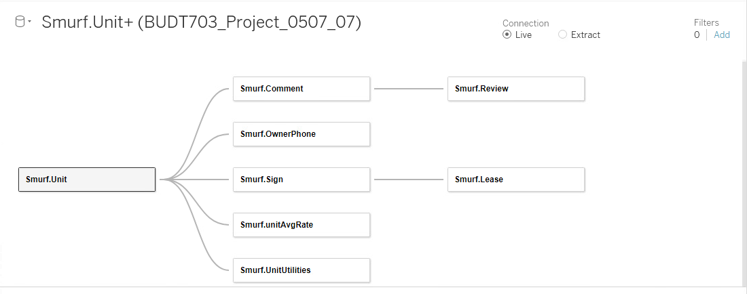

Fig.9: Data connections

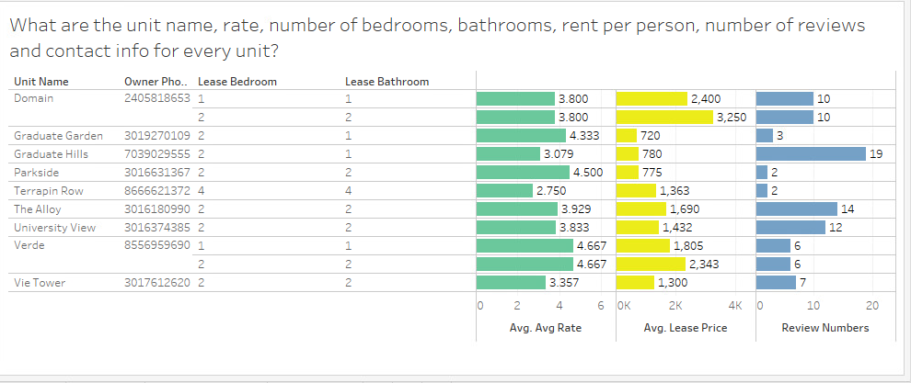

Fig.10: Business Transaction 1 visualization

Fig.11 Business Transaction 2 visualization

Fig.12 Business Transaction 3 visualization

Fig.13 Business Transaction 4 visualization

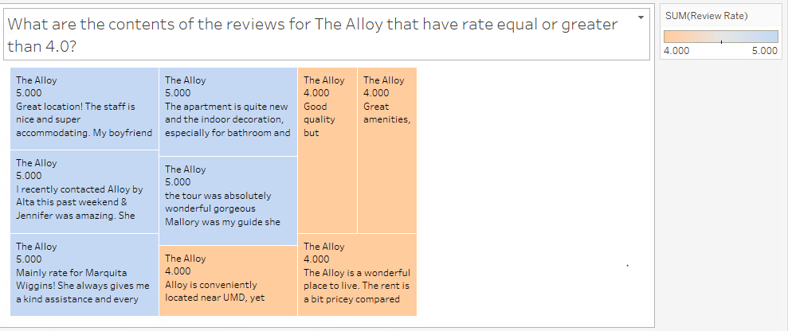

Fig.14 Business Transaction 5 visualization

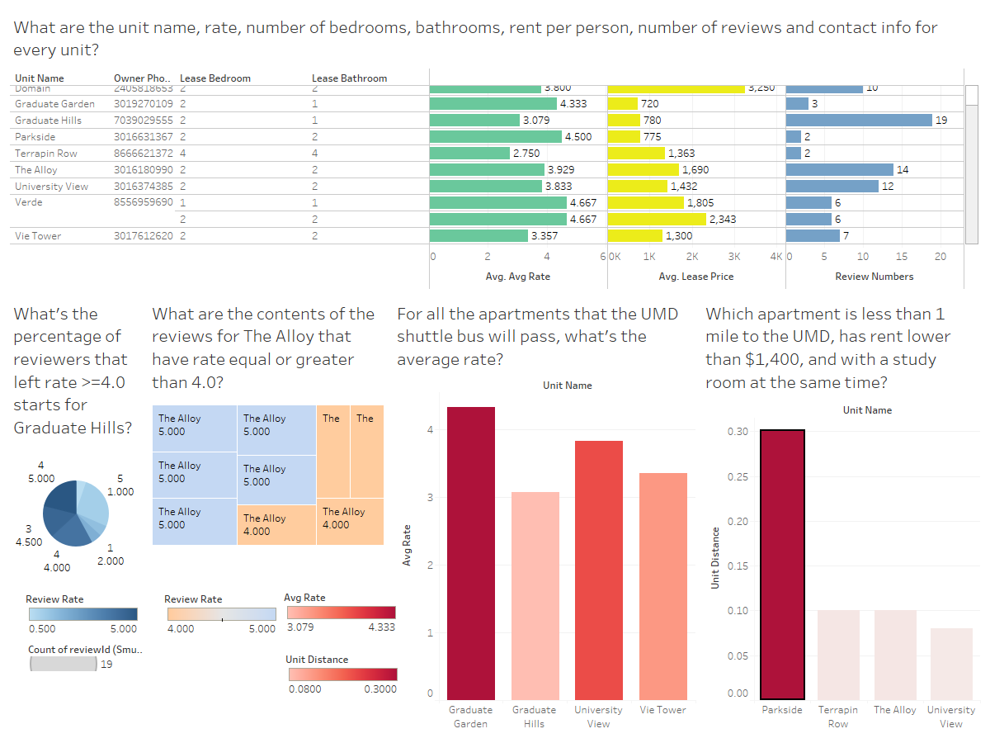

Fig 15. Business Transactions Dashboard