Designing an Indoor Model using OpenSCAD

Roie R. Black

Designing a new model airplane usually involves generating a plan of some sort, then constructing a prototype model from that plan. Of course you can use a pencil and paper to generate your plans, but if you think you might want to publish the plan, you will need to use some form of *Computer Aided Design* tool to produce your final plan. Unfortunately many popular CAD tools are complex, and often too expensive for the average modeler.

Having recently retired from teaching Computer Science, and finally getting back into model building, I decided to design a new indoor model for the *Limited Pennyplane* class. As part of the design process, I wanted to see that airplane in 3D even before I built the first prototype. I decided to use a different form of CAD tool: OpenSCAD , a tool designed for computer programmers!

While that description may discourage some folks from reading further, rest assured that this particular tool is simple enough that non-programmers can certainly master it. In fact, some teachers have successfully managed to get elementary school kids to use OpenSCAD to design simple 3D models.

OpenSCAD is an open-source (meaning free) 3D modeling program, available on all major platforms. It is commonly used by folks designing parts to be printed on 3D printers. What makes OpenScad different is how you generate the design. Instead of using your mouse to drag things around on the screen, you describe your model in a simple programming language. Formally, OpenSCAD uses something called *Constructive Solid Geometry* to construct your model, then gives you a visual interface you can use to examine your 3D model in detail.

I will only show example code from the project so you can get a feel for the design process. You are encouraged to explore the project website for much better documentation and complete source code. .

# OpenSCAD

Installing OpenSCAD is oretty simple using instructions found on the projects website. Once it is installed, open it up and take a look at the basic interface:

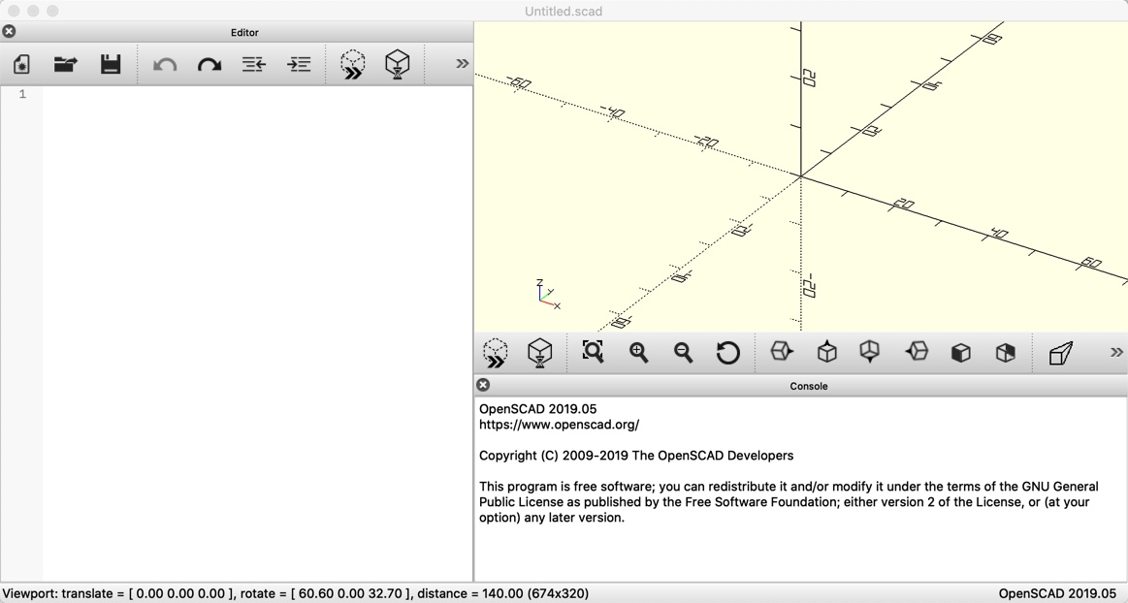

OpenSCAd interface

There are three areas we will be using in this view:

* Editor - the left panel where you type in your code.
* Preview - the top right panel will be where your model is displayed.
* Messages - the bottom right panel is where error messages will be shown when processing your code.

I will not try to show everything you need to know about the language *OpenSCAD* uses for describing a model. Instead, I will show fragments of code to give you a feel for what you need to write to design your model. The project website  has more details, as does the *OpenSCAD* *User Manual* .

A Handy “cheat-sheet” is available here: .

## Organizing Your Code

*OpenSCAD* lets you write your code in one file or in multiple files. I like to split up a design into multiple files in order to keep them short and focused on one just part of the design. If you split things up you will need to use either an *include* or a *use* line specifying the file you want to access with the code in the present file. If you choose *include*, all that code in the second file will be processed as though it had been typed in the current file. On the other hand, using the *use* line only makes the names from the second file available in this one. The code in the second file will only be processed when those names are encountered in the current file.

A typical setup is to create a single file with variables you want every piece of code to be able to use. You *include* that file like so:

include <m th-magik-data.scad>

Another example might be in a file defining the wing for this design. That file needs to use ribs, which I define in another file. In my wing file I would add this line

use <rib.scad>

You will see a lot of this notation in the full project code files on the project website.

## The Designng Process

Building a 3D model is a trial and error process. You type in or modify your code, then click on a command to process that code. You look at the preview window to see your model, and search the message area for hints about what went wrong. Non-programmers will find this a bit frustrating, but this takes practice to master, so do not get discouraged. My advice is to always take small steps. That limits the number of problems you face in getting things to work.

The best way to learn anything new is to experiment. Beginning programmers are always searching the Internet for solutions they can copy into their problems, but the only thing you actually learn when copying and pasting stuff is how to copy and paste. You will learn far more by typing in code yourself - at least until you get more proficient at this. Reading the code gives you a chance to really think about what is going on. There is nothing wrong with looking at code written by others. Many times studying that code will teach you how to better write your own code. I will show you enough code in this design to give you a feel for how you do things using *OpenSCAD*. The actual code I generated for this design is on the project Github account .

I highly recommend building small files that generate one part of your overall design. Test that component until you are sure it looks like what you want. Then use that part in building other components. I like to work from small parts up to bigger assemblies, and that is how we will work through this design. Don’t be afraid to fire up *OpenSCAD* and try things are you read this article. Of course, you should look at the project website to see all the code in greater detail.

# Constructive Solid Geometry

OpenSCAD builds 3D models using a small set of primitive shapes, and a set of movement and combining operations to create more complex models.

## Primitive Shapes

Openscad supports both 2D and 3D shapes. We will be using some simple 2D shapes, like circles and rectangles, and more complex 2D shapes like a polygon. The 3D shapes we will use include spheres, cylinders, and cubes. All of these shapes can be scaled and moved around using simple movement operations.

## 3D Primitives

For our first look at how you do things in OpenSCAD, here is a piece of code that will show the three basic 3D shapes:

cube();  
translate([3,0,0])  
 sphere();  
translate([6,0,0])  
 cylinder();

Figure 2 shows the result.

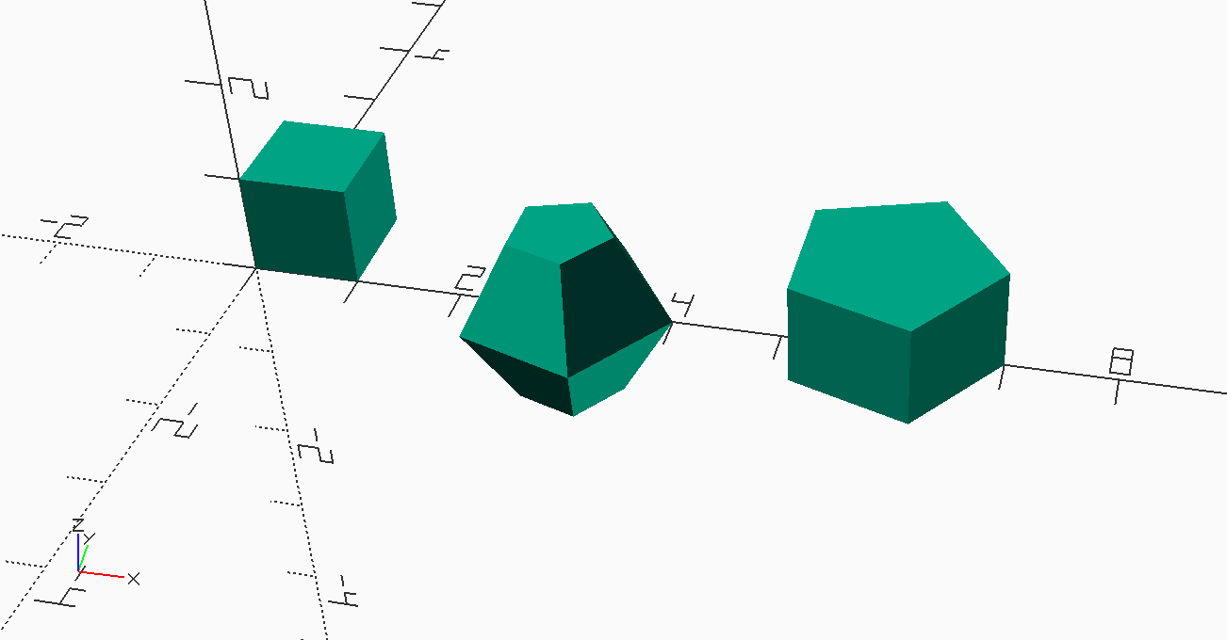

Demo 1

Each primitive shape is created at the origin. Cubes are created in the region where all three coordinates are positive. Spheres are created with the center of the sphere at the origin. The cylinder is centered along the **Z** axis. If you look closely, you will see a small representation of the coordinate directions at the lower left of this image.

We used a *translate* operation to move shapes aside so they do not overlap. The numbers inside square brackets control the distance we want to *translate* the following shape in the **[x,y,z]** directions. This bracketed group of numbers is is called a *vector* which we will use a lot in our work.

Notice how I indent code to show how things happen. In this example, we *translate* the following *cube* shape. The semicolon ends this command. Failing to put semicolons where they are needed is a common mistake when writing *OpenSCAD* code.

These shapes do not look quite right. The problem is that *OpenSCAD* generates approximations to the rounded shapes, using a set of small polygons to build up the model. If we make these polygons smaller, things look better. All we need to do to fix this is change the code so it looks like this:

cube();  
translate([3,0,0])  
 sphere($fn=100);  
translate([6,0,0])  
 cylinder($fn=100);

Figure 3 shows a much better result. The special variable *$fn* controls the resolution of rounded objects. Bigger numbers make things look smoother but cost of longer times to generate images on the screen.

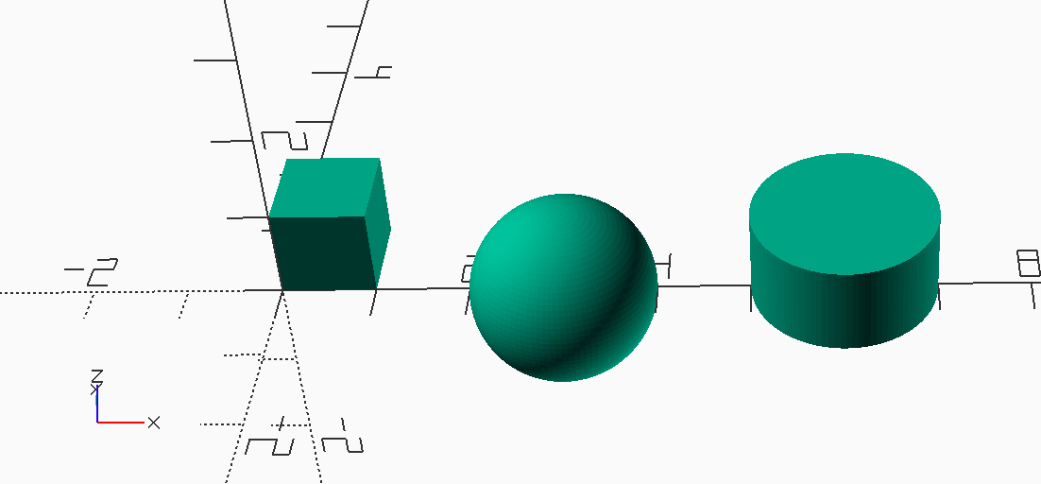

Demo 2

Some shapes are smart and can form different versions of themselves:

cube([1,3,1]);  
translate([4,0,0])  
 sphere(r=2, $fn=100);  
translate([8,0,0])  
 cylinder(  
 r1=1, r2=0.25, $fn=100  
 );

Figure 4 shows a warped cube and cylinder. Spheres are not so smart, they stay spheres unless we warp them with external commands.

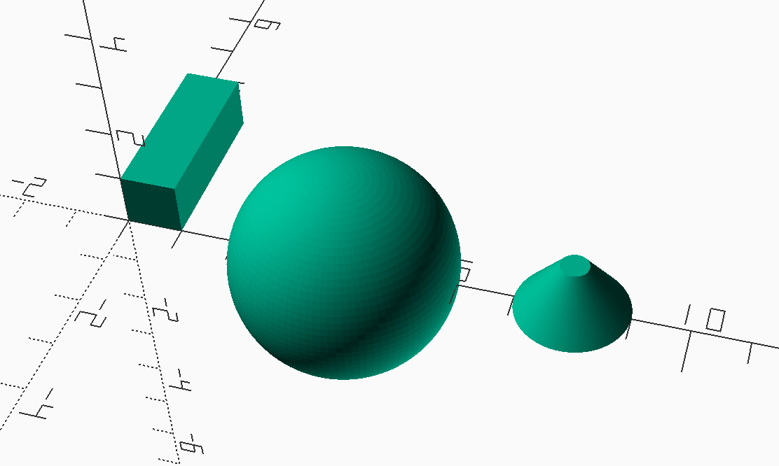

Demo 3

## 2D primatives

We will use a few 2D shapes in this design, including the circle and square, which act much like their 3D counterparts. A more interesting 2D shape we will use is the *polygon*.

triangle_points =[  
 [0,0],[100,0],[0,100],[  
 10,10],[80,10],[10,80]  
];  
triangle_paths =[  
 [0,1,2],[3,4,5]  
];  
polygon(  
 triangle_points,  
 triangle_paths,  
 10  
);

Here, we create two *variables* and set them equal to a list of vectors. 2D vectors have only 2 numbers, for the **X** and **Y** coordinate values. The first list defines a set of six points: three for the outer triangle, and three more for the inner triangle. The second list identifies *paths* meaning a continuous line that makes up a closed circuit, one for the outer triangle, and one for the inner triangle. The numbers refer to the position of vectors in the first list (programmers count starting at zero!) That final **10** parameter is not important here, it helps the operation work properly.

I know this is a bit confusing, but we will not need much of this kind of code in our design work. Remember to try things and see what happens.

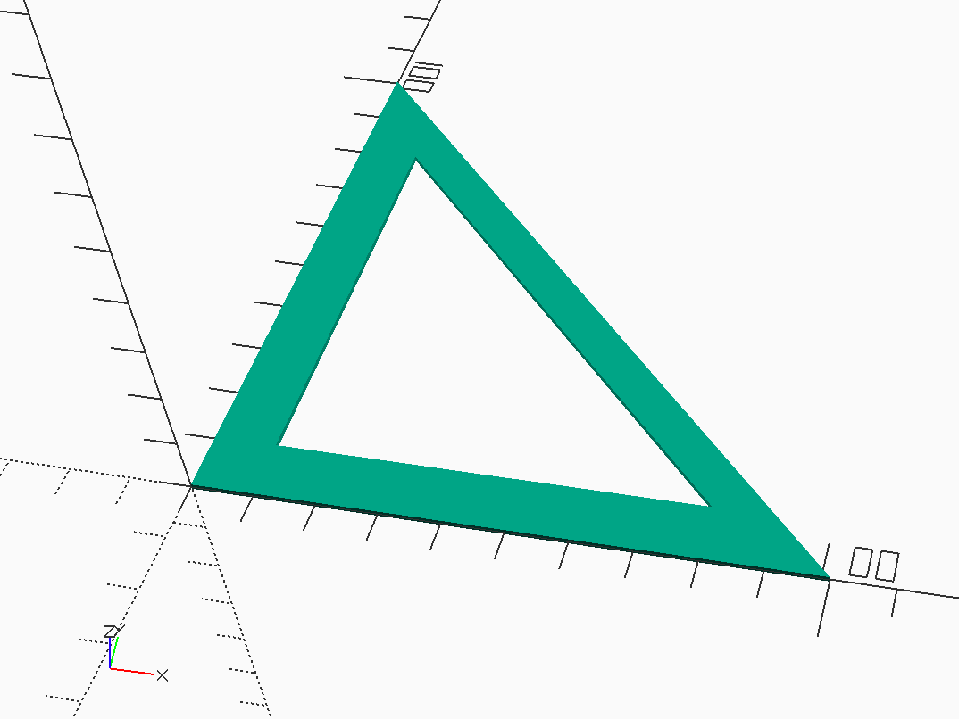

Polygon Demo 1

Figure 5 shows a 2D shape with no thickness, although *OpenSCAD* gives it enough of a thickness to show up on the screen.

We can use this 2D shape to create a 3D object by *extruding it* in the **Z** direction:

triangle_points =[  
 [0,0],[100,0],[0,100],  
 [10,10],[80,10],[10,80]  
];  
triangle_paths =[  
 [0,1,2],[3,4,5]  
];  
linear_extrude(h=1)  
 polygon(  
 points = triangle_points,  
 paths = triangle_paths,  
 convexity=10  
 );

Figure 6 definitely shows an interesting shape. We will use *extrusion* to make some parts that would be difficult to construct with just the basic primitive shapes.

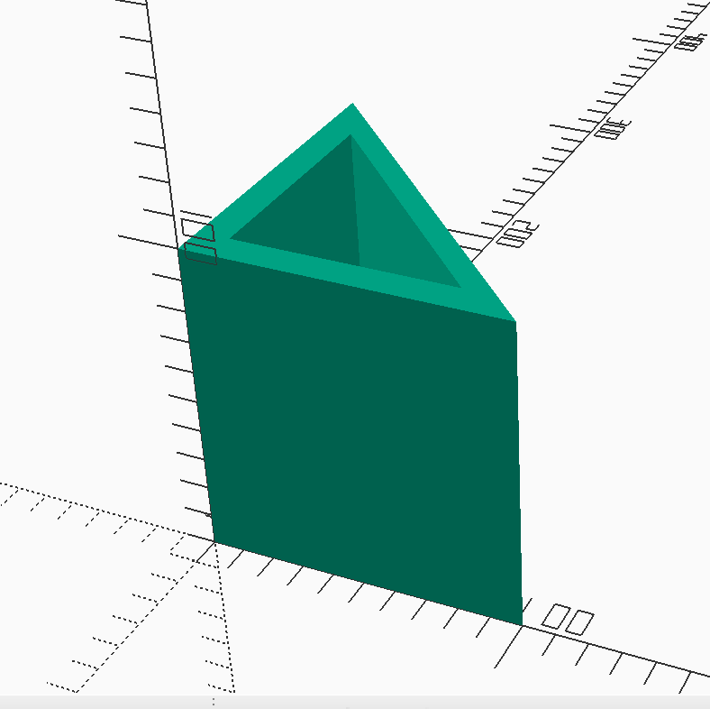

Polygon Demo 2

Obviously, we can form some interesting things with *OpenSCAD*. But things get even more interesting when we start combining multiple shapes to form more complex objects.

## Movement Operations

We saw the *translate* operation earlier. We can also *rotate* a shape. In this command we provide a vector of angles (in degrees) that we want to use to rotate the shape. Each number in the vector will be used to rotate the shape around the coordinate axis associated with that number. For instance **rotate([90,0,0])** will rotate the shape around the **X** axis ninety degrees. This operation uses the *right-hand* rule. If you want to rotate around the bf X axis, take your right hand and point the thumb in the direction of increasing **X** in your coordinate system. Your fingers “curl” around that axis in a positive direction.

Combining translations and rotations is done by writing both commands like this:

translate)[10,15,0])  
 rotate[90,0,0])  
 cube(1,1,5);

It helps to read this bottom up. We are creating a *cube* at the origin. We rotate it so it is aligned the way we want, then we translate that result to the position we have chosen. The semicolon at the end of this list ends the command. Notice that I indent so show what I want my code to do.

Be warned that you can swap the *translate* and *rotate* commands, but you might not get the result you expect. Rotations are applied to the shape as it is positioned when the command is processed. If you rotate after translating, The shape will swing a long way!

## Combining Operations

We form more complex objects by moving things around and combining them to form new objects. An example found in the *Wikipedia* article on CSG  demonstrates these operations.

Suppose you wanted to build something that looks like Figure 7.

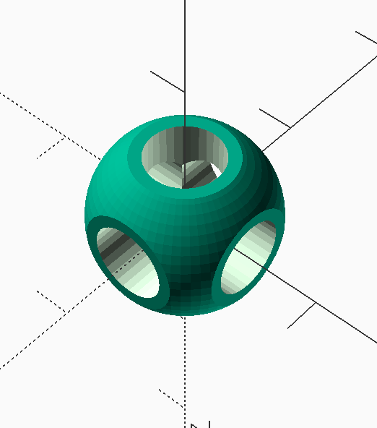

CSG Example Shape

We can form this shape using three cylinders, a sphere, and a cube. We use all three basic combining operations to construct the final shape.

Here is the OpenSCAD code used to generate this shape:

module core() {  
 union() {  
 cylinder(  
 r=0.25,  
 h=2,  
 center=true,  
 $fn=32  
 );  
 rotate([90,0,0])  
 cylinder(  
 r=0.25,  
 h=2,  
 center=true,  
 $fn=32  
 );  
 rotate([0,90,0])  
 cylinder(  
 r=0.25,  
 h=2,  
 center=true,  
 $fn=32  
 );  
 }  
}  
  
module round_cube() {  
 intersection() {  
 cube(  
 [1,1,1],  
 center=true  
 );  
 sphere(  
 r=0.6,  
 $fn=64,  
 center=true  
 );  
 }  
}  
  
module part() {  
 difference() {  
 round_cube();  
 core();  
 }  
}  
  
core();

There is a point to be made here. We can move two objects together so they touch, like a rib to a spar, but we do not really need to join them together in this design work. Visually, things will look right, but the two objects remain separate. Joining them together to make a combined part would be important if we were going to 3D print the object. Since we do not have he technology to print with balsa (yet), I will not worry about combining the components of our design to create a single airplane object.

### Modules

*OpenSCAD* lets you package a number of operations in a *module* that you can activate later, one or more times. In fact those primitive shapes were all predefined *modules*. The module can have parameters, which makes this a powerful way to manage shapes that are similar, but differ depending on the parameters you specify. We saw that when we showed “warped” shapes earlier. We will create a basic rib module for this model, and use parameters to control the exact rib we want.

All modules have a unique name in your code. The name you choose should help you remember what the module is all about. In this example, we are interested in the final **part** shape, which is constructed using the difference operation. This final module uses two supporting modules to build the part. You can write your code almost any way you like, but it is common to use spaces,indentations, and newlines to organize your code to make reading it easier. Also, we surround a sequence of individual operations inside of curly braces when needed. I always indent any code inside of these braces.

When you add parameters to a module, you define names for each one between the parentheses. Commas separate parameters if you have more than one. You can optionally provide a default value for each parameter by adding an equal sign followed by the default value you want. When you activate the module, you must provide actual values you want the module to use. You can just provide a sequence of numbers in the right order with commas separating them, or you can add the parameter name from the definition, an equal sign, then the new value you want. In this case, the order is not important, and you can leave off any parameters where you are happy with the default value. The rules for all of this are detailed in the *OpenSCAD* *User Manual* , so I will not go further in this discussion here.

### Building the Example Shape

To build this part, we first set up three cylinders, aligned along each coordinate axis. The bf center parameter, sets each cylinder up with the origin of the coordinate system at the exact center of the cylinder. Remember, The **$fn=32** parameter is really only needed to make the cylinders actually look round.

Notice that all three of these cylinders occupy the same space. In the real world, we could not do that, but in our 3d modeling world this is common. We form the **union** of these three overlapping cylinders to form one merged shape.

The outer shell of our part is made up of the **intersection** of a sphere and a cube. We size the cube shape so it trims off six sides of the sphere where holes will end up. Finally, we use the **difference** operator to carve out the inside of the part, using our three-cylinder shape.

Successfully building 3D models involves visualizing what you want, then arranging simple shapes as needed and performing these three basic combining operations to generate the gadget you want! It takes practice! The more you experiment the better you will get!

I encourage you to fire up *OpenSCAD* and type in this code. You will be better able to see how things work by doing this!

# Design Constraints

The *Limited Pennyplane* class rules define a few constraints on dimensions for our model. Specifically we must honor these limits:

* **max_wing_span** - 18”
* **max_wing_chord** - 5”
* **max_stab_span** - 12”
* **max_spab_chord** - 4”
* **max_length** - Max Prop to Tail length = 20”
* **max_prop_diameter** - 12”

What this means is that the model must fit in a box that measures **max_wing_span** wide by **max_length** long. There is no limit on how tall this box can be.

Furthermore, the wing must fit in a smaller box measuring **max_wing_span** by **max_wing_chord**. The stabilizer must fit in a similar box measuring **max_stab_span** by **max_stab_chord**. There are no constraints on where these boxes fit inside the outer box. The propeller is only limited by diameter, blade shape it up to the designer. However, the **max_length** constraint is measured from the forward-most point, usually on the propeller, to the aft-most point on the model. We could build a pusher, but I have not considered that idea.

Note: The labels in this diagram are abbreviations for the names shown above. In my code I will use full names to improve readability of the code.

# Biography

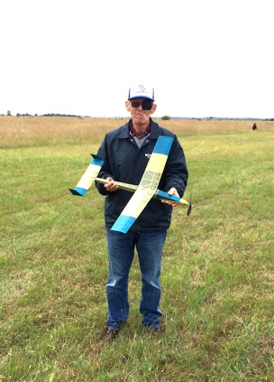

In the Summer of 1955 I was delivering the evening newspaper in Falls Church, Virginia, when I rounded the corner of an apartment building and saw a man release the propeller on a rubber-powered model airplane. The plane circled in front of this man’s home for several minutes, and magically landed where it had started. The airplane was a Henderson Gadfly, published in Model Airplane News that year. I was fascinated by that sight, and decided to figure out how the airplane managed to do that. I talked the man into giving me the plans he used to build the model, traced from the magazine. I still has those plans to this day!) Soon, a couple of my friends and I decided to start building model airplanes of our own. We all took a bus to downtown Washington, D.C (kids could do that back then), and joined the Academy of Model Aeronautics. We also joined the Fairfax Model Associates and began competing in a variety of events, mostly control line and gas free flight. At one meeting, Bill Bigge, an internationally known indoor model builder, was the guest speaker. I got my first look at a new form of model airplane. The indoor models Bill brought to the meeting were fascinating, and cheap enough even a kid with a limited allowance could build one. Bill became my mentor, and I managed to build an ornithopter and helicopter and set two national records! I spent 20 years as an officer in the USAF, then another 17 years teaching college-level Computer Science. I finally retired for good in 2018, and moved with my wife to Kansas City, where I joined the Heart of America Free Flight Association, and again began flying model airplanes, this time focusing on rubber and electric powered outdoor free flight, and indoor events.When not building model airplanes, I am active in Amateur Radio and am currently authoring a book on Computer Architecture.