# Management of dynamic disks and volumes

To do this exercise you will need to have a hard disk of 32 GB, in addition to the disk containing the operating system.

It is recommended to create a snapshot of the state of your virtual machine before starting.

## Exercise 1. Simple volumes

At this point, we have a new disk that does not contain any volume. Create a simple volume by completing the following steps:

1. Open **Disk Management.**
2. Initialize the hard disk if you have not yet initialized it.

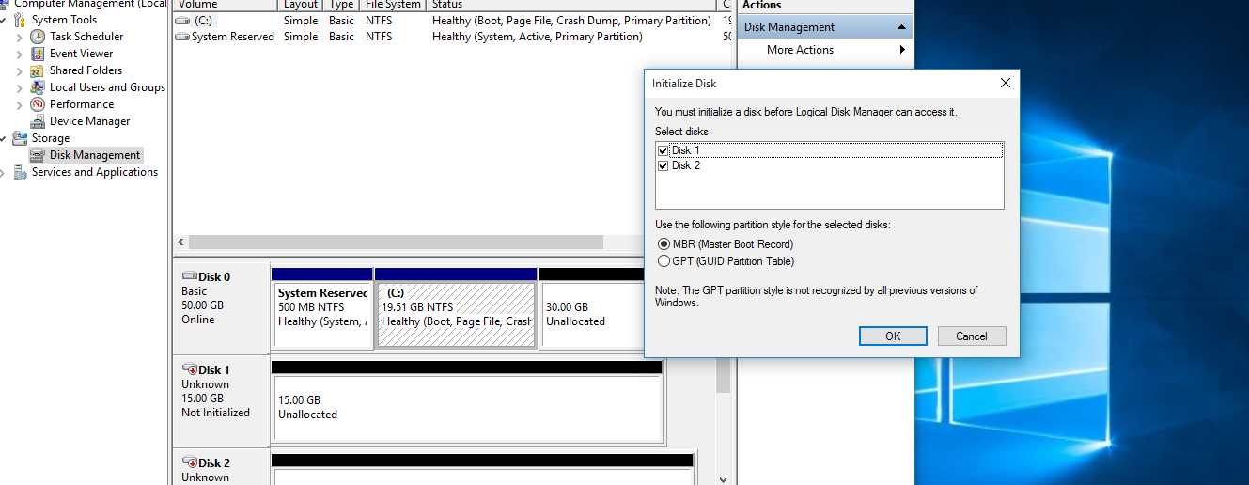

1. Convert the disk to dynamic by right clicking on the disk icon. Then, select **“Convert to dynamic disk...”**

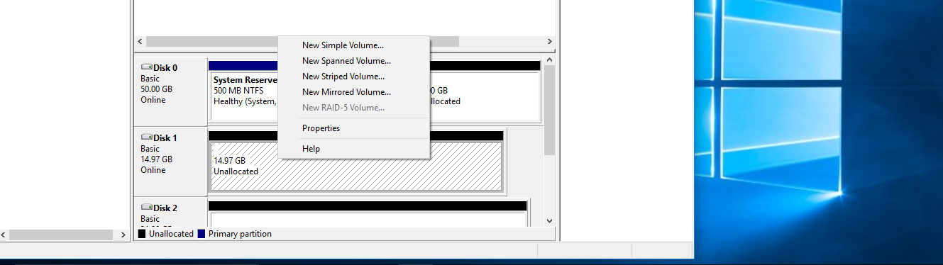

1. Right-click on the unallocated space of the new dynamic disk. Then, click “New simple volume...”
2. Then, click **Next** in wizard in order to create the volume.
3. Next, select the dynamic disk and the type in the 10 GB as the size of the disk. Enter this size in MB and select **Next**.
4. Assign the letter V and click Next.
5. In the following screen, type **DDV1** as “Volume label” and click **Next**.
6. Then, click **Finish**.
7. Check that the new volume has been correctly created.

Take a screenshot of the Disk Management showing the simple volume that you have created.

Take a screenshot of the Windows Explorer including the size of the already created volume.

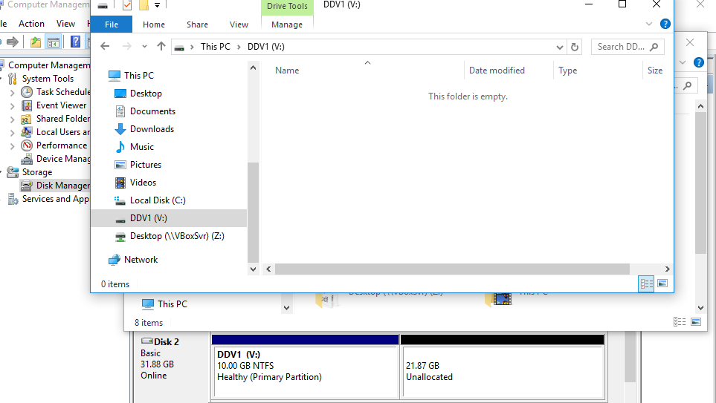

**Now, we are going to extend the volume named “DDV1”.**

1. Right-click the simple volume you want to extend and select “Extend volume”. In the “Extend Volume Wizard” click “Next”.
2. Select the target disk. Next, type the space in MB you want to extend (the equivalent to 5 GB in this case)

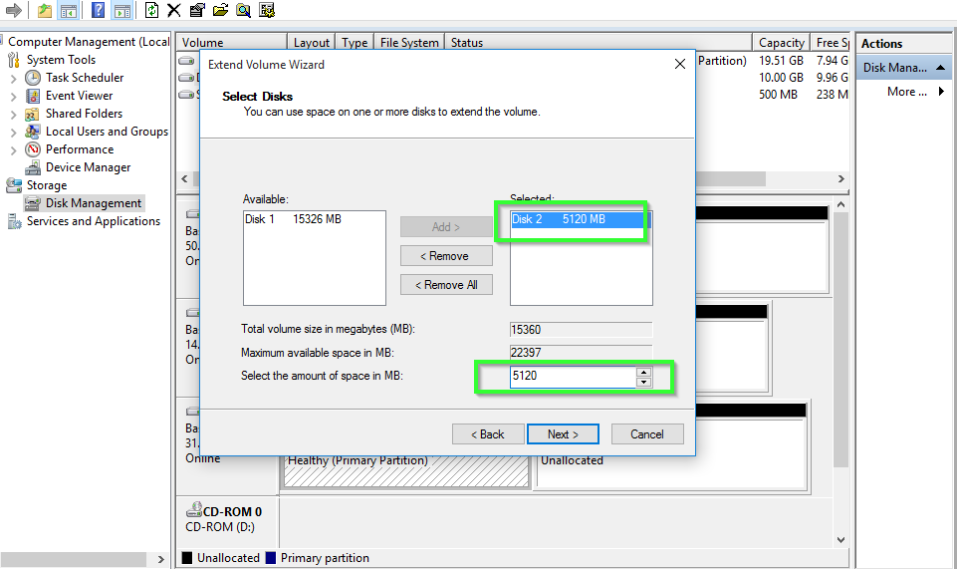

1. Then, click “Next” and “Finish” in the last screen.

Take a screenshot of the Disk Management showing the simple volume that you have extended

Take a screenshot of the Windows Explorer including the size of the extended volume.

1. Check that the volume has been correctly resized.

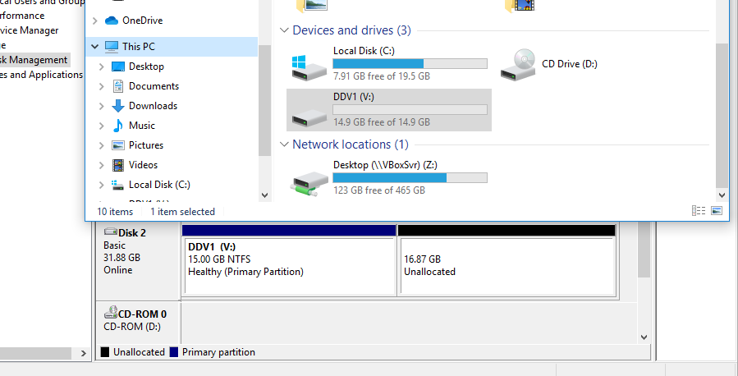

**Now, we are going to delete the volume**

1. Click the volume named “DDV1” and select “Delete volume”. Click “Yes”.

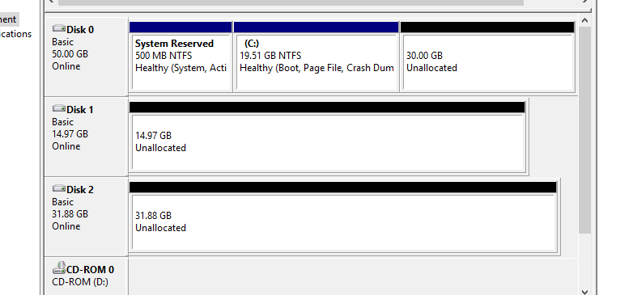

## Exercise 2. Spanned volumes

Create a new 15 GB virtual disk before starting.

1. Open **Disk Management.**
2. Right-click the unallocated space on one of the dynamic disks where you want to create the spanned volume. Select “New spanned volume…”

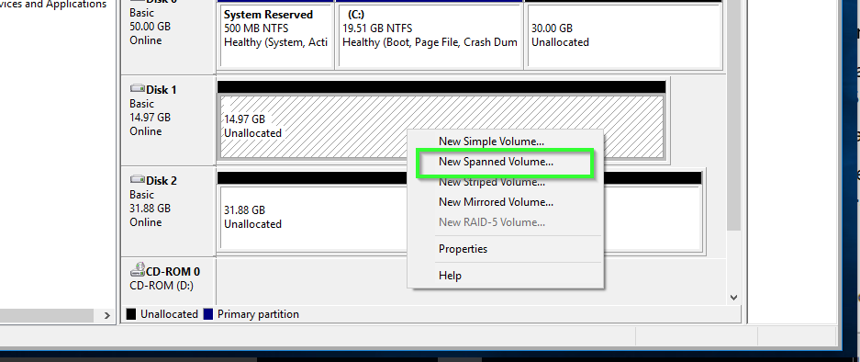

1. Click “Next” in the wizard first screen.
2. Add the two hard drives to the “Selected” box. Set 10GB as the amount of space for the biggest hard drive and 5 GB for the smallest one (type the amount in MB).

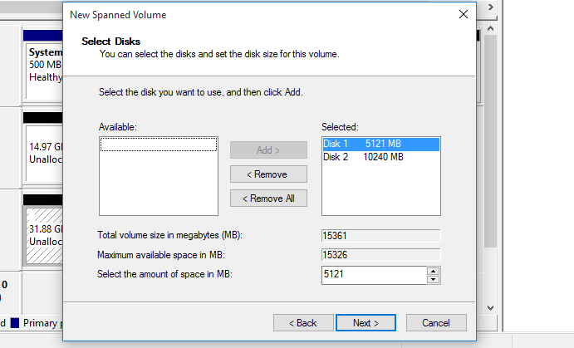

1. Assign the letter S and click **Next**.
2. In the following screen, type **DDD1** as “Volume label” and click **Next**.
3. Then, click **Finish**.

Take a screenshot of the Disk Management showing the new spanned volume

Take a screenshot of the Windows Explorer including the size of the spanned volume.

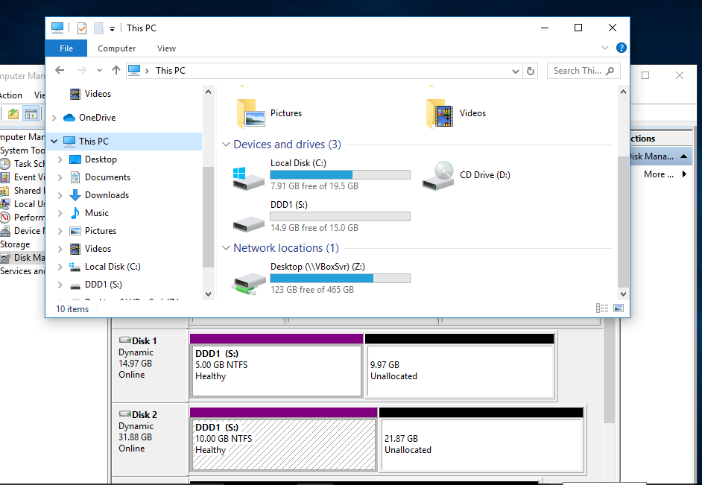

**Now, we are going to extend the volume named “DDD1”.**

1. Right-click the simple volume you want to extend and select **“Extend volume”**. In the “Extend Volume Wizard” click “Next”.
2. Select only the biggest disk and type the amount of MB you want to extend (the equivalent to 3 GB in this case).

Take a screenshot of the Disk Management showing the spanned volume and the new size.

Take a screenshot of the Windows Explorer including the new size of the spanned volume.

## Exercise 3. Striped volumes

1. Right-click the unallocated space on one of the dynamic disks you used for the spanned volume above. Now, select **“New striped volume…”**
2. Click **Next** in the wizard first screen.
3. Add the two hard drives to the “Selected” box. Set the amount of space to use on the disks for the striped volume (we want 10 GB in this case). The amount must be the same on each disk. If you type an amount greater than the available space, it will be adjusted to the maximum possible size. Click **Next**
4. Assign the letter K and click **Next**.
5. In the following screen, type **DDS1** as “Volume label” and click **Next**.
6. Then, click **Finish**.

Take a screenshot of the Disk Management showing the striped volume that you have created.

Take a screenshot of the Windows Explorer including the size of the already created striped volume.



## Exercise 4. Mirrored volumes

First, delete the volumes you created on exercises 2 and 3.

1. Open **Disk Management.**
2. Right-click the unallocated space on one of the dynamic disks and select **“New Mirrored volume…”**
3. Click **Next** in the wizard first screen.
4. Add the two hard drives to the “Selected” box. Select the amount of space you want to dedicate to the mirrored volume (the equivalent to 5 GB in this case) and click **Next**.
5. Assign the letter R and click **Next**.
6. Format as NTFS and type **Mirrored** as “Volume label”. Click **Next**.
7. Then, click **Finish**.

Take a screenshot of the Disk Management showing the mirrored volume that you have created.

Take a screenshot of the Windows Explorer including the size of the already created mirrored volume. Why is the size 5 GB instead of 10 GB?

Create an empty file named **Document1.txt** in R:\

Then, we are going to see what happens if we “Remove a mirror”

1. Right-click the disk 1 and select **Remove a mirror…**
2. Select “Disk 1” and **“Remove Mirror”**

1. Check that the document has not been deleted.

Now, we are going to add a mirror to the volume R:

1. Right-click the disk 2 and **“Add mirror…”.** Select disk 1 in the screen and continue.

Take a screenshot of the Disk Management showing the state of the mirrored volumes.

To finish, we are going to divide the mirrored volume into two independent simple volumes.

1. Right-click the disk 1 and **“Break mirrored volume…”**
2. What are the drive letters of the volumes? In which volume can you find the document that you created before?

Once mirrored volume is two simple volumes show up both with the same data. One retains the drive letter while to the other a new volume letter is assigned.

