# Mount point folders

## Exercise

Create a new 3 GB simple volume assigned to **mount point folder** in the free space in one of your virtual disks.

The path of the folder will be **C:\mount_folder** and you must label the volume as **DDUM1**

1. First, create the folder in **C:\mount_folder**

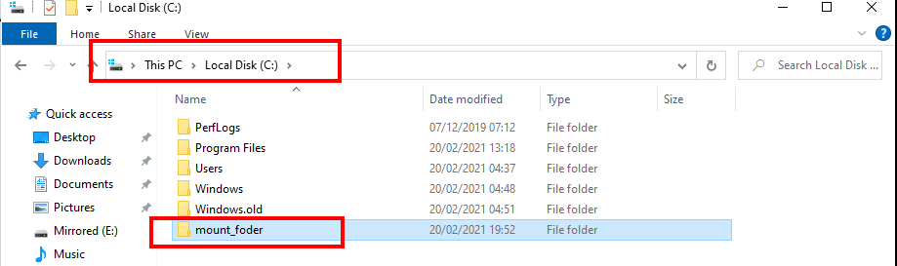

1. Right-click on the unallocated space of one of your disks. Then, click **“New simple volume...”**
2. Next, type 3 GB as the size. Enter this size in MB and select **Next**.

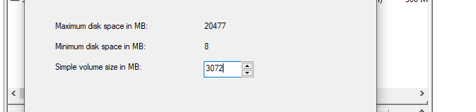

1. Then, in the screen **“Assign drive, letter or path”**, select **“Mount in the following empty NTFS folder”** and choose the path **C:\mount_folder**

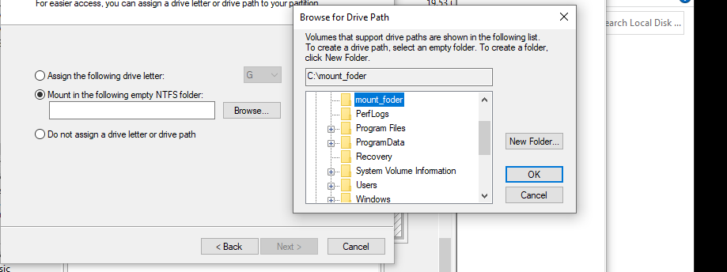

1. In the following screen, type **DDUM1** as “Volume label” and click **Next**.

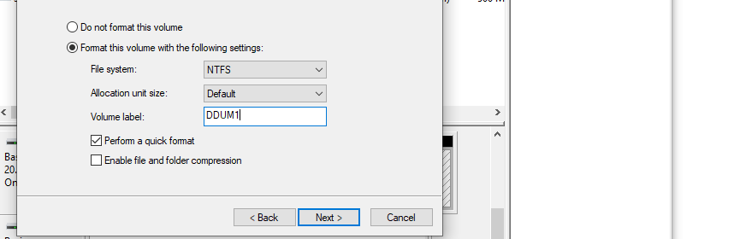

1. Then, click **Finish**.

Take a screenshot of the Disk Management showing the simple volume that you have mounted in a folder (as you can see, there is no drive letter)

Take a screenshot of the Windows Explorer including the folder in which you can access the volume.

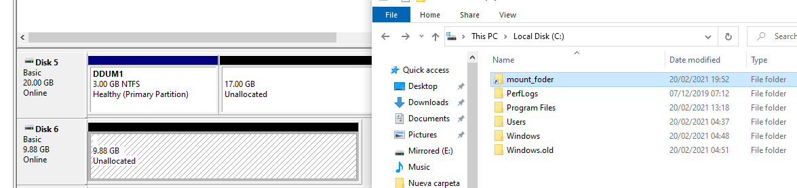

Create two folders in **C:\mount_folder**

Take a screenshot of the folders

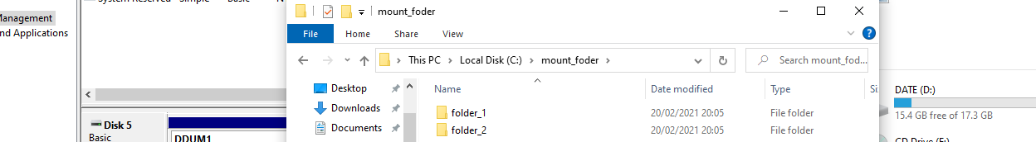

Change the mount point folder to the drive letter P:

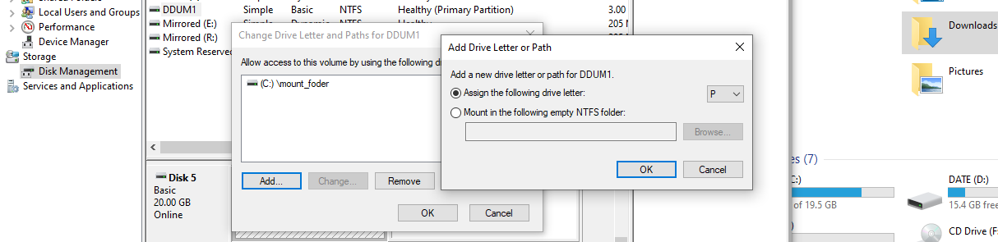

Check that the folder is empty and that you can only access the volume through the path P:\

1. Right-click on the volume and select “**Change Drive Letter and Paths**”
2. Remove the “C:\mount_folder” mount point.
3. Then, open “**Change Drive Letter and Paths**” again and assign **P:** as drive letter

Take a screenshot of C:\mount_folder (it is empty)

Take a screenshot of the Disk Management showing the volume assigned to P:

Take a screenshot of the Windows Explorer including the folder P:\ (you can see the folders you created before)

