# COPY, RENAME AND EDIT FILES

Create the following directory structure in /home/<user>/exercises

exercises

Africa Asia

Tunisia Egypt Seul Laos

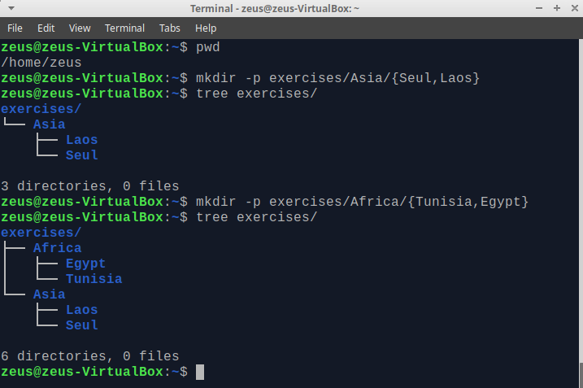f

1. Create the following files using **nano** (or another editor): **song.doc** (write a few lines of a song) in the directory **Egypt**; **tv.doc** (write the name of your favourite TV programs) in the directory **Seul** and **marks** (write the marks you expect to get this year) in the directory **Tunisia**.

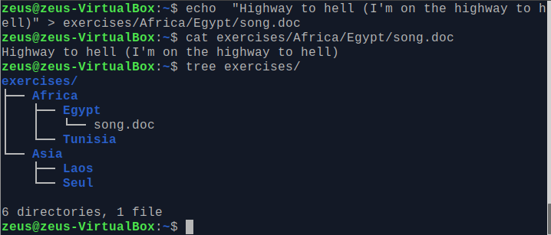



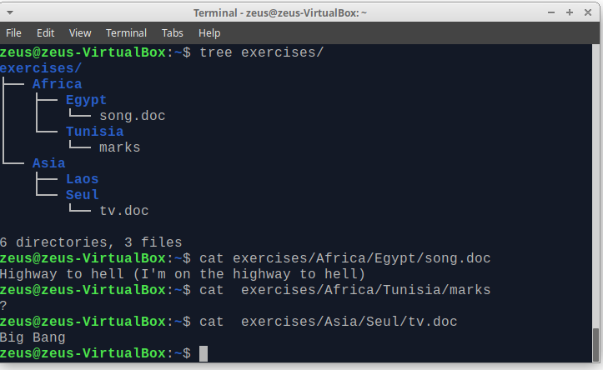

## CHANGE THE CURRENT DIRECTORY TO AFRICA AND DO THE FOLLOWING EXERCISES USING RELATIVE PATHS

1. Copy the file “song.doc” into “Laos”

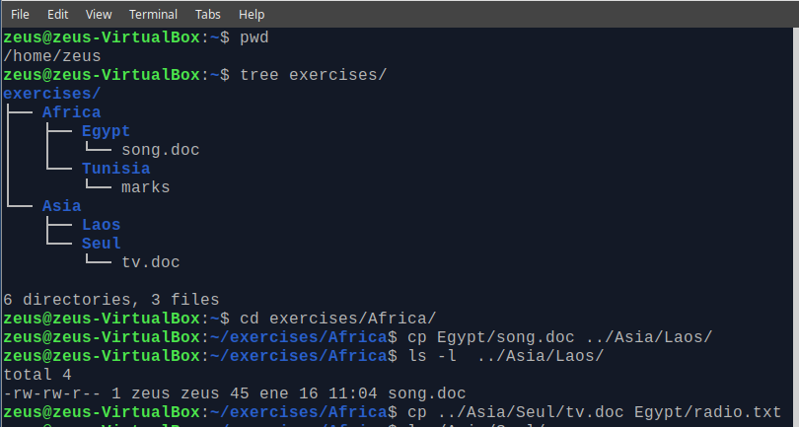

1. Copy the file “tv.doc” into “Egypt” with the name “radio.txt”

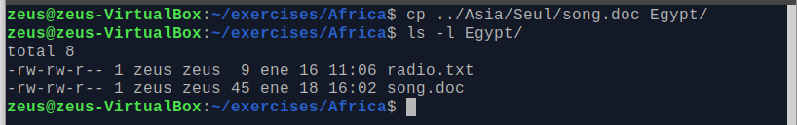

1. Rename the file “marks” to “exam.wri” (it is located in the directory named Tunisia)
2. Copy the file “song.doc” (located in “Egypt”) inside “Tunisia”
3. Print the content of the current directory using long listing format

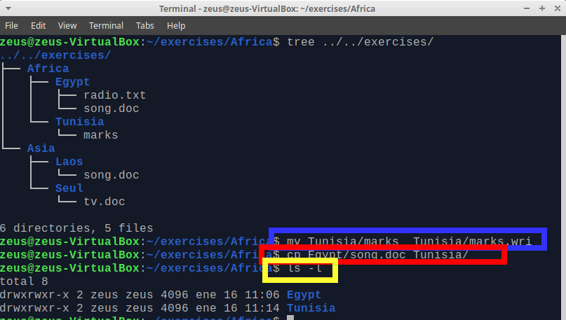

1. Rename the file “song.doc” (located in “Laos”) to “aa.doc”

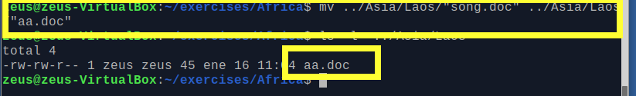

1. Create the directory “Others” in “Laos”

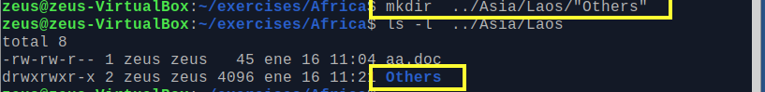

1. Rename the directory named “programming” (which you created in the first exercises) to pro-c.

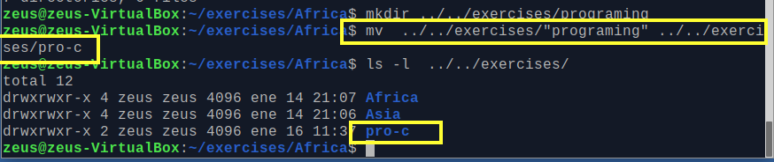

1. Create the following directory tree in “exercises” (using as few commands as possible)

ONE

TWO THREE

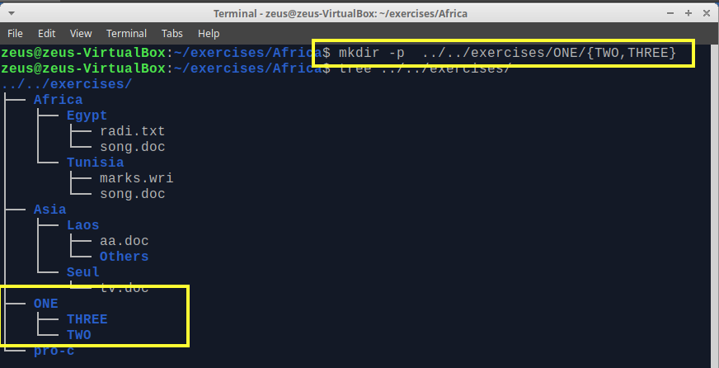

1. Copy the files with txt extension from the directory named “systems” to “exercises”.

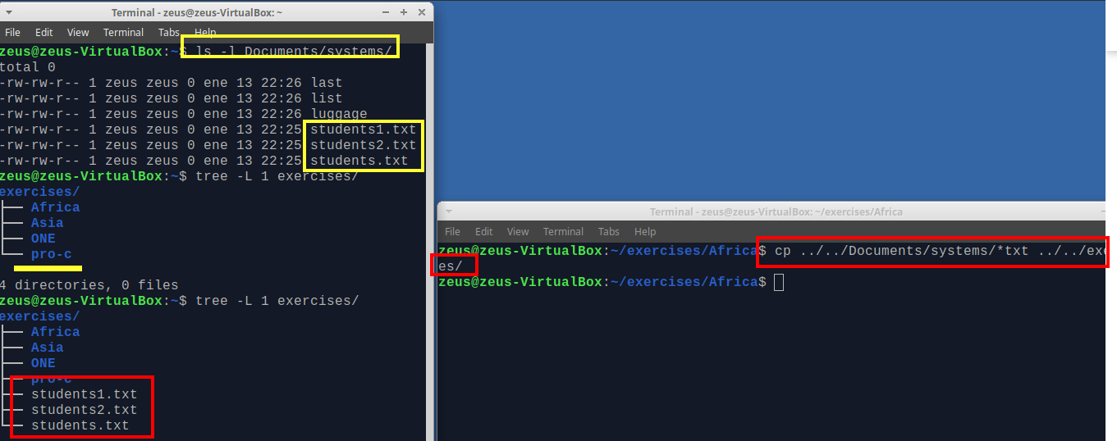

1. Move the files you copied in the exercise above to the directory THREE.

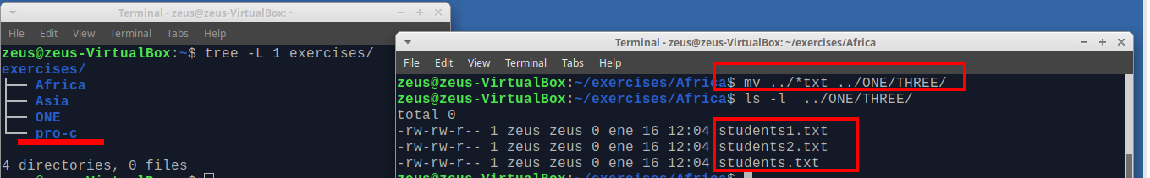

1. Delete the directory named THREE, including all the files and, if so, subdirectories



## CHANGE INTO SYSTEMS AND DO THE FOLLOWING EXERCISES USING ABSOLUTE PATHS

1. Copy the files that end with “txt” of the directory named “systems” to “Tunisia”

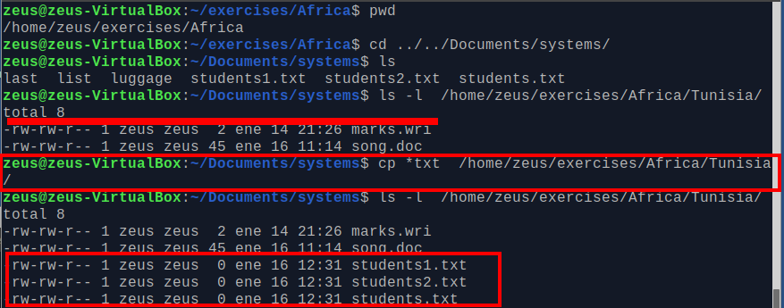

1. Copy the file “tv.doc” (located in “Seul”) to the directory named “exercises”

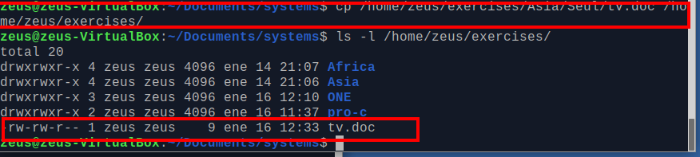

1. Rename the file student1.txt (located in “Tunisia”) to tuition.txt

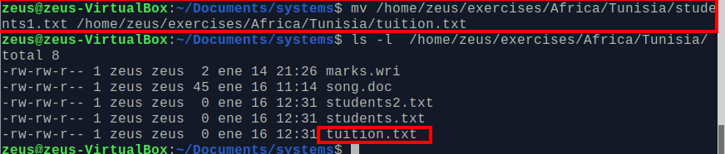

1. Create a new directory called “earth” into “systems”. Create another directory called “countries” inside “earth”

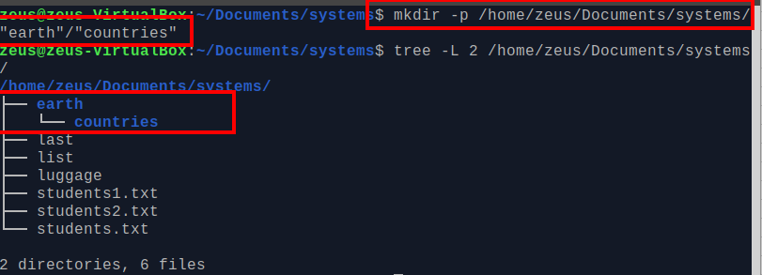

1. Rename “Africa” (located in “exercises”) to “Afri”

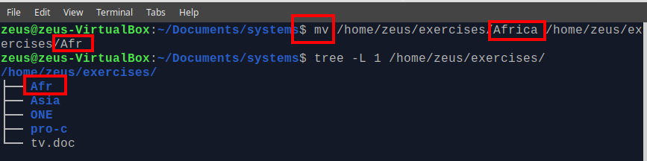

## NOW YOU CAN BE PLACED IN THE DIRECTORY YOU WANT

1. Move the file “song.doc”, which is located in Egypt, to “Laos” with the name “bb.doc”

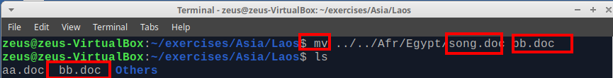

1. Copy the files whose name contains the letter “u” from “systems” to “exercises”

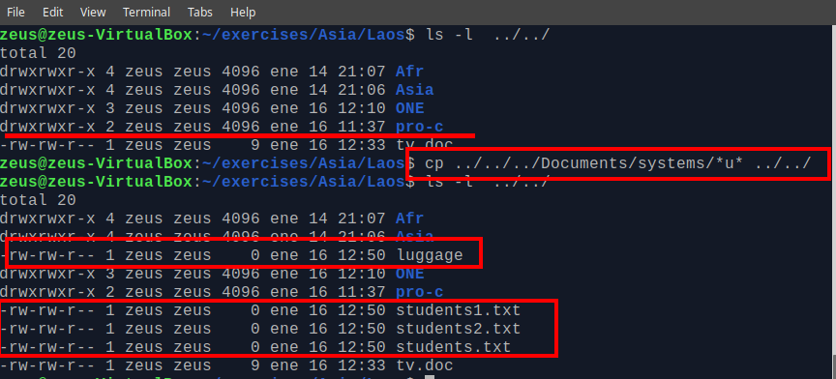

1. Print the content of the /etc directory, including subdirectories, in reverse alphabetical order

Yes

tree –r

*( tree spugL 1 # s = size, p= permissions, u= user, g= group, L= level, in this case on ly print first level)

1. How can you print the name of the current directory?*

With full path

pwd

**Only the name Without full path

echo "${PWD##*/}"

basename $PWD

1. Copy the folder “Afri” including files and subdirectories to “Asia”

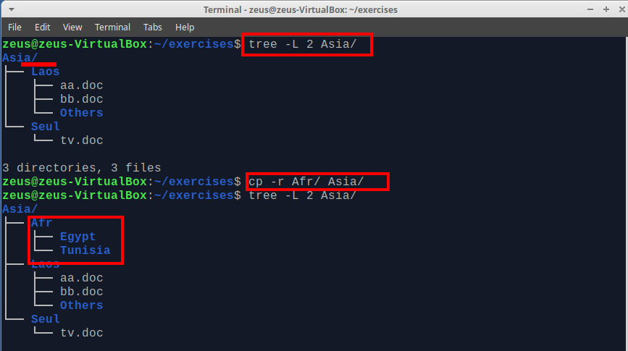

1. Move all the files and subdirectories of “Laos” to “Seul” and rename it to “Seul2”

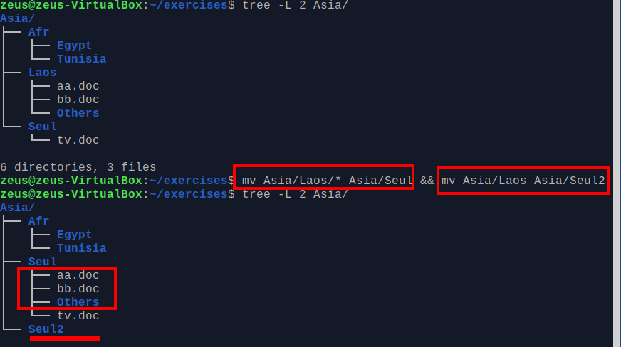

References:

*https://linux.die.net/man/1/tree

**https://stackoverflow.com/questions/1371261/get-current-directory-name-without-full-path-in-a-bash-script