**LINUX: Exercises about files manipulation**

# Part 1

Create a file called “awards” in your home directory, containing

JESSE#EISENBERG#THE SOCIAL NETWORK#ACTOR

COLIN#FIRTH#THE KING’S SPEECH#ACTO

HALLE#BERRY#FRANKIE AND ALICE#ACTRESS

NATALIE#PORTMAN#BLACK SWAN#ACTRESS

DARREN#FINCHER#THE SOCIAL NETWORK#DIRECTOR

ANNETTE#BENING#THE KIDS ARE ALRIGHT#ACTRESS

Also using cat > awards

1. Add a new line, containing CHRISTOPHER#NOLAN#INCEPTION#DIRECTOR, at the end of the file. You should complete this exercise using commands instead of file editors.

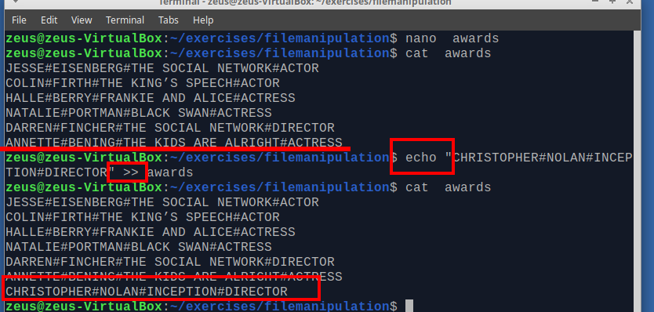

(also cat >> awards and add the new content, watch out \n))

1. Create a file called “actors” in which you only include ACTORS.

grep -i "actor" awards > actors

cat actors

JESSE#EISENBERG#THE SOCIAL NETWORK#ACTOR

COLIN#FIRTH#THE KING’S SPEECH#ACTOR

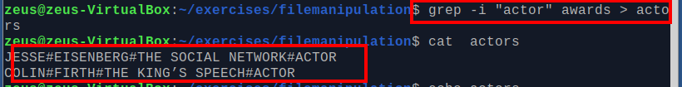

1. Display the files which begin with a in your home directory.

ls $HOME | grep ^a



1. Create a file called “directors” in which you only include DIRECTORS.

grep -i "director" exercises/filemanipulation/awards > exercises/filemanipulation/direstors

cat exercises/filemanipulation/direstors

DARREN#FINCHER#THE SOCIAL NETWORK#DIRECTOR

CHRISTOPHER#NOLAN#INCEPTION#DIRECTOR

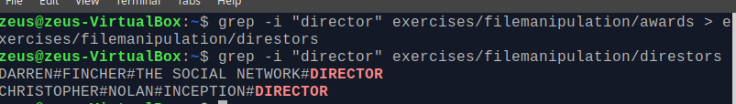

(grep -i "#director" exercises/filemanipulation/awards > exercises/filemanipulation/direstors)

1. Display the lines of “awards” containing actresses. Show the line number.

grep -in "actress" awards

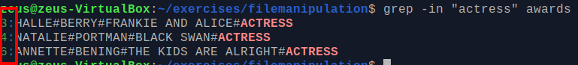

1. Display the lines in “awards” which are not directors. Show the line number.

grep -ivn "director" awards

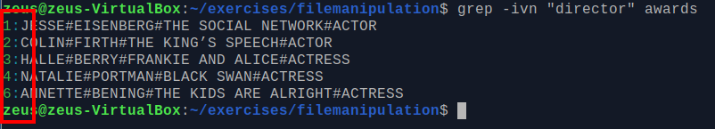

# Part 2

Create the file called “people.txt” Ana;Perrrrrrrales;1000

Pedro;Soria;1600

Jacinto;Manzano;500

Claudia;Pastor;600

Xavier;Granados;1000

Soraya;Annnnnnnneja;3000

Xavier;Guerra;4500

Sara;Siria;675

Pablo;Serrano;1000

Sonia;Mono;1600

cat > people.txt

On the keyboard press ctrl+d

cat > people.txt

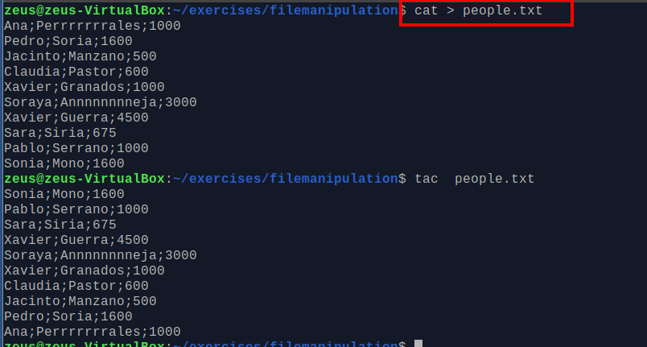

1. Create a file called “people2.txt”, containing those people whose name begins with J or S.

grep –i “^[J,S]” people.txt > people2.txt

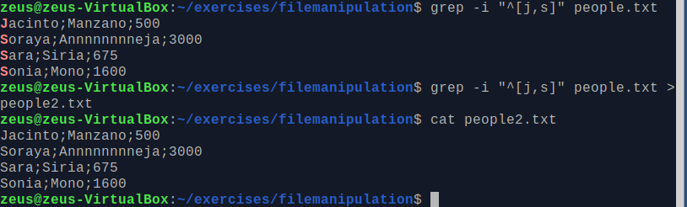

1. Create a file called “people3.txt”, containing those people whose names do not begin with S

grep -iv "^S" people.txt > people3.text

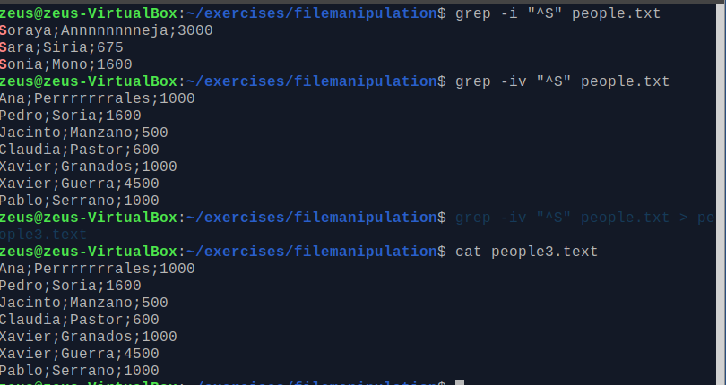

1. Display people whose name begin with S and redirect to file to “people_s.txt”

grep ^S people.txt

grep ^S people.txt > people_s.txt

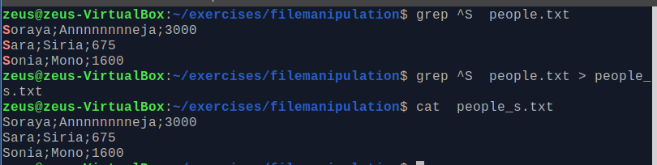

1. Display the number of people whose name begins with A (case insensitive).

grep -ic ^a people.txt



1. Display how many people earn 1000 and concatenate the result in people2.txt

grep –ic 1000 people.txt



grep -n "1000" people.txt >> people2.txt

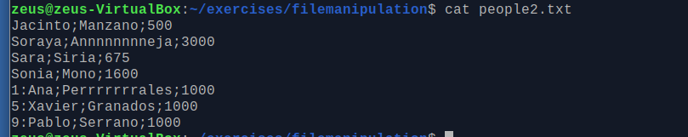

# Part 3

1. Create a file called list, including the contents from the current directory
2. Open the file to check if the content is right using cat, more and less and observe the differences

ls -l > filterexercises/list

cat filterexercises/list

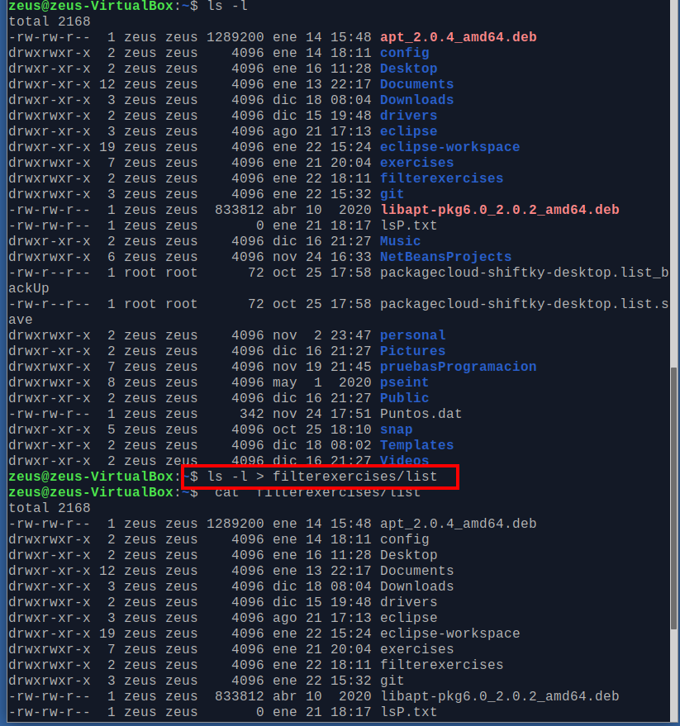

1. Print the contents of the current directory in reverse alphabetical order.

ls -l -r

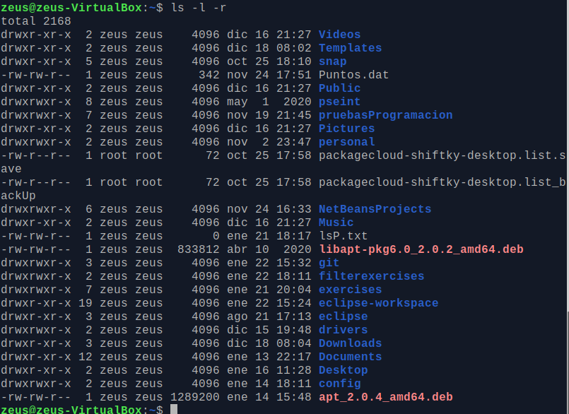

1. Create a file called inform, containing the long format list of the files and directories in your home directory

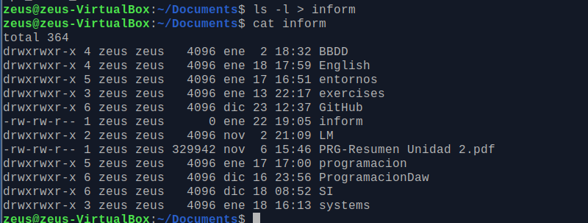

1. Find the word FILE in each file of your home directory, ignoring case and showing the line number (create files containing this word if you want any match).

grep -si "file" *

-s, --no-messages

Suppress error messages about nonexistent or unreadable files.

-I, --ignore-case

