# MANAGING DIRECTORIES

* 1. Change the current directory to C:\Users*<user>*

*get-location*

*set-location $HOME*

set-location c:\users\rblaper

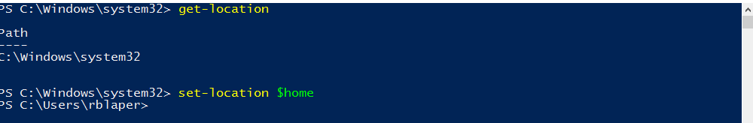

* 1. Create a directory called **systems** into your home directory

New-item systems –itemtype directory

New-item systems –type directory

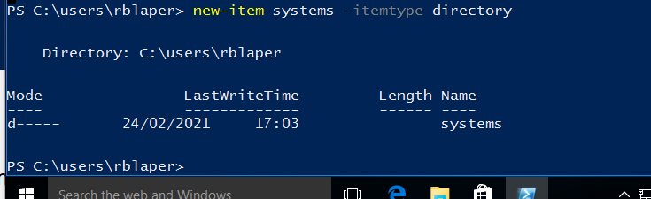

* 1. Create a directory called **exercises** into your home directory. Go to this directory and create another new directory called **programming**

new-item –path exercises\programming -itemtype directory

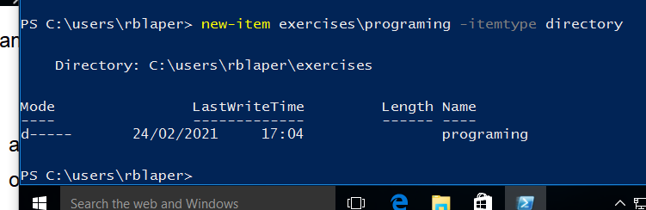

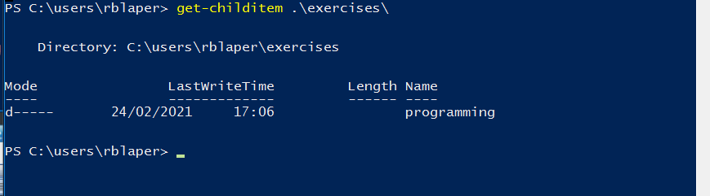

* 1. Go back to the user’s home directory. Delete the directories “exercises” and “programming” using just one command. Create the directories again with one command.

set-location ..

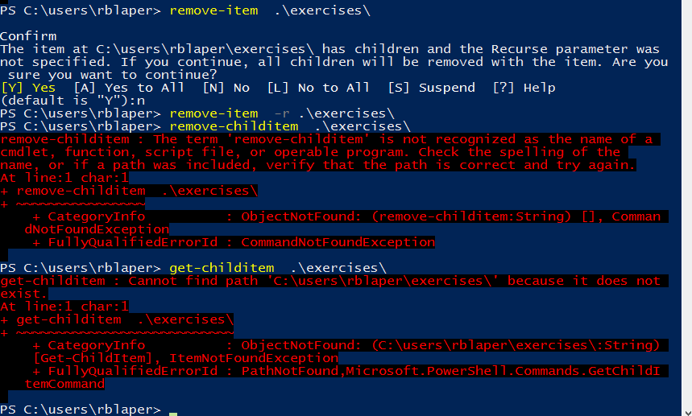

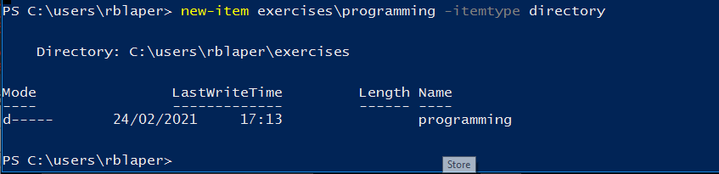

* 1. Create the empty files called student.txt, student1.txt, student2.txt, list, luggage and last in the directory named “systems”

set-location systems

new-item students1,students2

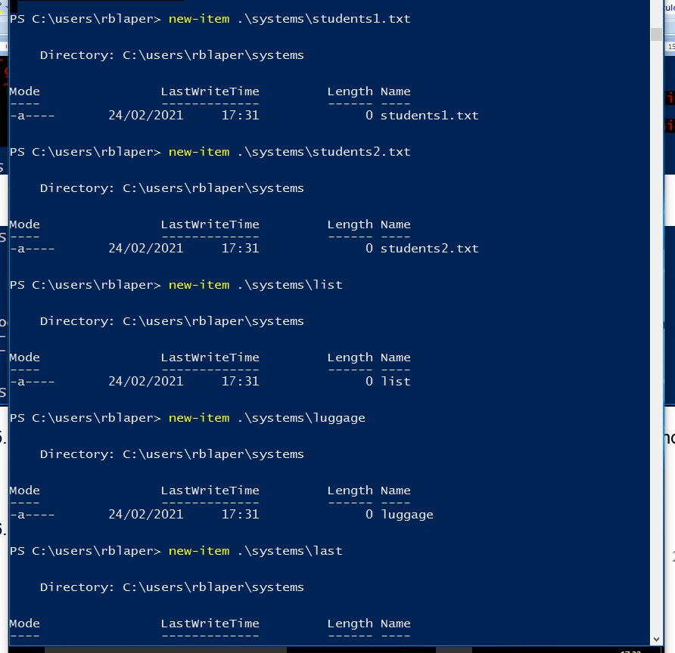

* 1. Print all the files that begin with “l” in the directory “systems”

get-childitem l* -file

get-childitem l* -directory

get-chilitem –path * -include l* -file

get-chilitem * -include l*

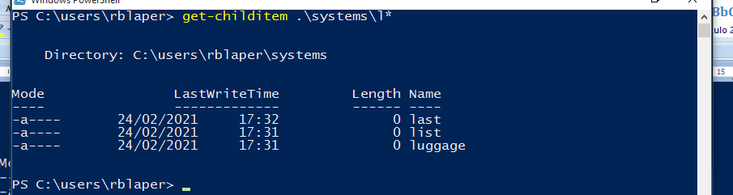

* 1. Print all the files that end with “txt” in the directory “systems”. Display the output as a list only showing the properties name and mode

get-childitem -path * -include *txt –file | format-list –Property name,mode

get-childitem *txt –file | format-list –Property name,mode

get-childitem *txt –file | select-object -Property name,mode

get-childitem *txt –file | get-member

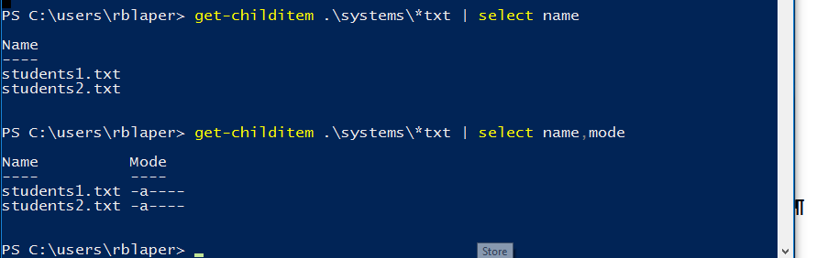

* 1. Create a new directory into your home directory called “config” using an absolute path

new-item -path C:\users\rblaper\config -itemtype directory

new-item $HOME\config

remove-item $HOME\config

tree /f exercises

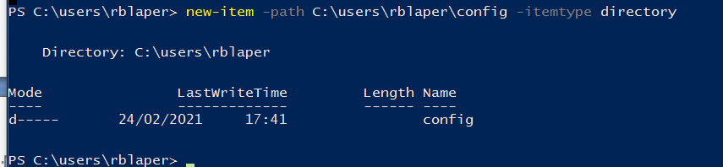

# COPY, RENAME AND EDIT FILES

Create the following directory structure in C:\Users\<user>\exercises

exercises

Africa Asia

Tunisia Egypt Seul Laos

set-location

new-item –itemtype directory Africa\tunisia, directory Africa\tunisia

new-item –itemtype directory Africa\tunisia

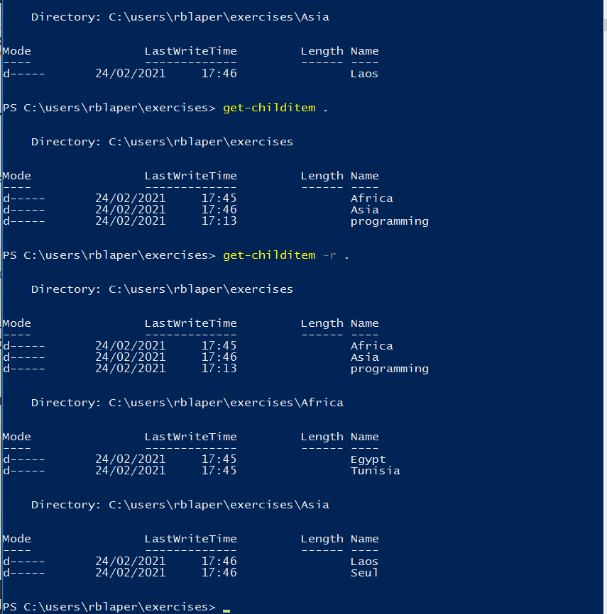

1. Create the following empty files using **the command line song.doc** in the directory **Egypt**

**tv.doc** in the directory **Seul marks** in the directory **Tunisia**

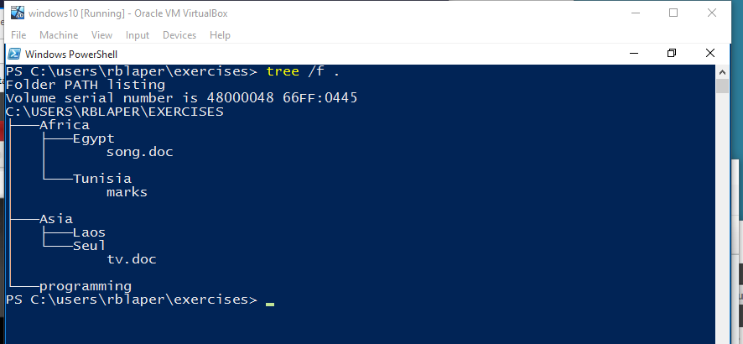

1. Copy all the files in C:\Windows which begin with “a” into “Africa”

Only copy the container but not the contenct

copy-item –path c\windows\s* -destination “Africa” –container: $false

get-childitem c\windows\s* -file | copy-item –destination “Africa” # copy only files

get-childitem c\windows\s* -directory | copy-item –destination “Africa” # copy only directories

get-childitem –recursive

tree

tree #folders

tree /f # show folders and files

new-item -itemtype directory /one/one, /two/two

removw-item –recursive –force /one #remove all the tree

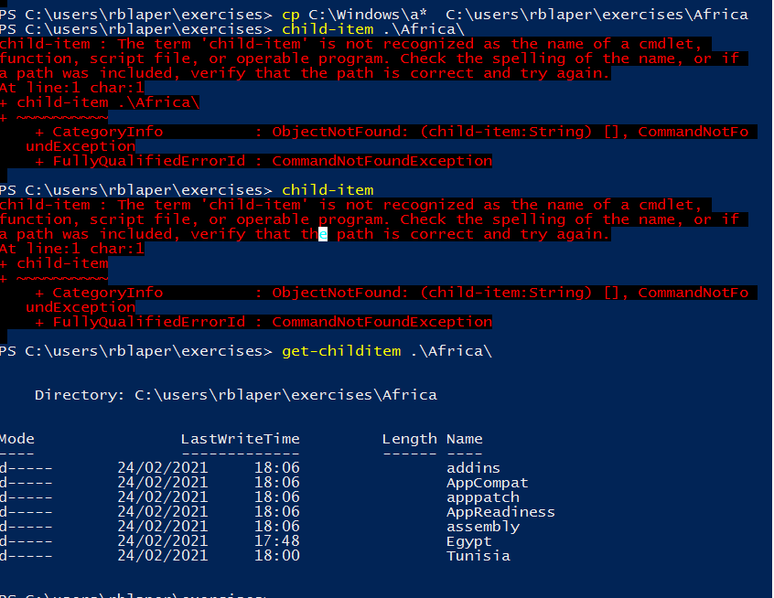

1. Delete all the files in “Africa” which end with “exe”

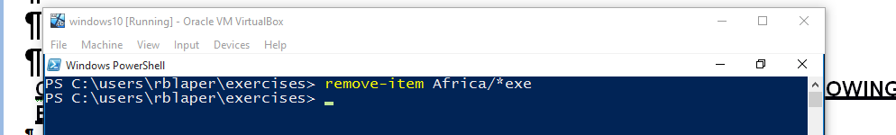

## CHANGE THE CURRENT DIRECTORY TO AFRICA AND DO THE FOLLOWING EXERCISES USING RELATIVE PATHS

1. Copy the file “song.doc” into “Laos”
2. Copy the file “tv.doc” into “Egypt” with the name “radio.txt”
3. Rename the file “marks” to “exam.wri” (it is located in the directory named Tunisia)
4. Copy the file “song.doc” (located in “Egypt”) inside “Tunisia”
5. Print the content of the current directory and subdirectories
6. Rename the file “song.doc” (located in “Laos”) to “aa.doc”
7. Create the directory “Others” in “Laos”
8. Rename the directory named “programming” (which you created in the first exercises) to pro-c.
9. Create the following directory tree in “exercises” (using as few commands as possible)

ONE

TWO THREE

1. Copy the files with txt extension from the directory named “systems” to “exercises”.
2. Move the files you copied in the exercise above to the directory THREE.
3. Delete the directory named THREE, including all the files and, if so, subdirectories

## CHANGE TO SYSTEMS AND DO THE FOLLOWING EXERCISES USING ABSOLUTE PATHS

1. Copy the files that end with “txt” of the directory named “systems” to “Tunisia”
2. Copy the file “tv.doc” (located in “Seul”) to the directory named “exercises”
3. Rename the file student1.txt (located in “Tunisia”) to tuition.txt
4. Rename “Africa” (located in “exercises”) to “Afri”

## NOW YOU CAN BE PLACED IN THE DIRECTORY YOU WANT

1. Move the file “song.doc”, which is located in Egypt, to “Laos” with the name “bb.doc”
2. Copy the files whose name contains the letter “u” from “systems” to “exercises”
3. Print the content of the C:\Windows, including subdirectories, formatted as a list and only displaying the name and “Last Write Time”
4. How can you print the name of the current directory?
5. Copy the folder “Afri” including files and subdirectories to “Asia”
6. Move the folder Laos including files and subdirectories to “Seul” and rename it to “Seul2”