**STATEMENT**

Complete the required steps to configure a RAID5 in Windows 10. The size for each disk will be 10 GB (link for help https://www.youtube.com/watch?time_continue=3&v=4Za2ibLrSrE).

Once you have set your RAID5, delete one of the virtual hard disks from VirtualBox. Check what happens in “Storage Devices”. If necessary, restore RAID5 adding a new disk to the existing configuration.

IMPORTANT: implement the assignment in a Windows 10 virtual machine (Windows 10 because a software RAID5 does not work in Windows 7).

**MATERIAL:**

Host Windows 10 Pro x64

Guest Windows 10 enterprise ltsc x64

VirtualBox Graphical User Interface Version 6.1.14 r140239

(Qt5.6.2)

Windows 10 x64

Four virtual drives of 10 GB

[RAID](https://www.tomshardware.com/reviews/raid-controller-card-definition,5756.html) (Redundant Array of Independent Disks) is a setup that uses multiple storage drives to create a single workable storage system. It brings together multiple hard drives using striping, mirroring, or parity to create a reliable data store within a network or computer. The aim is not only improving overall storage efficiency, but protect against drive failure by incorporating backup drives systems. It is usually a configuration for enterprise systems.

RAID 5’s configuration involves at least 3 drives; it offers the security of redundant drives and the additional efficiency that comes with data striping. The total amount of storage space is equal to N (number of HDs) -1*storage capacity.

**PRACTISE**

Creation of three dynamic HD of 10 GB

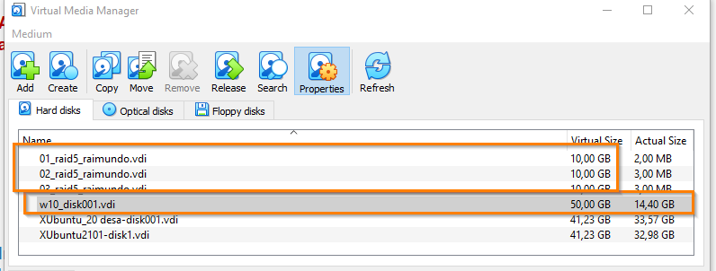

Adding the three drives to the mv and boot is. Under management, disk management at the three drives.

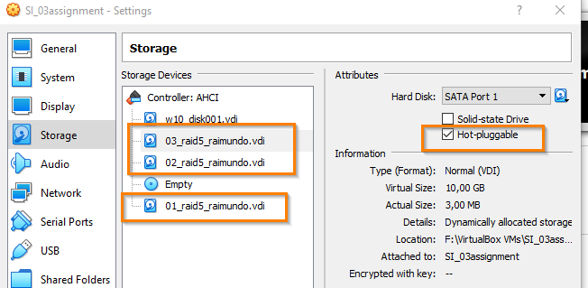 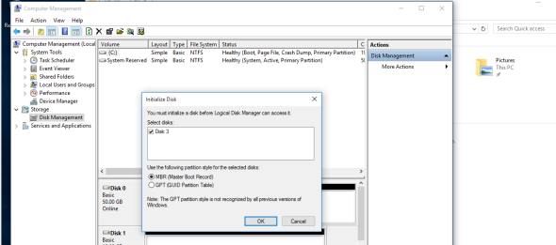

In the Windows 10´s searching box typ4 write Control panel, in the search box write Storages spaces, tap on Manage Storage Spaces and create a new volume, and click yes on the popup panel.

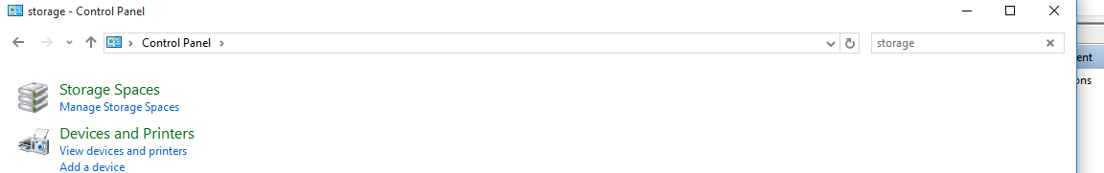 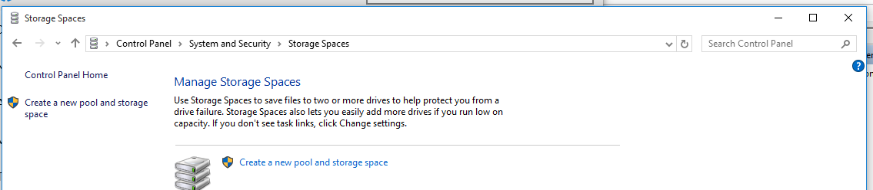 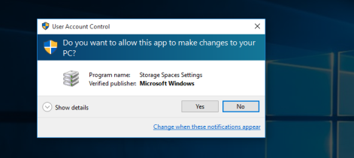

Select the drives if they are not already selected and tap on create a poolin order to create a storage pool

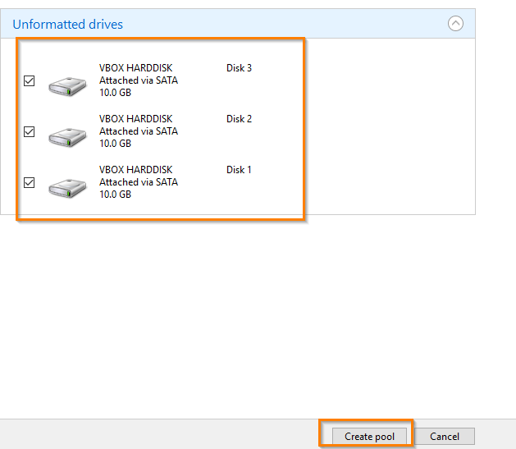 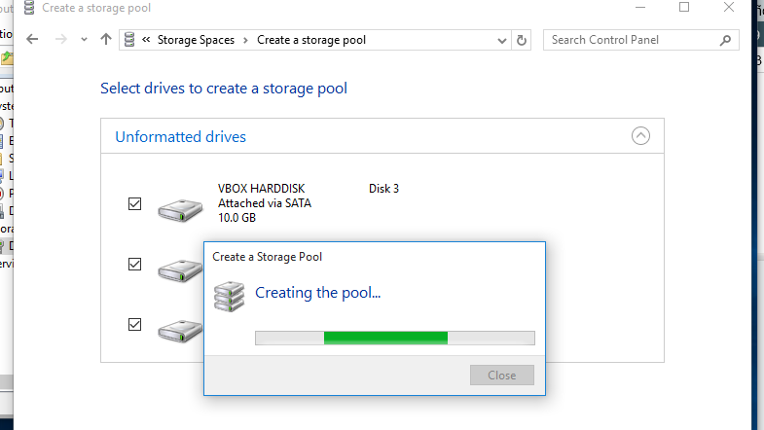

Firstly under the “Name and drive letter” section, specify a name, letter, and also file system for the storage array; secondly the “Resiliency” section, use the “Resiliency type” drop-down menu and choose the Parity option (it is the equivalent to the RAID 5 level), and finally under the “Size” section, specify the maximum size as needed; and click on Create storage space button.

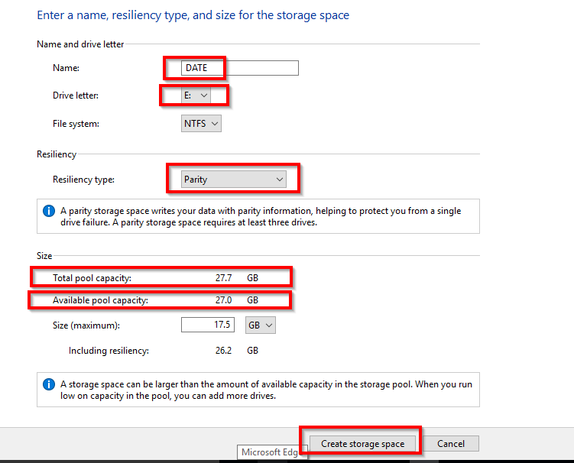 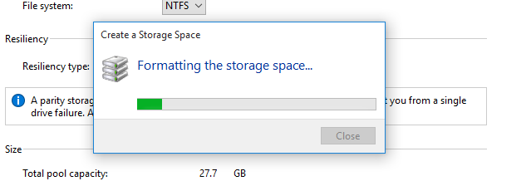

Checking the setting of the new Raid 5 storage created

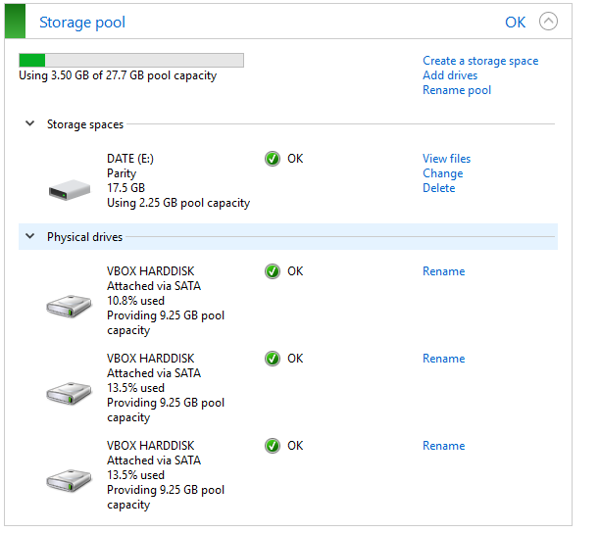 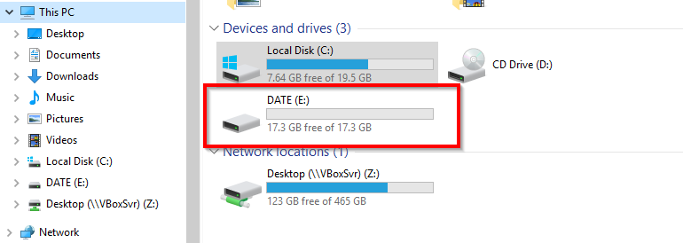

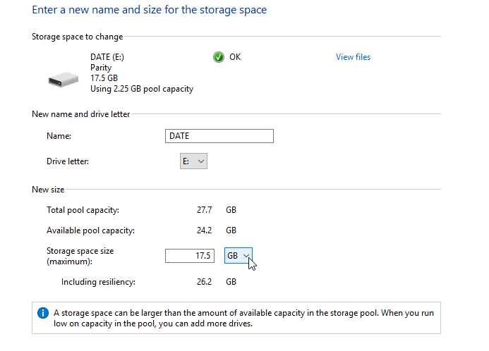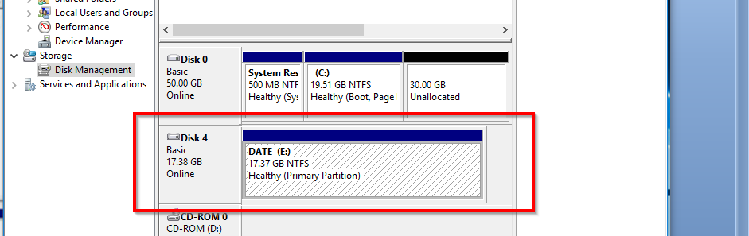

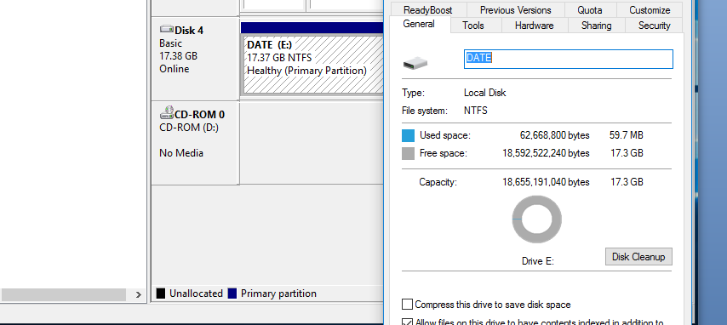 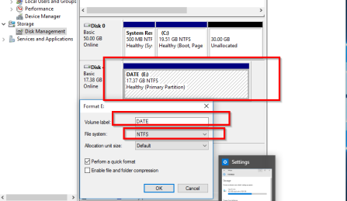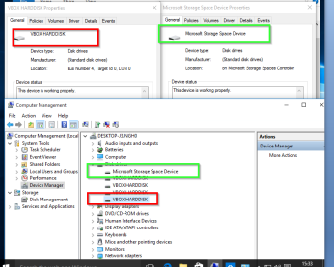

Storing data in the new unit.

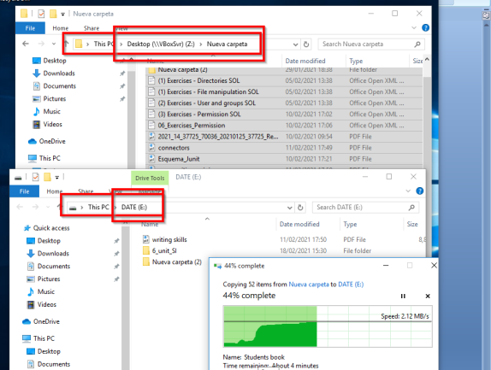

Making one drive fails. In case rebooting a Message popup Click on Continue

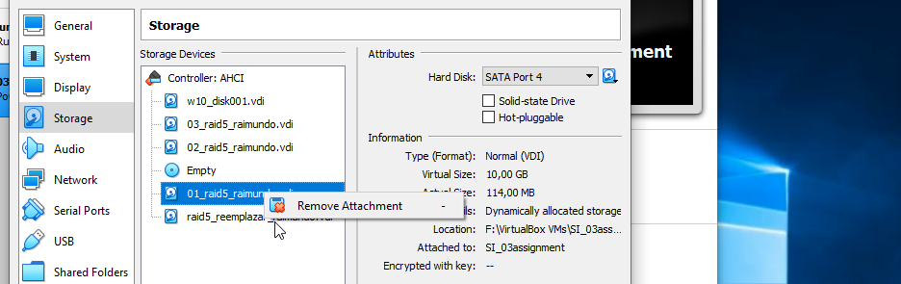 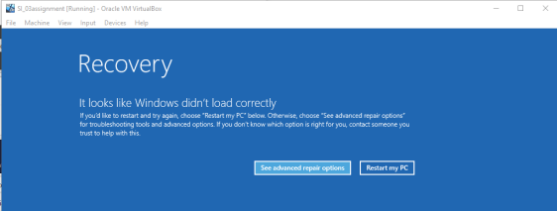

In other case, the system detects the fail and a message show up, although data is still accessible in the unit DATA.

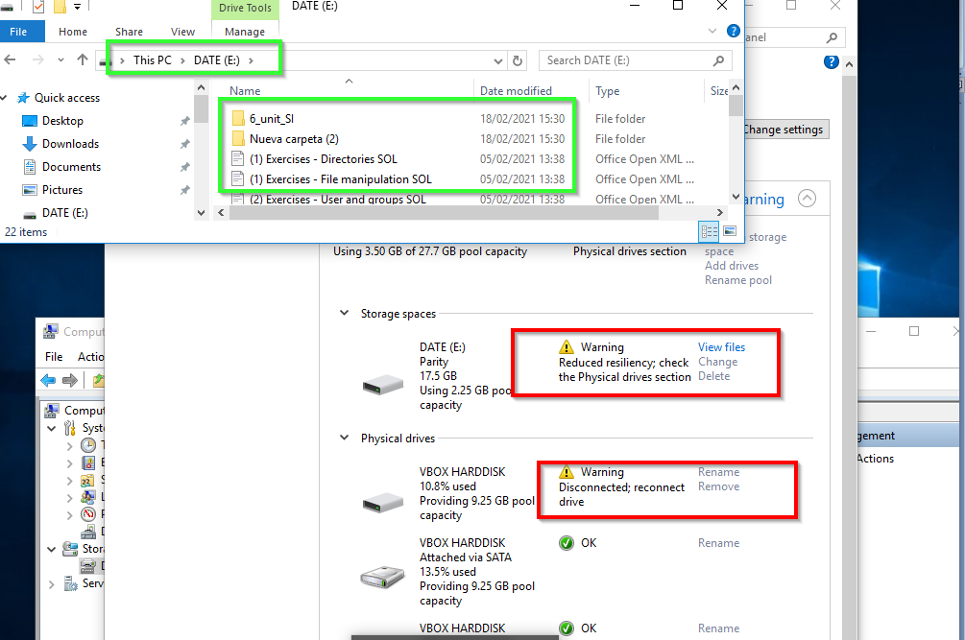

The first thing that must be done, when after a drive failure, is to completely backup all the data in the RAID, preferably on an external hard drive, because, if a second drive fails, all the array data is gone for good.

If the same disk is plugged back (if it is not faulty), the pool will automatically be restored.

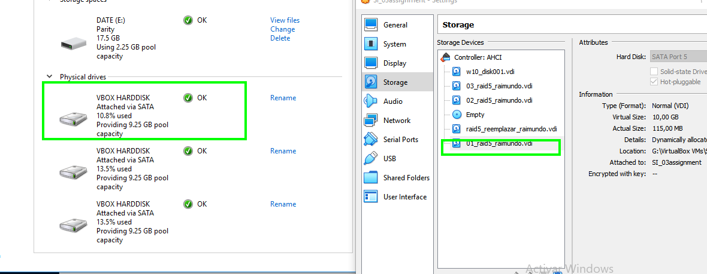

If it is a new HDD, just after replaced the faulty one, at the "Manage Storage Spaces" window click on "Change settings"..., .and then "Add drives."

The system will recognize the new drive, provided it is unformatted.

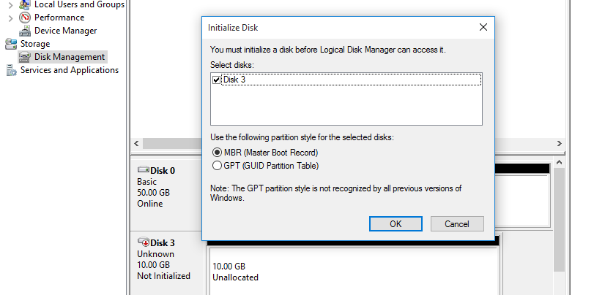

After, the new drive has to be added and the faulty removed from the RAID (the pool).

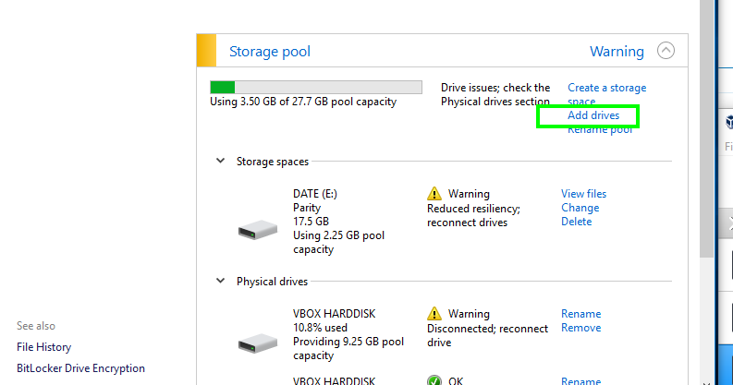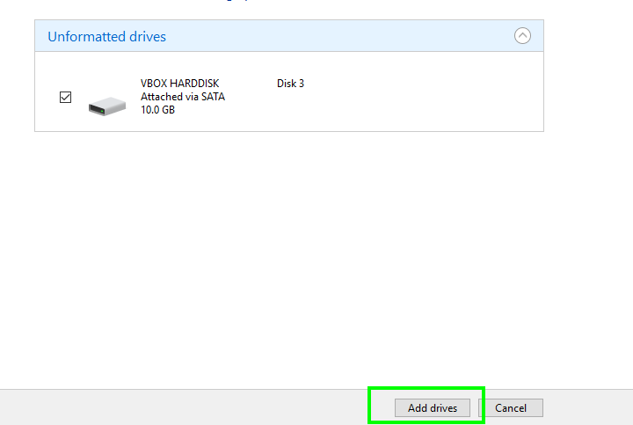

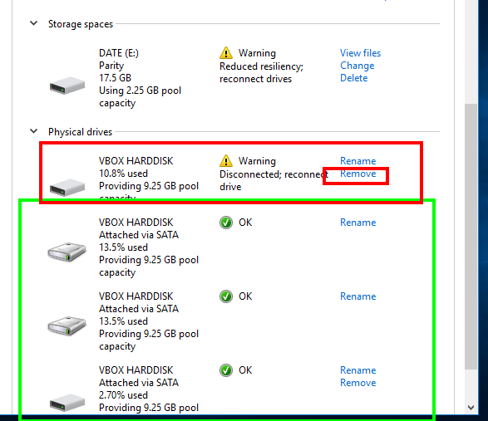 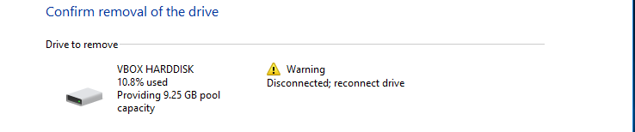

That's it.

The software RAID 5 is healthy again and can withstand a single disk failure.

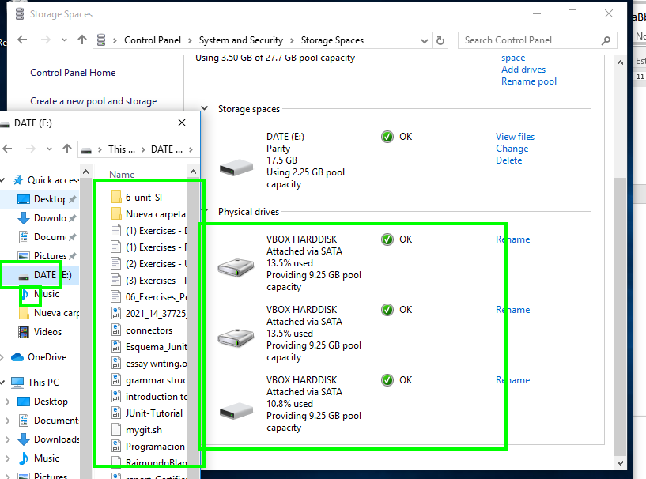

References

<https://www.pcsteps.com/738-software-raid-windows-storage-pools/>

<https://store.hp.com/us/en/tech-takes/how-to-set-up-raid-windows-10-pc>