Imagine we have a computer with Windows 10 for two-year courses. The first year can access two types of students: hardware and software (2 users for each type and 1 group for the first year). The second year can access security and servers (2 users for each type and 1 group for the second year).

The users above are standard, but we also have an advanced user called “responsible” with administrator permissions.

We want to create some folders in D:\ according to the following criteria:

• A personal folder for each user, which can only be accessed by the corresponding user.

They can do everything. You only need to create the folder for one of the users, since the others are similar.

• A read-only folder for all the students called “shared”. The responsible user is able to create or delete files and folders. The software user cannot access this folder.

• A folder only for first year students into the shared folder, where they can create files and folders, but not delete them. Second year students will not be able to access.

• Do the same as above for second year students (into the shared folder too). First year students will not be able to access.

Do the following:

a) Explain the users and groups required for the computer.

b) Explain the folders we need according to the criteria above.

c) Set the NTFS permissions for all the users and groups in each folder created in part B. For

the subfolders, consider two scenarios: inheritance and non-inheritance.

Root diretory permissions

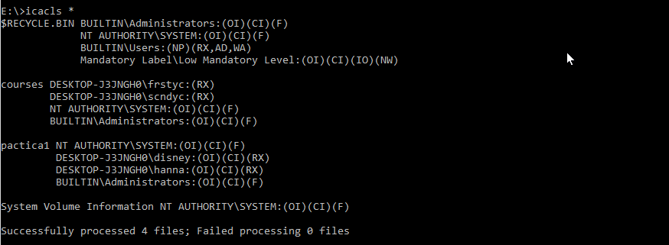

Courses folder and children

