**EXERCISES: Users, groups and local policies**

1. **Add a new standard user named “Class_1” including the description and full name. The user must change the password at next logon.**

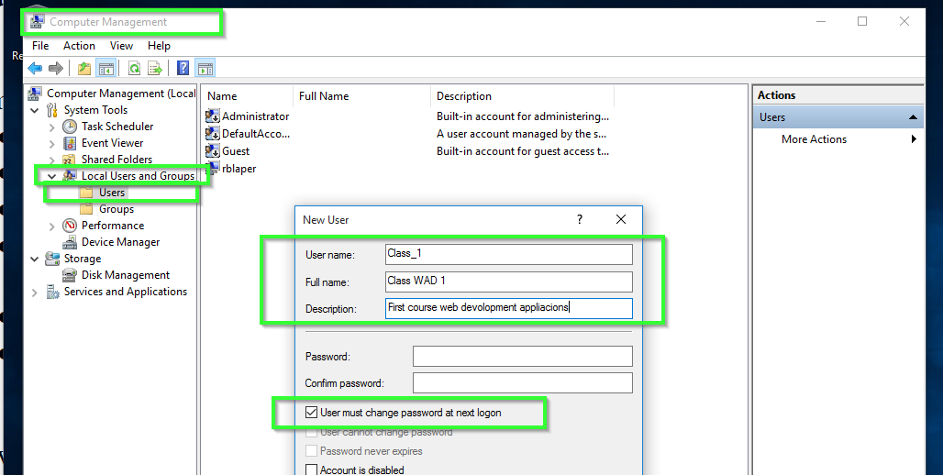

1. **Complete the following parts about the user “Class_1” from the previous exercise.**
   * 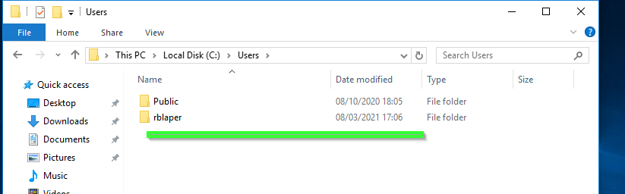Verify if the profile folder exists.
   * Log in as “Class_1”.

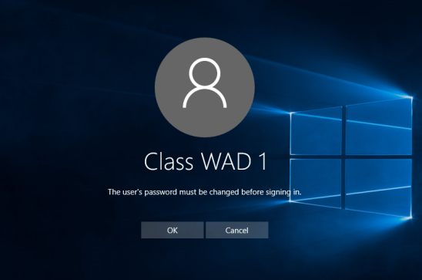 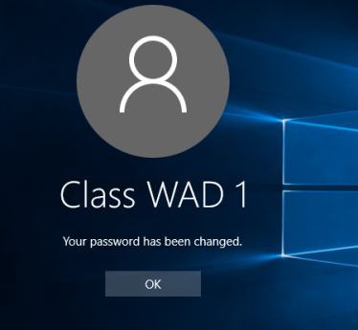 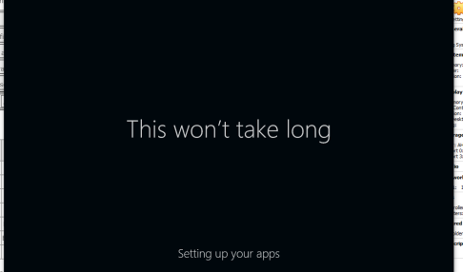



* + Verify if the profile folder now exists.

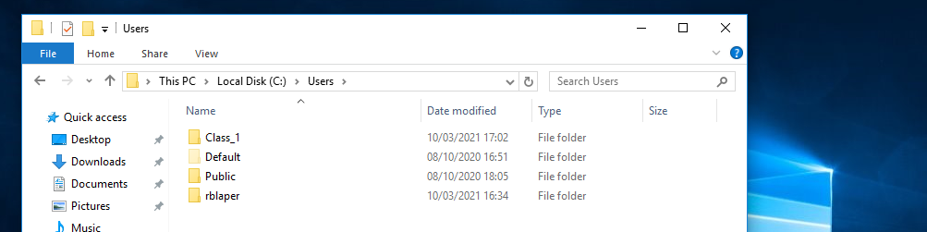

* + Add a second hard drive to the virtual machine and create a folder called “My Documents” in F:\

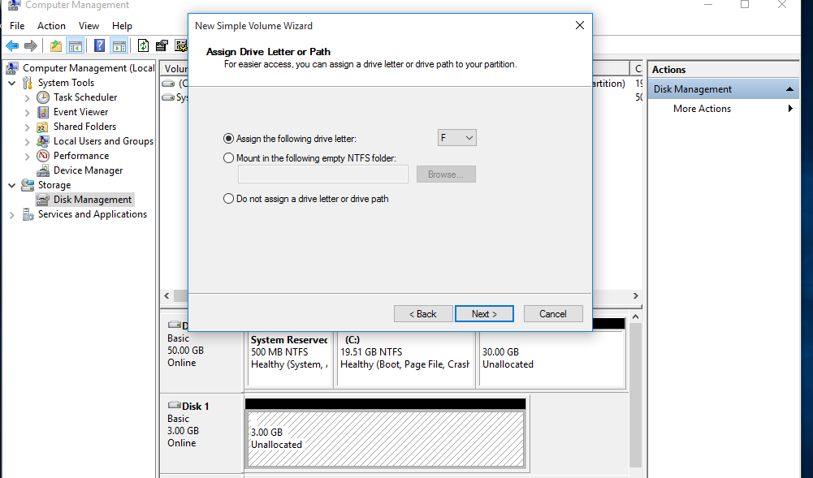

* + Move “Class_1” Documents folder to the directory you have just created.

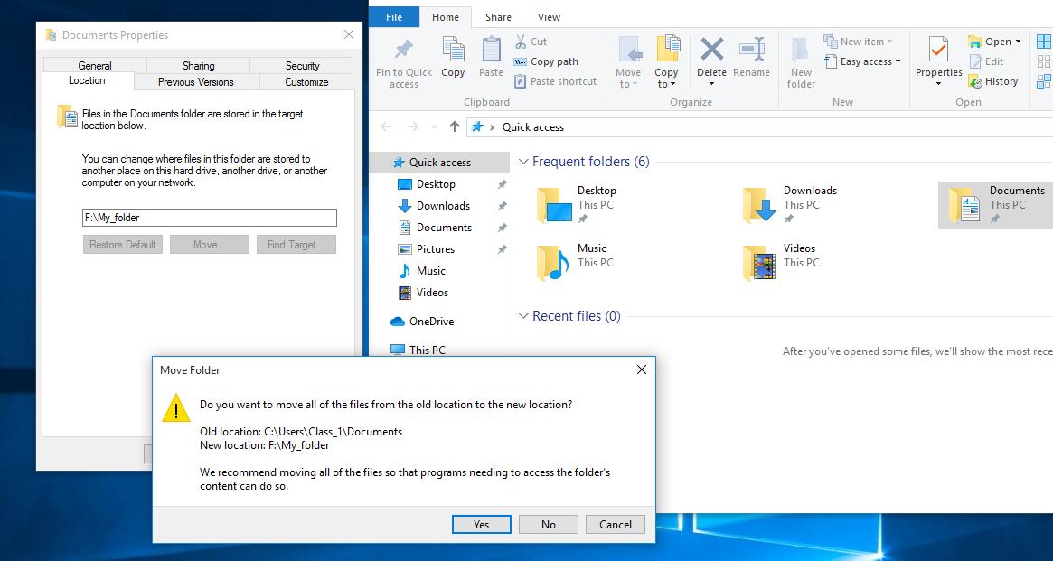

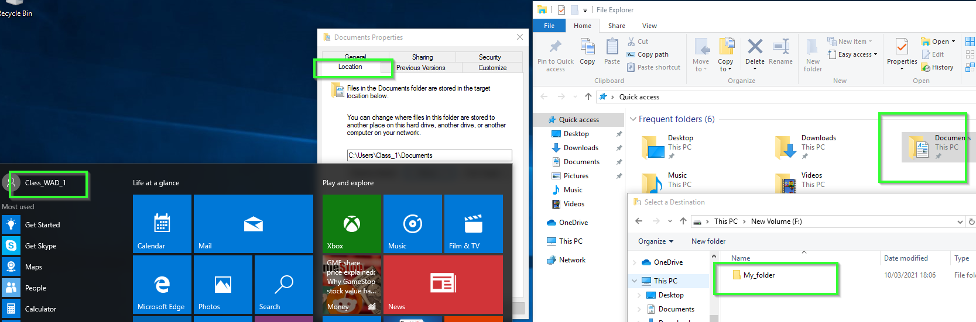

* + Open “Documents” shortcut and create a new folder. Check if this folder has actually been created in “F:\My Documents”.

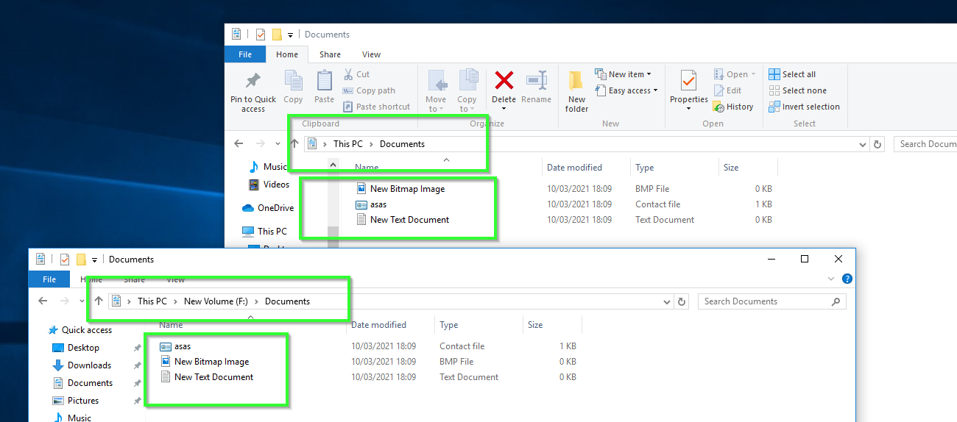

1. **How do you configure a user to log in without a password and automatically when turning the computer on?**

netplwiz.exe

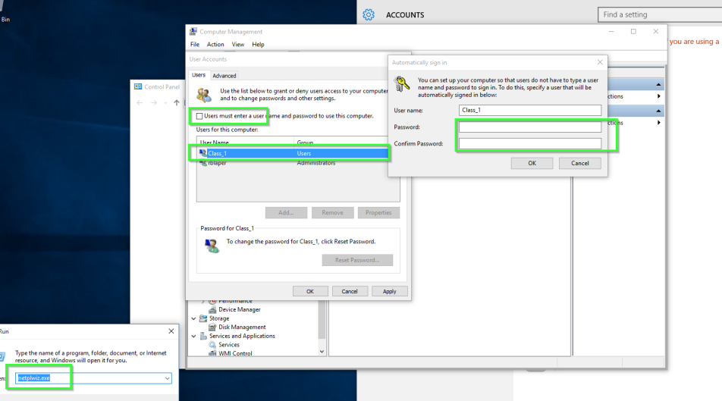

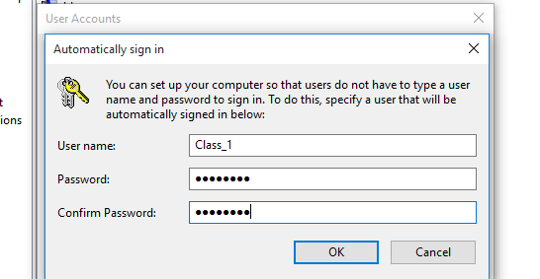

1. **How do you configure a specific user so that the password never expires? How can you configure this policy for everyone?**

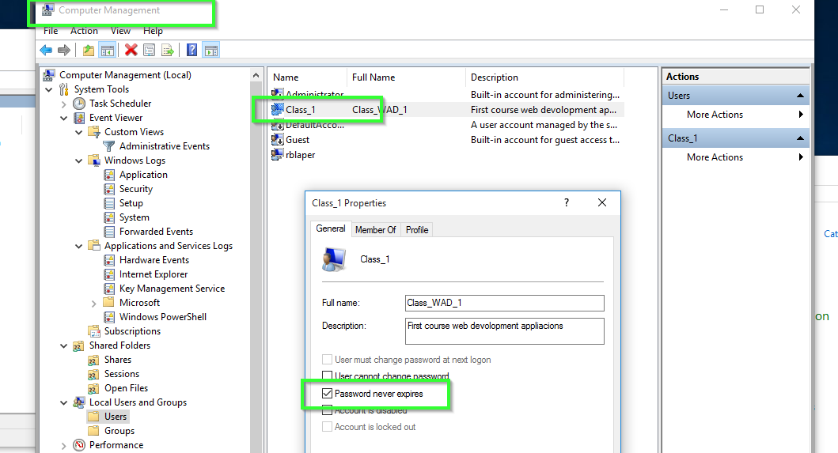

Yes

gpedit.msc

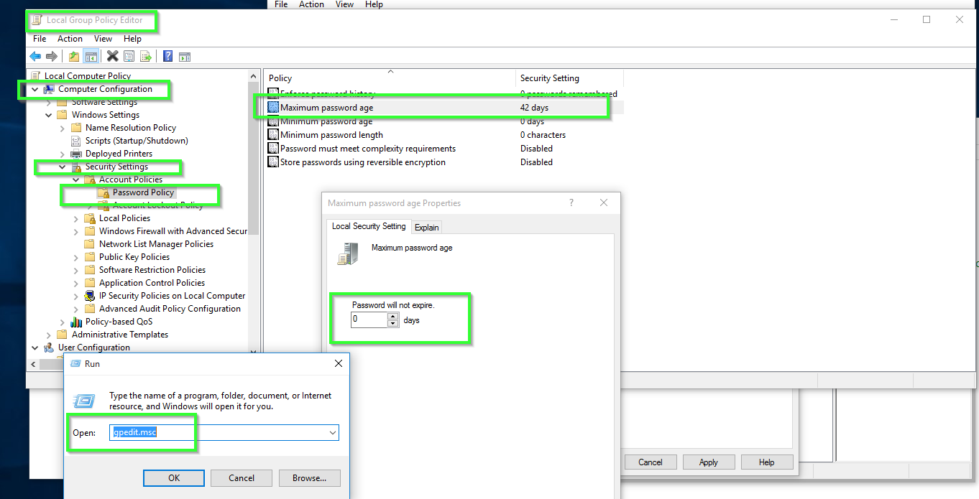

1. **When can you use a locked account?**

A locked account cannot be used until the administrator reset it or until the number of minutes specified by the Account lockout duration policy setting expires.

1. **Imagine you define an “Account lockout threshold” of 3 and “Account lockout duration” of 5. What would be the valid values of “Reset account lockout counter after”? What if “Account lockout threshold” value were 0?**

At least 5 minutes.

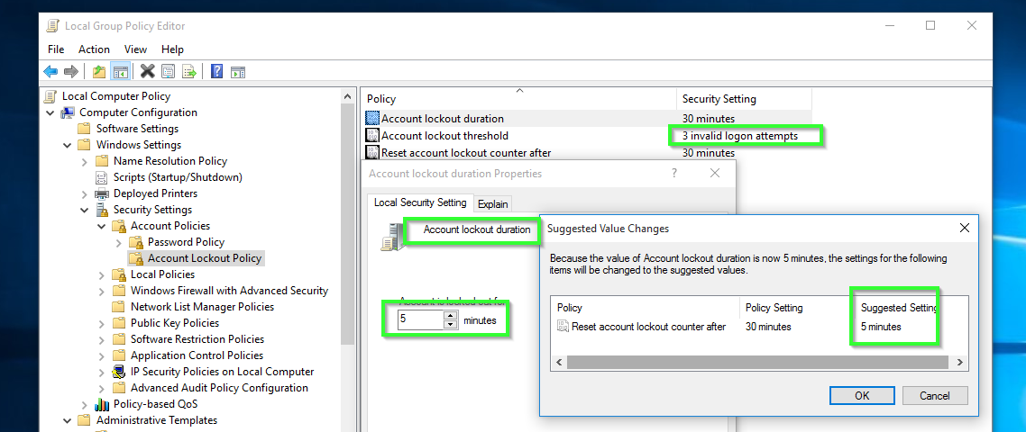

By setting the value to 0, the account will never be locked

1. **Configure the system according to the following criteria:**
   * **All the passwords must have at least 8 characters.**

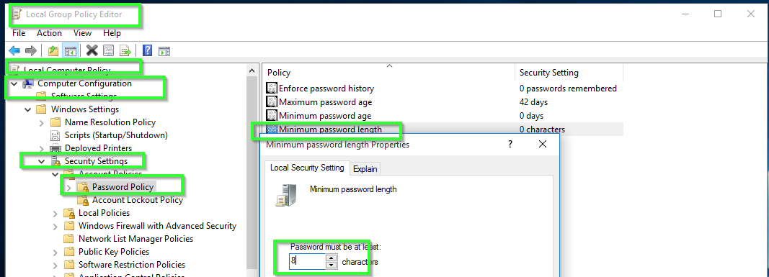

* + **All the passwords must contain uppercase, lowercase, numbers and non- alphanumeric characters.**

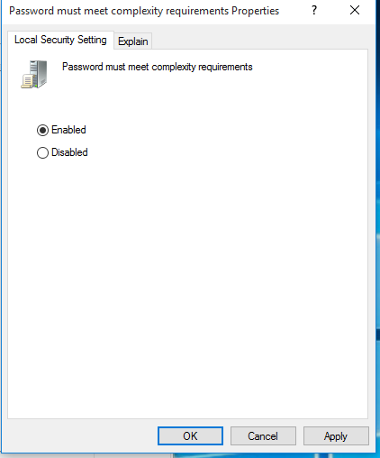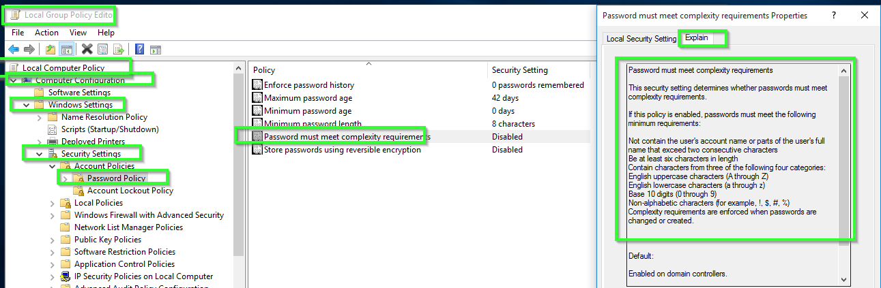

* + **The system stores the last 10 passwords for each user.**

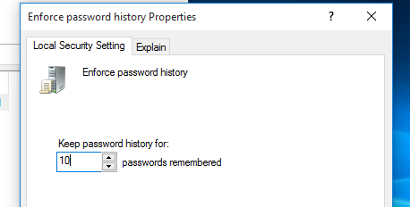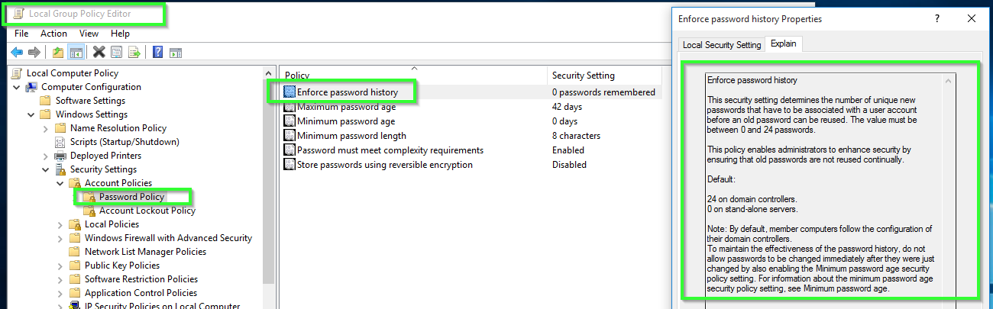

* + **All the passwords expire after 3 months.**

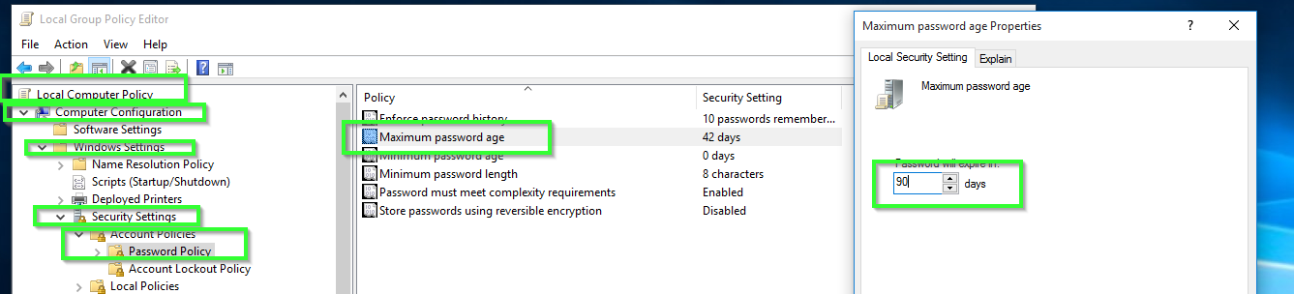

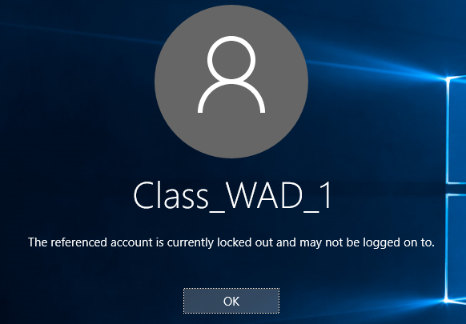

1. **Configure the user “Class_1” to be locked after 3 invalid logon attempts. If the user is locked out, it will be able to type the password again in 5 minutes. Complete the following steps:**
   * **Lock the user.**

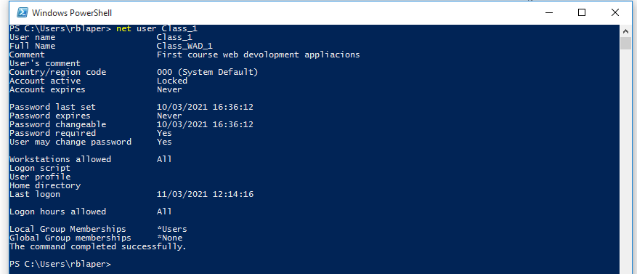

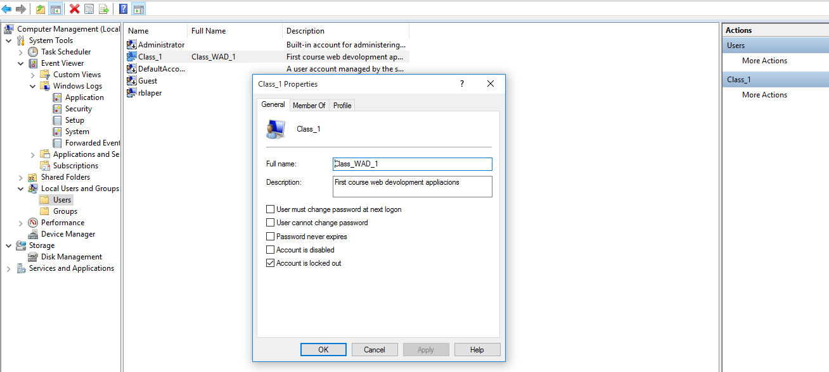

* + **Unlock the user as administrator and check if the user is able to log in.**

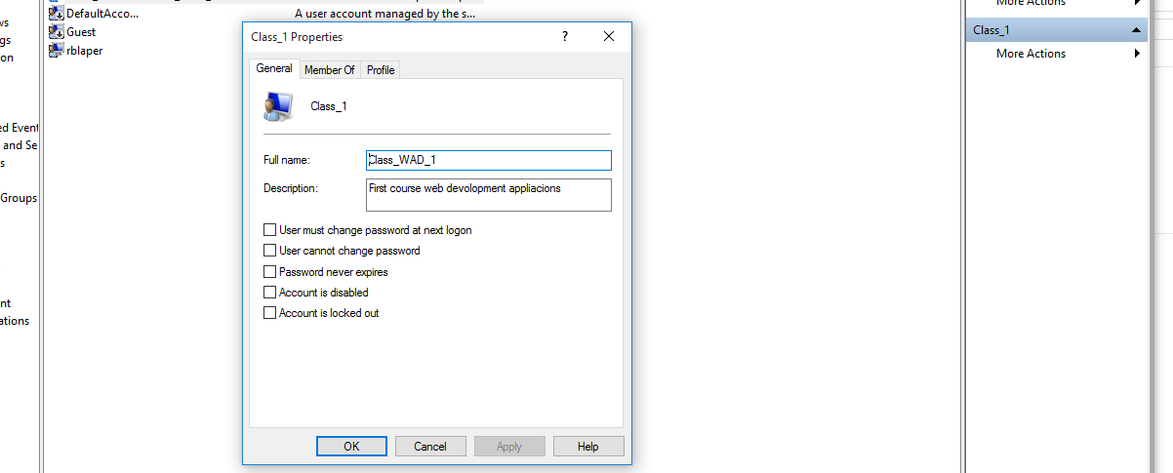

* + **Lock the user again.**
  + **Wait for 5 minutes.**
  + **Type the right password and check if the user is able to log in.**

1. Add a new group name “Class” and complete the following:
   * Add the user “Class_1” to the group “Class”.
   * Create a guest user called “Class_2”, initially disabled that cannot change the password. Then, add the user to “Class”.
2. Modify the user rights so “Class_1” and “Class_2” will be able to “Change the system time”.
3. Modify the user rights so that only the administrator users can “Shut down the system”
4. Suppose all the standard users are able to log in. How can we deny log on to the specific user “Class_1”?
5. Overall, add a new user called “Test” according to the requirements in exercise 7. What if we deleted “Test” from the group “Users”? Try to log in and explain what happens.