# STATEMENT

**OS Windows 10 x64**

Configure a computer for a wine distributor company. The company needs to create the following users:

* An administrator called Ryley James, whose password never expires. He belongs to the sales department.
* Three standard users that cannot change their password:
  + MJ Bryant, who belongs to the sales department.
  + Sofia Lawrence and Miriam Cassel, who belong to the training department.
* A guest user from the training department named Tori Williamson, but initially disabled. She will have to change the password at next logon.
* All the users must have a name, full name and description. For example, for Ryley James we can assign the username “Ryley_SBF”, the full name “Ryley James” and the description “Ryley James, administrator of sales department”.

**Users Accounts**

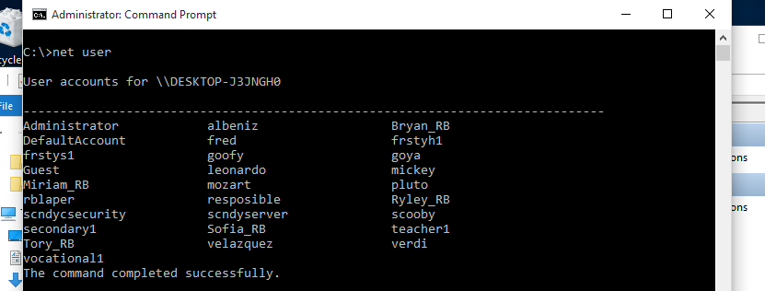

**User account properties**

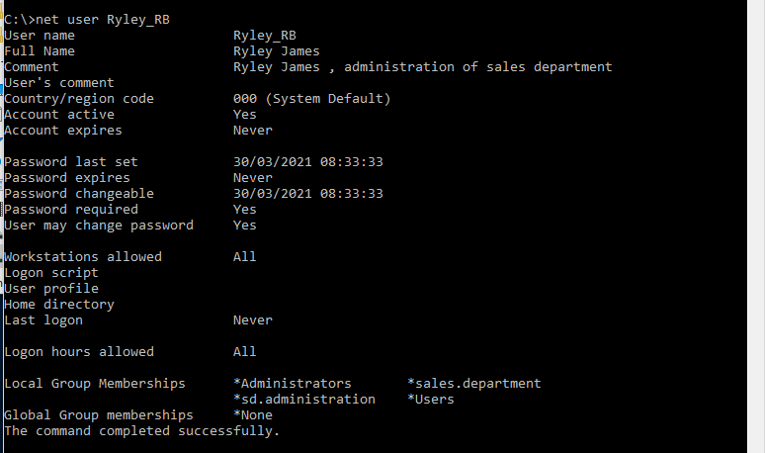

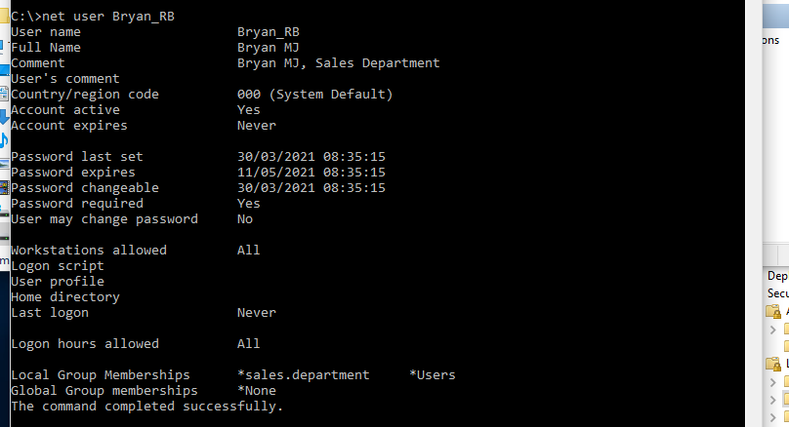

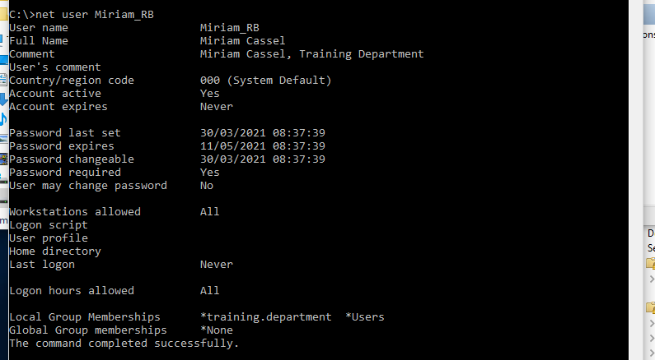

Tori Williamson, initially disabled

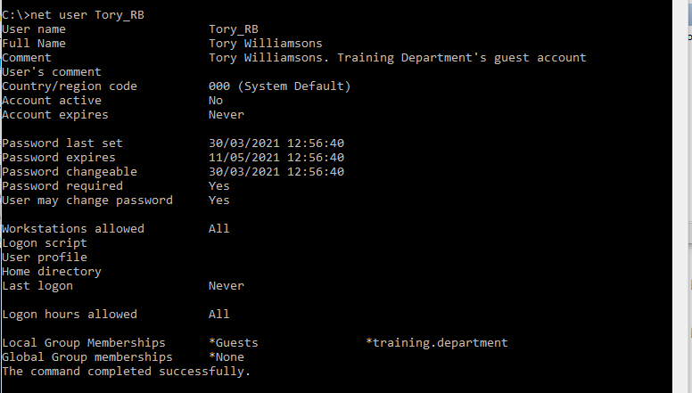

**Account policies**

Each user account will be locked after 3 failed attempts to login, although they will become unlocked after 30 minutes, unless Ryley unlocks them before.

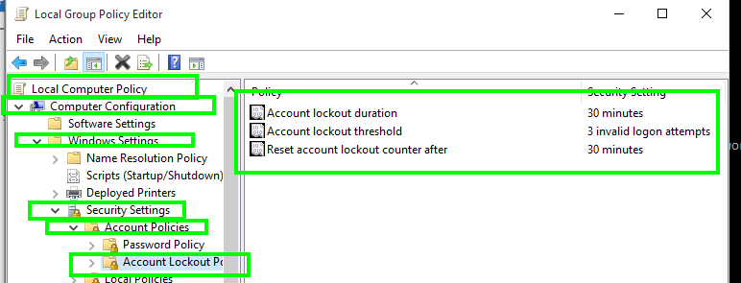

**Set time policy**

As Ryley belongs to administrators group is the only one that is able to change the date and time.

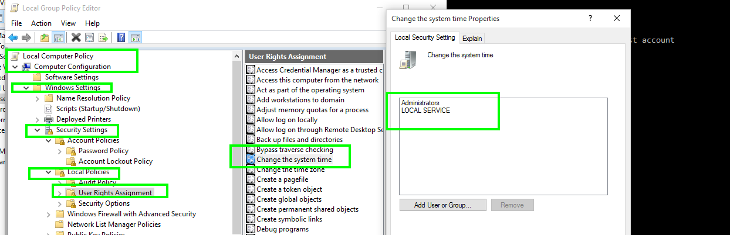

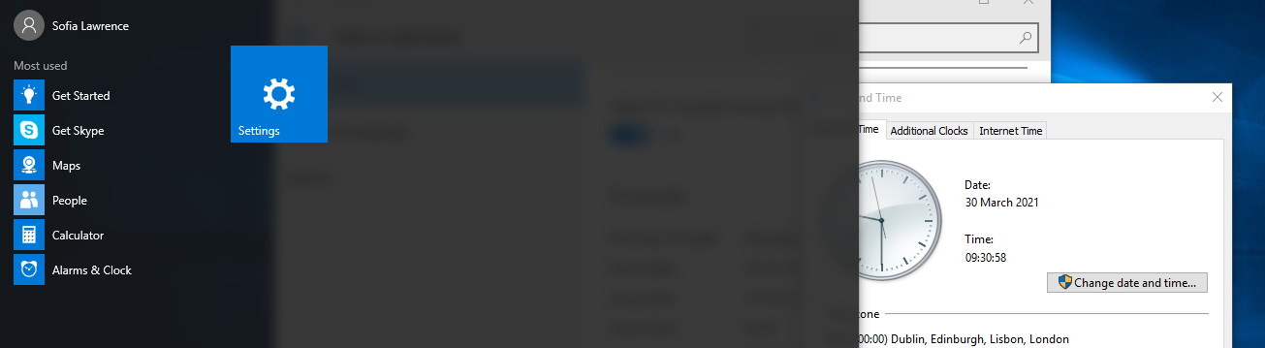

**User’s folders creation**

There is a hard drive in the volume C:\ where we want to create the following folders according to the criteria below:

* A personal folder for each user, where only the corresponding user can do everything except change permissions and take ownership. This folder will be different from the default Windows profile folder.
* A folder for the entire company, where everybody can copy or create files, but only Ryley can delete them.
* A folder for the sales department into the folder for the entire company, where the employees from this department only have read permissions, while the other employees cannot see the content. Complete this part disabling the inheritance.
* A folder named “Key accounts” into the folder for the entire company, where the employees from the sales department are able to copy files, while the other departments will only have read permission. Ryley will inherit the permissions from the parent folder. However, Miriam cannot access this folder because she is always in trouble. Explain how to complete this part with inheritance and disabling inheritance. Then, decide the most efficient.

Finally, there is a file nam ed “confidentia l. xlsx” in the folder “Key a ccounts” that the training department employees cannot access, while the permissions for the sales department will be the same as in the “Key accounts” folder. Complete this part with

Cmd

for /F %i in (users.txt) do md %i

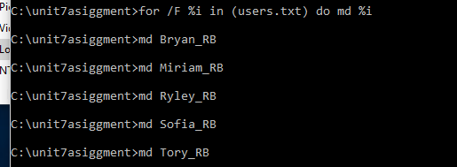 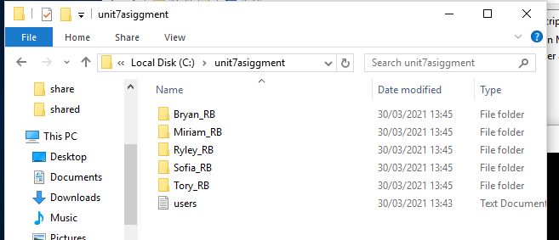

Tree directory

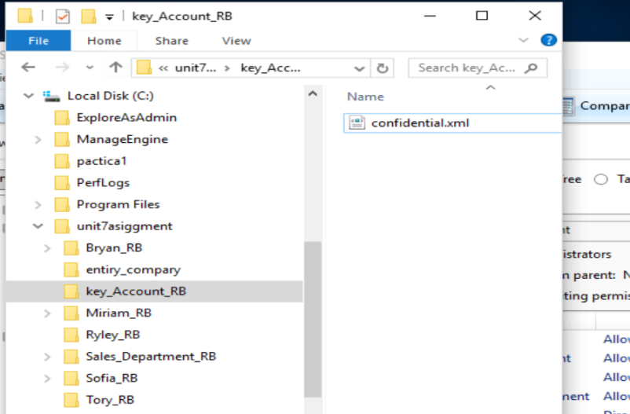

**Permissions**

**Root folder**

Disabling inheritance to remove users and authenticated. Adding sales and training with only read permission to access to this folder. Users cannot rename or delete root folder.

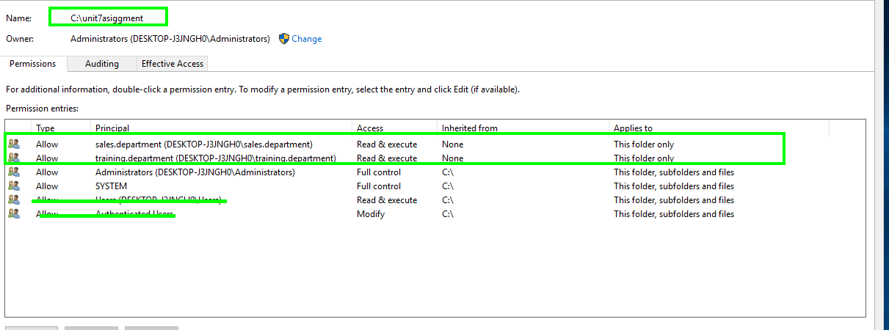

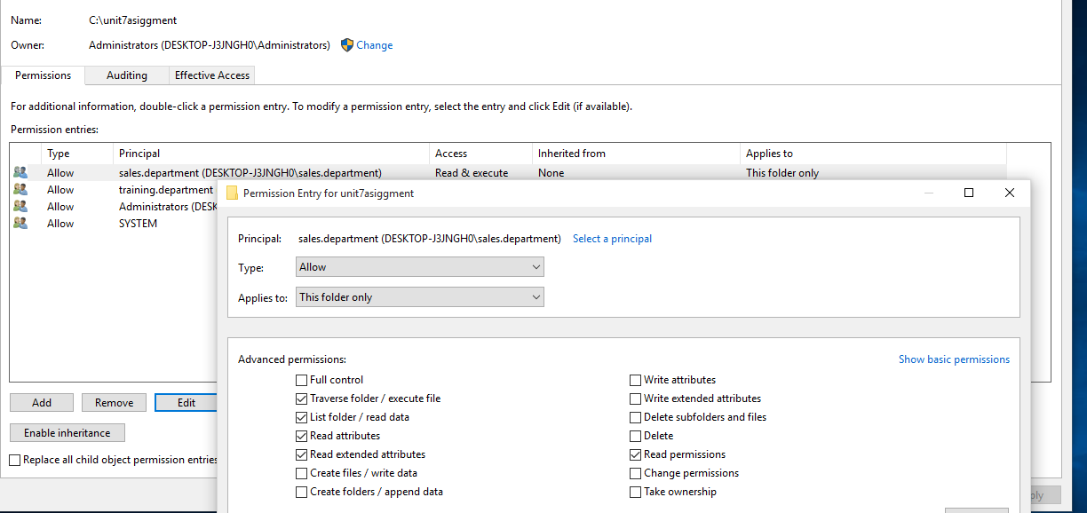

**Personal_folder for each user**

* A personal folder for each user, where only the corresponding user can do everything except change permissions and take ownership. This folder will be different from the default Windows profile folder.

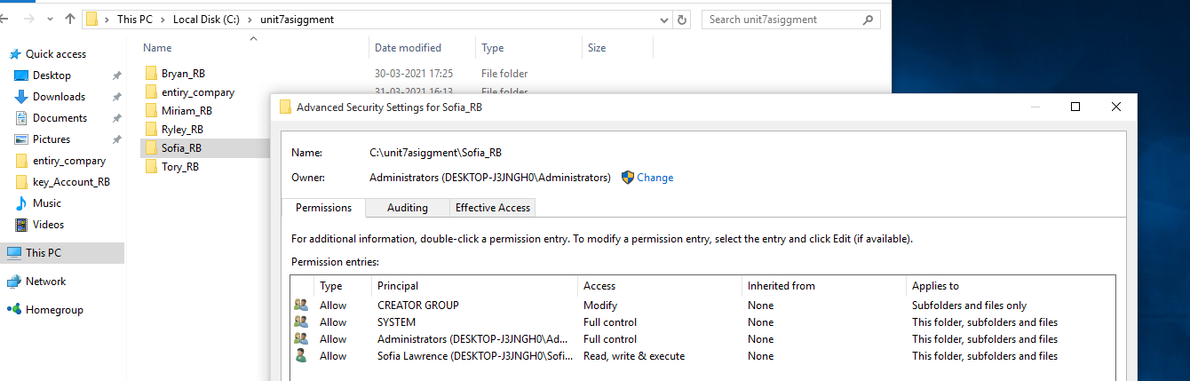

**entery_company folder**

* A folder for the entire company, where everybody can copy or create files, but only Ryley can delete them.

Although users can create and copy files, they cannot delete (delete *sensu stricto* or renamed). They can copy files from their directories into entery_company (create) and copy and paste files inside entery_company. Users cannot rename or delete entery_company folder.

Although Ryley belong to administrators group but it should be given modify permission .

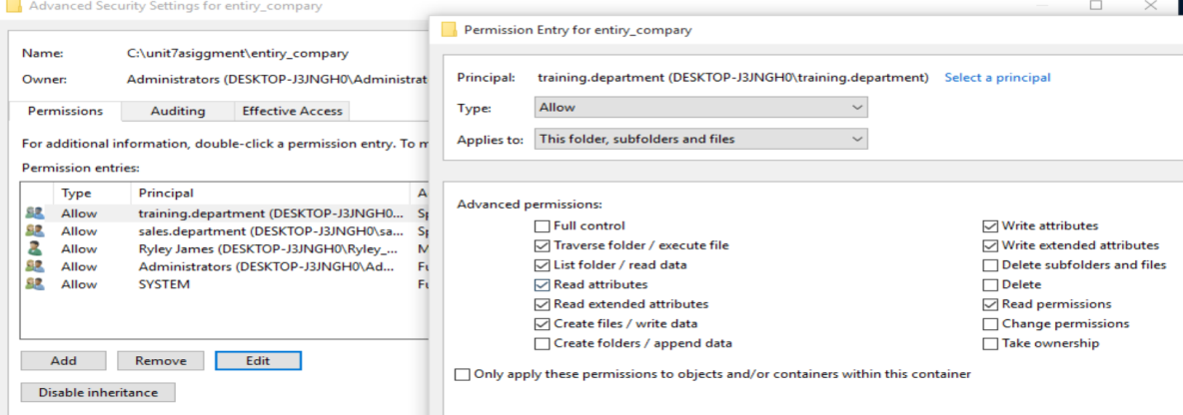

**Sales_department**

* A folder for the sales department into the folder for the entire company, where the employees from this department only have read permissions, while the other employees cannot see the content. Complete this part disabling the inheritance.

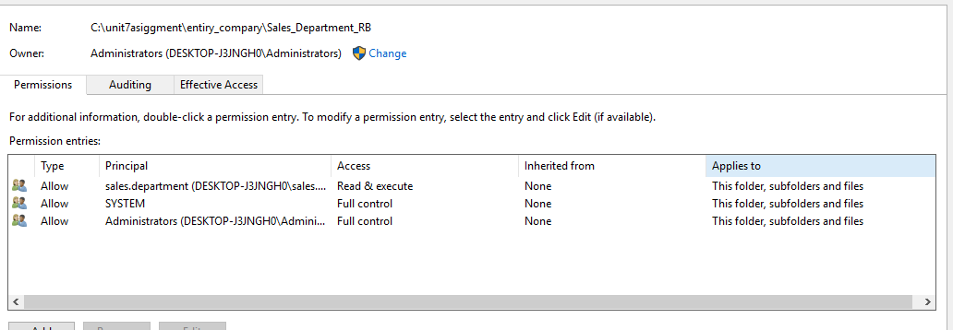

**Key_accounts**

* A folder named “Key accounts” into the folder for the entire company, where the employees from the sales department are able to copy files, while the other departments will only have read permission. Ryley will inherit the permissions from the parent folder. However, Miriam cannot access this folder because she is always in trouble. Explain how to complete this part with inheritance and disabling inheritance. Then, decide the most efficient.

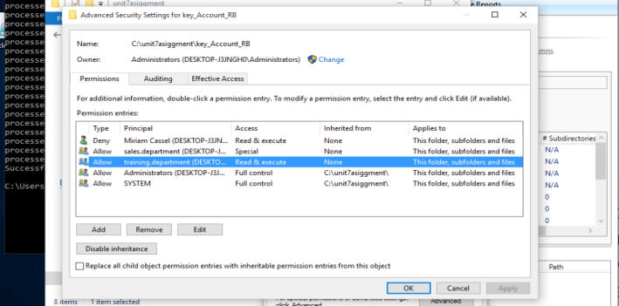

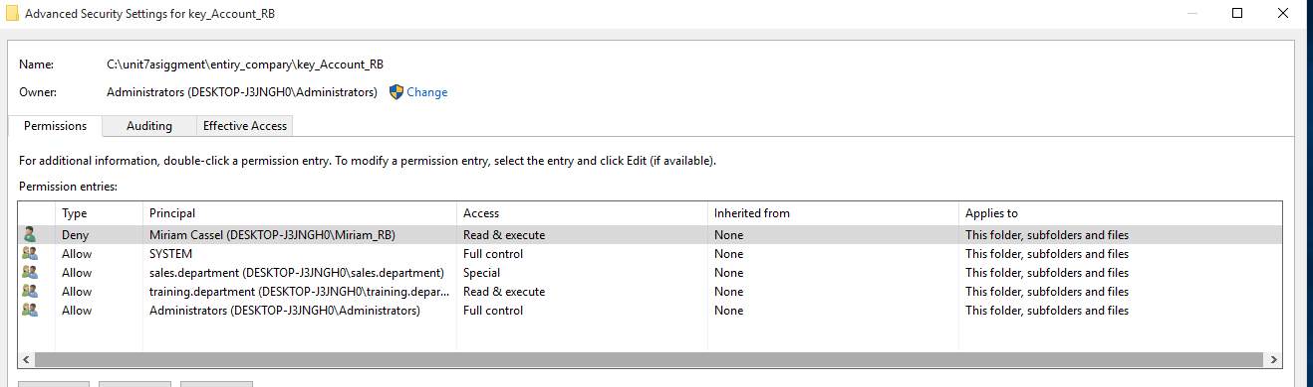

Sales.department users can create files and copy files, although they cannot rename files,

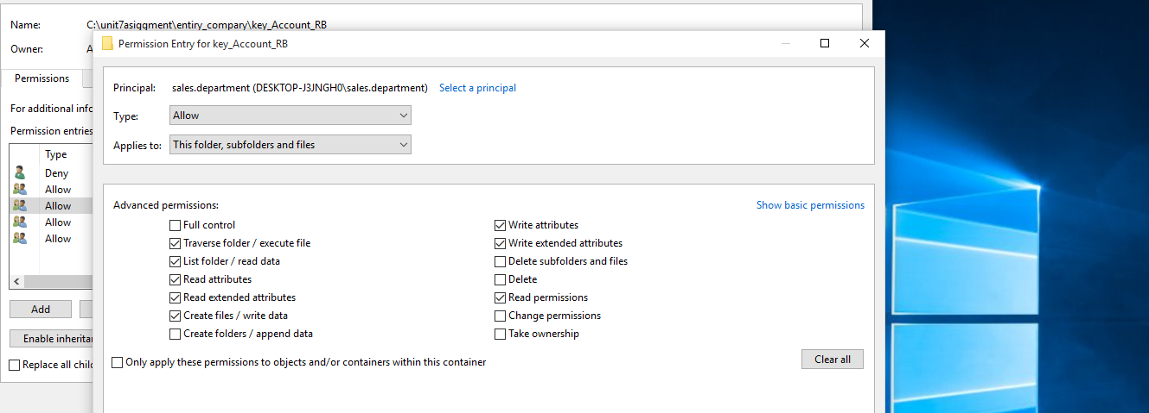

Training.department users only can read

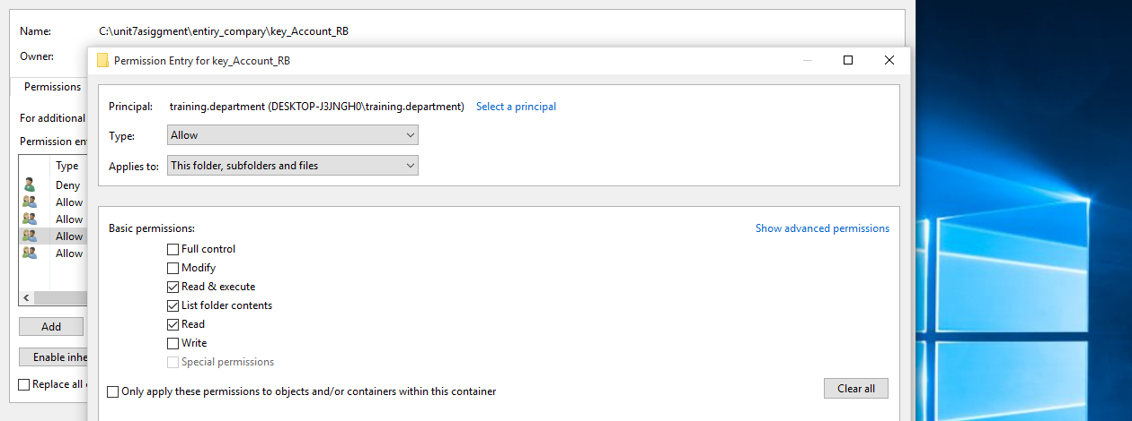

**Miriam**

Denying Miriam reading this folder, subfolders and files (maybe it is enough only applying this permission to this folder).

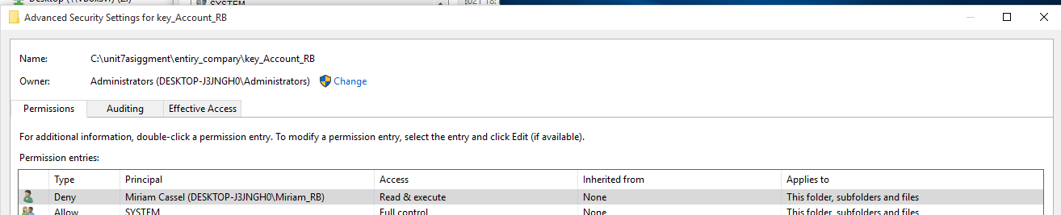

**confidentia l. xlsx**

In the folder “Key a ccounts” that the training department employees cannot access, while the permissions for the sales department will be the same as in the “Key accounts” folder. Complete this part with the inheritance options you consider more efficient.

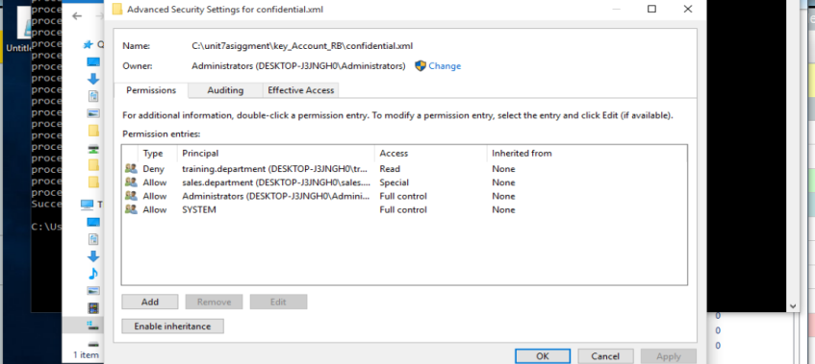

**Saving and Formatting ACLS**

**Save ACLs to a file:**

icacls c:\unit7asiggment /save unit7assignament_N_perms.txt /t /c

**Restore ACLs from a file:**

icacls c: /restore unit7assignament_N_perms.txt /t /c

**Print ACL to a file .csv**

Allowing run scripts in power shell isa

Set-ExecutionPolicy RemoteSigned

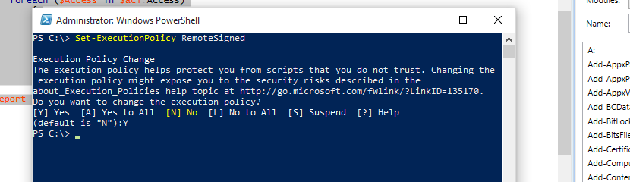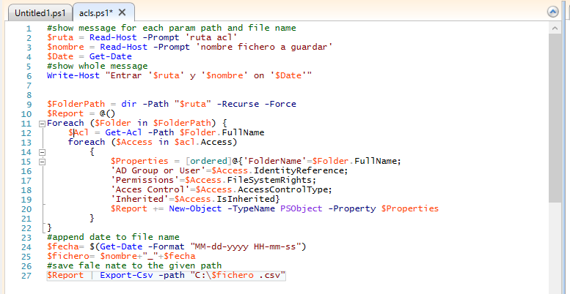

Script to get the ACL of the directory tree

#show message for each param path and file name

$ruta = Read-Host -Prompt 'ruta acl'

$nombre = Read-Host -Prompt 'nombre fichero a guardar'

$Date = Get-Date

#show whole message

Write-Host "Entrar '$ruta' y '$nombre' on '$Date'"

$FolderPath = dir -Path "$ruta" -Recurse -Force

$Report = @()

Foreach ($Folder in $FolderPath) {

$Acl = Get-Acl -Path $Folder.FullName

foreach ($Access in $acl.Access)

{

$Properties = [ordered]@{'FolderName'=$Folder.FullName;

'AD Group or User'=$Access.IdentityReference;

'Permissions'=$Access.FileSystemRights;

'Acces Control'=$Access.AccessControlType;

'Inherited'=$Access.IsInherited}

$Report += New-Object -TypeName PSObject -Property $Properties

}

}

#append date to file name

$fecha= $(Get-Date -Format "MM-dd-yyyy HH-mm-ss")

$fichero= $nombre+"_"+$fecha

#save fale nate to the given path

$Report | Export-Csv -path "C:\$fichero .csv"

**References**

<https://petri.com/list_all_users_and_groups_in_domain>

<https://social.technet.microsoft.com/Forums/ie/en-US/0e2347e4-15ba-449f-b119-4d1bb836f717/powershell-getacl-formatting?forum=winservergen>

<https://social.technet.microsoft.com/Forums/en-US/4375ba22-e758-42f9-a7ec-7f2abfaa2574/using-getacl-to-view-the-advanced-permissions-of-as-folder?forum=ITCG>

<https://tecadmin.net/powershell-running-scripts-is-disabled-system/>

<http://woshub.com/how-to-backup-and-restore-ntfs-permissions-using-icacls/>

**ANEXE I**

|  |  |  |  |  |
| --- | --- | --- | --- | --- |
| **FolderName** | **AD Group or User** | **AC** | **Permissions** | **Inh** |
| C:\unit7asiggment\Bryan_RB | CREATOR GROUP | Allow | Modify, Synchronize | False |
| C:\unit7asiggment\Bryan_RB | NT AUTHORITY\SYSTEM | Allow | FullControl | False |
| C:\unit7asiggment\Bryan_RB | BUILTIN\Administrators | Allow | FullControl | False |
| C:\unit7asiggment\Bryan_RB | DESKTOP-J3JNGH0\Bryan_RB | Allow | Write, ReadAndExecute, Synchronize | False |
| C:\unit7asiggment\Miriam_RB | CREATOR GROUP | Allow | Modify, Synchronize | False |
| C:\unit7asiggment\Miriam_RB | NT AUTHORITY\SYSTEM | Allow | FullControl | False |
| C:\unit7asiggment\Miriam_RB | BUILTIN\Administrators | Allow | FullControl | False |
| C:\unit7asiggment\Miriam_RB | DESKTOP-J3JNGH0\Miriam_RB | Allow | Write, ReadAndExecute, Synchronize | False |
| C:\unit7asiggment\Ryley_RB | CREATOR GROUP | Allow | Modify, Synchronize | False |
| C:\unit7asiggment\Ryley_RB | NT AUTHORITY\SYSTEM | Allow | FullControl | False |
| C:\unit7asiggment\Ryley_RB | BUILTIN\Administrators | Allow | FullControl | False |
| C:\unit7asiggment\Ryley_RB | DESKTOP-J3JNGH0\Ryley_RB | Allow | Write, ReadAndExecute, Synchronize | False |
| C:\unit7asiggment\Sofia_RB | CREATOR GROUP | Allow | Modify, Synchronize | False |
| C:\unit7asiggment\Sofia_RB | NT AUTHORITY\SYSTEM | Allow | FullControl | False |
| C:\unit7asiggment\Sofia_RB | BUILTIN\Administrators | Allow | FullControl | False |
| C:\unit7asiggment\Sofia_RB | DESKTOP-J3JNGH0\Sofia_RB | Allow | Write, ReadAndExecute, Synchronize | False |
| C:\unit7asiggment\Tory_RB | CREATOR GROUP | Allow | Modify, Synchronize | False |
| C:\unit7asiggment\Tory_RB | NT AUTHORITY\SYSTEM | Allow | FullControl | False |
| C:\unit7asiggment\Tory_RB | BUILTIN\Administrators | Allow | FullControl | False |
| C:\unit7asiggment\Tory_RB | DESKTOP-J3JNGH0\Tory_RB | Allow | Write, ReadAndExecute, Synchronize | False |
| C:\unit7asiggment\entiry_compary | DESKTOP-J3JNGH0\Ryley_RB | Allow | Modify, Synchronize | False |
| C:\unit7asiggment\entiry_compary | DESKTOP-J3JNGH0\sales.department | Allow | CreateFiles, WriteExtendedAttributes, WriteAttributes, ReadAndExecute, Synchronize | False |
| C:\unit7asiggment\entiry_compary | DESKTOP-J3JNGH0\training.department | Allow | CreateFiles, WriteExtendedAttributes, WriteAttributes, ReadAndExecute, Synchronize | False |
| C:\unit7asiggment\entiry_compary | BUILTIN\Administrators | Allow | FullControl | True |
| C:\unit7asiggment\entiry_compary | NT AUTHORITY\SYSTEM | Allow | FullControl | True |
| C:\unit7asiggment\Sales_Department_RB | NT AUTHORITY\SYSTEM | Allow | FullControl | False |
| C:\unit7asiggment\Sales_Department_RB | BUILTIN\Administrators | Allow | FullControl | False |
| C:\unit7asiggment\Sales_Department_RB | DESKTOP-J3JNGH0\sales.department | Allow | ReadAndExecute, Synchronize | False |
| C:\unit7asiggment\key_Account_RB | DESKTOP-J3JNGH0\Miriam_RB | Deny | ReadAndExecute | False |
| C:\unit7asiggment\key_Account_RB | DESKTOP-J3JNGH0\sales.department | Allow | CreateFiles, WriteExtendedAttributes, WriteAttributes, ReadAndExecute, Synchronize | False |
| C:\unit7asiggment\key_Account_RB | DESKTOP-J3JNGH0\training.department | Allow | ReadAndExecute, Synchronize | False |
| C:\unit7asiggment\key_Account_RB | BUILTIN\Administrators | Allow | FullControl | True |
| C:\unit7asiggment\key_Account_RB | NT AUTHORITY\SYSTEM | Allow | FullControl | True |
| C:\unit7asiggment\key_Account_RB\confidential.xml | DESKTOP-J3JNGH0\training.department | Deny | Read | False |
| C:\unit7asiggment\key_Account_RB\confidential.xml | DESKTOP-J3JNGH0\Miriam_RB | Deny | ReadAndExecute | True |
| C:\unit7asiggment\key_Account_RB\confidential.xml | DESKTOP-J3JNGH0\sales.department | Allow | CreateFiles, WriteExtendedAttributes, WriteAttributes, ReadAndExecute, Synchronize | True |
| C:\unit7asiggment\key_Account_RB\confidential.xml | DESKTOP-J3JNGH0\training.department | Allow | ReadAndExecute, Synchronize | True |
| C:\unit7asiggment\key_Account_RB\confidential.xml | BUILTIN\Administrators | Allow | FullControl | True |
| C:\unit7asiggment\key_Account_RB\confidential.xml | NT AUTHORITY\SYSTEM | Allow | FullControl | True |