**STATEMENT**

**Setting Virtual Box**

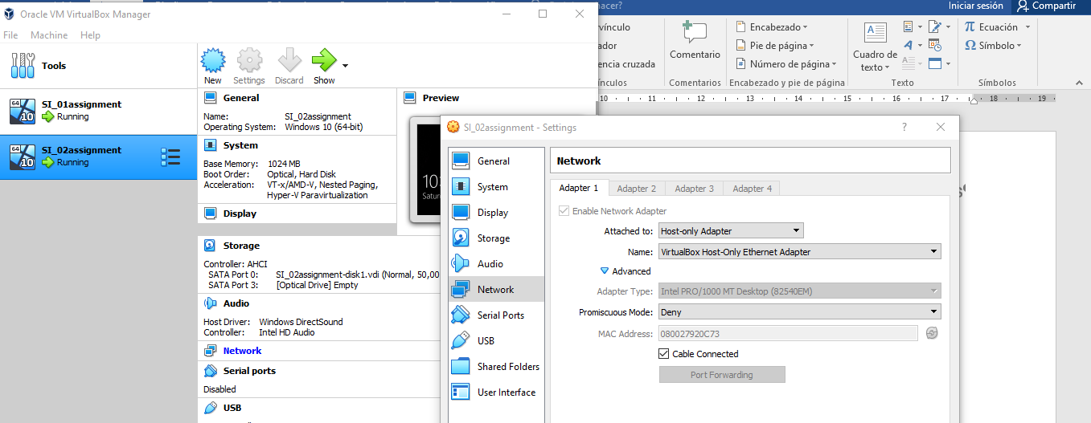

**Setting the shared folder called “Company” at SI_assignment vm (server role).**

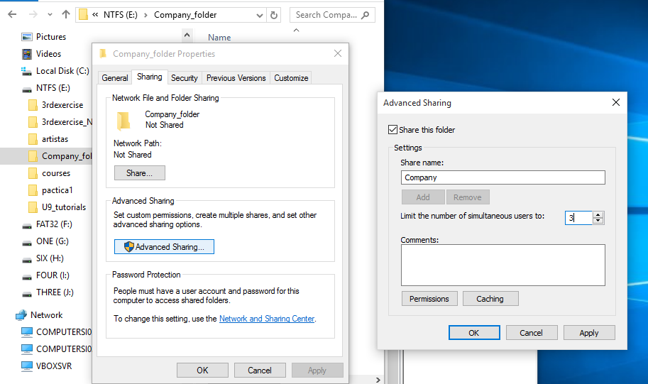

**Creation a group called “IT”, whose only member so far is “IT_admin”.**

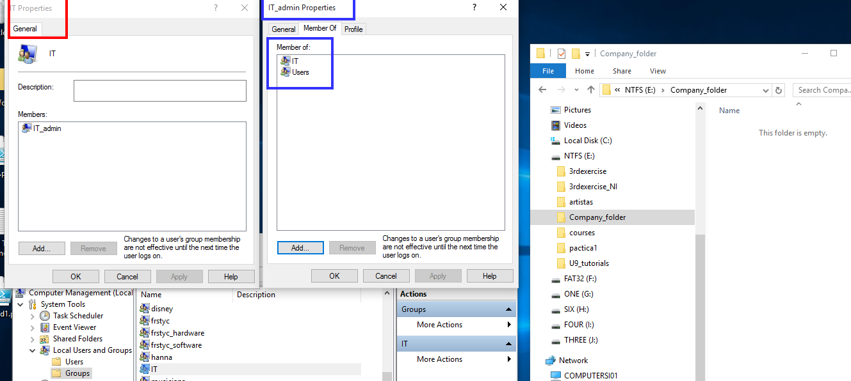

**Setting local permissions follow the criteria:**

* **Administrators will have “Full Control”.**
* **There will also be an “administrator user” called “IT_admin” with “Full Control” permissions.**
* **There will be a group called “IT” capable of creating files and folders, but not deleting them.**

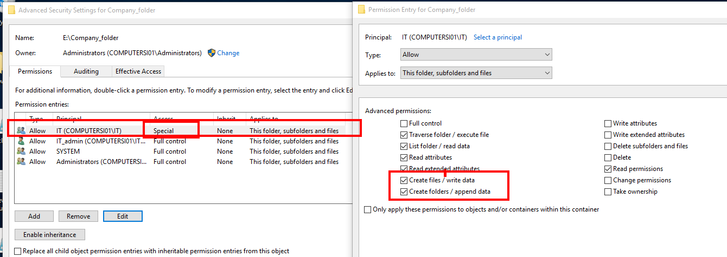

**Setting sharing permissions follow the criteria:**

**The folder “Company” will be shared with for IT and IT_admin. The shared permissions will be the following ones:**

* Setting **“IT” shared network permission at minimum to preserve local permissions.**

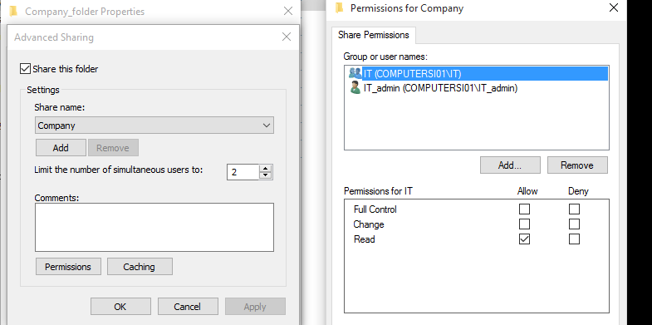

* Setting “IT_admin” network shared permission equivalent permissions to the local “Modify.

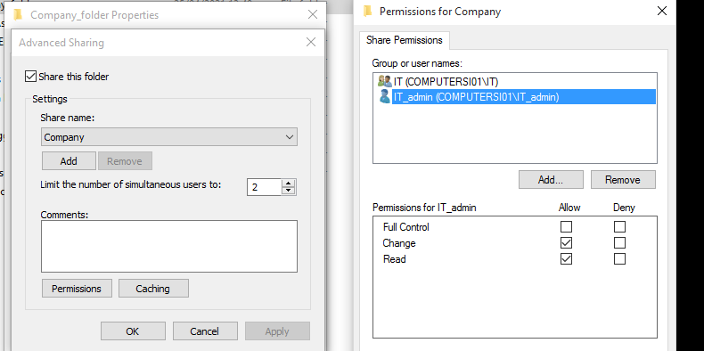

* Adding every to allow access to the share resource a user without account. These type of users will have “Read “permissions (however, these users cannot access the folder because local ntfs permissions)

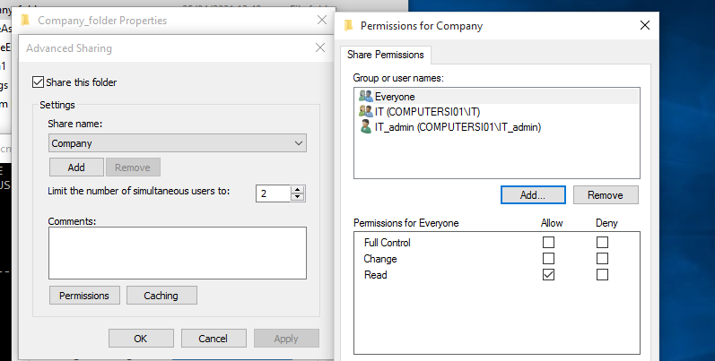

**Turning off password protected sharing to allow users without account access to shared resources.**

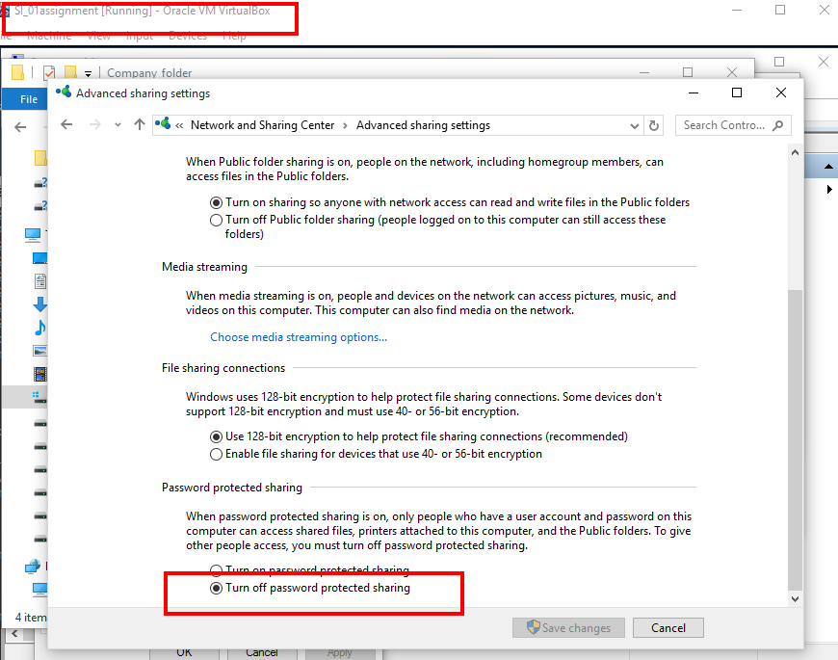

**Steps to demonstrate that everyone can show Company, although they cannot access because nets permissions.**

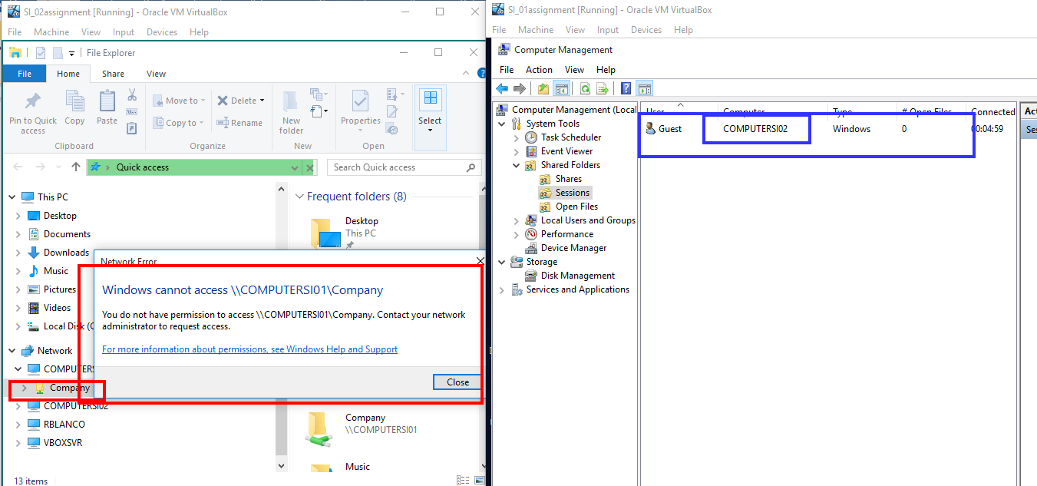

**Steps to demonstrate that The user “IT_admin” can access the shared folder Company and he can modify the content.**

* **The user “IT_admin”.**

**First of all, refresh net and delete all shared resources in server (management console and command line close sessions) and client**

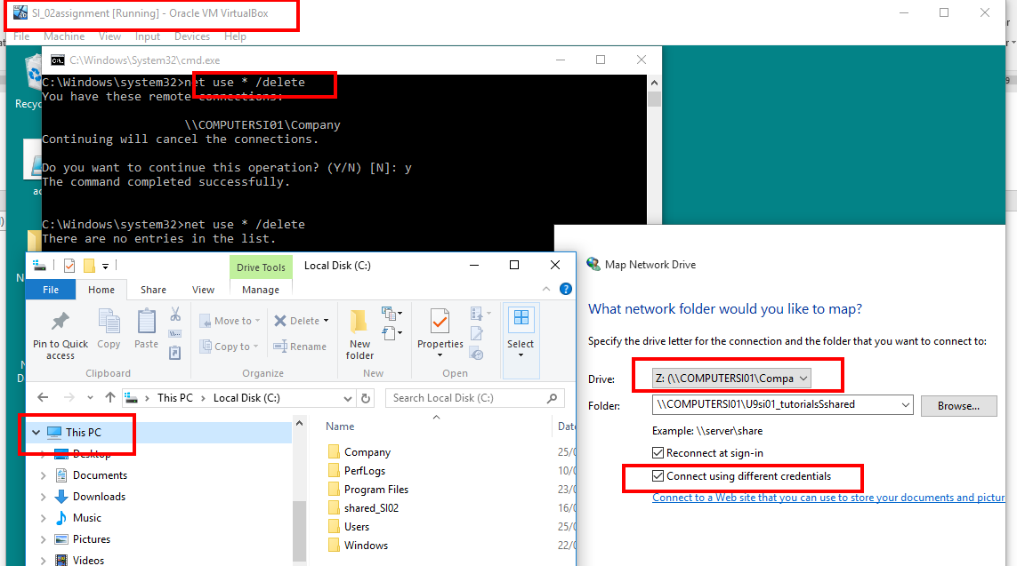

**Second, map the network resource selecting connect using different credentials.**

