**Unit 5: Exercise to practise. Create a new repository using the local Git and complete the following parts:**

Create the corresponding repository on GitHub and add the remote to the local one.

Create two branches Unit-1 and Unit-2 from the empty master/main branch.

Upload a different file for each branch. Then, push the changes to GitHub.

Checkout Unit-1 and update the same line of one file both from the local and remote repository. Solve the conflicts.

Merge the branches Unit-1 and Unit-2 to master/main.

**Create the corresponding repository on GitHub and add the remote to the local one.**

Create a directory and go into it.

zeus@zeus-VirtualBox:~/Documents/GitHub/InformationSystems$ mkdir InformationSystems

zeus@zeus-VirtualBox:~/Documents/GitHub/InformationSystems$ cd InformationSystems

Create an empty repository.

zeus@zeus-VirtualBox:~/Documents/GitHub/InformationSystems$ git init

Initialized empty Git repository in /home/zeus/Documents/GitHub/InformationSystems/.git/

Global settings. Add some SVN-like aliases

zeus@zeus-VirtualBox:~/Documents/GitHub/InformationSystems$ git config --global alias.st status && git config --global alias.co checkout && git config --global alias.br branch && git config --global alias.up rebase && git config --global alias.ci commit

zeus@zeus-VirtualBox:~/Documents/GitHub/InformationSystems$ git config --global --list

filter.lfs.clean=git-lfs clean -- %f

filter.lfs.smudge=git-lfs smudge -- %f

filter.lfs.process=git-lfs filter-process

filter.lfs.required=true

user.name=raimundo.blanco

user.email=raimbp@gmail.com

credential.helper=store

core.editor=nano

alias.st=status

alias.co=checkout

alias.br=branch

alias.up=rebase

alias.ci=commit

# git config --global --unset user.mail “” to unset

# git config --global –edit to manually edit the configuration

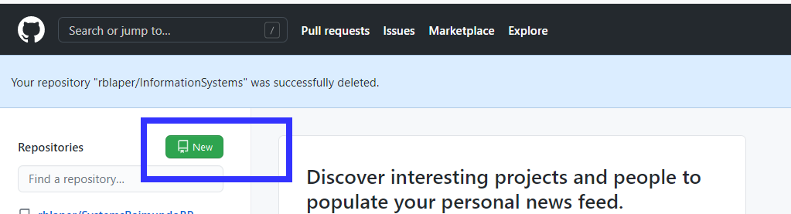

zeus@zeus-VirtualBox:~/Documents/GitHub/InformationSystems$ git remote add origin https://github.com/rblaper/InformationSystems.git

git remote set-url origin [repo-url] # to edit an existing remote

git remote –v # check existing remotes

zeus@zeus-VirtualBox:~/Documents/GitHub/InformationSystems$ git config --get remote.origin.url

<https://github.com/rblaper/InformationSystems.git>

zeus@zeus-VirtualBox:~/Documents/GitHub/InformationSystems$ git branch

zeus@zeus-VirtualBox:~/Documents/GitHub/InformationSystems$ git status

On branch master

No commits yet

nothing to commit (create/copy files and use "git add" to track)

zeus@zeus-VirtualBox:~/Documents/GitHub/InformationSystems$ git log

fatal: your current branch 'master' does not have any commits yet

zeus@zeus-VirtualBox:~/Documents/GitHub/InformationSystems$ nano readme.text

zeus@zeus-VirtualBox:~/Documents/GitHub/InformationSystems$ git status

On branch master

No commits yet

Untracked files:

(use "git add <file>..." to include in what will be committed)

readme.text

nothing added to commit but untracked files present (use "git add" to track)

zeus@zeus-VirtualBox:~/Documents/GitHub/InformationSystems$ git add readme.text

zeus@zeus-VirtualBox:~/Documents/GitHub/InformationSystems$ git status

On branch master

No commits yet

Changes to be committed:

(use "git rm --cached <file>..." to unstage)

new file: readme.text

zeus@zeus-VirtualBox:~/Documents/GitHub/InformationSystems$ git commit -m "Initial commit"

[master (root-commit) 6b839c0] Initial commit

1 file changed, 9 insertions(+)

create mode 100644 readme.text

zeus@zeus-VirtualBox:~/Documents/GitHub/InformationSystems$ git log

commit 6b839c0e17868d6d96c909b96f4c0b7e2a3b5c83 (HEAD -> master)

Author: raimundo.blanco <raimbp@gmail.com>

Date: Tue Dec 22 19:59:59 2020 +0100

Initial commit

**Rename branch for avoiding conflicts o synchronising**

zeus@zeus-VirtualBox:~/Documents/GitHub/InformationSystems$ git branch -M main

zeus@zeus-VirtualBox:~/Documents/GitHub/InformationSystems$ git branch

*main

**Create two branches Unit-1 and Unit-2 from the empty master/main branch.**

**Upload a different file for each branch. Then, push the changes to GitHub.**

zeus@zeus-VirtualBox:~/Documents/GitHub/InformationSystems$ git branch Unit-1

zeus@zeus-VirtualBox:~/Documents/GitHub/InformationSystems$ git branch

Unit-1

*main

zeus@zeus-VirtualBox:~/Documents/GitHub/InformationSystems$ git checkout Unit-1

Switched to branch 'Unit-1'

zeus@zeus-VirtualBox:~/Documents/GitHub/InformationSystems$ nano readme_Unit_1.text

zeus@zeus-VirtualBox:~/Documents/GitHub/InformationSystems$ ls -l

total 4

-rw-rw-r-- 1 zeus zeus 523 dic 22 19:56 readme.text

-rw-rw-r-- 1 zeus zeus 0 dic 22 20:35 readme_Unit_1.text

zeus@zeus-VirtualBox:~/Documents/GitHub/InformationSystems$ git status

On branch Unit-1

Untracked files:

(use "git add <file>..." to include in what will be committed)

readme_Unit_1.text

nothing added to commit but untracked files present (use "git add" to track)

zeus@zeus-VirtualBox:~/Documents/GitHub/InformationSystems$ git commit -m "Unit-1 file creation"

[Unit-1 531c920] Unit-1 file creation

1 file changed, 1 insertion(+)

create mode 100644 readme_Unit_1.text

git zeus@zeus-VirtualBox:~/Documents/GitHub/InformationSystems$ git log --oneline

531c920 (HEAD -> Unit-1) Unit-1 file creation

6b839c0 (main) Initial commit

zeus@zeus-VirtualBox:~/Documents/GitHub/InformationSystems$ git status

On branch Unit-1

nothing to commit, working tree clean

zeus@zeus-VirtualBox:~/Documents/GitHub/InformationSystems$ git branch

* Unit-1

Main

zeus@zeus-VirtualBox:~/Documents/GitHub/InformationSystems$ git checkout main

Switched to branch 'main'

zeus@zeus-VirtualBox:~/Documents/GitHub/InformationSystems$ git checkout -b Unit-2

Switched to a new branch 'Unit-2'

zeus@zeus-VirtualBox:~/Documents/GitHub/InformationSystems$ ls -l

total 4

-rw-rw-r-- 1 zeus zeus 523 dic 22 19:56 readme.text

zeus@zeus-VirtualBox:~/Documents/GitHub/InformationSystems$ git branch

Unit-1

* Unit-2

Main

zeus@zeus-VirtualBox:~/Documents/GitHub/InformationSystems$ nano readme_Unit_2.text

zeus@zeus-VirtualBox:~/Documents/GitHub/InformationSystems$ git log

commit 6b839c0e17868d6d96c909b96f4c0b7e2a3b5c83 (HEAD -> Unit-2, main)

Author: raimundo.blanco <raimbp@gmail.com>

Date: Tue Dec 22 19:59:59 2020 +0100

Initial commit

zeus@zeus-VirtualBox:~/Documents/GitHub/InformationSystems$ git status

On branch Unit-2

Untracked files:

(use "git add <file>..." to include in what will be committed)

**readme_Unit_2.text**

nothing added to commit but untracked files present (use "git add" to track)

zeus@zeus-VirtualBox:~/Documents/GitHub/InformationSystems$ git add readme_Unit_2.text

zeus@zeus-VirtualBox:~/Documents/GitHub/InformationSystems$ git commit -m "Unit-2 file creation"

[Unit-2 f1f80e3] Unit-2 file creation

1 file changed, 2 insertions(+)

create mode 100644 readme_Unit_2.text

zeus@zeus-VirtualBox:~/Documents/GitHub/InformationSystems$ git log

commit f1f80e3adfcc756721a46fdec2fbb94cc8742edc (HEAD -> Unit-2)

Author: raimundo.blanco <raimbp@gmail.com>

Date: Tue Dec 22 21:38:49 2020 +0100

Unit-2 file creation

commit 6b839c0e17868d6d96c909b96f4c0b7e2a3b5c83 (main)

Author: raimundo.blanco <raimbp@gmail.com>

Date: Tue Dec 22 19:59:59 2020 +0100

Initial commit

zeus@zeus-VirtualBox:~/Documents/GitHub/InformationSystems$ git log

commit f1f80e3adfcc756721a46fdec2fbb94cc8742edc (HEAD -> Unit-2)

Author: raimundo.blanco <raimbp@gmail.com>

Date: Tue Dec 22 21:38:49 2020 +0100

Unit-2 file creation

commit 6b839c0e17868d6d96c909b96f4c0b7e2a3b5c83 (main)

Author: raimundo.blanco <raimbp@gmail.com>

Date: Tue Dec 22 19:59:59 2020 +0100

Initial commit

zeus@zeus-VirtualBox:~/Documents/GitHub/InformationSystems$ git checkout Unit-1

Switched to branch 'Unit-1'

zeus@zeus-VirtualBox:~/Documents/GitHub/InformationSystems$ git log

commit 531c9207f904efc60276b397342e143ca97eb639 (HEAD -> Unit-1)

Author: raimundo.blanco <raimbp@gmail.com>

Date: Tue Dec 22 20:46:41 2020 +0100

Unit-1 file creation

commit 6b839c0e17868d6d96c909b96f4c0b7e2a3b5c83 (main)

Author: raimundo.blanco <raimbp@gmail.com>

Date: Tue Dec 22 19:59:59 2020 +0100

Initial commit

zeus@zeus-VirtualBox:~/Documents/GitHub/InformationSystems$ git checkout main

Switched to branch 'main'

zeus@zeus-VirtualBox:~/Documents/GitHub/InformationSystems$ git log

commit 6b839c0e17868d6d96c909b96f4c0b7e2a3b5c83 (HEAD -> main)

Author: raimundo.blanco <raimbp@gmail.com>

Date: Tue Dec 22 19:59:59 2020 +0100

Initial commit

zeus@zeus-VirtualBox:~/Documents/GitHub/InformationSystems$

**Updating the branch main on the remote repository**

zeus@zeus-VirtualBox:~/Documents/GitHub/InformationSystems$ git push -u origin main

Username for 'https://github.com': rblaper

Password for 'https://rblaper@github.com':

Enumerating objects: 3, done.

Counting objects: 100% (3/3), done.

Compressing objects: 100% (2/2), done.

Writing objects: 100% (3/3), 483 bytes | 241.00 KiB/s, done.

Total 3 (delta 0), reused 0 (delta 0)

To https://github.com/rblaper/InformationSystems.git

* [new branch] main -> main

Branch 'main' set up to track remote branch 'main' from 'origin'.

Increasing login time

zeus@zeus-VirtualBox:~/Documents/GitHub/InformationSystems$ git config --global credential.helper 'cache --timeout=3600'

Updating Branch Unit-2 on the remote repository

zeus@zeus-VirtualBox:~/Documents/GitHub/InformationSystems$ git push -u origin Unit-1

Username for 'https://github.com': rblaper

Password for 'https://rblaper@github.com':

Enumerating objects: 4, done.

Counting objects: 100% (4/4), done.

Compressing objects: 100% (2/2), done.

Writing objects: 100% (3/3), 299 bytes | 299.00 KiB/s, done.

Total 3 (delta 0), reused 0 (delta 0)

remote:

remote: Create a pull request for 'Unit-1' on GitHub by visiting:

remote: https://github.com/rblaper/InformationSystems/pull/new/Unit-1

remote:

To https://github.com/rblaper/InformationSystems.git

* [new branch] Unit-1 -> Unit-1

Branch 'Unit-1' set up to track remote branch 'Unit-1' from 'origin'.

Updating Branch Unit-2 on the remote repository

zeus@zeus-VirtualBox:~/Documents/GitHub/InformationSystems$ git push -u origin Unit-2

Enumerating objects: 4, done.

Counting objects: 100% (4/4), done.

Compressing objects: 100% (2/2), done.

Writing objects: 100% (3/3), 310 bytes | 310.00 KiB/s, done.

Total 3 (delta 0), reused 0 (delta 0)

remote:

remote: Create a pull request for 'Unit-2' on GitHub by visiting:

remote: https://github.com/rblaper/InformationSystems/pull/new/Unit-2

remote:

To https://github.com/rblaper/InformationSystems.git

* [new branch] Unit-2 -> Unit-2

Branch 'Unit-2' set up to track remote branch 'Unit-2' from 'origin'.

zeus@zeus-VirtualBox:~/Documents/GitHub/InformationSystems$ git log Unit-1

commit 531c9207f904efc60276b397342e143ca97eb639 (HEAD -> Unit-1, origin/Unit-1)

Author: raimundo.blanco <raimbp@gmail.com>

Date: Tue Dec 22 20:46:41 2020 +0100

Unit-1 file creation

commit 6b839c0e17868d6d96c909b96f4c0b7e2a3b5c83 (origin/main, main)

Author: raimundo.blanco <raimbp@gmail.com>

Date: Tue Dec 22 19:59:59 2020 +0100

Initial commit

zeus@zeus-VirtualBox:~/Documents/GitHub/InformationSystems$ git checkout Unit-2

Switched to branch 'Unit-2'

Your branch is up to date with 'origin/Unit-2'.

zeus@zeus-VirtualBox:~/Documents/GitHub/InformationSystems$ git log Unit-2

commit f1f80e3adfcc756721a46fdec2fbb94cc8742edc (HEAD -> Unit-2, origin/Unit-2)

Author: raimundo.blanco <raimbp@gmail.com>

Date: Tue Dec 22 21:38:49 2020 +0100

Unit-2 file creation

commit 6b839c0e17868d6d96c909b96f4c0b7e2a3b5c83 (origin/main, main)

Author: raimundo.blanco <raimbp@gmail.com>

Date: Tue Dec 22 19:59:59 2020 +0100

Initial commit

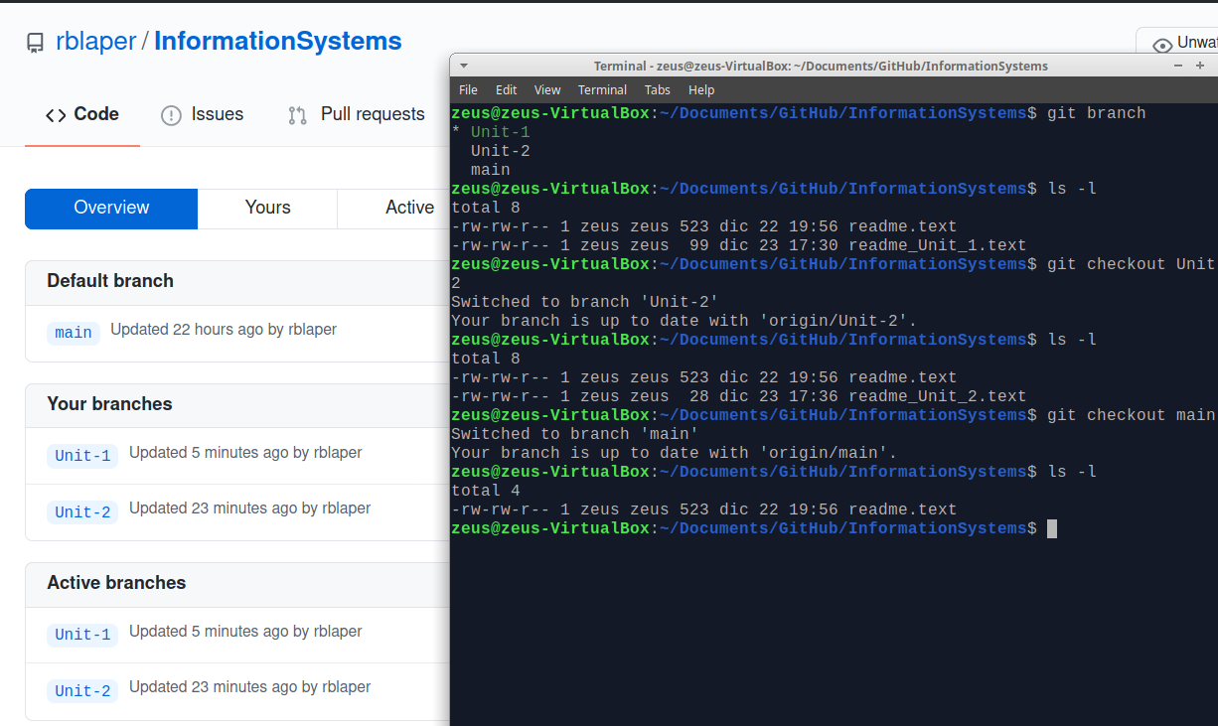

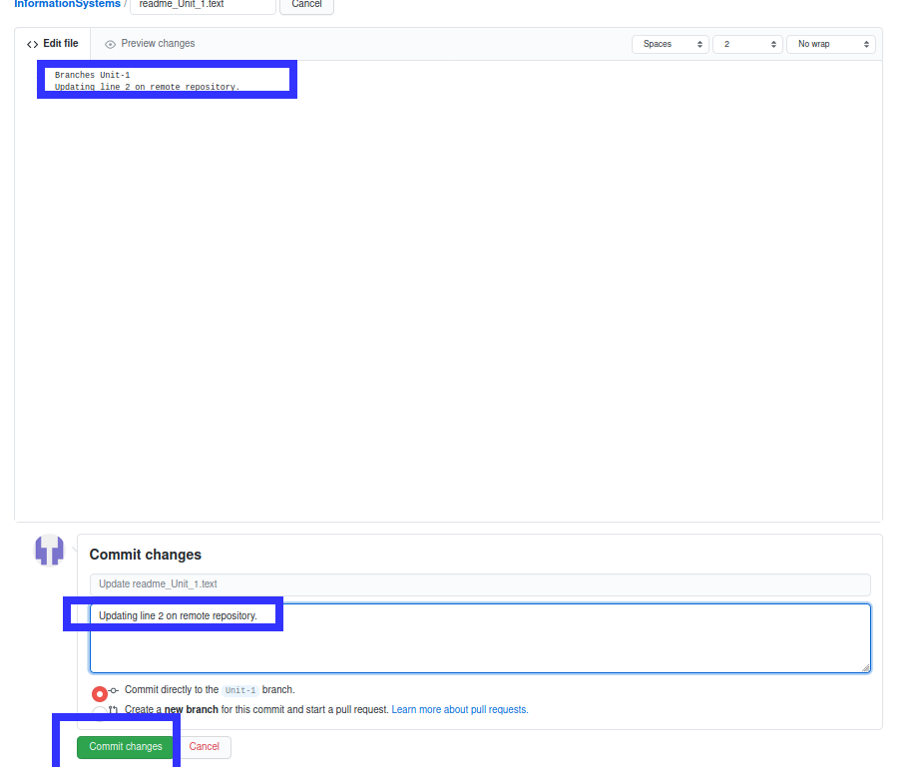

**Solving conflicts**

Editing a file at the same time on the remote and on the local repository cause conflicts.

Start editing on local

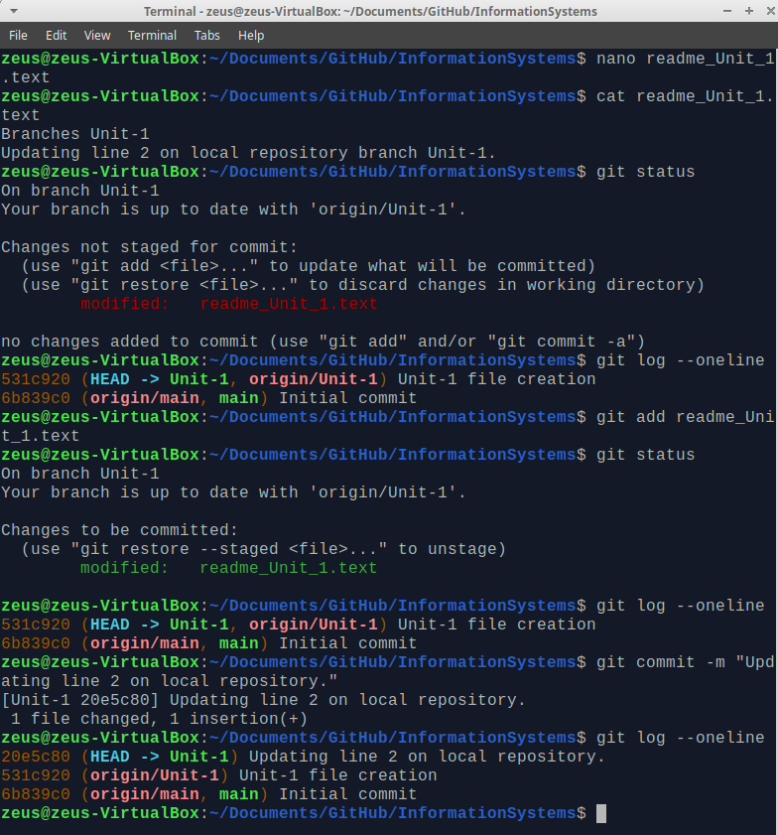

On github edit the same file.

Commit changes on both sides and then push / pull

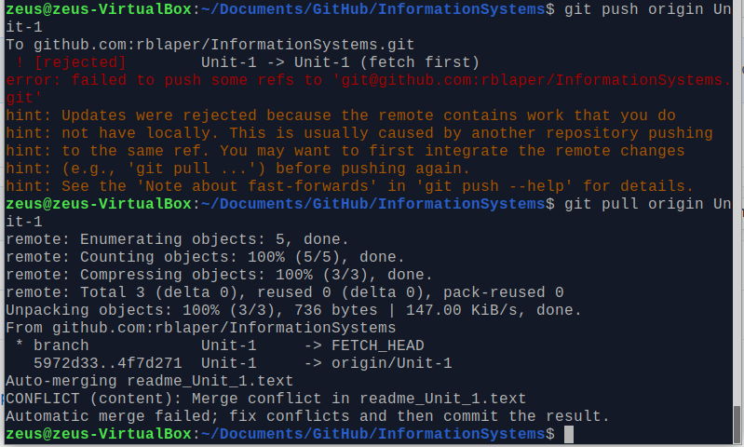

Edit the file and select the changes to be acepted

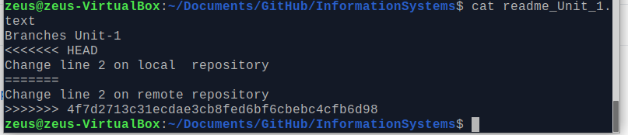

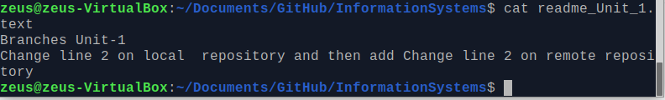

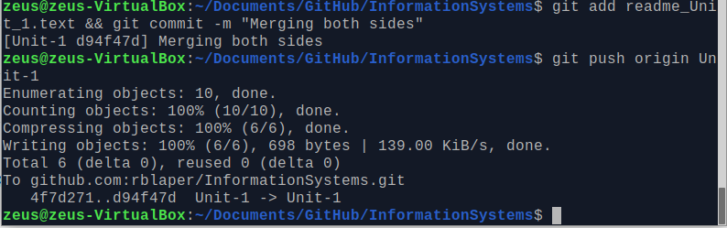

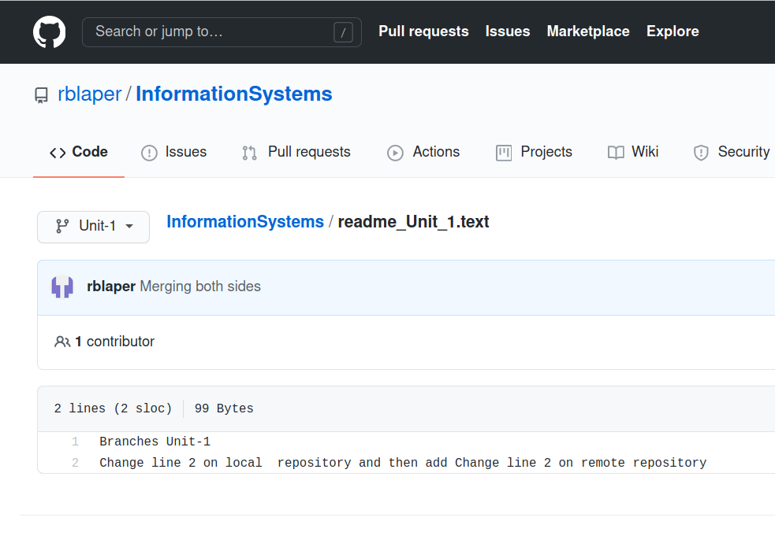

Merging Branches

zeus@zeus-VirtualBox:~/Documents/GitHub/InformationSystems$ git merge Unit-1

Updating 6b839c0..d94f47d

Fast-forward

readme_Unit_1.text | 2 ++

1 file changed, 2 insertions(+)

create mode 100644 readme_Unit_1.text

zeus@zeus-VirtualBox:~/Documents/GitHub/InformationSystems$ git push origin

Total 0 (delta 0), reused 0 (delta 0)

To github.com:rblaper/InformationSystems.git

6b839c0..d94f47d main -> main

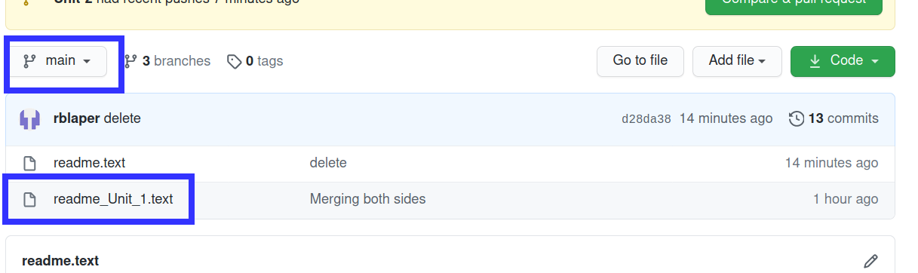

zeus@zeus-VirtualBox:~/Documents/GitHub/InformationSystems$ mkdir Unit_2/

zeus@zeus-VirtualBox:~/Documents/GitHub/InformationSystems$ mv readme_Unit_2.t Unit_2/

zeus@zeus-VirtualBox:~/Documents/GitHub/InformationSystems$ git branch

Unit-1

Unit-2

* main

zeus@zeus-VirtualBox:~/Documents/GitHub/InformationSystems$ git checkout Unit-2

D readme.text

Switched to branch 'Unit-2'

Your branch is up to date with 'origin/Unit-2'.

zeus@zeus-VirtualBox:~/Documents/GitHub/InformationSystems$ git add Unit_2

zeus@zeus-VirtualBox:~/Documents/GitHub/InformationSystems$ git commit -m "Unit-2 folder"

[Unit-2 53901f9] Unit-2 folder

3 files changed, 13 insertions(+)

create mode 100644 Unit_2/readme.text

create mode 100644 Unit_2/readme_Unit_2.text

zeus@zeus-VirtualBox:~/Documents/GitHub/InformationSystems$ git push origin

