**开源邮件系统postfix部署文档**

**版本：V1.0**

**运维支撑中心**

**2019年12月**

**文档信息**

|  |  |
| --- | --- |
| 文档标题 | Postfix邮件系统部署文档 |
| 版 本 号 | v1.0 |
| 版本日期 |  |
| 打印日期 |  |
| 文 件 名 | 开源邮件系统postfix部署文档 |
| 归档目录 |  |
| 提交人员 | 李紫恒 |

**审批信息**

|  |  |  |  |
| --- | --- | --- | --- |
| 姓名 | 部门/角色 | 意见 | 日期 |
|  |  |  |  |
|  |  |  |  |
|  |  |  |  |
|  |  |  |  |

**修改历史**

|  |  |  |  |
| --- | --- | --- | --- |
| 版本 | 日期 | 修改说明 | 修改人 |
|  |  |  |  |
|  |  |  |  |
|  |  |  |  |
|  |  |  |  |
|  |  |  |  |
|  |  |  |  |
|  |  |  |  |

目录

[1前期准备 3](#_Toc9058)

[1系统 3](#_Toc4346)

[2系统环境 3](#_Toc22620)

[3 创建虚拟邮件用户 4](#_Toc17770)

[2邮件服务器构建 7](#_Toc6545)

[1 cyrus-sasl 7](#_Toc23638)

[2 Postfix 8](#_Toc25293)

[3 Dovecot 9](#_Toc32195)

[3 虚拟用户配置 11](#_Toc4543)

[1 postfix配置虚拟用户 11](#_Toc5985)

[2Dovecot配置虚拟用户 14](#_Toc12588)

[3Postfixadmin配置 17](#_Toc21864)

[4邮件连接测试 26](#_Toc32459)

[5 WEB端邮件系统 29](#_Toc16271)

[1.下载roundcube webmail软件包 29](#_Toc2281)

[2.配置webmail 29](#_Toc663)

[3.安装roundcube webmail 30](#_Toc27208)

[4.测试WEB版 36](#_Toc29494)

[6 附件 37](#_Toc7637)

# 1前期准备

## 1系统

使用CentOS7.0

## 2系统环境

LAMP或LNMP皆可，本文使用apache。

安装apache mysql php 一律使用yum安装。

yum install httpd php mariadb-server

关闭防火墙，selinux

在生产环境中，基于安全策略可能并不允许关闭防火墙。但是要保证下列端口畅通

25，465，587，110，995，143，993

mysql建表建用户

先给root用户生成密码，在此不做赘述。

登录mysql

mysql -uroot -p密码

mysql>create database postfix default character set utf8 collate utf8\_bin;

mysql>grant all on postfix.\* to 'postfix'@'%' identified by 'postfix';

mysql>flush privileges;

mysql>quit

测试新用户

mysql -upostfix -ppostfix

1. Hostname

vim /etc/sysconfig/network

HOSTNAME=mail.test.com

重启机器后生效

重启完成后

hostname



## 3 创建虚拟邮件用户

为了后续的管理方便，我们使用系统的一个用户映射为对邮件服务器的用户，该用户对于postfix来说是一个虚拟用户。  
 所在在此之前，我们需要添加一个不能登录到系统的，并且指定用户组和用户ID的特殊用户vmail，该用户也可以自行定义。

groupadd -g 5000 vmail

useradd -g vmail -u 5000 -s /sbin/nologin vmail

cat /etc/passwd |grep vmail

4 构建局域网DNS

注意：如果已经在第三方上购买了域名，就不需要再在本机搭建DNS服务器了。  
 注意：如果是局域网内已经有DNS服务器了，把mail.test.net绑定即可，要绑一条A记录，一条MX记录

yum install -y bind bind-chroot

先备份

cp /etc/named.conf /etc/named.conf.20191211

vim /etc/named.conf

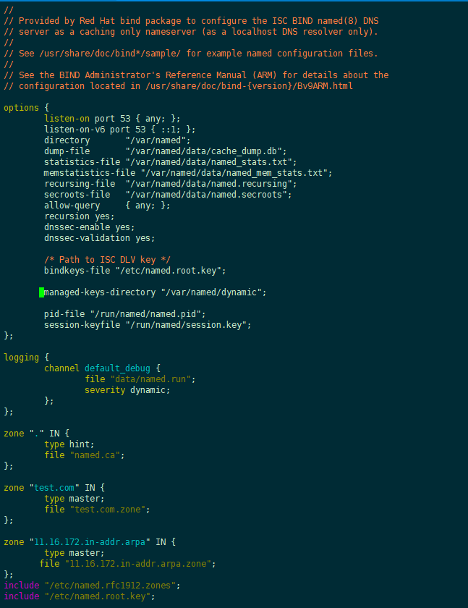

cd /var/named

cp named.localhost test.com.zone

cp named.localhost 11.16.172.in-addr.arpa.zone

vim test.com.zone

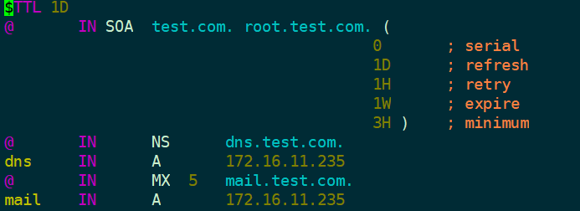

vim 11.16.172.in-addr.arpa.zone

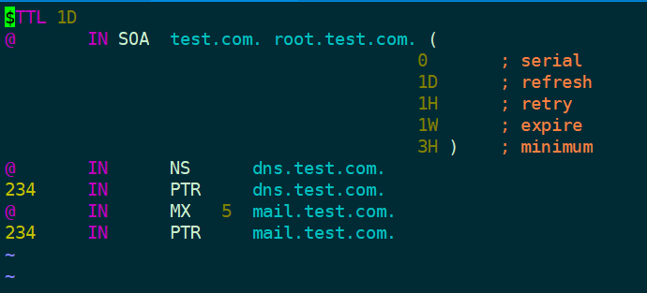

# 赋权限

chown :named test.com.zone

chown :named 11.16.172.in-addr.arpa.zone

#验证配置是否正确

named-checkconf /etc/named.conf

named-checkzone test.com test.com.zone

named-checkzone 11.16.172.in-addr.arpa 11.16.172.in-addr.arpa.zone

#重启服务

systemctl restart named

#把本机IP的DNS指向DNS服务器（本例中就是自己）

vim /etc/resolv.conf



整机重启。

# 2邮件服务器构建

## 1 cyrus-sasl

cyrus-sasl(Simple Authentication Security Layer)简单认证安全层, SASL主要是用于SMTP认证。而cyrus-sasl在OS里面，saslauthd是其守护进程。

yum -y install cyrus-sasl

查看版本

/usr/sbin/saslauthd -v

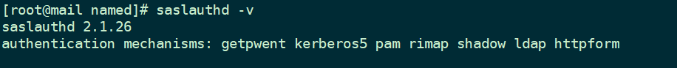  
# 配置

vim /etc/sysconfig/saslauthd

# 修改mech

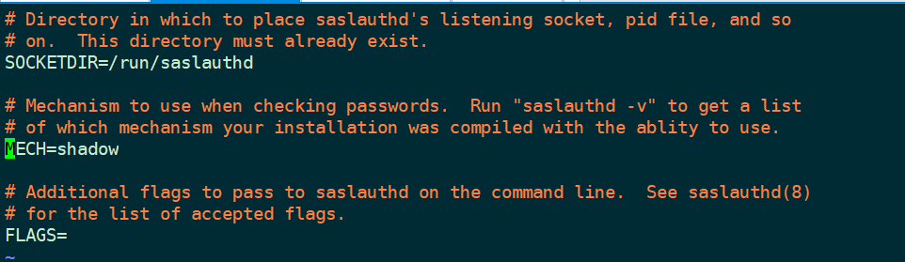

# 如果没有该文件，就创建。

vim /etc/sasl2/smtpd.conf



测试一下

useradd test

passwd test

# 切换到新用户

su - test

#切换回ROOT

systemctl start saslauthd

systemctl enable saslauthd

#进行认证测试

testsaslauthd -u test -p '密码'



意味着创建成功。

## 2 Postfix

postfix作为发送邮件服务器。

yum -y install postfix

#先备份

cp /etc/postfix/main.cf /etc/postfix/main.cf.20191211

#修改配置

vim /etc/postfix/main.cf

#参见 《附件1main.cf》

#测试postfix配置

systemctl start postfix

systemctl enable postfix

## 3 Dovecot

#安装

yum -y install dovecot dovecot-devel dovecot-mysql pam-devel

#修改配置之前先备份

cp /etc/dovecot/dovecot.conf /etc/dovecot/dovecot.conf.20191211

cp /etc/dovecot/conf.d/10-mail.conf /etc/dovecot/conf.d/10-mail.conf.20191211

cp /etc/dovecot/conf.d/10-master.conf /etc/dovecot/conf.d/10-master.conf.20191211

cp /etc/dovecot/conf.d/10-auth.conf /etc/dovecot/conf.d/10-auth.conf.20191211

cp /etc/dovecot/conf.d/10-ssl.conf /etc/dovecot/conf.d/10-ssl.conf.20191211

cp /etc/dovecot/conf.d/10-logging.conf /etc/dovecot/conf.d/10-logging.conf.20191211

#进行配置

vim /etc/dovecot/dovecot.conf

>protocols = imap pop3

>listen = \*

>!include conf.d/\*.conf

vim /etc/dovecot/conf.d/10-auth.conf

>disable\_plaintext\_auth = no

>auth\_mechanisms = plain login

>!include auth-system.conf.ext

vi /etc/dovecot/conf.d/10-mail.conf

>mail\_location = maildir:~/Maildir

vi /etc/dovecot/conf.d/10-master.conf

>unix\_listener /var/spool/postfix/private/auth {

> mode = 0666

> user = postfix

> group = postfix

>}

vim /etc/dovecot/conf.d/10-ssl.conf

>ssl = no

vim /etc/dovecot/conf.d/10-logging.conf

# Log file to use for informational messages. Defaults to log\_path.

>info\_log\_path = /var/log/dovecot\_info.log

# Log file to use for debug messages. Defaults to info\_log\_path.

>debug\_log\_path = /var/log/dovecot.debug.log

# 注意：如果后续日志中提示没有写入权限的话，修改其权限即可。

#查看dovecot生效的非默认配置

doveconf -n

/etc/init.d/dovecot start

chkconfig dovecot on

/etc/init.d/portreserve stop

chkconfig portreserve off

# 3 虚拟用户配置

## 1 postfix配置虚拟用户

修改master.cf文件

#接下来会修改大量的配置文件,记得备份#先统一进行备份

cp /etc/postfix/master.cf /etc/postfix/master.cf.20191211

vim /etc/postfix/master.cf#添加下面两句

dovecot unix – n n – – pipe

flags=DRhu user=vmail:vmail argv=/usr/libexec/dovecot/dovecot-lda -f ${sender} -d ${recipient}#注意 flags前面有两个半角空格。

数据库连接相关文件  
连接数据库相关文件有7个，在创建配置文件之前，我们要在/etc/postfix/目录下建立sql目录用来存放这些配置如下：

mkdir /etc/postfix/sql/

vim /etc/postfix/sql/mysql\_virtual\_alias\_maps.cf

user = postfix

password = postfix

hosts = localhost

dbname = postfix

query = SELECT goto FROM alias WHERE address='%s' AND active = '1'

vim /etc/postfix/sql/mysql\_virtual\_alias\_domain\_maps.cf

user = postfix

password = postfix

hosts = localhost

dbname = postfix

query = SELECT goto FROM alias,alias\_domain WHERE alias\_domain.alias\_domain = '%d' and alias.address = CONCAT('%u', '@', alias\_domain.target\_domain) AND alias.active = 1 AND alias\_domain.active='1'

vim /etc/postfix/sql/mysql\_virtual\_alias\_domain\_catchall\_maps.cf

user = postfix

password = postfix

hosts = localhost

dbname = postfix

query = SELECT goto FROM alias,alias\_domain WHERE alias\_domain.alias\_domain = '%d' and alias.address = CONCAT('@', alias\_domain.target\_domain) AND alias.active = 1 AND alias\_domain.active='1'

vim /etc/postfix/sql/mysql\_virtual\_domains\_maps.cf

user = postfix

password = postfix

hosts = localhost

dbname = postfix

query = SELECT domain FROM domain WHERE domain='%s' AND active = '1'

vim /etc/postfix/sql/mysql\_virtual\_mailbox\_maps.cf

user = postfix

password = postfix

hosts = localhost

dbname = postfix

query = SELECT maildir FROM mailbox WHERE username='%s' AND active = '1'

vim /etc/postfix/sql/mysql\_virtual\_alias\_domain\_mailbox\_maps.cf

user = postfix

password = postfix

hosts = localhost

dbname = postfix

query = SELECT maildir FROM mailbox,alias\_domain WHERE alias\_domain.alias\_domain = '%d' and mailbox.username = CONCAT('%u','@',alias\_domain.target\_domain) AND mailbox.active = 1 AND alias\_domain.active='1'

vim /etc/postfix/sql/mysql\_virtual\_mailbox\_limit\_maps.cf

user = postfix

password = postfix

hosts = localhost

dbname = postfix

query = SELECT quota FROM mailbox WHERE username='%s' AND active = '1'

2Dovecot配置虚拟用户

修改dovecot.conf文件

vim /etc/dovecot/dovecot.conf

#修改

protocols = imap pop3

listen = \*

!include conf.d/\*.conf

#追加

passdb {

driver = sql

args = /etc/dovecot/dovecot-sql.conf.ext

}

userdb {

driver = static

args = uid=5000 gid=5000 home=/home/vmail/%d/%n

}

#log

auth\_debug\_passwords=yes

mail\_debug=yes

auth\_verbose=yes

auth\_verbose\_passwords=plain

修改10-auth.conf文件

vim /etc/dovecot/conf.d/10-auth.conf#修改红色

disable\_plaintext\_auth = no

auth\_mechanisms = plain login cram-md5!include auth-system.conf.ext

修改10-mail.conf文件

vim /etc/dovecot/conf.d/10-mail.conf

#修改

mail\_location = maildir:/home/vmail/%d/%n

mbox\_write\_locks = fcntl

修改10-master.conf文件  
10-master.conf文件定义了dovecot的pop3和imap端口，以及其他的一些信息。

vim /etc/dovecot/conf.d/10-master.conf

inet\_listener imap {

port = 143

}

inet\_listener pop3 {

port = 110

}

service auth {

unix\_listener auth-userdb {

mode = 0600

user = vmail

group = vmail

}

# Postfix smtp-auth

unix\_listener /var/spool/postfix/private/auth {

mode = 0666

user = postfix

#group = postfix （注释掉）

}}

添加dovecot-sql.conf.ext文件

vim /etc/dovecot/dovecot-sql.conf.ext

driver = mysql

connect = host=localhost dbname=postfix user=postfix password=postfix

default\_pass\_scheme = MD5-CRYPT

password\_query = SELECT username AS user,password FROM mailbox WHERE username = '%u' AND active='1'

user\_query = SELECT maildir, 5000 AS uid, 5000 AS gid, CONCAT('dict:storage=',floor(quota/1000),' proxy::quota') as quota FROM mailbox WHERE username = '%u' AND active='1'#注意： proxy::quata 的前面有半角空格

3Postfixadmin配置

确保LAMP环境

**安装postfixadmin**

wget http://nchc.dl.sourceforge.net/project/postfixadmin/postfixadmin/postfixadmin-2.93/postfixadmin-2.93.tar.gz

tar -xf postfixadmin-2.93.tar.gz

mv postfixadmin-2.93 /var/www/html/postfixadmin

chown -R apache:apache /var/www/html/postfixadmin

chmod -R 755 /var/www/html/postfixadmin

配置postfixadmin

#先备份

cp /var/www/html/postfixadmin/config.inc.php /var/www/html/postfixadmin/config.inc.php.20191211

vim /var/www/html/postfixadmin/config.inc.php

#下列均需要修改

$CONF['configured'] = true;

$CONF['default\_language'] = 'cn';

$CONF['database\_type'] = 'mysql';

$CONF['database\_host'] = 'localhost';

$CONF['database\_user'] = 'postfix';

$CONF['database\_password'] = 'postfix';

$CONF['database\_name'] = 'postfix';

$CONF['encrypt'] = 'dovecot:CRAM-MD5';

$CONF['aliases'] = '1000';

$CONF['mailboxes'] = '1000';

$CONF['maxquota'] = '1000';

$CONF['fetchmail'] = 'NO';

$CONF['quota'] = 'YES';

$CONF['used\_quotas'] = 'YES';

$CONF['new\_quota\_table'] = 'NO';

启动postfixadmin

#启动apache

#如果已经启动，就restart

systemctl restart httpd

浏览器中打开  
[http://172.16.11.235/postfixadmin/setup.php](https://link.jianshu.com?t=http://192.168.2.234/postfixadmin/setup.php" \t "_blank)

该页面是自检页面

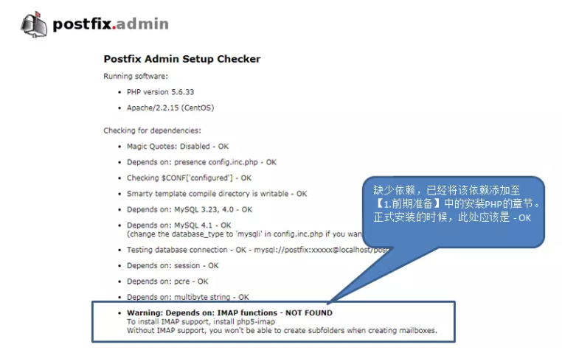

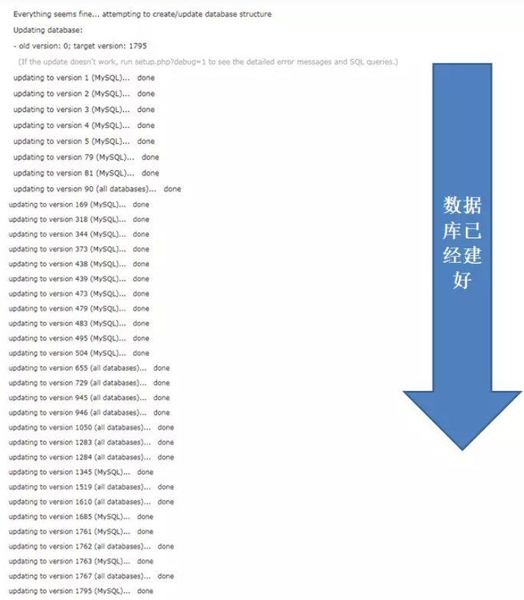

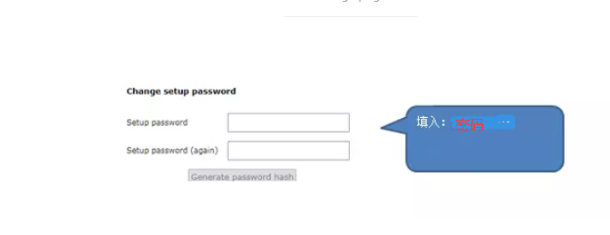

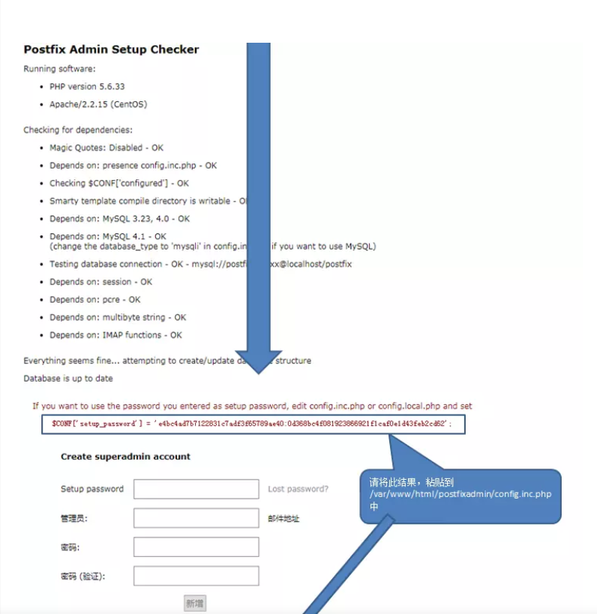

vim /var/www/html/postfixadmin/config.inc.php

# 修改为刚才画面上的值

$CONF['setup\_password'] = 'changeme';

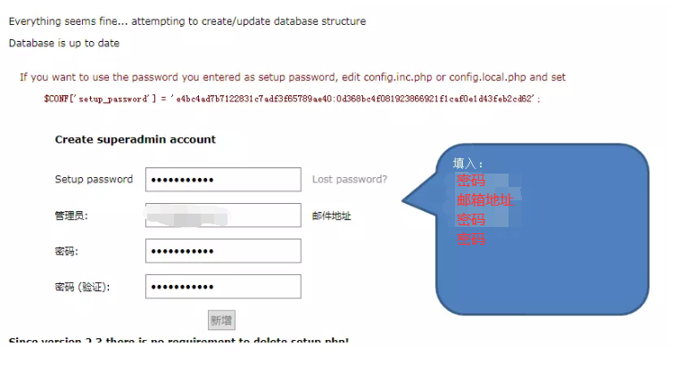

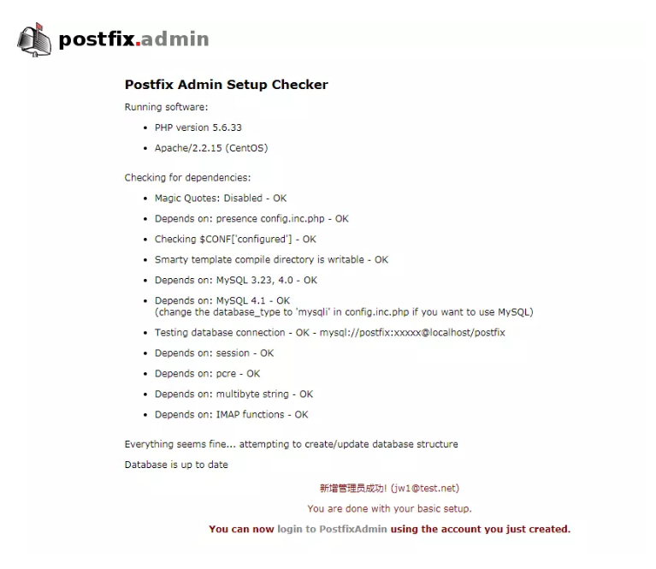

登录： [http://172.16.11.235/postfixadmin/login.php](https://link.jianshu.com/?t=http://192.168.2.234/postfixadmin/login.php" \t "https://www.jianshu.com/p/_blank)

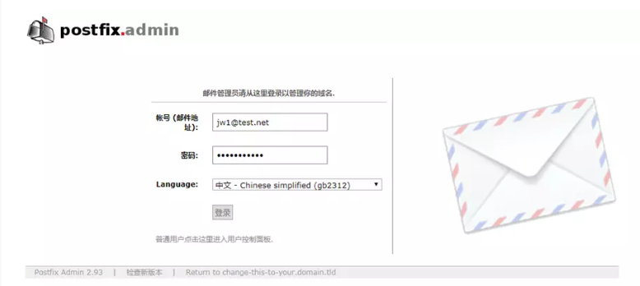

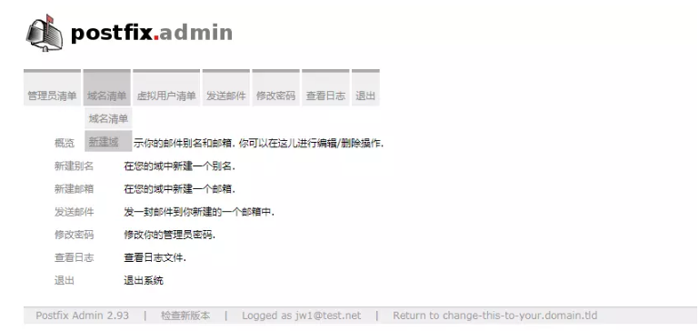

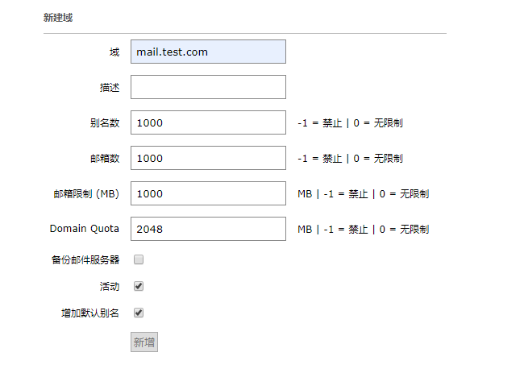

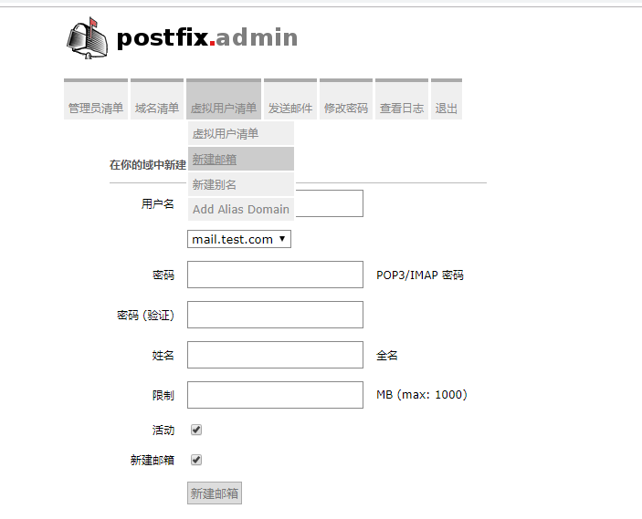

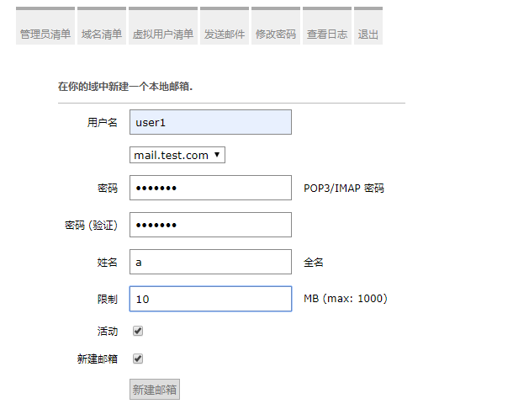

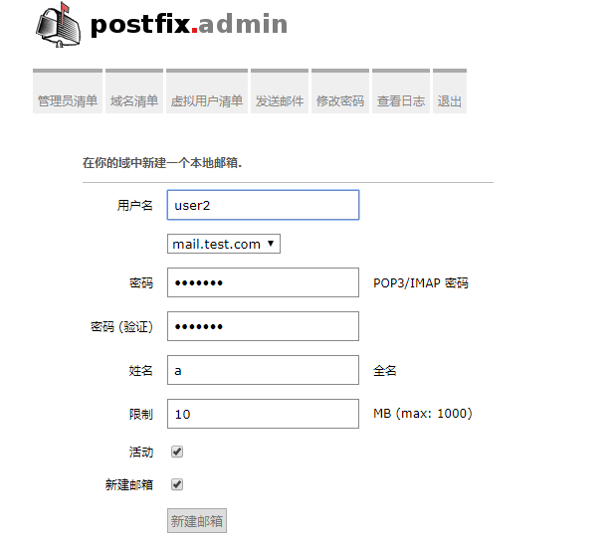

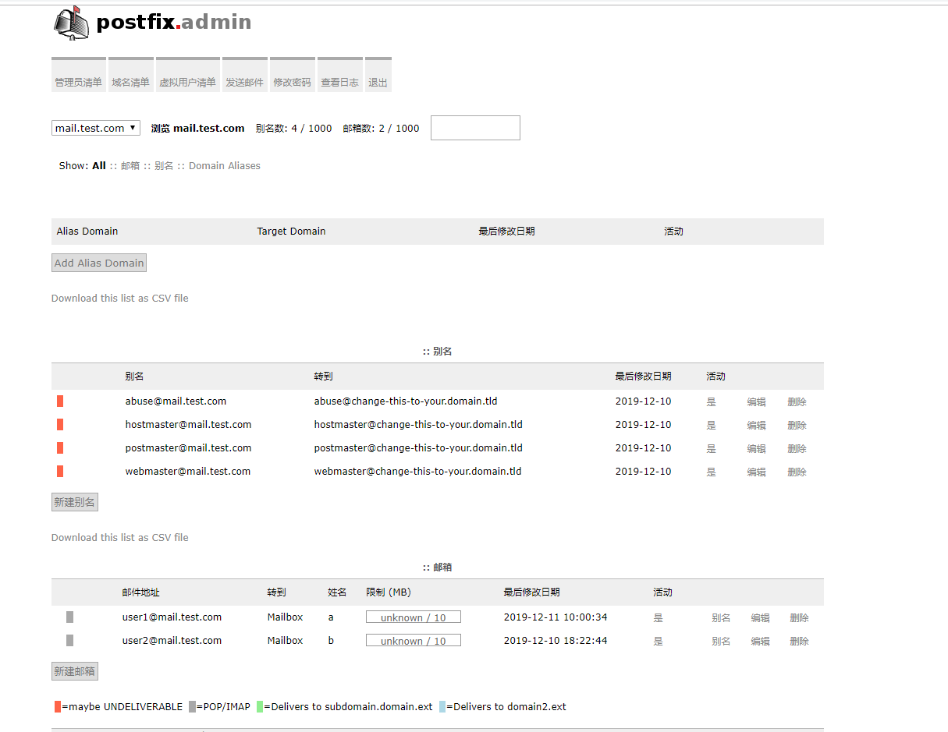

**4邮件连接测试**

注意是 IMAP，虚拟用户只支持IMAP，即143端口

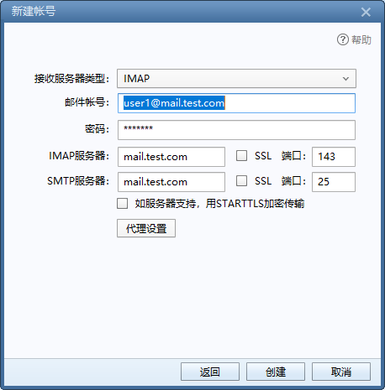

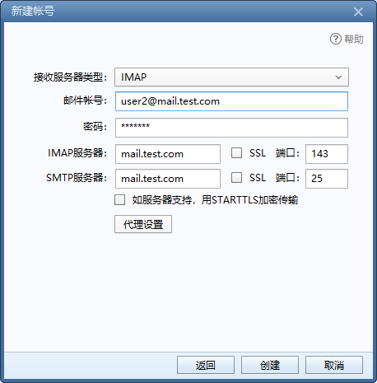

尝试建立一个不存在的账户的连接，说明服务器的验证生效了。

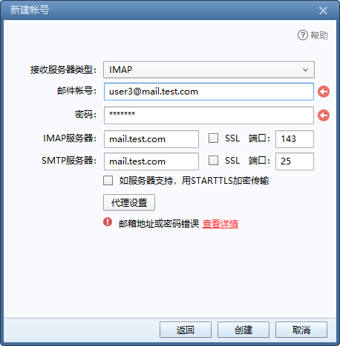

测试收发信件

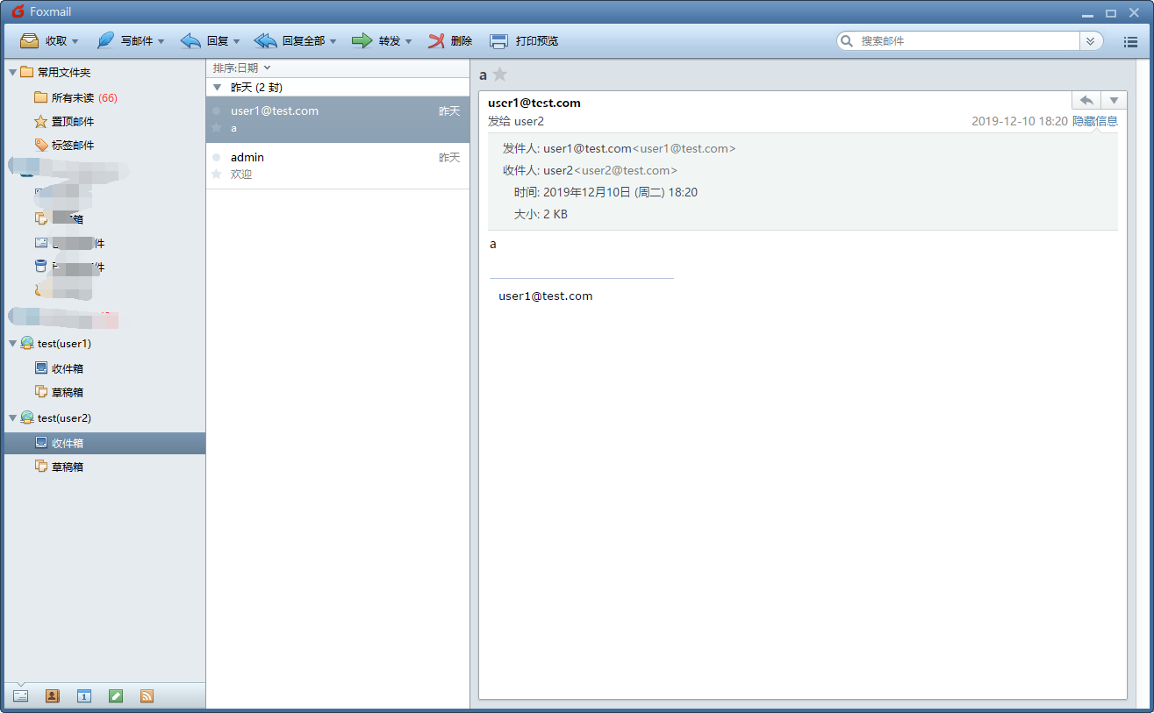

# 5 WEB端邮件系统

## **1.下载roundcube webmail软件包**

wget <http://jaist.dl.sourceforge.net/project/roundcubemail/roundcubemail/1.1.4/roundcubemail-1.1.4-complete.tar.gz>

#解压roundcube webmail软件包，并移动到apache根目录下，如下：

tar -xf roundcubemail-1.1.4-complete.tar.gz

mv roundcubemail-1.1.4 /var/www/html/webmail/

chown -R apache:apache /var/www/html/webmail/

chmod -R 755 /var/www/html/webmail/

ll /var/www/html/webmail/

## **2.配置webmail**

#安装pear环境，为了下面更新PHP

wget http://pear.php.net/go-pear.phar

php go-pear.phar

pear channel-update pear.php.net

pear install Auth\_SASL Net\_SMTP Net\_IDNA2-0.1.1 Mail\_Mime

修改配置：

vim /etc/php.ini +889

date.timezone = Asia/Chongqing

#以上修改完毕后，重启apache，使用如下命令：

/etc/init.d/httpd restart

建库，建用户

mysql -uroot -p #输入123456

mysql>create database webmail default character set utf8 collate utf8\_bin;

mysql>grant all on webmail.\* to 'webmail'@'localhost' identified by 'webmail';

mysql>flush privileges;

mysql>quit

测试新用户

mysql -uwebmail -pwebmail

## **3.安装roundcube webmail**

http://172.16.11.235[/webmail/installer/index.php](https://link.jianshu.com/?t=http://192.168.2.234/webmail/installer/index.php" \t "https://www.jianshu.com/p/_blank)

默认进行环境检验

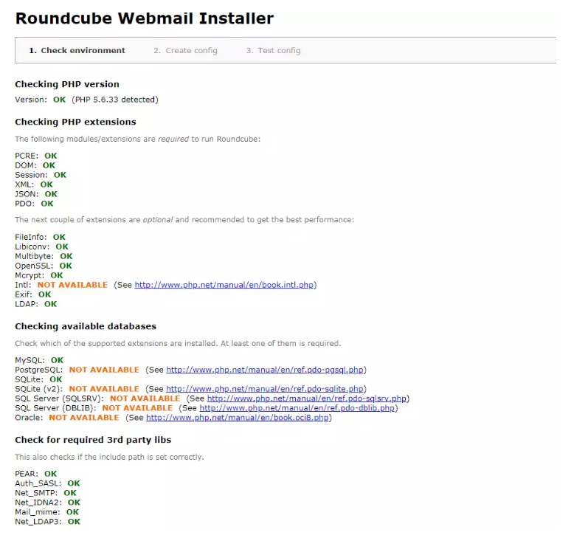

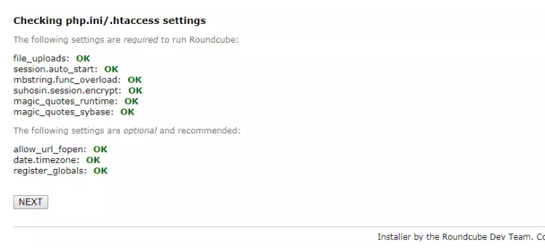

填写各种配置

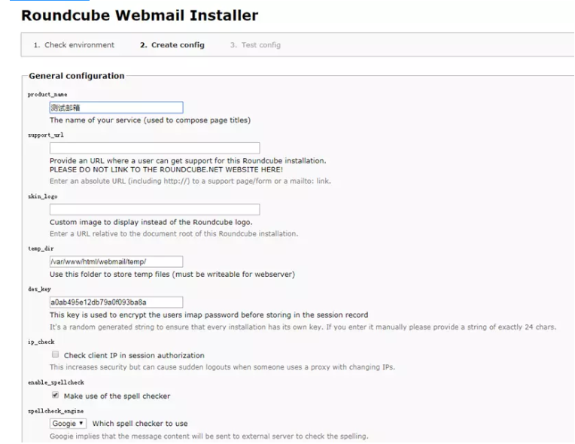

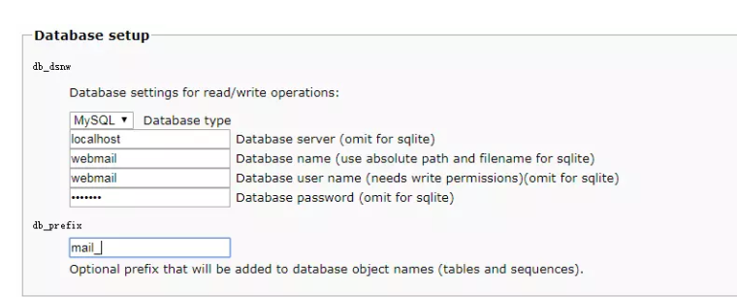

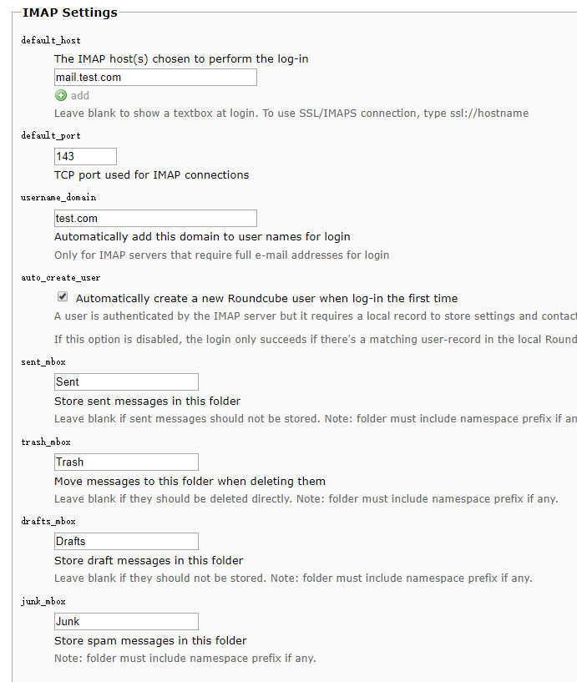

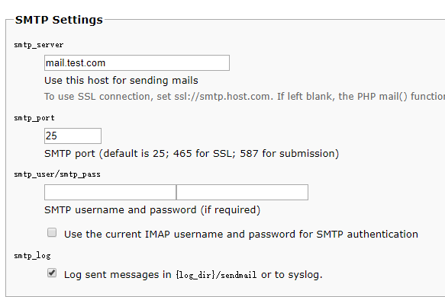

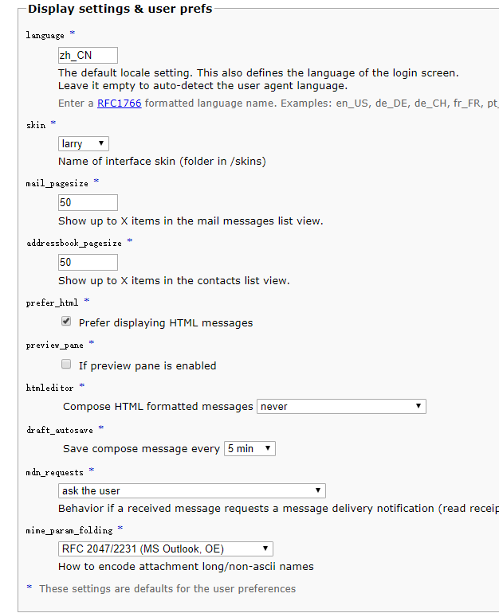

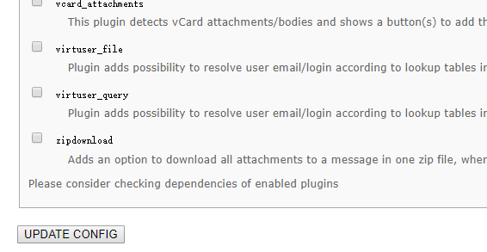

点击【继续】

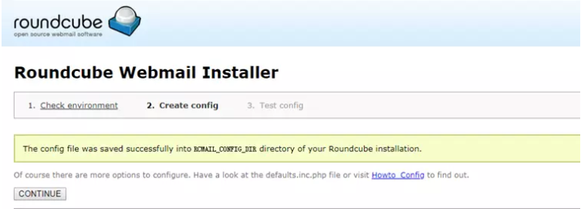

点击【初始化数据库】

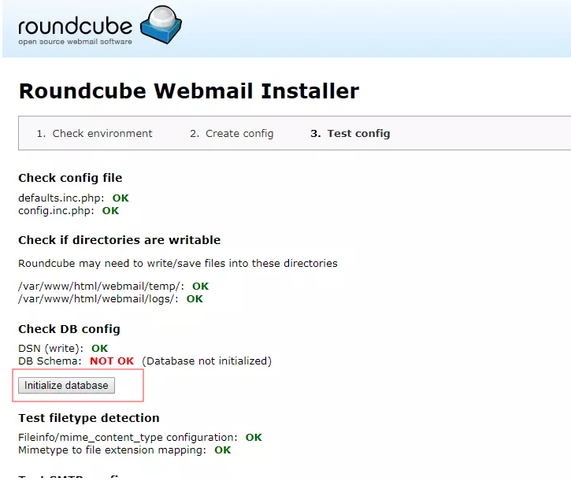

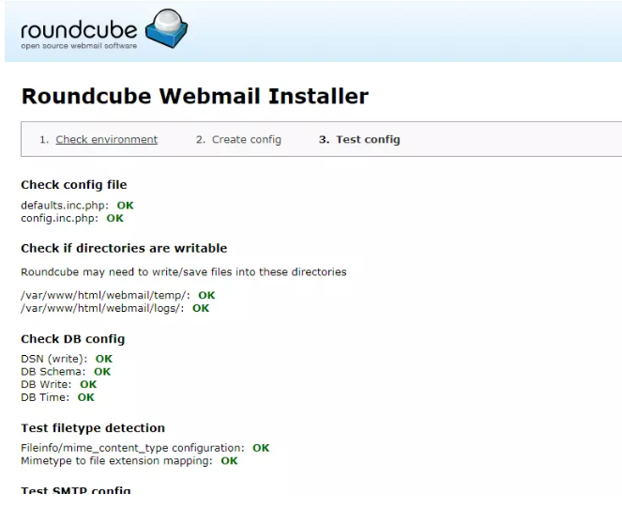

WEB上收发邮件的测试

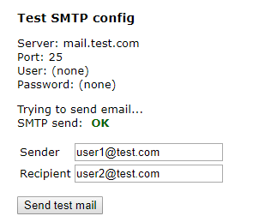

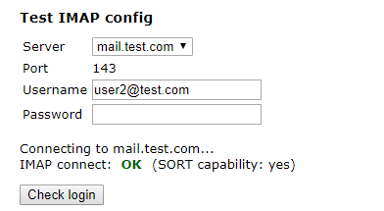

## **4.测试WEB版**

http://172.16.11.235[/webmail/](https://link.jianshu.com/?t=http://192.168.2.234/webmail/" \t "https://www.jianshu.com/p/_blank)

输入之前建立的虚拟用户

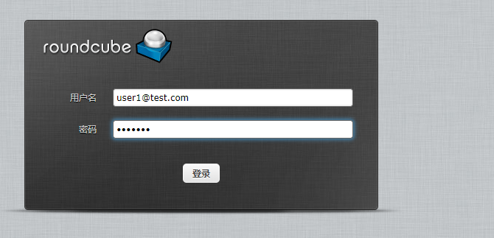

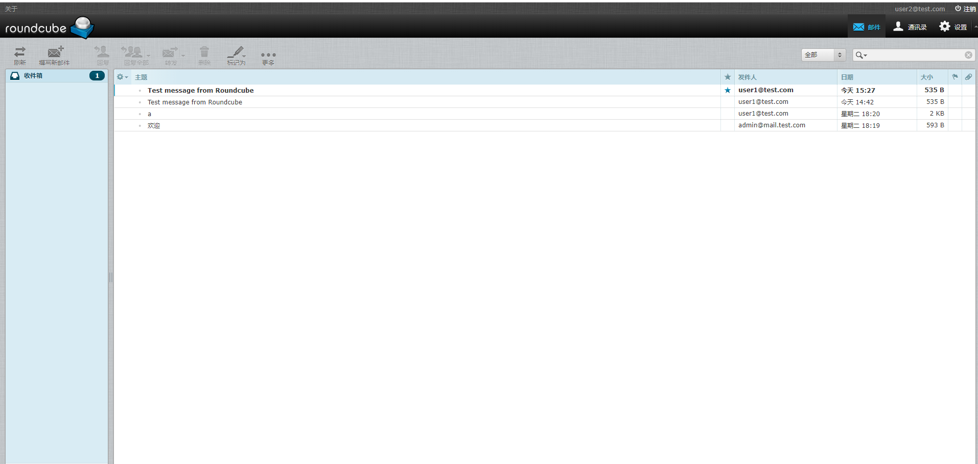

基于安全考虑，请删除 installer/index.php 这个文件。防止他人误操作。  
可以在此为该服务器设置一个还原点。

****至此，整个服务器搭建完毕。****

# 6 附件

alias\_database = hash:/etc/aliases

alias\_maps = hash:/etc/aliases

broken\_sasl\_auth\_clients = yes

command\_directory = /usr/sbin

config\_directory = /etc/postfix

daemon\_directory = /usr/libexec/postfix

data\_directory = /var/lib/postfix

debug\_peer\_level = 2

debugger\_command = PATH=/bin:/usr/bin:/usr/local/bin:/usr/X11R6/bin ddd $daemon\_directory/$process\_name $process\_id & sleep 5

dovecot\_destination\_recipient\_limit = 1

home\_mailbox = Maildir/

html\_directory = no

inet\_interfaces = all

inet\_protocols = ipv4

local\_recipient\_maps =

mail\_owner = postfix

mailq\_path = /usr/bin/mailq.postfix

manpage\_directory = /usr/share/man

mydestination =

mydomain = test.com

myhostname = mail.test.com

mynetworks = 10.168.60.0/24, 127.0.0.0/8, 114.247.94.0/24

myorigin = $mydomain

newaliases\_path = /usr/bin/newaliases.postfix

proxy\_read\_maps = $local\_recipient\_maps $mydestination $virtual\_alias\_maps $virtual\_alias\_domains $virtual\_mailbox\_maps $virtual\_mailbox\_domains $relay\_recipient\_maps $relay\_domains $canonical\_maps $sender\_canonical\_maps $recipient\_canonical\_maps $relocated\_maps $transport\_maps $mynetworks $virtual\_mailbox\_limit\_maps

queue\_directory = /var/spool/postfix

readme\_directory = /usr/share/doc/postfix-2.10.1/README\_FILES

sample\_directory = /usr/share/doc/postfix-2.10.1/samples

sendmail\_path = /usr/sbin/sendmail.postfix

setgid\_group = postdrop

smtpd\_client\_restrictions = permit\_sasl\_authenticated

smtpd\_recipient\_restrictions = permit\_mynetworks,permit\_sasl\_authenticated,reject\_unauth\_destination,reject\_unknown\_sender\_domain

smtpd\_sasl\_auth\_enable = yes

smtpd\_sasl\_local\_domain = $myhostname

smtpd\_sasl\_path = private/auth

smtpd\_sasl\_security\_options = noanonymous

smtpd\_sasl\_type = dovecot

unknown\_local\_recipient\_reject\_code = 550

virtual\_alias\_maps = proxy:mysql:/etc/postfix/sql/mysql\_virtual\_alias\_maps.cf, proxy:mysql:/etc/postfix/sql/mysql\_virtual\_alias\_domain\_maps.cf, proxy:mysql:/etc/postfix/sql/mysql\_virtual\_alias\_domain\_catchall\_maps.cf

virtual\_gid\_maps = static:5000

virtual\_mailbox\_base = /home/vmail/

virtual\_mailbox\_domains = proxy:mysql:/etc/postfix/sql/mysql\_virtual\_domains\_maps.cf

virtual\_mailbox\_maps = proxy:mysql:/etc/postfix/sql/mysql\_virtual\_mailbox\_maps.cf, proxy:mysql:/etc/postfix/sql/mysql\_virtual\_alias\_domain\_mailbox\_maps.cf

virtual\_transport = virtual

virtual\_uid\_maps = static:5000

postconf: warning: /etc/postfix/main.cf: unused parameter: smtpd\_sasl\_security\_restrictions=permit\_mynetworks,permit\_sasl\_authenticated,reject\_unauth\_destination

postconf: warning: /etc/postfix/main.cf: unused parameter: smtpd\_sasl\_application\_name=smtpd