SELECT package demonstration  
Alternate haul

## Summary

This is a simple case study that revisits the alternate haul data analysed in Wileman et al. (1996, Manual of Methods of Measuring the Selectivity of Towed Fishing Gears, ICES Coop Research Report, No 215).

**This case study demonstrates:**

* The use of data that is provided within the SELECT package.
* Fixing the relative fishing power using the experimental design type dtype=re.

### Data source

The data are originally from Pope et al. (1975, Manual of methods for fish stock assessment Part 111 Selectivity of fishing gear.FA0 Fish. Tech. Pap. (41) Rev. 1.) These are alternative haul catch data of haddock in an 87 mm diamond experimental codend alternating with a 35 mm control gear.

The data are only given as totals summed over hauls, so no exploration of between-haul variability is possible. The data are included with the SELECT package.

require(SELECT)  
require(dplyr)

### Load and inspect the data

data(Pope)  
Pope

## Lengths nfine nwide  
## 1 24 1 0  
## 2 25 1 0  
## 3 26 3 0  
## 4 27 14 1  
## 5 28 30 5  
## 6 29 49 19  
## 7 30 60 29  
## 8 31 50 51  
## 9 32 70 91  
## 10 33 108 120  
## 11 34 88 118  
## 12 35 84 107  
## 13 36 68 78  
## 14 37 37 52  
## 15 38 33 40  
## 16 39 12 17  
## 17 40 5 17  
## 18 41 6 14  
## 19 42 10 10  
## 20 43 1 4  
## 21 44 6 6  
## 22 45 2 2  
## 23 46 1 5  
## 24 47 0 1

### Define variable names

v.names=c("Lengths","nfine","nwide")

### Produce a plot of catch-share proportions

Pope=transform(Pope,n=nfine+nwide,y=nwide/(nfine+nwide))   
plot(y~Lengths,data=Pope)  
abline(h=0.5,lty=3)

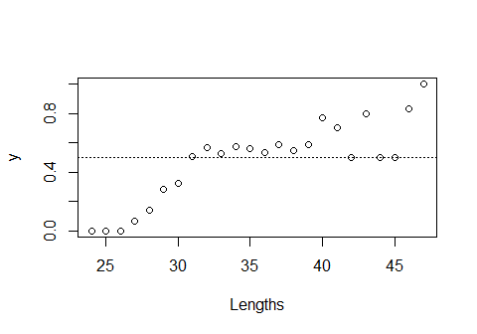

The experimental condend has catch share of 50% or more for all of the larger lengths, indicating that it has higher fishing power than the control.

### Fit logistic selection curve

Logist.fit=SELECT(Pope,var.names=v.names,dtype="ph")

##   
## Design specification `ph` is deprecated and  
## has been changed to `ec` (experimental/control)

plot(Logist.fit)

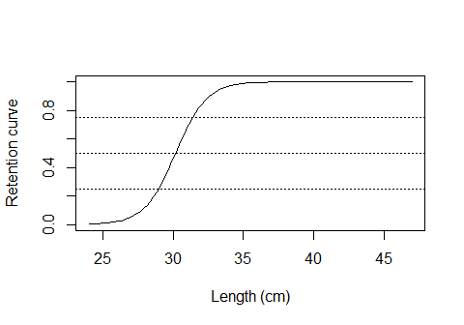

ModelCheck(Logist.fit)

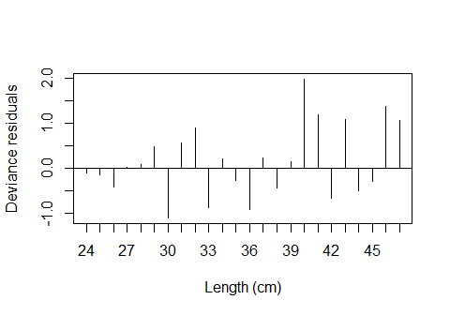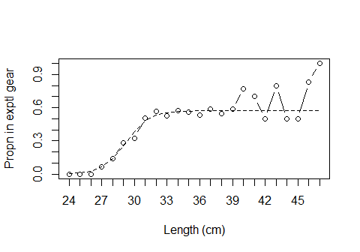

## Model fit:  
## null.l model.l full.l npar AIC   
## -87.53367 -47.37439 -39.95578 3.00000 100.74877   
## GOF:  
## Deviance Pearson.chisq dof Deviance.CF Pearson.CF   
## 14.8372118 13.7355791 21.0000000 0.7065339 0.6540752

Estimates(Logist.fit)

## par raw s.e.  
## L50 30.1753462 0.35526986  
## SR 2.3982465 0.51419914  
## p 0.5728614 0.01721912

The logistic fit looks good. For completeness we’ll do the Richards fit also.

### Fit Richards curve

Rich.fit=SELECT(Pope,var.names=v.names,dtype="ph",stype="richards")

##   
## Design specification `ph` is deprecated and  
## has been changed to `ec` (experimental/control)

plot(Rich.fit)

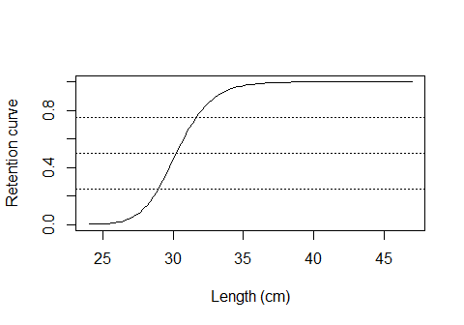

ModelCheck(Rich.fit)

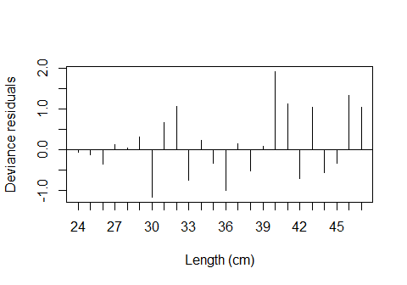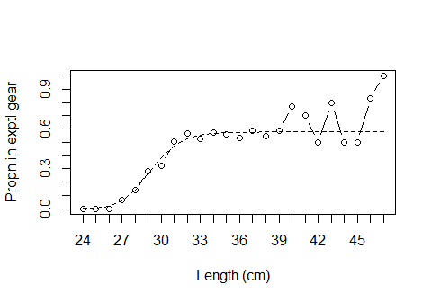

## Model fit:  
## null.l model.l full.l npar AIC   
## -87.53367 -47.44057 -39.95578 4.00000 102.88114   
## GOF:  
## Deviance Pearson.chisq dof Deviance.CF Pearson.CF   
## 14.9695751 13.9217412 20.0000000 0.7484788 0.6960871

Estimates(Rich.fit)

## par raw s.e.  
## L50 30.2153970 0.39757545  
## SR 2.6700871 0.87875467  
## delta 0.5690927 1.10616876  
## p 0.5782163 0.02314456

There is very little difference between the logistic and Richards fits.

The logistic is preferred, since even without being able to correct for over-dispersion, AIC prefers the logistic. A likelihood-ratio test also would not reject goodness of fit of the logistic.

## Fixing the split parameter

This requires specifying the design type as relative, re. Also, meshsizes must be given, as well as start values for the optimizer. These start values are for the intercept and slope parameters of the logistic model, and the parameters of the above logistic fit can be used for this purpose.

#Get start values, x0  
Logist.fit$par

## [1] -27.6460369 0.9161796 0.2935352

EqualPower.fit=SELECT(Pope,var.names=v.names,dtype="re",  
 Meshsize=c(35,87), x0=c(-27.6,0.92))

##   
## Design specification `re` is deprecated and  
## has been changed to `dc` (direct comparison)

plot(EqualPower.fit)

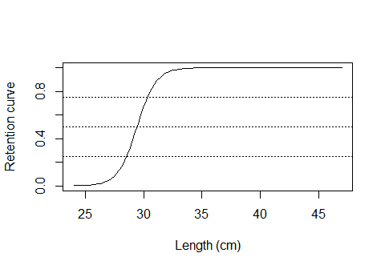

ModelCheck(EqualPower.fit)

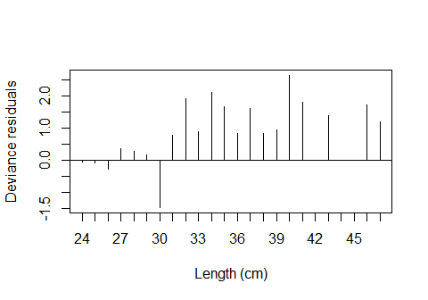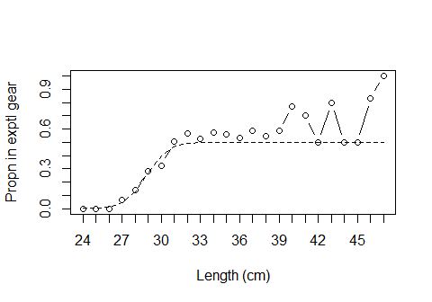

## Model fit:  
## null.l model.l full.l npar AIC   
## -87.53367 -57.97030 -39.95578 2.00000 119.94059   
## GOF:  
## Deviance Pearson.chisq dof Deviance.CF Pearson.CF   
## 36.029030 34.683001 22.000000 1.637683 1.576500

Estimates(EqualPower.fit)

## par raw s.e.  
## L50 29.427707 0.2508234  
## SR 1.780782 0.3387383

This is clearly not a good model.