SELECT package demonstration  
Gillnet

## Summary

**This case study demonstrates:**

1. Fitting five different shapes of selection curves to gillnet data
2. Use of dtype=dc for direct comparison experiments whereby relative fishing power is NOT being estimated. (The default is equal power, but it can be specified by the user.)
3. Use ofx0= to give required start values for the optimizer
4. Model selection using AIC
5. Geometric similarity of selectivity curves

### Data source

The data are for trout caught by gillnet in Gull Island Refuge, Lake Superior (Hansen et al., 1997. Gillnet selectivity for lake trout (Salvelinus namaycush) in Lake Superior. Canadian Journal of Fisheries and Aquatic Sciences, 54: 2483-2490.

### Load required packages

require(SELECT)  
require(tidyverse)

### Load data

data(Trout)  
Trout

## $Counts  
## lgth M102 M114 M127 M140 M152  
## 1 438 6 1 0 0 0  
## 2 463 6 3 0 0 1  
## 3 488 18 5 3 0 0  
## 4 513 10 16 7 1 0  
## 5 538 17 18 9 5 1  
## 6 563 8 14 24 10 4  
## 7 588 11 20 30 22 10  
## 8 613 20 15 16 23 9  
## 9 638 11 20 20 29 17  
## 10 663 15 19 25 26 23  
## 11 688 7 22 21 14 25  
## 12 713 10 19 11 15 21  
## 13 738 5 16 13 10 11  
## 14 763 1 6 11 2 4  
## 15 788 0 1 3 5 0  
## 16 813 1 1 3 1 3  
## 17 838 0 1 1 1 2  
## 18 863 0 0 0 1 3  
##   
## $Meshsize  
## [1] 102 114 127 140 152

Fit five different parametric selectivity curves to the data.

1. Normal with common standard deviation (spread)
2. Normal with standard deviation scaling with mesh size
3. Log normal
4. Binormal mixture
5. Bilognormal mixture

Note that curves 2-5 all observe geometric similarity whereby the curves scale in proportion to mesh size.

### Fit the curves

Meshs=Trout$Meshsize  
Counts=Trout$Counts   
Vars=names(Counts)  
  
SEL1=SELECT(Counts,Vars,dtype="dc",  
stype="norm.loc",Meshsize=Meshs,x0=c(500,50))   
AIC1=AIC(SEL1,type="Poisson")  
  
SEL2=SELECT(Counts,Vars,dtype="dc",  
stype="norm.sca",Meshsize=Meshs,x0=c(500,50))   
AIC2=AIC(SEL2,type="Poisson")  
  
SEL3=SELECT(Counts,Vars,dtype="dc", stype="lognorm",Meshsize=Meshs,x0=c(6,0.2))  
AIC3=AIC(SEL3,type="Poisson")  
  
SEL4=SELECT(Counts,Vars,dtype="dc",  
stype="binorm.sca",Meshsize=Meshs,x0=c(500,50,600,50,0))  
AIC4=AIC(SEL4,type="Poisson")  
  
SEL5=SELECT(Counts,Vars,dtype="dc",  
stype="bilognorm",Meshsize=Meshs,x0=c(6.2,0.1,6.5,0.1,0))  
AIC5=AIC(SEL5,type="Poisson")  
  
cat("Poisson AICs are",AIC1,AIC2,AIC3,AIC4,AIC5)

## Poisson AICs are 468.151 480.6302 458.6767 412.8643 417.2718

The above SELECT fits show that the bimodal selectivity curves are preferred, and the binormal (SEL4) has the lowest Poisson AIC of 412.9.

### Check goodness of fit of preferred model

ModelCheck(SEL4)

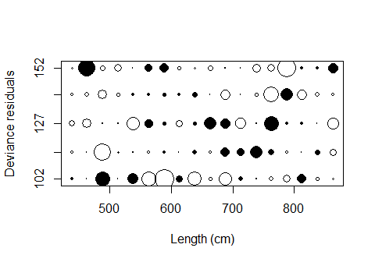

## Model fit:  
## null.l model.l full.l npar AIC   
## -212.74398 -136.47456 -98.71324 5.00000 282.94911   
## GOF:  
## Deviance Pearson.chisq dof Deviance.CF Pearson.CF   
## 75.522642 80.594716 67.000000 1.127204 1.202906

cat("Goodness of fit p-value is",1-pchisq(80.6,67))

## Goodness of fit p-value is 0.1229541

The above output from `ModelCheck`` enabled a goodness-of-fit test using the Pearson chi-square statistic (or deviance), and this shows that the Poisson assumption is reasonable. The plot of deviances residuals does not dispay any concerning patterns.

### Plot the fitted selection curves

par(oma=c(0,0,0,0),mar=c(4,4,1,4))   
plot(SEL5,standardize=T) #Use standardize=T to set maximum retention to 1  
#Add plot legend  
legend(600,0.3,legend=paste(Meshs,"mm"),lty=1:5,col=1:5,cex=0.8)

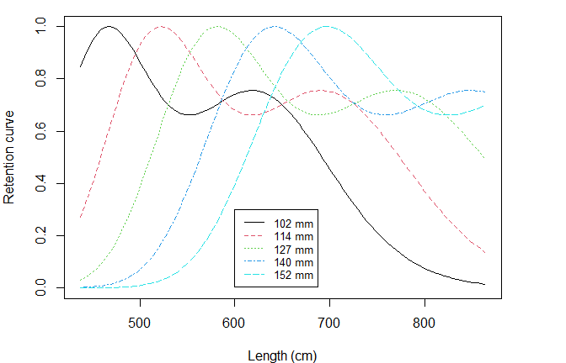

Note the geometric similarity of the curves, with each curve scaling in proportion to mesh size.