A SELECTion of SELECTivity curves

Russell Millar

require(SELECT)

## Loading required package: SELECT

lenseq=21:100  
nlens=length(lenseq)  
M=rep(1,nlens) #Hypothetical meshsize

# Gillnet curves

SelnCurves=matrix(NA,80,8)  
colnames(SelnCurves)=c("normal","gamma","lognormal1","lognormal2","binormal1",  
 "binormal2","bilognormal1","bilognormal2")  
   
SelnCurves[,1]=selncurves("re.norm.loc")(lenseq,M,c(50,10))  
SelnCurves[,2]=selncurves("re.gamma")(lenseq,M,c(6,10))  
SelnCurves[,3]=selncurves("re.lognorm")(lenseq,M,c(4,0.25))  
SelnCurves[,4]=selncurves("re.lognorm")(lenseq,M,c(4.25,0.5))  
SelnCurves[,5]=selncurves("re.binorm.sca")(lenseq,M,c(40,10,70,10,0.7))  
SelnCurves[,6]=selncurves("re.binorm.sca")(lenseq,M,c(50,10,60,20,0.7))  
SelnCurves[,7]=selncurves("re.bilognorm")(lenseq,M,c(4,0.15,4.4,0.2,0.7))  
SelnCurves[,8]=selncurves("re.bilognorm")(lenseq,M,c(4,0.25,4.5,0.25,0.7))  
  
#jpeg("GillnetCurves.jpg",width=1200,height=900,pointsize=20)  
par(mfrow=c(4,2),mar=c(1,4,1,4))  
for(i in 1:8) {  
 Curve=colnames(SelnCurves)[i]  
 plot(lenseq,SelnCurves[,i],type="l",ylab=Curve,xaxt="n",yaxt="n")  
}

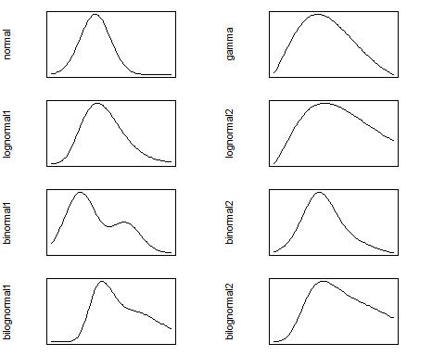

#dev.off()

# Trawl curves (monotone increasing)

SelnCurves=matrix(NA,80,4)  
colnames(SelnCurves)=c("logistic","richards1","richards2","richards3")  
   
SelnCurves[,1]=selncurves("re.logistic")(lenseq,M,c(-12,0.2))  
SelnCurves[,2]=selncurves("re.richards")(lenseq,M,c(-14,0.2,1))  
SelnCurves[,3]=selncurves("re.richards")(lenseq,M,c(-80,1,3))  
SelnCurves[,4]=selncurves("re.richards")(lenseq,M,c(-5,0.1,-1))  
  
par(mfrow=c(2,2),mar=c(1,4,1,4))  
for(i in 1:4) {  
 Curve=colnames(SelnCurves)[i]  
 plot(lenseq,SelnCurves[,i],type="l",ylab=Curve,xaxt="n",yaxt="n",ylim=c(0,1))  
}

