Covered codend

Summary
This case study demonstrates:
- Using the R package SELECT to fit selection curves to covered-codend data.
- Fitting of logistic, Richards and semiparametric (smooth) selection curves to covered-codend data.
- Model selection and checking
- Handling sub-sampled data.
- Visualization of between-haul variability.
- Using the bootstrap to estimate uncertainty.

Data source
The data are from a study investigation school prawn selectivity in a 30 mm square-mesh stow-net(MacBeth et al. 2005. Improving selectivity in an Australian penaeid stow-net fishery. Bulletin of Marine Science, 76: 647-660). Nineteen replicate deployments were performed.
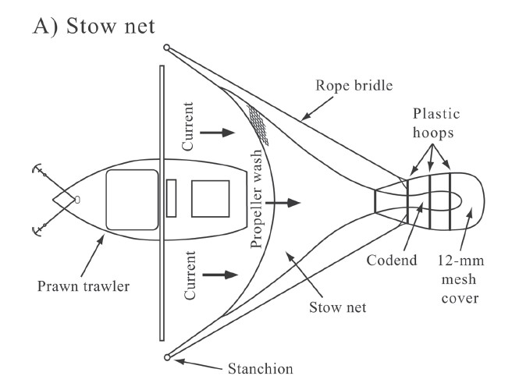

Load required packages
require(SELECT)
require(dplyr)
require(ggplot2) #For bootstrap plot

Input and inspect the data
#Read in data and remove zero catch lengths
Stow.df=read.csv("../Data/LgSq.csv",header=T) #343 rows
Stow.df=subset(Stow.df,total>0) #213 rows
#Quick peek at data
head(Stow.df)
## lgth codend cover WtSch qcodend qcover total Haul
## 6 11 0 2 2.02 0.585 0.34 2 1
## 8 13 2 8 2.02 0.585 0.34 10 1
## 9 14 3 6 2.02 0.585 0.34 9 1
## 10 15 25 34 2.02 0.585 0.34 59 1
## 11 16 47 82 2.02 0.585 0.34 129 1
## 12 17 65 62 2.02 0.585 0.34 127 1
Note the presence of the sampling fractions qcodend and qcover' in the data due to the catch being sub-sampled. VariableHaul` identifies the deployment, and takes values from 1 to 19.

Define variable names, and the names of sampling fraction variables
The names of the length and gear variables need to be specified, with the length name always given first. If there is sub-sampling then these variable names also need to be specified.
v.names=c("lgth","cover","codend")
q.names=c("qcover","qcodend")

Produce a plot of retention proportions
It is always a good idea to inspect the data before analysis. The code below sums the data over the nineteen deployments, and then calculates and plots the retention proportions by length.
Tots=Raw2Tots(Stow.df,v.names,q.names)
Tots=transform(Tots,n=codend+cover,y=codend/(codend+cover))
Tots
## lgth cover codend n y
## 1 6 2.239274 0.000000 2.239274 0.0000000
## 2 8 1.502768 0.000000 1.502768 0.0000000
## 3 9 5.259689 0.000000 5.259689 0.0000000
## 4 10 7.513842 1.502768 9.016610 0.1666667
## 5 11 35.978043 4.389272 40.367315 0.1087333
## 6 12 42.402885 7.235204 49.638089 0.1457591
## 7 13 71.259699 23.271511 94.531210 0.2461781
## 8 14 131.173924 55.648326 186.822250 0.2978678
## 9 15 359.150971 235.007945 594.158916 0.3955305
## 10 16 729.029720 679.320778 1408.350498 0.4823521
## 11 17 619.185516 921.883354 1541.068870 0.5982104
## 12 18 338.090283 819.113029 1157.203312 0.7078385
## 13 19 102.530989 426.214007 528.744996 0.8060861
## 14 20 14.358586 140.110820 154.469406 0.9070458
## 15 21 0.000000 36.272249 36.272249 1.0000000
## 16 22 0.000000 11.034010 11.034010 1.0000000
## 17 23 0.000000 1.320535 1.320535 1.0000000
plot(y~lgth,data=Tots,xlab="Carapace length (mm)",ylab="Propn retained")
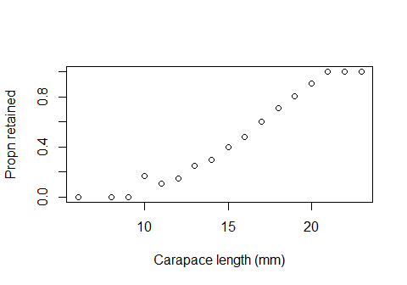
The proportions look S-shaped as would normally expect. There is one possibly anomalous value at 10 mm length, but this may just be due to low numbers of this length.

Fit a logistic selection curve, plot it, and do model checks
Standard practice is to start with the simple logistic curve and then to evaluate its fit to determine whether a more flexible curve may be preferred.
Logist.fit=SELECT(Stow.df,var.names=v.names,q.names=q.names)
plot(Logist.fit, xlab="Carapace length (mm)")
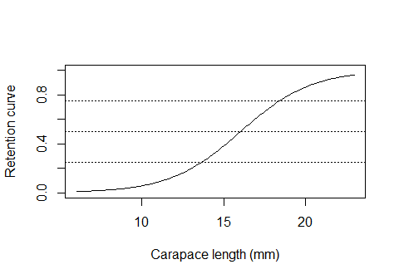
par(mfrow=c(1,2))
ModelCheck(Logist.fit, xlab="Carapace length (mm)")
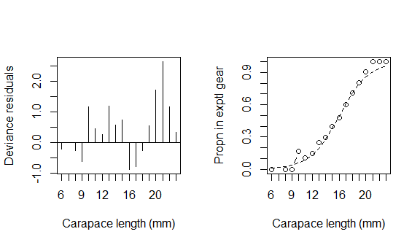
## Model fit:
## null.l model.l full.l npar AIC BIC
## -370.68605 -38.60693 -29.77578 2.00000 81.21385 82.88028
## GOF:
## Deviance Pearson.chisq dof Deviance.CF Pearson.CF
## 17.6623038 13.8283885 15.0000000 1.1774869 0.9218926
Estimates(Logist.fit)
## par raw s.e.
## L50 16.051802 0.06689251
## SR 4.746722 0.20555085
The logistic fit estimates L50 and SR of 16.1 and 4.7 mm, respectively.
The Pearson chi-square value (13.8) is close to the degrees of freedom (15) and so the omnibus overdispersion test does not indicate lack of fit. However, the deviance residual plot does suggest some mild lack of fit due to blocks of negative and positive residuals. So, let’s try an asymmetric Richards curve fit.

Fit a Richards selection curve
plot(Rich.fit, xlab="Carapace length (mm)")
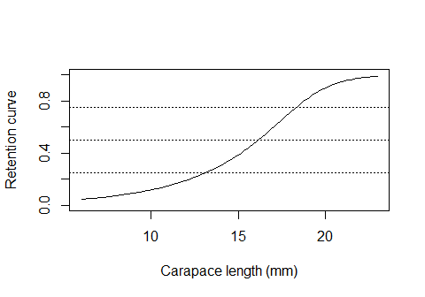
par(mfrow=c(1,2))
ModelCheck(Rich.fit, xlab="Carapace length (mm)")
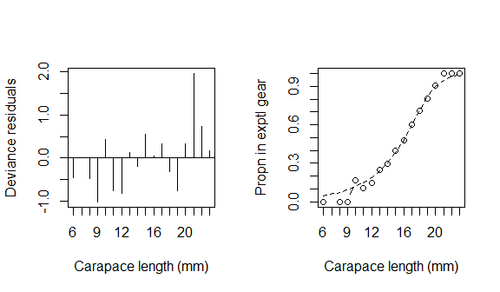
## Model fit:
## null.l model.l full.l npar AIC BIC
## -370.68605 -34.03063 -29.77578 3.00000 74.06125 76.56089
## GOF:
## Deviance Pearson.chisq dof Deviance.CF Pearson.CF
## 8.5097014 5.6168274 14.0000000 0.6078358 0.4012020
Estimates(Rich.fit)
## par raw s.e.
## L25 13.165287 0.31172347
## L50 16.170395 0.07621766
## L75 18.335320 0.07830442
## SR 5.170033 0.33887230
## delta 3.318629 1.19486367
The Richards fit eliminates the pattern in the residuals, and moreover it has considerably lower AIC than the logistic fit. Hence, the Richards is preferred. It estimates L50 and SR of 16.2 and 5.2 mm, respectively. Note the asymmetry in the L25 and L75 values around the L50 value.

Between-haul variation
CAUTION: The estimated standard errors shown above are not valid to use due to the presence of between-haul variability. The lattice plot below shows retained proportions for individual deployments. to

Produce a lattic plot of retention proportions by haul
HaulCatch=Raw2Tots(Stow.df,v.names,q.names,sumHauls=F)
HaulCatch=transform(HaulCatch,n=codend+cover,y=codend/(codend+cover))
require(lattice) #For xyplot
## Loading required package: lattice
xyplot(y~lgth | Haul,data=HaulCatch)
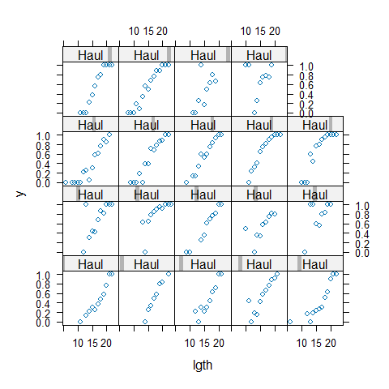
There is some consistency between hauls, but also considerable between-haul (BHV) variation is shown. Note that haul 5 (bottom right) suggests an L50 of about 18 mm while other hauls suggest an L50 of around 15 mm.

Fit a Richards selection curve to the stacked individual-haul data
Fitting to the combined individual-hauls data allows for proper quantification of between-haul variability.
Rich.fit2=SELECT(Stow.df,var.names=v.names,q.names=q.names,stype="richards",
sumHauls=F)
ModelCheck(Rich.fit2, xlab="Carapace length (mm)", minE=5, plots=F)
## Model fit:
## null.l model.l full.l npar AIC BIC
## -984.2317 -647.5763 -218.2059 3.0000 1301.1526 1311.2365
## GOF:
## Deviance Pearson.chisq dof Deviance.CF Pearson.CF
## 858.740853 814.138287 210.000000 4.089242 3.876849
##
## Correction factors from cells with expected count > 5 :
## Deviance Pearson.chisq dof Deviance.CF Pearson.CF
## 742.15150 714.76893 71.00000 10.45284 10.06717
The variance correction factor Pearson.CF shows that the actual variabilty could be about 10 times that assumed under the binomial model.
With this amount of variability a bootstrap should be reasonable for appropriately quantifying the variability in the estimated parameters. (The bootstrap over-estimates parameter uncertainty if BHV is slight.)

Define function to return quantities of interest
The function defined below returns L25, L50, L75, SR, and also the predicted retention probabilities for lengths from 5 mm to 25 mm.
BootStats=function(data,var.names,q.names){
Fit=SELECT(data,var.names,q.names=q.names,stype="richards")
Pars=Estimates(Fit)[1:4,"par"]
Preds=predict(Fit,lens=5:25)[,3]
c(Pars,Preds)
}
#Check that BootStats works
BootStats(Stow.df,v.names,q.names)
## L25 L50 L75 SR
## 13.16528680 16.17039495 18.33532000 5.17003320 0.03526595 0.04484206
##
## 0.05701808 0.07249918 0.09218051 0.11719606 0.14897580 0.18930442
##
## 0.24035749 0.30464257 0.38465331 0.48180256 0.59397994 0.71196912
##
## 0.81890771 0.89900084 0.94870318 0.97543596 0.98860477 0.99479578
##
## 0.99764062

Implement a bootstrap
The bootstrap can produce some warning messages, but these can be ignored as they occur from unnecessary diagnostics calculated after each bootstrap fit.
nsim=1000 #Use at least 1000 in practice
BootOut=bootSELECT(Stow.df,v.names,q.names,BootStats,haul="Haul",paired=T,
nsim=nsim,verbose=F) #Use verbose=T to see progress
## Warning in sqrt(diag(varpars)): NaNs produced
## Warning in sqrt(diag(varpars)): NaNs produced
## Warning in sqrt(diag(varpars)): NaNs produced
## Warning in sqrt(diag(varpars)): NaNs produced
## Warning in sqrt(diag(varpars)): NaNs produced
## Warning in sqrt(diag(varpars)): NaNs produced
## Warning in sqrt(diag(varpars)): NaNs produced
## Warning in sqrt(diag(varpars)): NaNs produced
## Warning in sqrt(diag(varpars)): NaNs produced
## Warning in sqrt(diag(varpars)): NaNs produced
## Warning in sqrt(diag(varpars)): NaNs produced
## Warning in sqrt(diag(varpars)): NaNs produced
## Warning in sqrt(diag(varpars)): NaNs produced
## Warning in sqrt(diag(varpars)): NaNs produced
## Warning in sqrt(diag(varpars)): NaNs produced
##
## Bootstrap successfully completed
Now, calculate the bootstrap standard errors of L25, L50, L75, SR, and produce the 95% simultaneous bootstrap confidence band. Unlike pointwise confidence bands, we can be 95% confident that the true curve lies entirely within the simultaneous confidence band.
Boot.Pars=BootOut[,1:4] #Extract L25, L50, L75 and SR
Boot.Preds=BootOut[,-(1:4)] #Extract predicted values
Predicted.Propns=predict(Rich.fit,lens=5:25)[,3]
cat("Bootstrap estimated standard errors are\n",apply(Boot.Pars,2,sd))
## Bootstrap estimated standard errors are
## 0.5354391 0.513871 0.4844088 0.5507865
BootPlot(Boot.Preds,5:25,Predicted.Propns,Tots, show.pointwise=T)
##
## initial.pointwise.coverage: 0.95
## initial.simultaneous.coverage: 0.792
## adjusted.pointwise.coverage: 0.99375
## adjusted.simultaneous.coverage: 0.95
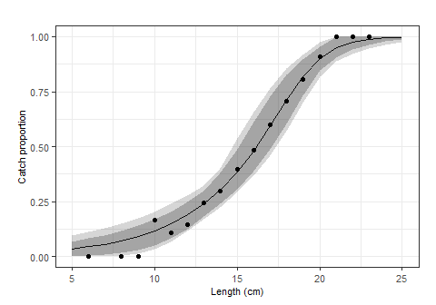
This bootstrap plot also shows the pointwise confidence bands (dark band). This could be usedif one is interested in an a-priori hypothesis or interval For example, the dark band could be used to give a 95% confidence interval for L50. However, statements about the general properties of the retention curve require use of the simultaneous (grey) confidence band.

Semiparametric analysis
The Richards fit does estimate somewhat high retention for very small prawns, so here we explore the performance of a semiparametric fit using the SELECT function SplineSELECT.

Fit a spline selectivity curve
require(mgcv)
Spline.fit=SplineSELECT(Stow.df,var.names=v.names,q.names=q.names,
k=7,quasi=F)
plot(Tots$lgth,resid(Spline.fit),type="h")
abline(h=0)
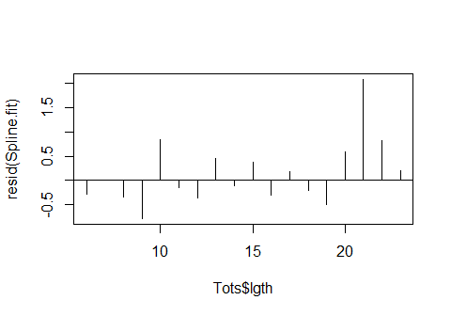
plot(y~lgth,data=Tots,xlab="Carapace length (mm)")
points(Tots$lgth,fitted(Spline.fit),type="l")
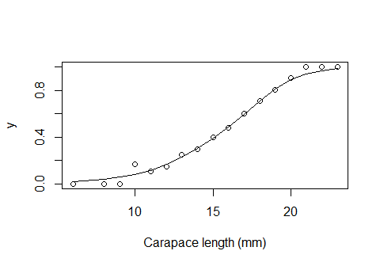
AIC(Spline.fit)
## [1] 75.95761
The spline fit achieves a nice fit, but does have somewhat higher AIC than the Richards.
To get the length corresponding to a specific retention probability the uniroot function can be used. The code below defines a function call Diff that, for a given length, returns the difference between the retention probability at that length and the target retention probability. It searches across a given range of lengths to find the one that sets the value of Diff to zero. For example, to find L50,
Diff=function(len, target.prob=0.5)
predict(Spline.fit,data.frame(lgth=len),type="response") - target.prob
#Search over lengths between 10 and 20
uniroot(Diff,c(10,20))$root
## [1] 16.1307
The L50 of the fitted spline curve is 16.1 mm.

The three fitted curves
Finally, we produce a plot overlaying the three curves that have been fitted, logistic, Richards, and spline.
plot(Logist.fit, xlab="Carapace length (mm)")
points(Tots$lgth,fitted(Rich.fit),type="l",lty=2)
points(Tots$lgth,fitted(Spline.fit),type="l",lty=3)
legend(6,1,legend=c("logistic","Richards","spline"),lty=1:3)
