SELECT package demonstration
Paired-haul relative selectivity

Summary
This case study demonstrates:
- Reading data from separate gear-specific files and merging them pairwise into a single data frame.
- Working with sub-sampled data.
- Fitting catch share (relative selectivity) curves using splines via the SplineSELECT function.
- Fitting catch share curves using an improved version of the averaged polynomial approach via the PolySELECT function (see bottom part of the code).
- Using the bootstrap function bootSELECT to estimate the uncertainty in the catch share curve.
- Using BootPlot to visualize simultaneous bootstrap confidence intervals.
- Using the permutation function permSELECT to quantify the evidence:
  - for a length effect on the catch share.
  - that the gears are not identical (i.e., catch comparison is not equal to 0.5 for all lengths).
  - that the proportion of commercial sized prawns differs between gears.

Data source
The data are for school prawn relative selectivity in penaeid trawls from the experiments conducted by Broadhurst et al., (2018, T45 side panels improve penaeid-trawl selection. Fisheries Research, 204: 8-15).
The data used here are from the twin-trawl experiment that fished two trawls differing in square mesh sizes used for the side panel, 32 mm or 35 mm. There are 12 such twin-trawls.

Load required packages
require(mgcv)
require(SELECT)
require(readxl) #This package is installed with tidyverse
nsim=nperm=40 #For bootstrapping and permutation tests, set to >=999 in practice
#source("T:/Russell_SSD/ACTIVE/CurrentWork/RPackages/SELECT/R/BOOTSTRAP&PERMUTATION.R")

Read in the data
The data for each mesh size are in individual xlsx files and require merging.
GearA.df=read_excel("SchoolPrawnLenFreqs.xlsx", sheet = "32 square trawl")
GearB.df=read_excel("SchoolPrawnLenFreqs.xlsx", sheet = "35 square trawl")
#The "Day" variable is actually the unique haul-pair identifier
GearA.df = GearA.df |> rename(Haul=Day, nA=No.school, sfA=Sf.school)
GearB.df = GearB.df |> rename(Haul=Day, nB=No.school, sfB=Sf.school)

Merge the separate dataframes to create a dataframe for the twin hauls
Note the conversion from sub-sampling scaling factors to sampling fractions and removal of CLs that are outside of the range of measured data.
The data files contain counts from tows when the square side-panel trawls were paired against a conventional, so only the tow IDs that match in both files are used. Here, this is most easily done using inner_join, since the lengthclasses are the same for every tow (inner_join should not be used otherwise).
#Merge the gears with the same identical haul-pair ID (i.e., twin tows)
Pairs.df = inner_join(GearA.df,GearB.df,by=c("Haul","CL"))
#Convert scaling factors to sampling fractions
Pairs.df = Pairs.df |>
transform(qA=1/sfA,qB=1/sfB) |> filter(CL>=5 & CL<=25)
#write.csv(Pairs.df,"Pairs.RData",row.names=F)

Define variable names
names(Pairs.df)
## [1] "Haul" "CL" "nA" "sfA" "nB" "sfB" "qA" "qB"
vNames=c("CL","nA","nB")
qNames=c("qA","qB")

Bootstrap

Define a prediction function to be used with the bootstrap
This fit used the SplineSELECT defaults, but more generally one may want to try other values of k, say 5 and 10.
#Define the bootstrap prediction function
CLseq=5:23 #Carapace lengths to use for predn
PrednFnc=function(data,var.names,q.names) {
SplineFit=SplineSELECT(data,var.names,q.names) #Using spline defaults
predict(SplineFit,newdata=data.frame(CL=CLseq),type="response") }
#Check that it works
predn=PrednFnc(Pairs.df,vNames,qNames)
#Plot predictions against observed proportions
Tots.df=Raw2Tots(Pairs.df,vNames,qNames) |>
transform(lgth=CL, y=nB/(nA+nB))
plot(y~CL,data=Tots.df,ylim=c(0,1),xlab="Carapace length (mm)",
ylab="Gear B catch share")
points(CLseq,predn,type="l")
abline(h=0.5,lty=3)
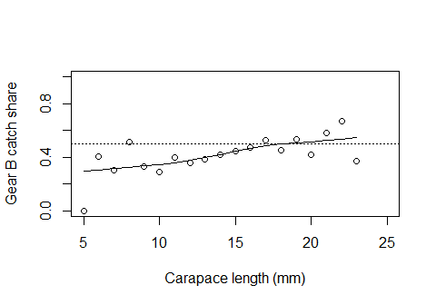

Do the bootstrap of the catch share curve
BootPreds=bootSELECT(Pairs.df,vNames,qNames,PrednFnc,haul="Haul",nsim=nsim,
paired=T,verbose=F) #Use verbose=T to see progress
##
## Bootstrap successfully completed

Simultaneous bootstrap confidence band plots
BootPlot(BootPreds,CLseq,predn,Data=Tots.df) +
geom_hline(yintercept=0.5,linetype="dashed")
## Warning in BootPlot(BootPreds, CLseq, predn, Data = Tots.df): Few valid
## bootstrap replicates - intervals may be unreliable
##
## initial.pointwise.coverage: 0.95
## initial.simultaneous.coverage: 0.675
## adjusted.pointwise.coverage: 1
## adjusted.simultaneous.coverage: 0.925
## Warning: Removed 2 rows containing missing values or values outside the scale range
## (`geom_point()`).
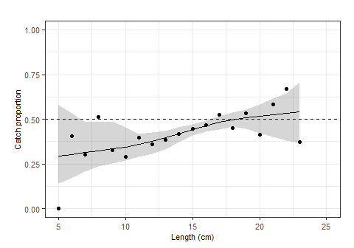
#With pointwise confidence band also shown
BootPlot(BootPreds,CLseq,predn,Data=Tots.df,show.pointwise=T) +
geom_hline(yintercept=0.45,linetype="dashed")
## Warning in BootPlot(BootPreds, CLseq, predn, Data = Tots.df, show.pointwise =
## T): Few valid bootstrap replicates - intervals may be unreliable
##
## initial.pointwise.coverage: 0.95
## initial.simultaneous.coverage: 0.675
## adjusted.pointwise.coverage: 1
## adjusted.simultaneous.coverage: 0.925
## Warning: Removed 2 rows containing missing values or values outside the scale range
## (`geom_point()`).
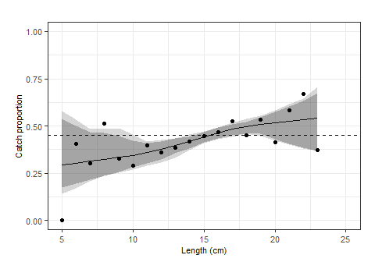
#Setting limits to include only lengths where >30 prawn caught
#This reduces the number of multiple comparisons
BootPlot(BootPreds,CLseq,predn,Data=Tots.df,show.pointwise=T,
limits=c(9,21)) +
geom_hline(yintercept=0.5,linetype="dashed")
## Warning in BootPlot(BootPreds, CLseq, predn, Data = Tots.df, show.pointwise =
## T, : Few valid bootstrap replicates - intervals may be unreliable
##
## initial.pointwise.coverage: 0.95
## initial.simultaneous.coverage: 0.75
## adjusted.pointwise.coverage: 1
## adjusted.simultaneous.coverage: 0.95
## Warning: Removed 2 rows containing missing values or values outside the scale range
## (`geom_point()`).
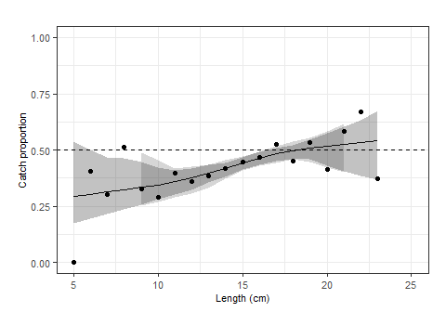

Permutation test(s)

Define a function to return permutation statistic(s)
For school prawns the commercial minimum landed carapace length is MLS=15 mm. In this example MLS=15 is passed to the SplineStatistics function so that it will also calculate the ratio of the proportion of commercial sized prawns in gear B versus gear A.
StatsFnc=function(data,var.names,q.names) {
SplineFit=SplineSELECT(data,var.names,q.names) #Defaults
SplineStatistics(SplineFit,MLS=15) }
#Check that it works
ObsStats=StatsFnc(Pairs.df,vNames,qNames)
ObsStats
## DevExpl EqualDevExpl null Equal full
## 0.7180213 0.8881293 -83.0303441 -140.1892519 -45.4400569
## model LRT EqualLRT RatioPropnMLS PropnGear2
## -56.0397163 53.9812556 168.2990712 1.1949629 0.4301829

Do permutations
PermStats=permSELECT(Pairs.df,vNames,qNames,StatsFnc,haul="Haul",nsim=nperm,
paired=T,verbose=F) #Use verbose=T to see progress
##
## Permutations successfully completed
colnames(PermStats)=names(ObsStats) #To add column names to PermStats
The permPval function is used to calculate the permutation p-values
Stat="LRT" #Likelihood ratio test for a length effect
cat("The observed",Stat,"is",ObsStats[Stat],"\n")
## The observed LRT is 53.98126
pval=permPval(ObsStats[Stat],PermStats[,Stat])
cat("The permutational p-value for a length effect is",pval,"\n")
## The permutational p-value for a length effect is 0.02439024
Stat="EqualLRT" #LRT for equivalence, i.e., catch comparison=0.5 for all lengths
cat("The observed",Stat,"is",ObsStats[Stat],"\n")
## The observed EqualLRT is 168.2991
pval=permPval(ObsStats[Stat],PermStats[,Stat])
cat("The permutational p-value for equivalence is",pval,"\n")
## The permutational p-value for equivalence is 0.02439024
Stat="RatioPropnMLS" #Proportion of large fish in gear B compared to in gear A
cat("The observed",Stat,"is",ObsStats[Stat],"\n")
## The observed RatioPropnMLS is 1.194963
pval=permPval(ObsStats[Stat],PermStats[,Stat])
cat("The permutational p-value for equal propns of large fish is",pval,"\n")
## The permutational p-value for equal propns of large fish is 0.02439024

Demonstration of the averaged-polynomial catch curve
This is included for completeness - we recommend using the spline approach instead of the averaged polynomial approach.
The default use of PolySELECT includes improvements to the Herrmann et al. (2017) implementation by reducing the tendency of the averaged polynomial to overfit. See PolySELECT documentation for details.

Averaged polynomial fits
require(MuMIn) #For MuMIn::dredge
options(na.action = "na.fail") #To ensure dredge terminates if there are NAs
#The default averaged-polynomial fit
PolyFit=PolySELECT(Pairs.df,vNames,qNames)
#The averaged-polynomial fit used by Herrmann et al. (2017)
HerrmannFit=PolySELECT(Pairs.df,vNames,qNames,q.ODadjust=F,quasi=F,All=T)
par(oma=c(0,0,0,0),mar=c(4,4,1,4),las=1)
PolyPredn=predict(PolyFit$avg.fit,newdata=data.frame(CL=CLseq),
type="response")
HerrmannPredn=predict(HerrmannFit$avg.fit,newdata=data.frame(CL=CLseq),
type="response")
plot(y~CL,data=Tots.df,ylim=c(0,1),xlab="Carapace length (mm)",
ylab="Gear B catch share")
points(CLseq,predn,type="l",col="blue") #Spline
points(CLseq,PolyPredn,type="l",col="blue",lty=2) #PolySELECT
points(CLseq,HerrmannPredn,type="l",col="red",lty=2) #Herrmann et al. (2017)
legend("topleft",
legend=c("Spline","order-weighted quartic","32-submodel quartic"),cex=0.8,
col=c("blue","blue","red"),lty=c(1,2,2),bty="n")
abline(h=0.5,lty=3)
