Design Document

Prasoon Nath

[prasoon.nath15@gmail.com](mailto:prasoon.nath15@gmail.com)

# Stylumia Internship Drive

Developed Software: Blog (front-end and back-end)

The software has been developed using PHP and MySQL(phpMyAdmin).

# Front-end Design

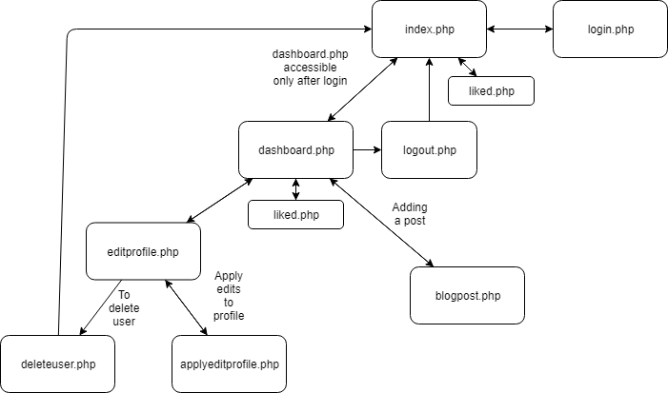

The front-end consists of four publicly visible PHP pages: dashoard.php , index.php, editprofile.php and login.php.

**Index.php** or the first page is the page where a user first interacts with the site.

It has a search bar which helps in finding a specific blog page. For the user to like or access dashboard he has to sign-in (Dashboard will redirect back to index.php without sign-in).

Index.php links to 2 webpages- dashboard.php and login.php.

**Login.php** is the page where a user login or registers himself to make an account on the site.

All the fields are required to be filled for submitting both the sign-in and the sign-up form. Username is checked if available during sign-up. If duplicate username is submitted an error message is sent back to the login page,” Username already taken”. An incorrect username will show an error,” Wrong Password or Username”.

Upon successful sign-up the user has to login by putting his valid credentials. Upon logging in the session variables are created.

**Dashboard.php** is the page where a user can add posts. Upon adding a post, a user can see his blog posts and even like his own post.

Dashboard.php also gives access to the user to edit his profile by clicking on” Edit Profile”.

**Editprofile.php** allows user to edit his username, firstname, lastname, password and email address. The provides the user with prefilled fields that the user filled during sign-up. The user can make changes in those fields and press “Submit”. The page also provides the user to delete his profile, thus removing him from all the tables in the database.

The other php documents used in the software are: applyeditprofile.php, blogpost.php, liked.php, loginaction.php, logout.php, deleteuser.php and signup.php.

All these php pages return back to login.php except signup.php when entered without login.

**Signup.php** inputs the details entered by the user during sign-up. Before entering the details into the database,it checks if the password is of length 8 or not and if the username is available or not. Then the page is redirected to login.php.

**Loginaction.php** checks if the username and the password are correct or not. The passwords are encoded into MD5 and then matched with the hash retrieved from the table **credentials**.

**Logout.php** destroys session and redirects to index.php

**Liked.php** records the like given by a user to a post in the database table **likes.**

**Blogpost.php** submits the blog post written by the user to the database table **blogs.**

**Applyeditprofile.php** updates the user details already in the database tables info and credentials.

**Deleteuser.php** deletes the user data from all the tables in the database.

# Back-end Design

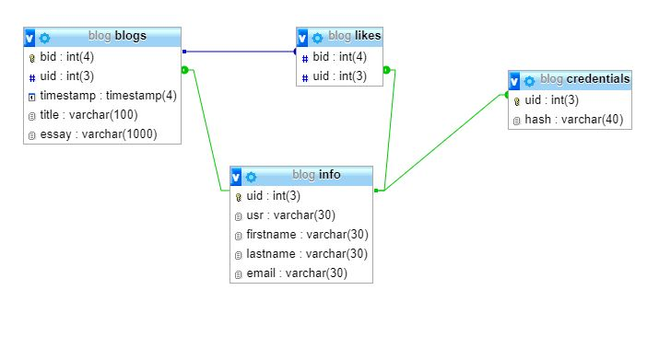

To support the features of the blog, the database consist of 4 tables- blogs, likes, credentials and info.

**Info:** Consists of uid(Primary Key), usr, firstname, lastname and email.

The table stores the general information of the user that he fills during sign-up.

The uid is used as primary key to represent these data items across the whole database.

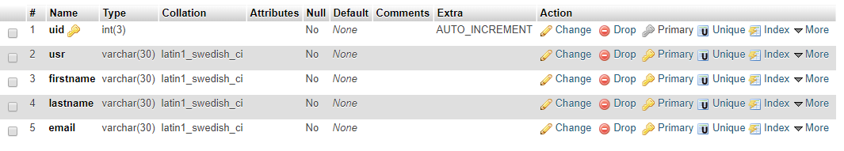

**Credentials:** Consists of uid(Foreign Key) and hash.

Uid represents the user details and hash is the MD5 hash of the password set by the user.

*Instead of storing password in plain-text I have used MD5 hash to store passwords as is recommended*. *For verification of passwords the entered password will be encoded in MD5 and then matched.*



**Blogs:** Consists of bid(Primary Key), uid(Foreign Key), timestamp, title and essay as the attributes.

bid is used as a primary key to represent the blog data across the database. Uid refers to the user who added the blog post. Timestamp is the time at which the post was added. Title refers to the title of the post. And essay refers to the whole blog post.

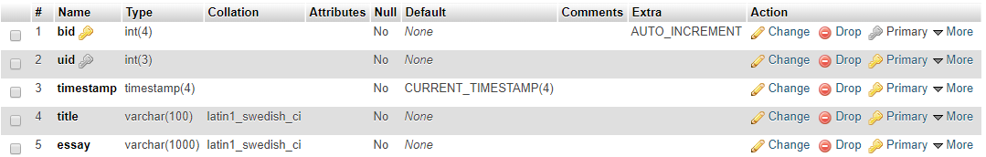

**Likes:** Consists of bid(Foreign Key) and uid(Foreign key)

This table has been made for recording the likes given by the users on blog posts. Bid represents the blog and uid the user who gave the like.

