**IST 263 Exam 1 Guide**

**General Procedures and Format**

* test is closed book
* test is on paper
* the test will include a syntax guide
* 20 multiple choice questions worth 4 points each
* 4 short answer questions worth 5 points each
* the short answers could be writing HTML or   
  writing a few sentences to explain a concept

**Tips**

* Use the review questions in blackboard to prepare.

**Exam Topics**

* Unit 1 - Github, Required page HTML (doctype, html, head, body, meta, title), how the web works, internet history, web vocabulary

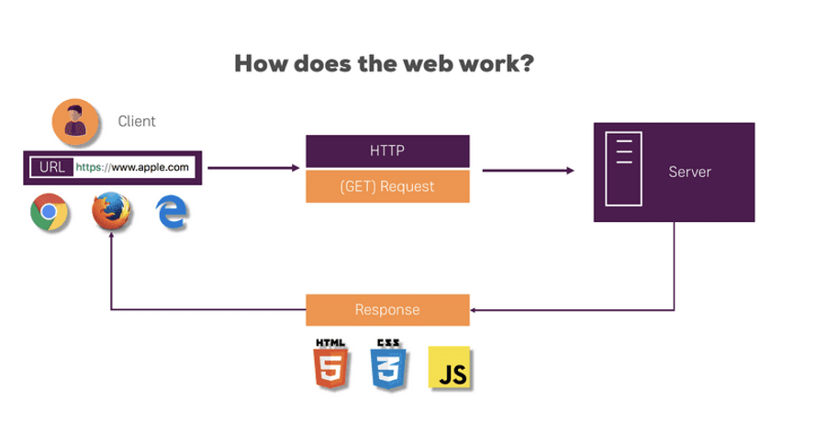

* URL (client)- HTTP (GET request)- server = response

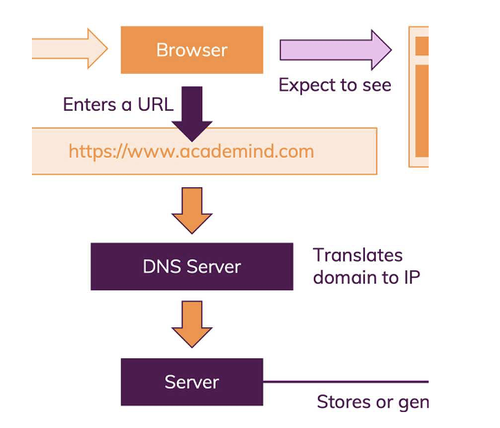

* Browser expected to see=URL- DNS server (translates domain to IP)- server (stores or gen)

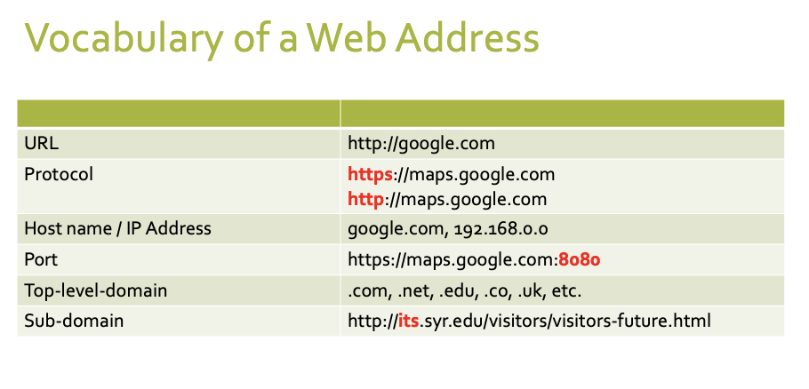

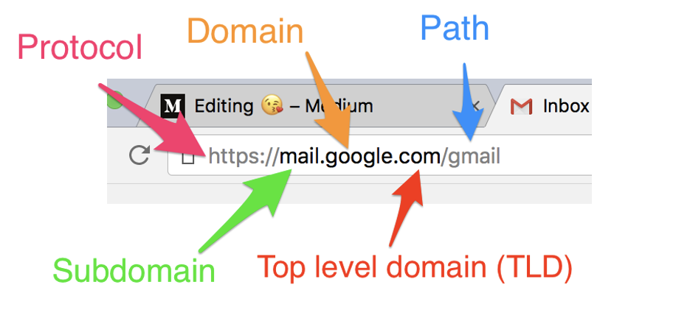

**A basic web page**

* Web pages are text
* The extension at the end of the file tells the browser how to interpret the files
* .htm or .html means that you are sending the browser an HTML file
* Index.html is a common name for a website’s home page

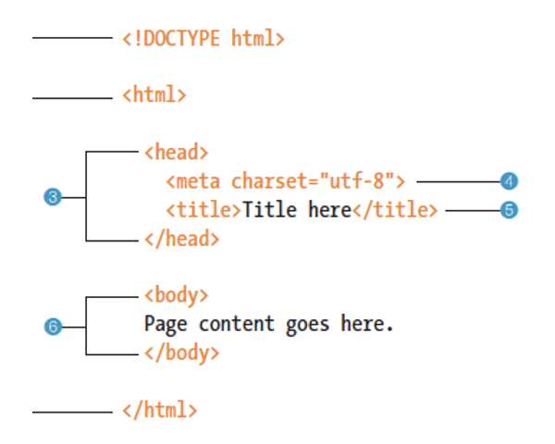

* Unit 2 – what is a tag/element, block vs inline, void elements, character escapes, lists, validating html

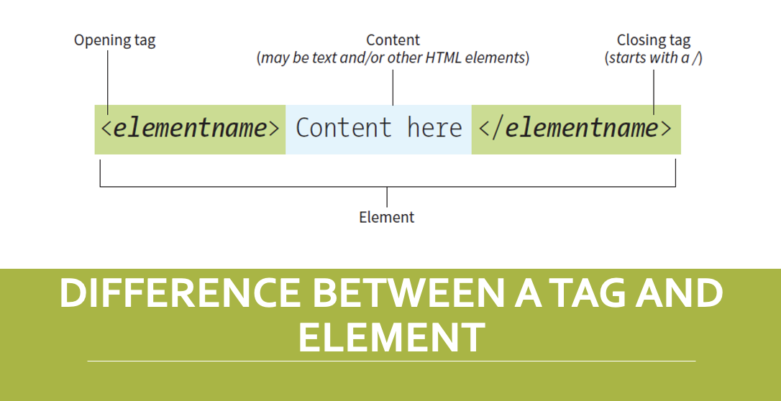

**HTML comments**

* <!—this is where you put notes that don’t display in your web browser
* A comment usually starts with <!—
* And ends with -->

**What is Lorem ipsum?**

* Dummy or placeholder text
* Used in laying out print, infographics, or web design
* Primary purpose is to create text that does not distract from the overall layout and visual hierarchy

**Block**

* a block-level element always starts on a new line
* always takes up the full width available (stretches out to the left and right as far as it can)
* has a top and bottom margin, whereas an inline element does not

**Inline**

* an inline element does not start on a new line
* only takes up as much width as necessary

**Void elements**

* void- HTML tags that are self-closing
* paragraph has a closing tag <p> the paragraph tag is not a void tag. </p>
* a void tag like line break has no closing tag <br>

**Character escapes**

* an HTML character escape is a piece of text (“string”) that begins with an ampersand (&) and end with a semicolon (;). Entities are frequently used to display reserved characters like ∞ © ® ™ Ω α
* character code for the infinity symbol: &infin;
* https://www.w3schools.com/html/html_symbols.asp

**Lists**

* types of lists
  + unordered
    - item one
    - item two
    - item three
  + ordered
    - 1. Item one
    - 2. Item two
    - 3. Item three
  + Definition
    - Item one title- item one description
    - Item two title- item two description
* Unit 3 – intellectual property, html attributes, links and parts of the link tag, relative link and images paths, external links, target attribute, mail links, images, embedding content

**HTML attributes**

* All HTML elements can be attributes
* Attributes are always specified in the start tag
* Attributes provide additional information about elements
* Attributes usually come in name/value pairs like: name=”value”

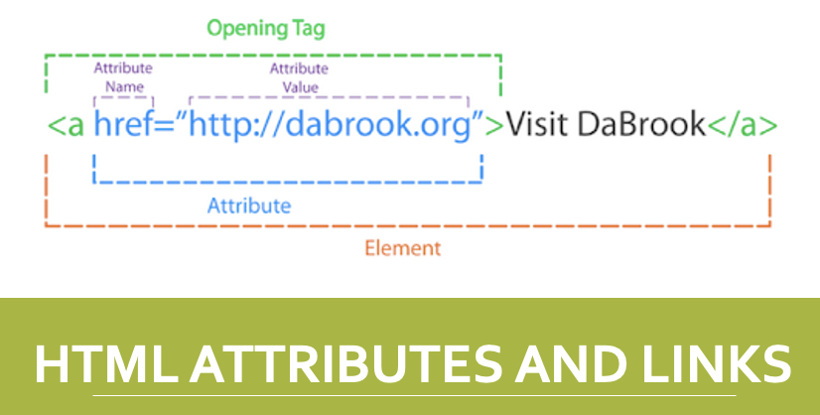

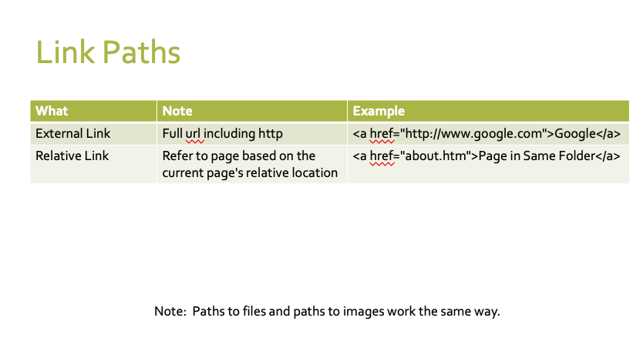

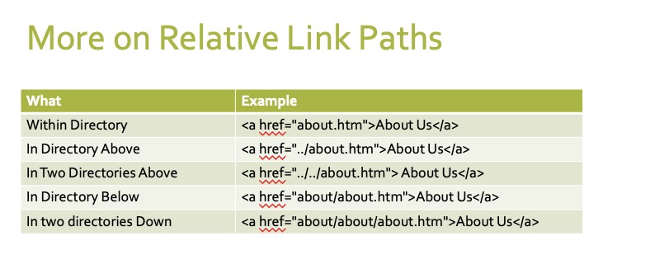

**Path Rules**

* Determine the folder your file resides in
* Traveling only along the lines figure out the path you want to travel to get to the folder that contains the file you want to link to
  + Every time you go to a parent folder you add a ../
  + Every time you go down to a sub folder you add a /folder_name where folder_name is the actual name of your folder
* Once you have arrived at the correct foler, add a /filer_name to the end of your path where file_name is the actual name of your file

**Images**

* Web images formats: PNG, JPEG, or GIF
* Element- img is a void element
* Src attribute specifies image location
* Alt attribute describes image as text
* <img src="images/photo.jpg" alt="my photo">

**Embedding with the <iframe> tag**

* An inline frame is used to embed another document within the current HTML document
* Title attribute describes the content of the iframe and should always be used
* <iframe src="https://www.w3schools.com" title="W3Schools Free Online Web Tutorials"></iframe>

* Unit 4 – tables, table elements (table, td, th, tr), forms, form method attribute (get vs post), form action attribute, labels, form elements (input, submit, radio, select, check boxes, textarea)

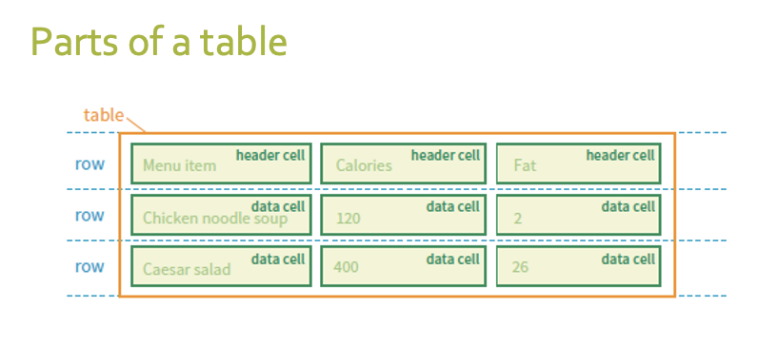

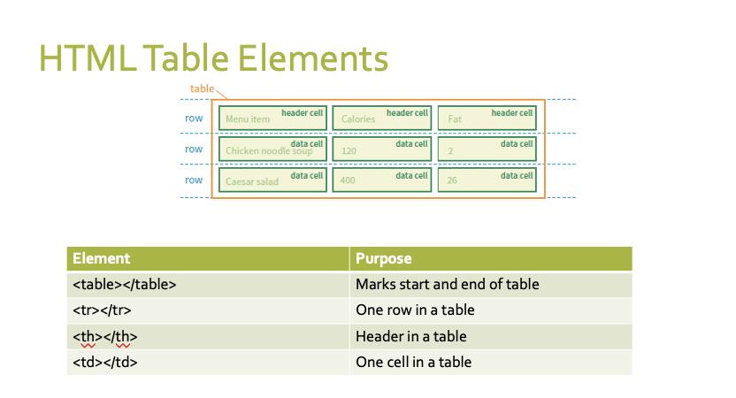

**Form element**

* <form action="" method="">

</form>

* Tells you where a form begins and ends
* Will contain elements with form control elements (checkboxes, dropdowns text boxes, etc.)
* Defines how form is processed and what method is used to send data

**Form attribute method**

* What is “get”
  + Sends the form data across the url
* What is “post”
  + Sends the form data on a special header with the http requ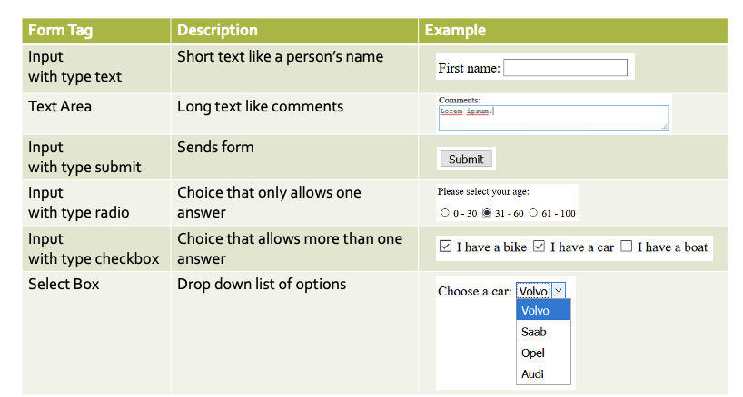

**Input type text**



* <input type="text" id="fname" name="fname">

