1. Submit the urls for the index page.

<https://rbnalitt.github.io/ist263/lab10/contact.html>

<https://rbnalitt.github.io/ist263/lab10/skills.html>

<https://rbnalitt.github.io/ist263/lab10/index.html>

Having trouble with my Github.

1. Validate the index and contact page and submit the validation links.

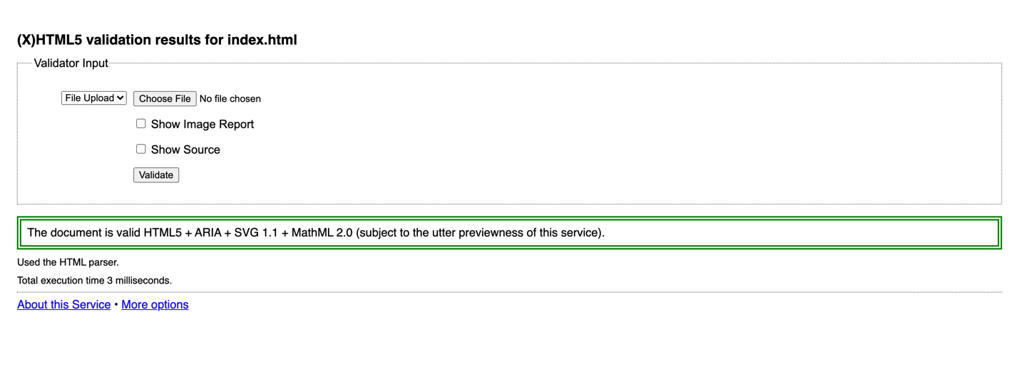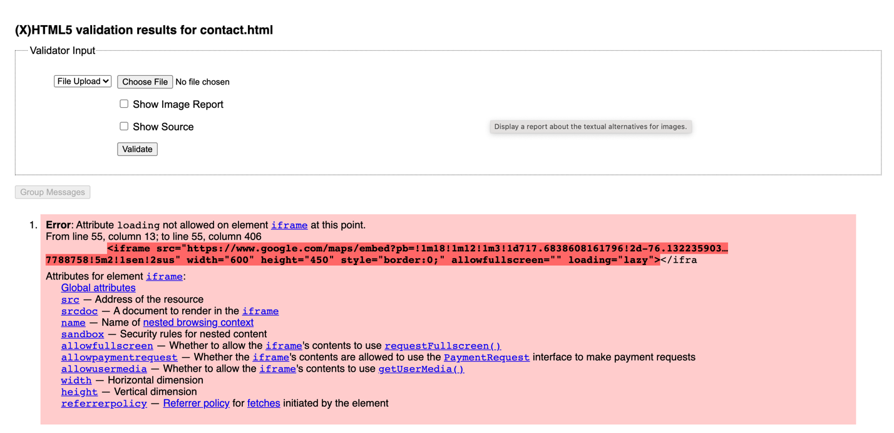

1. Submit answers to the following:
   1. What questions did you have about the lab? What didn't you fully understand?

I had a question when sizing the image and naming it as a descendent selector instead of a class.

* 1. What was the hardest part of the lab?

The hardest part of the lab was figuring out how to name the media tag and size it.

* 1. Rate your comfort level with this week's topics.  
     2 ==> I can do this on my own without any help.