**Analyzing the Impact of the Post-COVID-19 Nursing Shortage**

**Healthcare Systems and Nurses’ Intention to Leave**

by

Ronelle N.M. Bobb

Business Analytics

BUS 798

Joshua Lambert PhD.

University of South Alabama

Mitchell College of Business

November 16, 2024

rb2323@jagmail.southalabama.edu

ID: J00738214

**Enhancing Patient Experience: An Analysis of Patient Satisfaction**

**in National Healthcare**

1. **Introduction**

The COVID-19 pandemic has posed unprecedented challenges to healthcare systems worldwide, leading to an increased demand for healthcare services, including nursing care (Lopez et al., 2022; Turale & Nantsupawat, 2021). According to González-Gil et al.(2021), the COVID-19 pandemic has heightened the demand for nurses, with critical care nurses, emergency room nurses, infection control nurses, public health nurses, respiratory nurses, telehealth nurses, mental health nurses, and senior nurses being in high demand. Moreover, Hickey et al.(2020) stated that critical care nurses manage critically ill patients, emergency room nurses manage the influx of patients, infection control nurses prevent and control infectious diseases, public health nurses conduct mass testing and public education campaigns, respiratory nurses manage respiratory complications, telehealth nurses provide remote care, mental health nurses provide support to patients and healthcare workers, and senior nurses care for vulnerable older adults. Auerbach et al. (2024) projects that by 2035, the demand for nurses is anticipated to expand at a rate of 47% by Registered Nurses (RNs). The pandemic underscores the importance of these nursing specialties and the need for a flexible workforce (Hall et al., 2020; Tomblin Murphy et al., 2022& Martin et al., 2023).

However, Stubbs & Skillman (2020) depicted that before the COVID-19 pandemic, the nursing shortage was mainly due to an ageing nursing workforce approaching retirement and an insufficient number of new nurses to replace them. This issue was compounded by increased demand for healthcare services from an ageing population and high turnover and burnout rates among nurses, exacerbated by stressful work environments and often insufficient staffing (De Vries et al., 2023). As healthcare facilities struggled to manage the surge in COVID-19 cases, many healthcare workers, including nurses, were stretched to their limits (Gupta et al., 2021). Lopez et al. (2022) indicated that healthcare facilities were inundated with COVID-19 patients, significantly straining their capacity. This surge resulted in highly high workloads for nurses, who had to contend with both the physical and emotional challenges of treating a large number of critically ill patients, often in environments with limited resources and heightened risk of infection. While the need for nurses across all specialties remains high, emergency care nurses, in particular, have been in exceptionally high demand (Hoot & Aronsky, 2008). This demand was further intensified during the pandemic, underscoring their critical role during health crises (Ranney et al., 2020).

Even before the COVID-19 pandemic hit, there was already a notable shortage of nurses, influenced by a range of factors. Specifically, in the United States, the combination of an aging populace requiring more healthcare and a substantial segment of nurses approaching retirement heavily strained the healthcare infrastructure (Buerhaus et al., 2017). The onset of the pandemic further intensified this pre-existing nursing deficit, raising alarms about its enduring implications for healthcare systems and patient well-being (Martin et al., 2023). Flaubert et al. (2021) state that the pandemic escalated the nursing deficit as healthcare demands soared, especially for critical COVID-19 care. Nurses faced unprecedented workloads and stress due to the sheer number of patients and the complexity of their care needs. This scenario put immense pressure on healthcare systems and risked compromising patient well-being due to stretched resources and personnel.

During the COVID-19 pandemic, the nursing shortage notably compromised patient care quality, leading to prolonged hospital stays and, in some cases, adverse outcomes (Tamata & Mohammadnezhad, 2023). The deficit in skilled nursing professionals also strained hospital resources, contributing to burnout among existing staff and potentially impacted the overall recovery rates of COVID-19 patients (Shanafelt et al., 2020).

1. **Literature Review**

The nursing shortage has been an ongoing concern in many countries (Chan et al., 2013; Haddad et al., 2018). This global shortage of the nursing workforce stems from a myriad of reasons, encompassing individual educational, organizational, managerial and policy-making dimensions (Tamata & Mohammadnezhad, 2023). In particular, several factors, including an aging population, retirement of experienced nurses, and increased healthcare demand, have contributed to this shortage (Haddad et al., 2018). In addition, Flaubert et al. (2021) showed that the global nursing shortage arises from many interconnected variables. States with higher health equity measures will exhibit significantly greater patient satisfaction scores, mediated by the quality of nurse communication and equity commitment. The need for nursing professors and the restricted capacity of nursing programmes hinder the influx of graduates into the industry. This problem is exacerbated by the high rate nurses leave their jobs, typically due to burnout, stressful work environments, and insufficient pay, causing many to resign or retire prematurely. In addition, González-Gil et al. (2021) asserted that some nurse specializations, such as elderly, psychological, and critical care, experience more severe shortages. These domains necessitate specific expertise and instruction, and the scarcity of specialists in these disciplines can result in notable deficiencies in patient care.

In addition, Bengtsson et al. (2023) have shown that economic limitations in healthcare systems with insufficient funding can play a role in the shortage by impacting the capacity to attract and retain nursing personnel. Moreover, there is a significant discrepancy in the spatial allocation of nurses, whereby rural and underserved regions frequently have more acute deficiencies in staffing. To address this crisis effectively, it is necessary to adopt a comprehensive strategy that encompasses expanding educational possibilities, enhancing working conditions, and providing improved personal development and assistance. Policy reforms aimed at equitable distribution of nurses and increased investment in healthcare are also essential to address this global issue effectively (González-Gil et al., 2021). For these reasons, specialties such as psychiatric nursing, critical care and geriatric care have been pinpointed as areas facing significant shortages (Smiley et al., 2018; Stubbs & Skillman, 2020).

Likewise, the importance of developing a reliable nurse retention strategy within the hospital environment is widely acknowledged (De Vries et al., 2023). González-Gil et al. (2021) mentioned that developing a reliable nurse retention strategy is crucial because retaining experienced nurses leads to better patient care and outcomes. Experienced nurses possess critical knowledge and skills, ensuring high-quality care and efficiency. Moreover, Tamata & Mohammadnezhad (2023) stated that high turnover rates can be costly for hospitals financially and in terms of patient care continuity. Stable staffing improves team dynamics and morale, reducing burnout and fostering a more supportive work environment, benefiting staff and patients. Retaining experienced nurses in hospitals is pivotal for ensuring optimal patient outcomes and economic efficiency, as consistent staffing reduces associated turnover costs, fosters better organizational dynamics, and preserves invaluable nursing expertise (Flaubert et al., 2021; Hayes et al., 2006). Therefore, to maintain optimal patient care, reduce costs, and ensure hospital functionality, it's imperative to address nursing retention and staffing challenges (Clarke & Donaldson, 2008; Flaubert et al., 2021).

There are numerous challenges to the application and use of analytics in healthcare (Ward et al., 2014). Although the healthcare community is aware of these concerns, there are still a significant number of institutions that are currently falling short in their endeavors to create efficient approaches for inspiring, motivating and engaging nurses, which is essential for sustaining job satisfaction, minimizing turnover, and guaranteeing constant, high-quality patient care. In addition, these institutions face challenges and effectively addressing the ongoing staffing challenges within the industry (Flaubert et al., 2021; Haddad et al., 2018).

Previous research has shown that nursing shortages are associated with adverse patient outcomes, including higher mortality rates, longer hospital stays, and increased healthcare costs (Griffiths et al., 2019; Lasater et al., 2021; Musy et al., 2021). The evidence underscores the critical importance of addressing nursing shortages to ensure patients’ well-being and safety while managing healthcare costs more effectively.The COVID-19 pandemic has exacerbated the existing challenges caused by the already high workload of nurses in the midst of a shortage of nursing staff (Lopez et al., 2022). Therefore, understanding the post-pandemic consequences of these challenges is crucial for considering the reasons for the nurses’ shortage. "The nursing profession, especially in the aftermath of the COVID-19 pandemic, represents a complex and multifaceted field, which has a profound impact on healthcare systems and the retention of nurses. This complexity is reflected in various research areas: changes in healthcare practices post-COVID-19, the mental and physical demands on nursing staff (Jones, 2021), innovations in nursing education Jones (2021), the integration of technology in nursing practices ((Jones, 2021),), strategies to maintain nursing staff Flaubert et al. (2021), and the global implications of nursing shortages (González-Gil et al., 2021). Each of these areas provides essential insights into the varied and intricate nature of the nursing field in the current healthcare environment.

1. **Problem Statement**

The urgent issue central to this research arises from the repercussions of nursing shortages on global healthcare systems, an issue well-documented in recent literature. As highlighted by Aiken et al. (2014), challenges such as nurse retention, diminished job satisfaction, and imbalanced patient-nurse ratios critically affect patient care (Aiken et al., 2014). Moreover, the aftermath of the COVID-19 pandemic has exacerbated these challenges, necessitating a closer look at their impacts on vital patient outcomes. For instance, Griffiths et al. (2019) discovered a significant rise in mortality rates when nursing staff numbers didn't meet the advised benchmarks, indicating the direct risks to patients from staffing shortfalls.

In line with this, Lasater et al. (2021) noted that insufficient nursing teams resulted in extended hospital stays for patients, culminating in both patient discontent and added pressure on hospital facilities (Lasater et al., 2021). Concurrently, other studies affirm that optimal nurse staffing ensures improved results for patients and nursing professionals without detrimentally impacting a hospital's financial stability (Everhart et al., 2013). Besides, Martin et al. (2023) depicted that due to COVID-19, healthcare systems face a significant nursing shortage, impacting nurse retention and job satisfaction and potentially affecting patient outcomes such as mortality rates, length of hospital stay, and readmission rates. This study aims to explore these relationships, providing crucial insights for enhancing nurse retention and improving patient care in a post-pandemic healthcare environment. The main reason for conducting this study is that addressing these issues is essential for the sustainability and effectiveness of healthcare systems facing current and future challenges.

1. **Objectives**

Two primary objectives drive this original research study project

Firstly, it aims to explore the consequences of post COVID-19 nursing shortage on healthcare systems, encompassing aspects like nurse retention, job satisfaction, and patient-nurse ratios. Secondly, the research endeavors to analyze the connection between nurses and various critical patient outcomes, including mortality rates, hospital length of stay, and readmission rates.

1. **Research Questions**
2. How has the post-COVID-19 nursing shortage affected nurse retention rates within healthcare systems affected patient outcome?
3. How does the nursing shortage following-COVID-influence nurse job satisfaction among nursing professionals?
4. In what ways are patient to nurse ratios in healthcare settings due to the post-COVID-19 nursing shortage?
5. Does the quality of nurse communication influence overall patient satisfaction across different states?
6. Does equity commitment impact patient satisfaction levels?
7. What is the correlation between the post COVID-19 nursing shortage and patient mortality rates in healthcare institutions?
8. How does the nursing shortage post-pandemic affect the average duration of hospital stays for patients?
9. Is there a link between the nursing shortage after COVID-19 and the rates of hospital readmissions?
10. **Methodology**
    1. **Quantitative Data Collection**

Historical records will be acquired to assess nurse staffing levels, job satisfaction, and patient-nurse ratios in selected healthcare facilities. The McCloskey/Mueller Satisfaction Scale (MMSS) thorough approach makes it highly suitable for evaluating nurse job satisfaction, particularly in the challenging context of the post-COVID-19 era (Sadiq et al., 2022). This scale is widely recognized for its effectiveness in assessing various dimensions of job satisfaction within nursing. It includes pay, professional opportunities, work schedules, interpersonal relationships, and management styles (Adamopoulos, 2022). To gauge job satisfaction, we will employ the McCloskey/Mueller Satisfaction Scale (MMSS). Developed with the specific nuances of the nursing profession in mind, the MMSS provides a comprehensive assessment of job satisfaction by evaluating both extrinsic and intrinsic rewards. The scale consists of 31 items, each tapping into different facets of the nursing work environment, from interpersonal relationships to professional growth opportunities. The use of MMSS ensures that the multifaceted dimensions of a nurse's job satisfaction are captured effectively, offering a nuanced understanding of their professional contentment (Lee et al., 2016; Mueller & McCloskey, 1990).

We will undertake a systematic distribution of this questionnaire to a select group of nurses within our target healthcare facilities. The survey will be disseminated both electronically and in paper format, ensuring that participants can choose the most convenient method for completion. To maximize response rates and ensure a comprehensive collection of data, participants will be informed of the study's objectives, the confidentiality of their responses, and the importance of their input in understanding the broader implications of job satisfaction within the nursing profession. Similarly, a thorough collection of data concerning patient outcomes will be carried out, encompassing metrics such as mortality rates, hospital length of stay, and readmission rates. This method is linked to evaluating the effect of nurse job satisfaction on patient outcomes after the COVID-19 pandemic.

Additionally, this comprehensive approach will enable us to ascertain the potential association between nursing job satisfaction and patient care outcomes, shedding light on the intricate dynamics within healthcare settings in the post-pandemic era. To study the impact of the post-COVID-19 nursing shortage particularly on nurse retention, a qualitative approach will be employed. To achieve a rich, comprehensive understanding of the issue, we'll conduct semi-structured interviews. Our pool of interviewees will encompass a diverse range of healthcare professionals, including nurses at various career stages, administrative staff, and human resources experts, ensuring a broad spectrum of perspectives. Once these interviews are conducted, the qualitative data amassed will be subjected to meticulous content analysis. This will enable us to identify recurrent themes, patterns, and sentiments that shed light on the challenges and intricacies associated with nurse retention in the aftermath of the COVID-19 pandemic.

Fig. 1

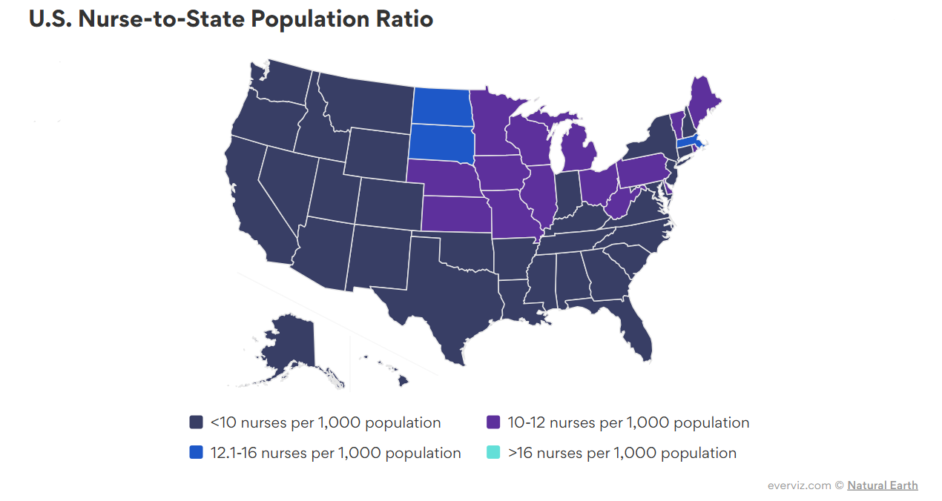

* 1. **Data Analysis**

Patients likeliness to refer the institution, builds on studies that link satisfaction and financial performance (Mittal & Freeney, 2010; Morgan & Rego, 2006) and confirm the reliability of customer ratings as indicators of satisfaction (Naumzik et al., 2021). An analysis of surveys of nurse likeliness to leave hospitals. Based on surveys on qualitative: To get surveys from the nurses and institution’s management, Quantitative: available data on the institutions to identify trends and patterns frequency of staff turn over, possibly patient evacuations of that sort. Data was collected online from the Hospital Consumer Assessment of Healthcare Providers and Systems HCAHPS Patient Survey, also known as the CAHPS® (2023).

Fig. 2

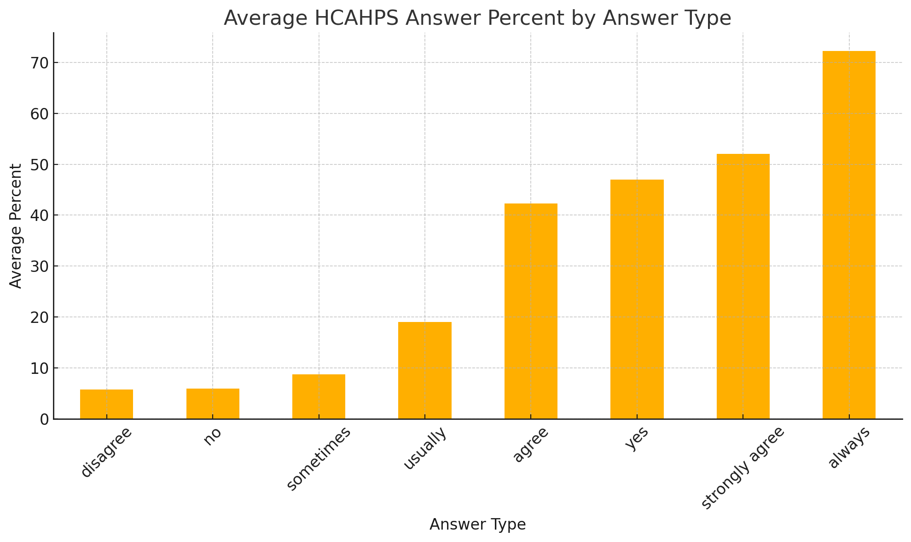

OLS results of the Analysis had no robustness, for the results of 63 patients

The Jarque-Bera test evaluates whether the residuals (errors) of the regression model are normally distributed as it states the the probability is less than.05 so I reject the null hypothes, Mean – 33.

R Square .9 and The overall model is highly significant, based on the combination of predictors effectively explains variations in satisfaction scores. - F – 88.72.

Consistency is crucial for patient satisfaction, with "Always" responses leading to significantly higher scores, while inconsistent responses like "Sometimes" or "Usually" reduce satisfaction. Negative responses such as "Disagree" or "No" indicate critical areas needing immediate attention. Hospitals should focus on consistently excelling in communication, respect, and responsiveness to boost satisfaction. 91.9% of the variance in the data.

P-Values: Significant predictors include Answer Type: always, disagree, no, sometimes, and usually (P < 0.05). Answer Type: strongly agree and yes are not statistically significant (P > 0.05).

Survey Questions displayed by results of fig. 2

Q1 During this hospital stay, how often did nurses treat you with courtesy and respect?

Q2 During this hospital stay, how often did nurses listen carefully to you?

Q3 During this hospital stay, how often did nurses explain things in a way you could understand?

Q4 During this hospital stay, after you pressed the call button, how often did you get help as soon as you wanted it?

Q5 During this hospital stay, how often did doctors treat you with courtesy and respect?

Q6 During this hospital stay, how often did doctors listen carefully to you?

Q7 During this hospital stay, how often did doctors explain things in a way you could understand?

Q8 During this hospital stay, how often were your room and bathroom kept clean?

Q9 During this hospital stay, how often was the area around your room quiet at night?

Q10 How often did you get help in getting to the bathroom or in using a bedpan as soon as you wanted?

Q11 Before giving you any new medicine, how often did hospital staff tell you what the medicine was for?

Q12 Before giving you any new medicine, how often did hospital staff describe possible side effects in a way you could understand?

Q13 During this hospital stay, did doctors, nurses or other hospital staff talk with you about whether you would have the help you needed when you left the hospital?

Q14 During this hospital stay, did you get information in writing about what symptoms or health problems to look out for after you left the hospital?

Q15 Using any number from 0 to 10, where 0 is the worst hospital possible and 10 is the best hospital possible, what number would you use to rate this hospital during your stay?

Q16 Would you recommend this hospital to your friends and family?

Q17 During this hospital stay, staff took my preferences and those of my family or caregiver into account in deciding what my health care needs would be when I left.

Q18 When I left the hospital, I had a good understanding of the things I was responsible for in managing my health.

Q19 When I left the hospital, I clearly understood the purpose for taking each of my medications.

Additional use application of SPSS for statistical analysis tool to examine the collected quantitative data. Techniques such as regression analysis, correlations and exploratory factor analysis will be applied to secondary data to investigate and further relationships among variables such as nurse staffing levels, job satisfaction, patient outcomes, and other pertinent factors.

Besides, the researcher will consider using structural equation modelling (SEM) to explore complex relationships between variables or mixed methods analysis to integrate qualitative insights with quantitative data. Time-series analysis could be beneficial for tracking changes over time, particularly relevant in COVID-19. Additionally, Multivariate Analysis of Variance (MANOVA) can help assess the impact of various factors on multiple outcomes at once, offering a more nuanced understanding of the dynamics in nursing and patient care (Wittenberg et al., 2023). Mueller (2023) mentioned that SEM enables detailed analysis of complex causal relationships, enriching insights into latent variables. Mixed-methods analysis combines qualitative depth with quantitative accuracy for a well-rounded perspective. Time-series analysis is critical for identifying and interpreting temporal trends, particularly relevant in dynamic situations like post-COVID changes. MANOVA simultaneously examines multiple outcome variables, providing a comprehensive view of how different factors collectively impact healthcare scenarios (Bayrak et al., 2023).

**Conclusion**

The COVID-19 pandemic has placed an unparalleled burden on healthcare infrastructures worldwide, leading to an exacerbated demand for dedicated healthcare workers. This increased requirement, combined with the immense pressure and stress endured by nurses during these trying times, has intensified the already looming nursing shortage crisis. By diving deep into this issue, this research aims to shed light on the multifaceted impacts of the post-COVID-19 nursing shortages. Moreover, by gaining a nuanced understanding of the underlying factors and consequences, this investigation hopes to unearth insights about areas like nurse retention and job satisfaction, among others. The ultimate goal is not merely to document the issue but to proactively identify potential intervention points. By doing so, we aim to preempt the complete burnout of nurses, thereby preventing them from abandoning their invaluable profession altogether. This proactive approach is crucial for sustaining the health of our communities and ensuring the continued provision of quality healthcare.

**References**

Adamopoulos, I. P. (2022). Job satisfaction in public health care sector, measures scales and theoretical background. *European Journal of Environment and Public Health*, *6*(2), em0116.,<https://www.ejeph.com/article/job-satisfaction-in-public-health-care-sector-measures-scales-and-theoretical-background-12187>

Auerbach, D. I., Buerhaus, P. I., Donelan, K., & Staiger, D. O. (2024b). Projecting the Future Registered Nurse Workforce After the COVID-19 Pandemic. *JAMA Health Forum*, *5*(2), e235389. https://doi.org/10.1001/jamahealthforum.2023.5389

Bayrak, F., Aktar, B., Aydas, B., Yilmaz, O., Alper, S., & Isler, O. (2023). Effective health communication depends on the interaction of message source and content: Two experiments on adherence to COVID-19 measures in Türkiye. *Psychology & Health*, 1–30. https://doi.org/10.1080/08870446.2023.2285445

Bengtsson, M. N., Dragosits, A., Nyende, A., & Zygouri, I. (2023). The Dynamics of Sustainability Concerning Recruitment and Retention Issues of Registered Nurses in Denmark, England, and Greece. *Klinisk Sygepleje*, *37*(4), 243–266. https://doi.org/10.18261/ks.37.4.4

Chan, Z. C., Tam, W. S., Lung, M. K., Wong, W. Y., & Chau, C. W. (2013). A systematic literature review of nurse shortage and the intention to leave. *Journal of nursing management*, *21*(4), 605-613. Flaubert, J. L., Le Menestrel, S., Williams, D. R., Wakefield, M. K., National Academies of Sciences, E., & Medicine. (2021). Supporting the Health and Professional Well-Being of Nurses. In *The Future of Nursing 2020-2030: Charting a Path to Achieve Health Equity*. National Academies Press (US). González-Gil, M. T., González-Blázquez, C., Parro-Moreno, A. I., Pedraz-Marcos, A., Palmar-Santos, A., Otero-García, L., Navarta-Sánchez, M. V., Alcolea-Cosín, M. T., Argüello-López, M. T., & Canalejas-Pérez, C. (2021). Nurses’ perceptions and demands regarding COVID-19 care delivery in critical care units and hospital emergency services. *Intensive and Critical Care Nursing*, *62*, 102966. https://www.sciencedirect.com/science/article/pii/S0964339720301695

Griffiths, P., Maruotti, A., Saucedo, A. R., Redfern, O. C., Ball, J. E., Briggs, J., Dall'Ora, C., Schmidt, P. E., & Smith, G. B. (2019). Nurse staffing, nursing assistants and hospital mortality: retrospective longitudinal cohort study. *BMJ quality & safety*, *28*(8), 609-617.

Gupta, N., Dhamija, S., Patil, J., & Chaudhari, B. (2021). Impact of COVID-19 pandemic on healthcare workers. *Industrial psychiatry journal*, *30*(Suppl 1), S282.

Haddad, L. M., Annamaraju, P., & Toney-Butler, T. J. (2018). Nursing shortage.

Hall, A. K., Nousiainen, M. T., Campisi, P., Dagnone, J. D., Frank, J. R., Kroeker, K. I., Brzezina, S., Purdy, E., & Oswald, A. (2020). Training disrupted: Practical tips for supporting competency-based medical education during the COVID-19 pandemic. *Medical Teacher*, *42*(7), 756–761. https://doi.org/10.1080/0142159X.2020.1766669

Hickey, S., Mathews, K. S., Siller, J., Sueker, J., Thakore, M., Ravikumar, D., Olmedo, R. E., McGreevy, J., Kohli-Seth, R., & Carr, B. (2020). Rapid deployment of an emergency department-intensive care unit for the COVID-19 pandemic. *Clinical and Experimental Emergency Medicine*, *7*(4), 319. https://www.ncbi.nlm.nih.gov/pmc/articles/PMC7808837/

Lasater, K. B., Aiken, L. H., Sloane, D., French, R., Martin, B., Alexander, M., & McHugh, M. D. (2021). Patient outcomes and cost savings associated with hospital safe nurse staffing legislation: an observational study. *BMJ open*, *11*(12), e052899.

Lopez, V., Anderson, J., West, S., & Cleary, M. (2022). Does the COVID-19 pandemic further impact nursing shortages? *Issues in Mental Health Nursing*, *43*(3), 293-295.

Martin, B., Kaminski-Ozturk, N., O’Hara, C., & Smiley, R. (2023). Examining the impact of the COVID-19 pandemic on burnout and stress among US nurses. *Journal of Nursing Regulation*, *14*(1), 4-12.

Mueller, J. M. (2023). *Becoming a Nurse: A Qualitative Descriptive Study of the Masters Entry into Professional Nursing Journey* [PhD Thesis, Arizona State University]. https://search.proquest.com/openview/c0f5ed3669ebfa7deb0874488afb6934/1?pq-origsite=gscholar&cbl=18750&diss=y

Musy, S. N., Endrich, O., Leichtle, A. B., Griffiths, P., Nakas, C. T., & Simon, M. (2021). The association between nurse staffing and inpatient mortality: A shift-level retrospective longitudinal study. *International journal of nursing studies*, *120*, 103950.

Sadiq, M. W., Hameed, J., Huo, C., & Abdullah, M. I. (2022). Service innovation in small neighborhood family firms: An advanced approach to enhance employee’s performance through social and psychological rewards. *Frontiers in Public Health*, *10*, 984848. https://www.frontiersin.org/articles/10.3389/fpubh.2022.984848/full

Tomblin Murphy, G., Sampalli, T., Bourque Bearskin, L., Cashen, N., Cummings, G., Elliott Rose, A., Etowa, J., Grinspun, D., Jones, E. W., Lavoie-Tremblay, M., MacMillan, K., MacQuarrie, C., Martin-Misener, R., Oulton, J., Ricciardelli, R., Silas, L., Thorne, S., & Villeneuve, M. (2022). Investing in Canada’s nursing workforce post-pandemic: A call to action. *FACETS*, *7*, 1051–1120. https://doi.org/10.1139/facets-2022-0002

Turale, S., & Nantsupawat, A. (2021). Clinician mental health, nursing shortages and the COVID‐19 pandemic: Crises within crises. *International nursing review*, *68*(1), 12-14.

Ward, M. J., Marsolo, K. A., & Froehle, C. M. (2014b). Applications of business analytics in healthcare. *Business Horizons*, *57*(5), 571–582. https://doi.org/10.1016/j.bushor.2014.06.003

Wittenberg, E., Goldsmith, J. V., Savage, M. W., & Sullivan, S. S. (2023). Exploring Differences in Caregiver Communication in Serious Illness. *Journal of Palliative Medicine*, *26*(7), 922–929. https://doi.org/10.1089/jpm.2022.0406