Assistive Technology for the Visually Impaired

|  |  |  |
| --- | --- | --- |
|  | **Robert Bobkoskie** Georgia Institute of Technology  Atlanta, Georgia rbobkoskie3@gatech.edu |  |
|  |  |  |

ABSTRACT

Digital media is becoming much more than a supplement in the field of educational technology. Online books, journals, collaboration, and even graduate degrees can be obtained exclusively through digital resources. Indeed, pedagogy has kept pace with advances in digital technology, and for most, the educational experience has been enhanced. However, for those with a visual impairment, the ability to travel unabated in a digital world is rife with restrictions that limit access to information and educational enrichment. Although assistive technologies such as screen readers (text to speech), magnifiers, and high contrast settings allow the visually impaired to ride this information superhighway, these tools are often difficult for the visually impaired to identify, locate, and administer. Even when configured, there are many differences in how assistive technologies are implemented. The current state of assistive technology is not progressive enough for alleviating the challenges and inconsistencies the visually impaired face when accessing digital media. Introducing standard(s) for assistive technology would remove barriers to digital media, and open this autobahn to the visually impaired.

Another approach to convey visual information is to utilize a second sensory input. A technology known as auditory graphing, which is an application of sonification [3] shows promise as an assistive technology to enhance learning in geometry, which is a completely visual form of mathematics [7]. Sonification uses sound: frequency, amplitude and timbre to convey information. Auditory graphs can increase accessibility by allowing observable objects such as curves in a Euclidian plane can be visualized. Sonification and standardization of assistive technology are tractable, cost effective approaches to enhance pedagogy for the visually impaired.

Author Keywords

Accessibility, assistive technology; auditory graphing; digital media; educational technology; sonification; standards; special needs, visual impairment.

ACM Classification Keywords

Human-centered computing---Human computer interaction (HCI)---HCI design and evaluation methods;500, Human-centered computing---Human computer interaction (HCI)---Interaction paradigms---Graphical user interfaces;500, Human-centered computing---Human computer interaction (HCI)---Interaction paradigms---Web-based interaction;300, Human-centered computing---Human computer interaction (HCI)---Interaction devices---Displays and imagers;500, Human-centered computing---Human computer interaction (HCI)---Interaction devices---Sound-based input / output;500, Human-centered computing---Human computer interaction (HCI)---Interaction techniques---Auditory feedback;500.

INTRODUCTION

The world of digital media is vast and seemingly unbounded. However, for the visually impaired, it can be narrow and challenging to explore. In the context of this paper, visually impaired will refer to individuals with low vision that require special needs. According to the National Eye Institute, “low vision means that even with regular glasses, contact lenses, and medicine or surgery, people find everyday tasks difficult to do.

Education has become increasingly digitized. Research [4] presented in Table 1 shows that teachers (K-12) are heavy users of digital content in the classroom. Driving this shift to a digital pedagogy is the faith that society places on the inherent power of digital media to enhance teaching and learning practices [12]. Indeed, society has driven electronic media in education, as policymakers have enacted laws [13, 14] supporting technology in the classroom. If this digital content is not accessible to the visually impaired, then a significant portion of their education is unapproachable.

|  |  |  |  |  |  |
| --- | --- | --- | --- | --- | --- |
| % | Videos Found Online | Real Time Data | Online Textbook | Anima-tion | Virtual Labs |
| All | 48 | 18 | 27 | 22 | 9 |
| Sci | 63 | 32 | 32 | 52 | 42 |

Table 1: Teachers’ Use of Digital Content in the Classroom.

A very effective assistive technology for those with low vision are High Contrast Settings (HCS) available on most operating systems (OS), and applications such as Adobe Reader and various web browsers. HCS is freely available, both in cost and distribution, and will be the focus of my research. Fok, et al. [2] show that Adaptive Computer Technologies (ADT) such as HCS are used by 57.7% of their sample group. Although this seems high, the utilization of HCS can be expanded if this technology was standardized across platforms and applications. Phillips and Zhao [6] identified the ease of device procurement, and poor device performance as reasons why users disregard assistive technology. Although the scope of assistive devices in [6] is much larger, and includes physical aides such canes and wheelchairs, the rational for user abandonment can be extrapolated to ADTs. For example, ‘device procurement’ can be translated to identifying and configuring HCS. Standardization of ADTs can abate procurement challenges while greatly improving the performance of HCS. Beyond abandonment, procurement challenges have a more impact on the usage of ADTs. Kapperman, et al. [11] discuss how the lack of technical knowledge by both educator and student limit the use of ADTs to less than half the students with visual impairments who could potentially benefit from assistive technology. Another approach is to provide a second (non-visual) modality to enhance pedagogy for the visually impaired. Auditory graphs using sonification provides an auricular method for the visually impaired to experience mathematics.

DISCUSSION OF {ROBLEM

In most cases, ADT and HCS grant the visually impaired access to digital media. However, at times, the user experience is inconsistent, and often dysfunctional. This discussion will explore issues faced by visually impaired when accessing standard contrast digital media and limitations the current state of HCS.

Light Reading

Persons who are visually impaired due to retinal issues can benefit from HCS. Light of a sufficiently high intensity will compromise visual acuity in persons having conditions that affect the retina, such as: macular degeneration, diabetic retinopathy and even age. In persons without a visual impairment, visual acuity has a well-defined relationship with illumination. That is, visual acuity increases in proportion to the log of the light intensity [10]. The retina is a surface composed of discrete rods and cones, therefore its resolving power depends on the number of elements present in a unit area [10]. In persons with a compromised retina, this unit area is decreased, thus decreasing the amount of illumination the retina can process. Even the ubiquitous white (RGB: 255, 255, 255) background used under most standard contrast settings for electronic displays is sufficient to overwhelm the ability to process information for a person with a retinal issue. The retina as analogous to a sensor in a digital camera. Consider taking a photograph of the sun. Aside from potential sensor damage, capturing an image of the sun without moderating the irradiation would not produce a viable image. The intensity of the light would inundate the sensor, creating at best, a very noisy image.

High Contrast Settings

High contrast is defined as a large difference in magnitude and gradient between colors in an image. In the context of this paper HCS will refer to the difference in magnitude between the background, which typically constitutes the majority of the display area (>> 50%), and foreground (text, images, etc.) in digital media.

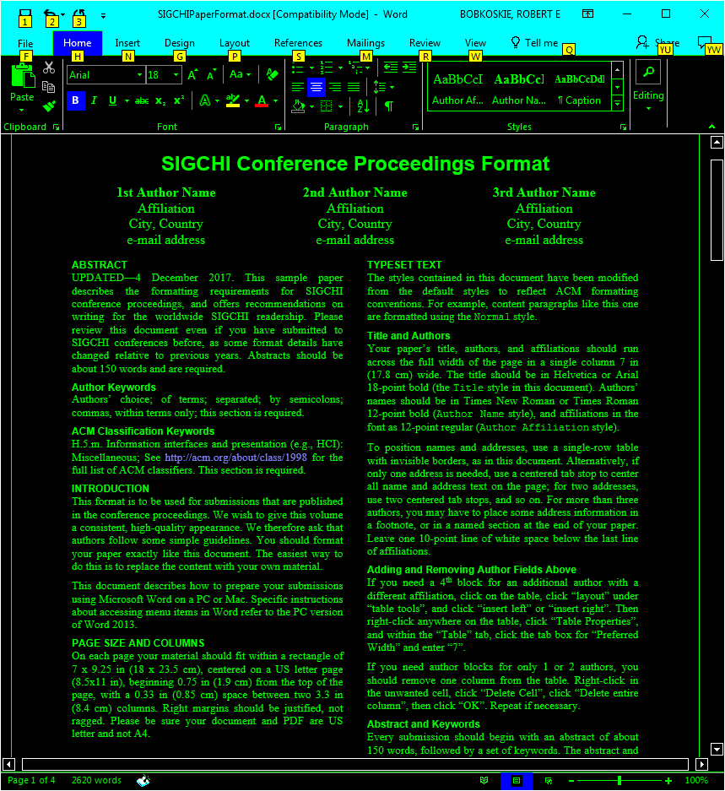 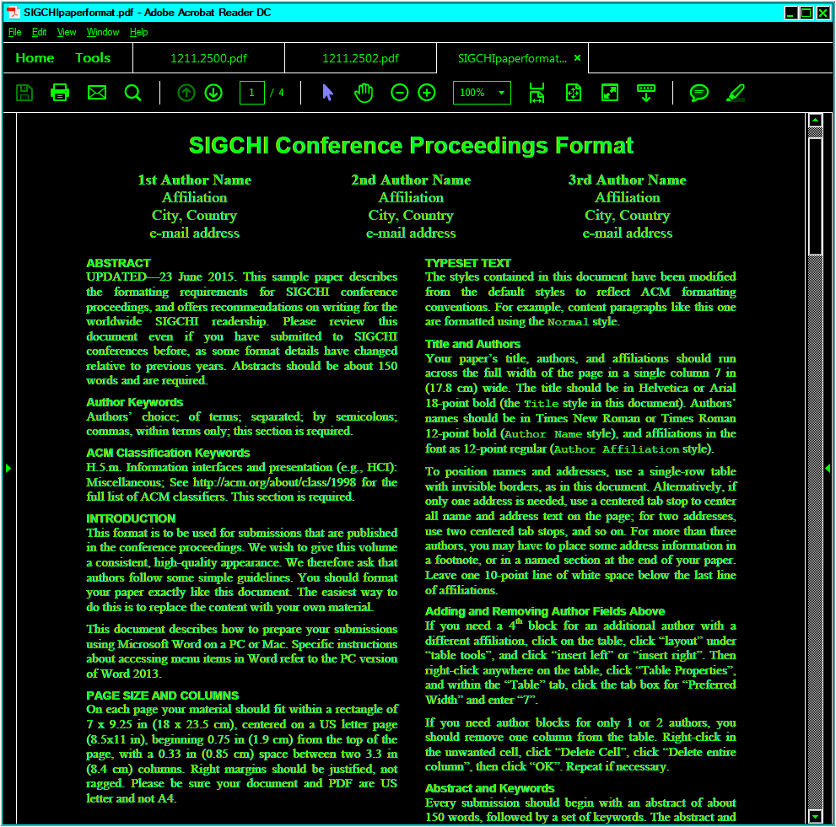

**Figure 1**: Windows high contrast theme, MS Word (left). Adobe Reader with high contrast colors (right).

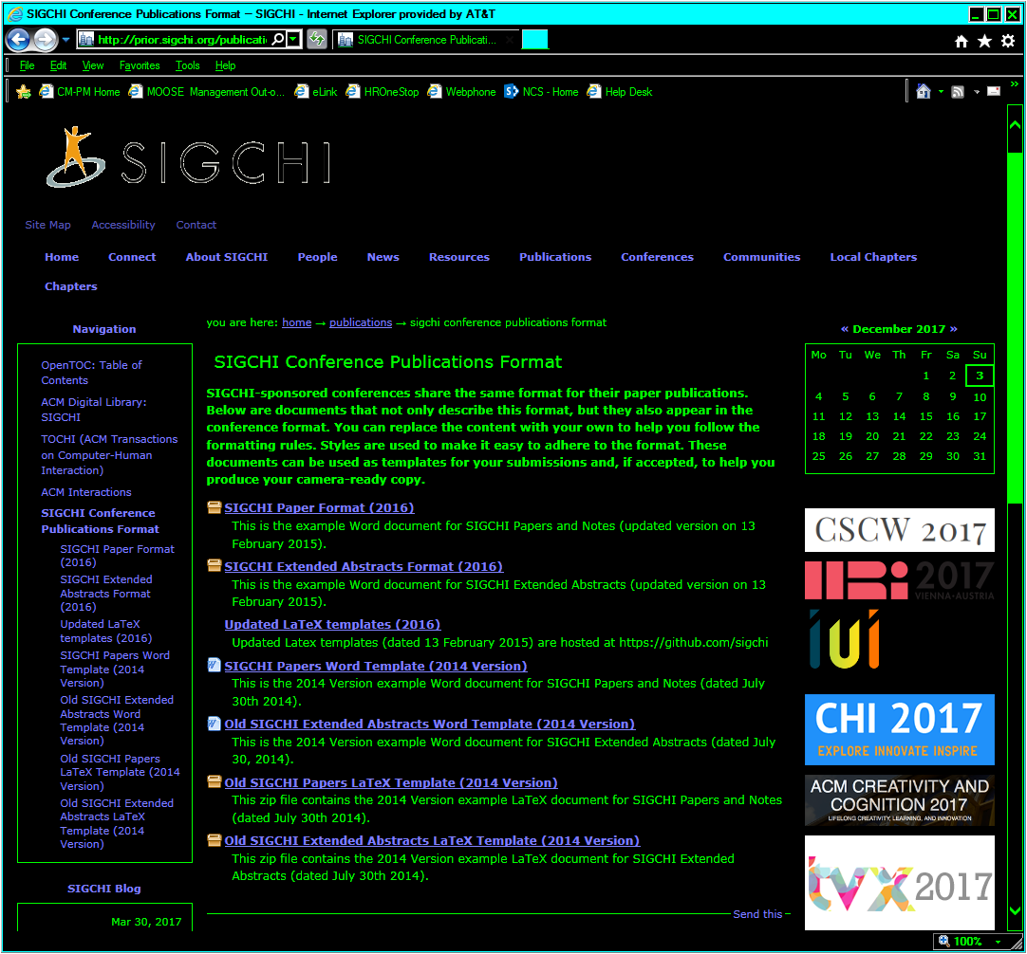 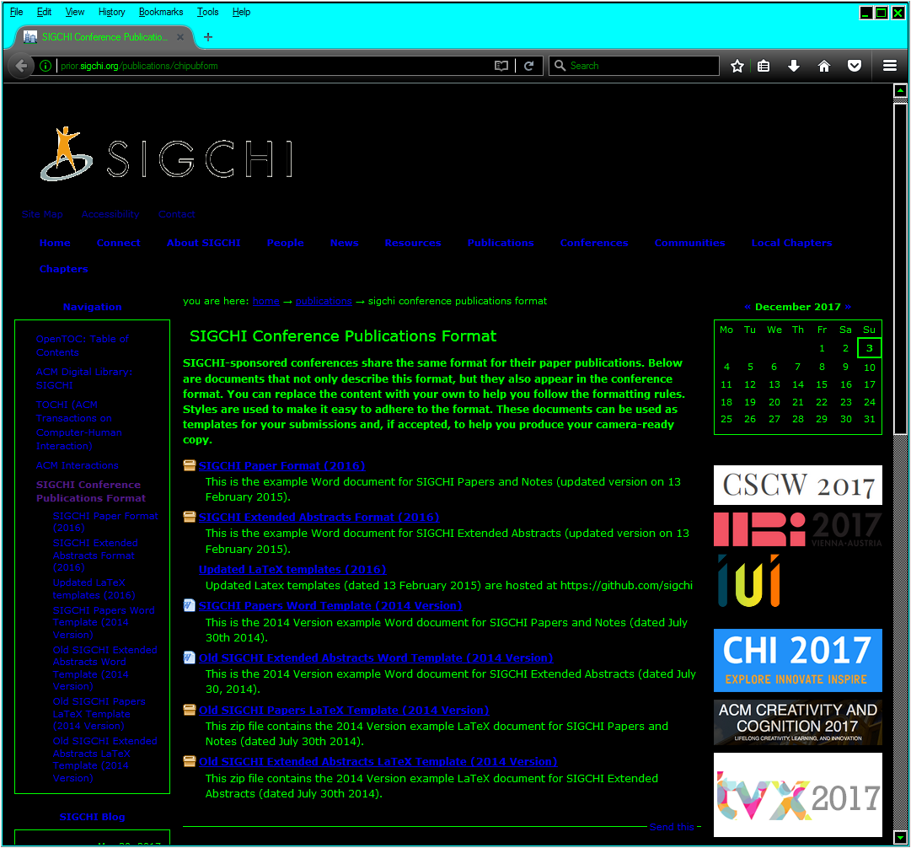 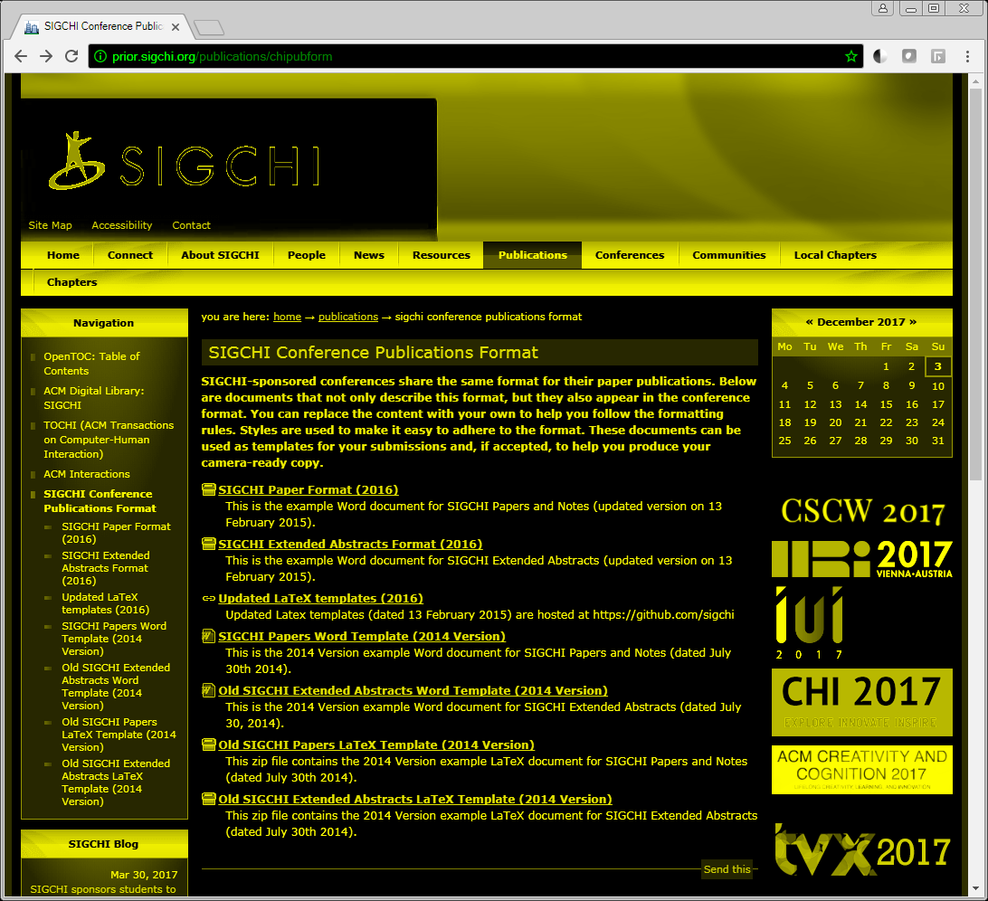

**Figure 2**: Web browsers with high contrast: Internet Explorer (left), Mozilla Firefox (center), Google Chrome (right).

The images in Figures 1 and 2 show the HCS available embedded with the OS (High contrast theme on Windows) or application (Adobe Reader, Google Chrome, Mozilla Firefox). It should be noted that the high contrast theme on Windows not only supports Microsoft applications: Word, Excel, PowerPoint, etc., but also Mozilla Firefox, and perhaps others (that are betond the scope of this paper). Google Chrome and Adobe Reader are not natively supported by Windows, and NCS must be configured independently. Both Windows and Adobe thoughtfully consider the need for HCS to provide a display with a high gradient between the background and foreground. More importantly, their HCS solutions invert the display from the typical light background, dark foreground (text) to dark background, light foreground. Recall that a white background has irradiance capable of decreasing acuity for the visually impaired.

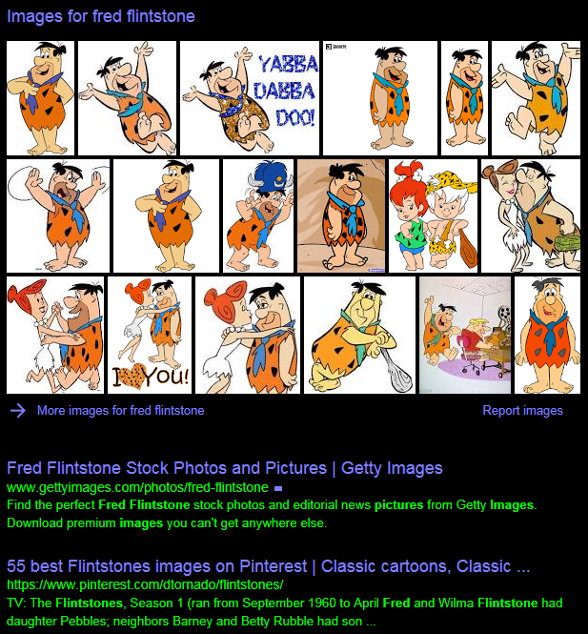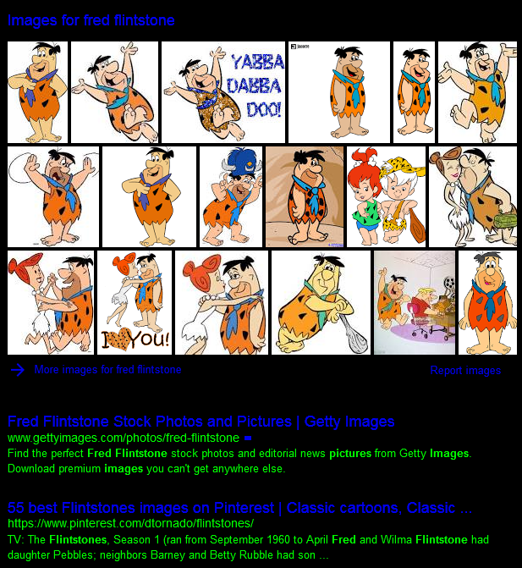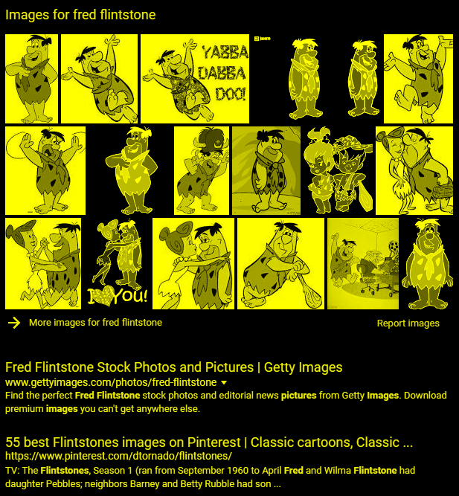

**Figure 3**: Web browser display results from a query of the string ‘Images for fred flintstone’: Internet Explorer (left), Mozilla Firefox (center), Google Chrome (right).

Therefore, it is important to not only have a high gradient between background and foreground, the background should be dark, ideally RGB [0, 0, 0]

Where is the High Contrast

The images in Figure 3 expose HCS web browser inconsistencies. Each application has (dis)advantages. The text in the search results, and heading using Mozilla Firefox is difficult to read. Internet Explorer does a better job distinguishing the text by applying a higher contast for the results headers, but could utilize a lighter color to the search results text for stronger differentiation. Google Chrome’s HCS employs a high gradient between text and background, and thus offers a good solution for viewing text on screen. However, Chrome falls short in attempting to resolve images (pictures) with HCS, leading to a strange, negatively colored image.

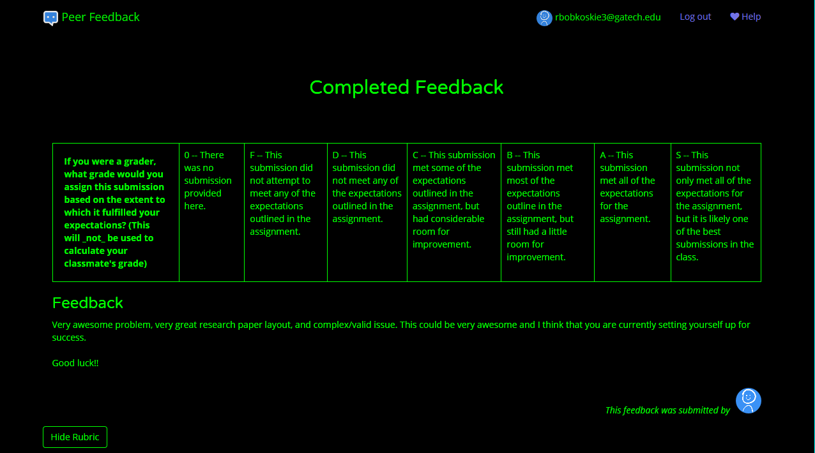 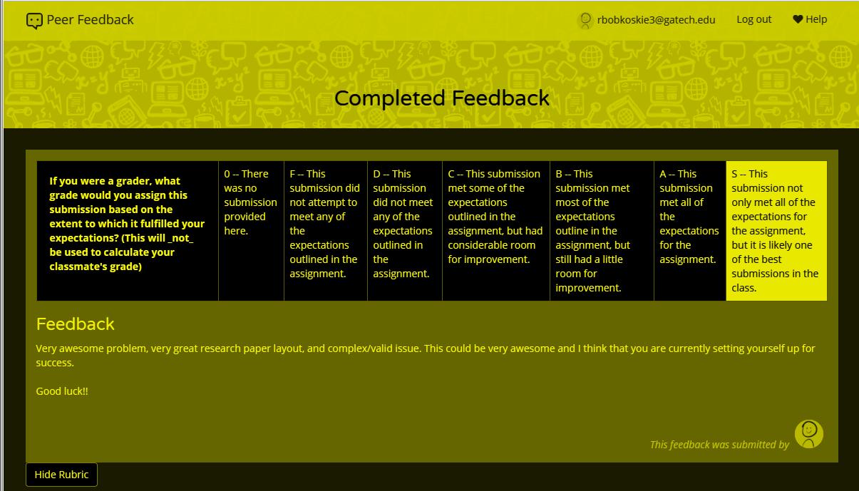

**Figure 4**: Highlighting to make selection in web browsers: Internet Explorer (left), Google Chrome (right). The selection of the right most choice using Internet Explorer (IE) was not obvious to the user. Mozilla Firefox, like (IE), makes use of the Windows high contrast theme, looks like IE, and was omitted.

Text and image rendition are not the only shortfalls of web browser HCS. Highlighting (Figure 4), and form input collectionmethods (Figure 5) present even more adversity for those using HCS with IE or Firefox.

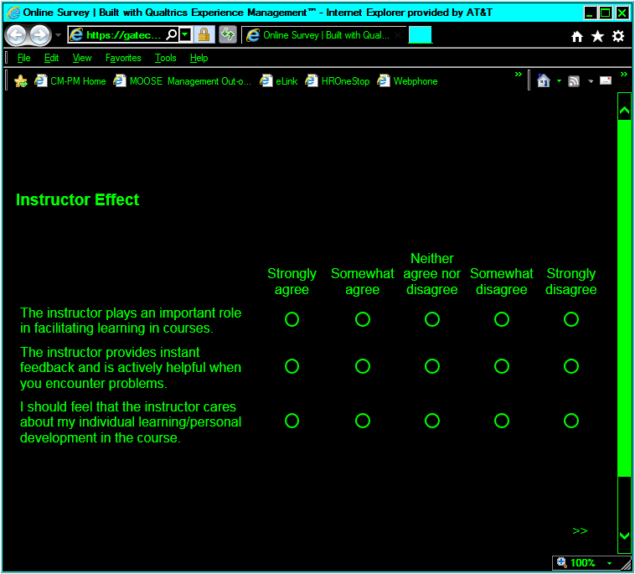 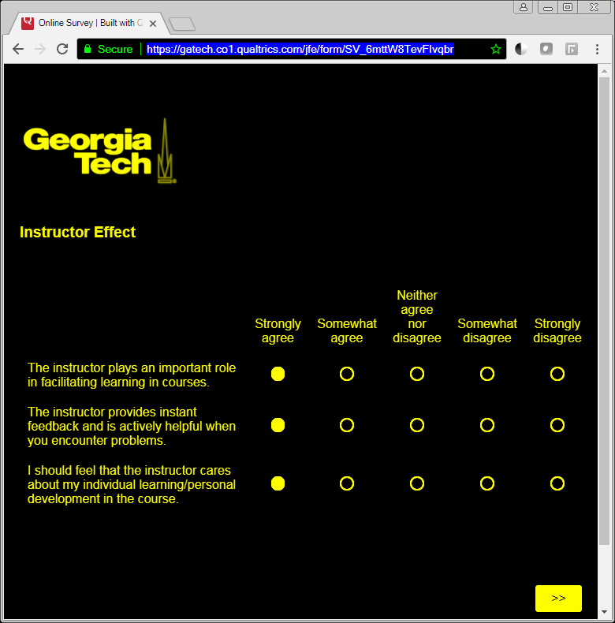

**Figure 5**: Radio buttons to make selection in web browsers: Internet Explorer (left), Google Chrome (right). The selection of the left most choices using Internet Explorer (IE) was not obvious to the user. Mozilla Firefox, like (IE), makes use of the Windows high contrast theme, looks like IE, and was omitted.

Fundamental attributes of usability, denoting selections are not possible unless HCS is disabled. This phenomenon is difficult to capture for this paper outside the application. That is, how can something that is not visible be depicted? Selections were made using IE in figures 4 and 5, however, the choices were not highlighted in way to make the choice obvious for the user, or in this case, the reader. Google chrome did not have this drawback, but was did not display a uniform dark background on the screen. The lighter colors could present issues for some visually impaired persons. The ideal scenario would have an unbroken dark background with a light colored foreground; including those elements that allow for user selection,

such as the fill for radio buttons, tick boxes, and other widgets.

Lastly, some documents viewed using Adobe Reader are not compatible with Reader’s HCS option. These documents will invariable present in standard contrast, signifcanly reducing perception for the visually impaired reader. Perfunctory research indicates that these documents were either created with settings incompatible with Reader’s HCS standards, or scanned in to create a PDF document.

Inaccessible Accessibility

The ADTs offered on operating systems and applications are difficult to initially configure for the visually impaired. This discussion will explore the challenges of provisioning HCS at the OS (Windows) and application level.

Although setting up HCS on Windows is a direct procedure, this option remains unknown to many users. HCS is enabled by ‘Personalizing’ the desktop with a High Contrast theme. Once enabled, this setting applies HCS to all Microsoft applications, Mozilla Firefox, but not Google Chrome. As already discussed, Windows HCS performs reasonably well creating a display that allows those with low vision good visual perception of the media.

Adobe Reader’s HCS is not covered under Window’s HCS option, and must be configured separately. To set up HCS for Reader, the user must navigate to the preferences drop-down, and locate HCS in the (sub)tree of options. This path is not obvious, and could be moved to a more direct path for the user.

Like Reader, Google Chrome also lacks support under Window’s HCS. Chrome is perhaps the most challenging application in this study to provision HCS. A user must use the Chrome browser, which is not initially set up for HCS, to acquire and configure HCS. The entire process is accomplished using standard contrast, which for those with low vision, presents a paradox. That is, a user with low vision experiences very low visual acuity under standard contrast, and depends on HCS, which is what the user is attempting to setup on Chrome.

Have Yo Heard About Sonification

Another ADT that has not been fully exploited is sonification. For this discussion, the term ‘sonification’ refers to the “use of non-speech audio to convey information or perceptualize data” [3]. Chew [1] assessed using auditory graphing systems for visually impaired middle school students in mathematics. Sonification can increase accessibility by allowing objects such as curves in a Euclidian plane to be perceived. Upson [7] discusses using sonification to visualize geometry, which is a completely visual form of mathematics. Upson’s proposes sonification as another vector for assimilating information, and targets middle school pupils. Essentially, using both sight and sound will increase the absorption of the material. Although Upson does not propose sonification for the visually impaired, others [8, 9] have. Studies in the field of ophthalmology have stressed the importance of assistive technology resources, such as learning tools for visually impaired students [5]. Sonification will be explored as a potential ADT for enhancing the pedagogy of mathematics for the visually impaired.

Sonification is not Widely Deployed

Sonification as an educational technology is not widely deployed. Upson [7] and Chew [1] discusses using sonification for middle school geometry. This is a narrow topic in a single subject over the pedantic universe. Even more narrow is the potential use for the visually impaired. Sonification is analogous to orphan drugs, a small market lacks economies of scale. Walker and Cothran [9] explore addition reasons why sonification is not widely used: “few sonification toolkits that have been developed are either proprietary, dependent on a specific hardware or software platform (e.g., SGI/Irix), or are built for the expert sonification designer, and not the schoolteacher or student. I propose a sonification solution for the visually impaired that extends the work of Walker and Cothran by including high contrast options in my sonification toolkit.

GOALS AND DESIGN

As discussed, an application designed for the visually impaired should have HCS as an option. Ideally, this would be through standards adopted by the development community. I designed an application to achieve two objectives: (1) evaluate the efficacy of sonification as an ADT for the visually impaired, (2) impliment HCS best practices, thus enabling access to the sonification application by the visually impaired. The application can be accessed at the following link: <https://rbobkoskie3.github.io/>. The user interface for the application is depicted with HCS in Figure 6.

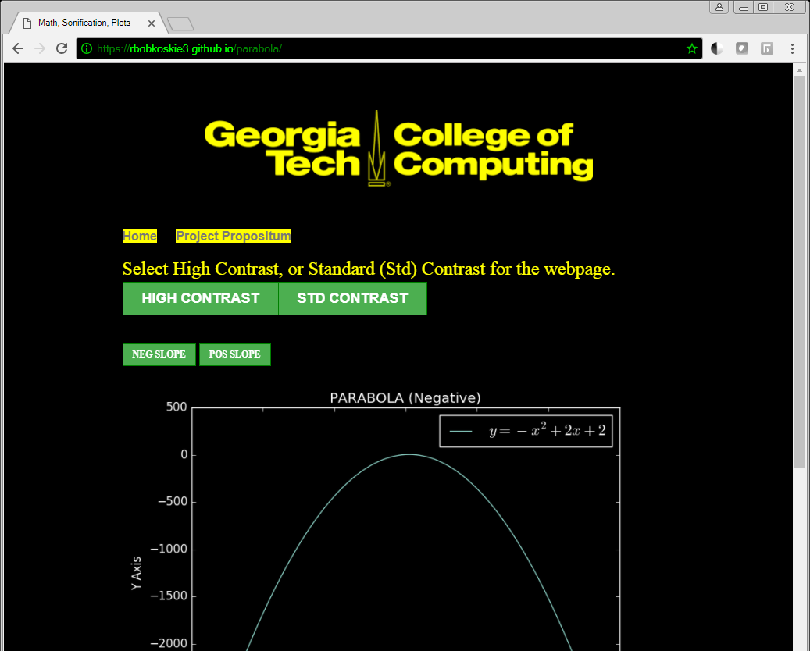

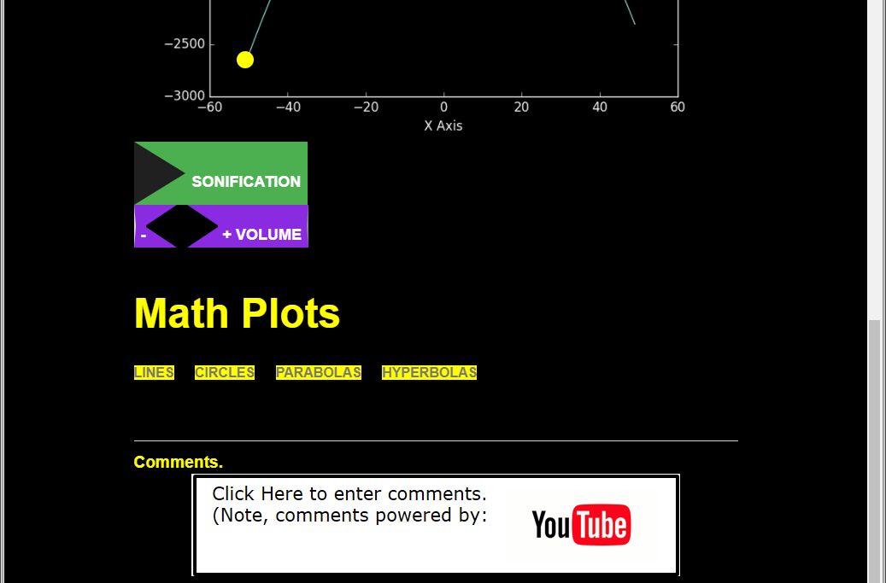



**Figure 6**: Application User Interface (HCS Parabolas).

Figure 7 shows the same page with standard contrast. Under either contrast option, the user experiences the same look and feel across the other pages that comprise this application.

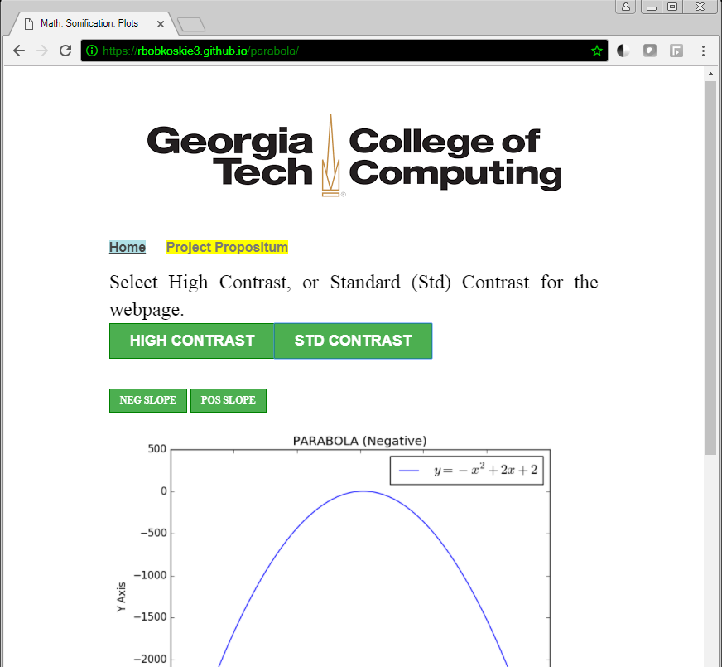

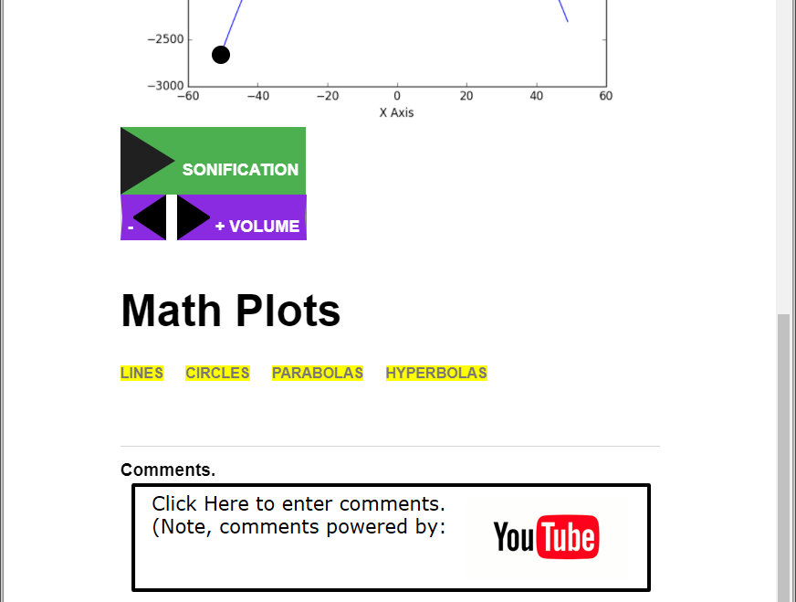

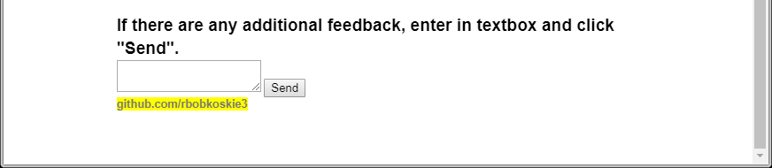

**Figure 7**: Application User Interface (Parabolas).

Dynamic Web Page

The application runs as a client-side dynamic web page, driven by user selection. This approach was chosen based on several factors:

1. This approach accomplishes the two goals of this study: the evaluation of both sonification and HCS.
2. Adding additional client-server functionality would be superfluous, and perhaps confusing to the target audience and scope of this study.
3. A strict and well defined timeframe to deliver the application and results of the evaluation.

A Standard Approach for High Contrast Settings

Research has shown the relationship between a compromised retina and a reduced ability to process light. This implies a reduction visual acuity under light of a sufficiently high intensity. Based on this research, I chose to have an option of displaying the application in high contrast. A user can toggle the entire page, including background and all foreground elements (tracer animation, buttons, images, text) between standard and high contrast (see Figures 6 and 7).

Auditory Graphing with Sonification

To achieve auditory graphing, a unique sound was developed, and applied to each function. This was accomplished using dissimilar frequencies and waveforms per plot:

* lines <=> ~300 to 500 Hz. sine wave
* circles <=> ~200 to 400 Hz. square wave
* paraboas <=> ~400 to 600 Hz. sawtooth wave
* hyperbolas <=> ~400 to 600 Hz. triangle wave

Rcall that sonification uses sound: frequency, amplitude, timbre, pitch, and duration to visualize object via an auditory pathway. To further enhance sonification, the duration and frequency were adjusted for each graph. That is, the duration of sonification is longer for a plot that has greater length or perimeter. Also, depending on the slope or shape of the plot, the frequency may remain constant, increase or decrease. For example, a line may have positive, negative, zero, infinite slope. I chose to apply sonification to lines having posttive, negative and zero slope by associating an increasing, decreasing or constant frequency respectively. For parabolas and circles, which are non-linear function, the frequency adjustments were not linear.

A user can play/pause sonification by clicking either the Sonification play button, or the plot. The user can adjust the sonification volume using the application buttons, or directly from their device. To reinforce the sonification, an animated element traces over the plot in sequence with the auditory stimuli.

IMPLIMENTATION ISSUES

As discussed, sonification is not widely deployed as an educational technology, therefore poetic license was used liberally to realize sonification. Lacking standards, HCS was developed with a similar approach. Research was used to provide high level direction; however, the development was mostly my interpretation of the requirements. As for the development, these challenges had to be addressed to produce the application:

1. The synchronization of the sonification parameters: frequency, amplitude, timbre, pitch, and duration with the various math plots: lines, circles, parabolas, and hyperbolas.
2. Creating an animated element to trace the math plots in tandem with sonification.
3. One click functionality to toggle page display between standard and high contrast.
4. Creating a web page that scales for device resolution. That is, the application can run on a smart phone, up to a large computer monitor. The duration for sonification, and tracer path are dynamic under varying resolution, and unique for each math plot.
5. Three dimensional plots were included, and required scaling of the animation element to achieve perspective (see Figure 8).

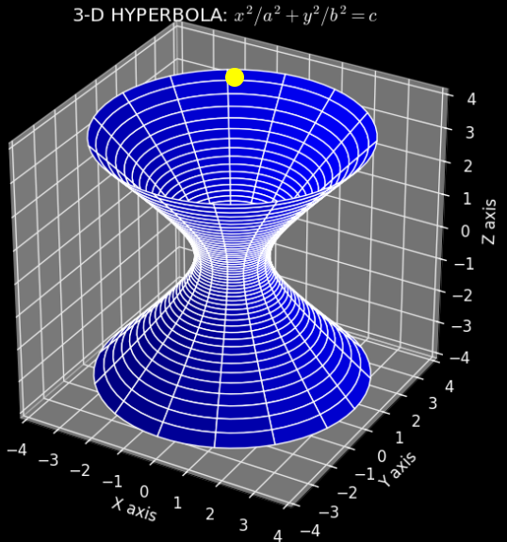 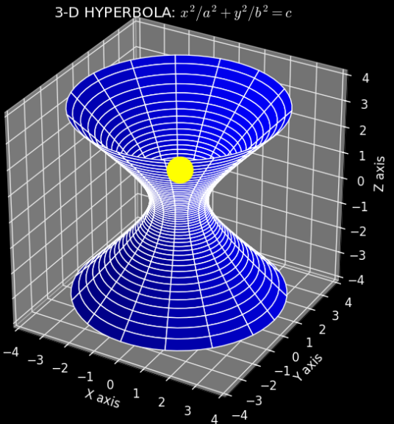

**Figure 8**: Use of element scaling to achieve perspective in three dimensional graphs.

RESULTS AND DISCUSSION

This study was primarily a quantitative effort. The application served as the independent variable, while a survey provided data that was quantitatively analyzed. The survey was taken to evaluate user response to the application: <https://docs.google.com/forms/d/e/1FAIpQLSc0ICzX_vJjHwATkwU86fbXTqOgTGyMJfLvh73lRyYgIZT9Xg/viewform>.

Qualitative Analysis

Although the data analysis of the survey was primarily quantitative in nature, there was the opportunity for limited qualitative analysis by collecting user response with comments on the survey. Some of these comments alluded to age corralting with HCS:

The application provided the independent variable for quantitative research.

FUTURE WORK

More work is needed to expound on the work discussed in this paper. The project scope was constrained due to both time constraints and knowledge limitations.

More Quantitative Analysis

I was not able to obtain results from my target audience, students of visually impaired schools located in the United States. The results came from my Georgia Tech cohort, which are mostly, if not exclusively a population without low vision, or a moderate visual impairment. Future work would include distributing the application and corresponding survey to my target audience.

More Qualitative Analysis

The duration of this study limited opportunities to perform more qualitative research. I would like to explore the usage of HCS and sonifiaction in the field. For example, I’d like to conduct field work to explore the relationship of the extraneous variables such as the demographic information on the survey with the use of HCS and sonification. This real-time observation and interaction has the potential to lead to more function development of protocols to imrove accessibility to digital media for the visually impaired.

Human Factors Study

I’d like to study human factors to evaluate sonification and high contrast settings for the visually impaired population.

Find additional research on sonification, and game development, as I plan a small proof of concept tool that uses sonification for simple graphs on a 2-dimensional plat. The objective is to host this tool, and have students (both sighted and visually impaired) evaluate it. The toll will count the number of times students enable high contrast and sonification.

Identify additional research that highlights the acceptance and efficacy of ADT for the visually impaired, in particular, high contrast. I would also like to have a counterpoint that shows good usage, but if the high contrast were more standardize, it would have an even greater impact.

Identify resource that show the traditional white background is not usable for the visually impaired. High contrast, in particular, a dark background with light text works best. Some examples from users of Adobe high contrast: <https://forums.adobe.com/thread/777688>

CONCLUSION

In summary, research has been presented that highlights the need for additional, and a more standardized approach toward assistive technologies for the visually impaired. Moreover, standardization and sonification can fill gaps in existing ADTs, and allow for a more effective and rich educational experience for the visually impaired.

ACKNOWLEDGEMENTS

My mentor, Zach Hooks. My cohort who provided invaluable peer feedback throughout this project.

**REFERENCES**

|  |  |
| --- | --- |
| 1. | Yee Chieh Chew. 2014. *Assessing the Use of Auditory Graphics for Middle School Mathematics*. Ph.D. Dissertation. Georgia Institute of Technology, Atlanta, GA. |
| 2. | Daniel Fok, Janice Miller Polgarb, Lynn Shawb and Jeffrey W. Jutai. 2011*. Low vision assistive technology device usage and importance in daily occupations*. IOS Press, Work 39 (2011) 37-48, DOI 10.3233/WOR20111149. |
| 3. | G. Kramer (ed), 1994. *Auditory Display: Sonification, Audification, and Auditory Interfaces.* Santa Fe Institute Studies in the Sciences of Complexity. Proceedings volume XVIII. Addison-Wesley. |
| 4. | Project Tomorrow. 2014. *The New Digital Playbook: Understanding the Spectrum of Students' Activities and Aspirations*. Chart 2, Teachers’ Use of Digital Content in the Classroom. |
| 5 | Alves CC, Monteiro GB, Rabello S, Gasparetto ME, Carvalho KM. 2009. *Assistive technology applied to education of students with visual impairment.* Rev Panam Salud Publica, 148-52. |
| 6 | B. Phillips and H. Zhao. 1993. *Predictors of assistive technology abandonment, Assistive Technology*. The Official Journal of RESNA, Volume 5, Issue 1, 36-45. |
| 7 | Robert Upson. 2001. *SONIFICATIONS AS MATHEMATICS TEACHING TOOLS*. Proceedings of the 2001 International Conference on Auditory Display, Espoo, Finland, July 29-August 1, 2001. |
| 8 | Lorna M. Brown and Stephen A. Brewster. 2003. *DRAWING BY EAR: INTERPRETING SONIFIED LINE GRAPHS*. Proceedings of the 2003 International Conference on Auditory Display, Boston, MA, USA, 6-9 July 2003. |
| 9 | Bruce N. Walker and Joshua T. Cothran. 2003. *SONIFICATION SANDBOX: A GRAPHICAL TOOLKIT FOR AUDITORY GRAPHS*. Proceedings of the 2003 International Conference on Auditory Display, Boston, MA, USA, 6-9 July 2003 ICAD03-161. |
| 10 | Selig Hecht. 1927. *THE RELATION BETWEEN VISUAL ACUITY AND ILLUMINATION*. From the Laboratory of Biophysics, Columbia University, New York, NY. |
| 11 | G. Kapperman, J. Sticken, and T. Heinze. 2002. *Survey of the Use of Assistive Technology by Illinois Students Who Are Visually Impaired*. Journal of Visual Impairment & Blindness. v96 n2 p106-08. |
| 12 | Courtney K. Blackwell*, Alexis R. Lauricella, Ellen Wartella. 2014*. Factors influencing digital technology use in early childhood education*. Computers & Education, 82–90. |
| 13 | Florida. 2011. *SB 2120: K-12 Education Funding. GENERAL BIL*. |
| 14 | California. 2009. *BILL NUMBER: SB 48*. |