Ryan Bockmon

GEOG 817

Final Paper

I went with a different design then what was asked of this class. Instead of having an interactive map showing spatial information, I wanted the user to use their spatial reasoning to interact with my map. Spatial skills have been shown to play an important roll across many STEM disciplines including computing as well. Most research with spatial skills has been done with mental rotations of an object. While a person’s mental rotations skills have been shown to have correlation to their computing programming skills there is not a good argument to why. Instead of mental rotation skills, I hypothesis that a person’s wayfinding skills are more closely related to their programming abilities.

The purpose of my web application is to test a person’s wayfinding ability. The specific skill that I wanted to target with my interactive web applications is 2D to 3D visualization and path creating. The task that I users do is draw an optimal path that you would take to get to two different points on a map. To do this I used the openlayers API to create an interactive map that users can draw on. The specific variable I needed to create was *draw = new ol.interaction.Draw;* This, as the name implies add in the capability to draw on the map (see code for full function call). To then add it to the map you use the function *map.addInteraction(draw);.* The one thing to keep in mind when using this function is that you are only able to draw on a vector layer.

The only purpose I wanted my web app to do is allow users to draw on the map. So, I disabled all other functionality of the map so that there is no way users could mess it up. To do this I set all functionality of a basic map to false. I.e *interactions: ol.interaction.defaults({ mouseWheelZoom: false, doubleClickZoom: false, dragAndDrop: false, dragPan: false, keyboardPan: false, keyboardZoom: false}).*

Just being able to draw on the map was not good enough. I needed users to be able to clear what they have drawn on the map if they didn’t like what they wanted. To do this I used the source.clear(); function. This will remove any feature that is on the source layer. I also needed users to save what they had drawn. To do this I created a new variable called GEOJSON_PARSER = new ol.format.GeoJSON(); and used the GEOJSON_PARSER.writeFeatures( source.getFeatures()); This saves any feature that is on your source layer and saves it to a GeoJson format. Right now, I have it print to the console. In the future I will have it save to a file. The idea is that I can save their drawing to a GeoJSON file so that I can open it later to grade their response. The rest of the application will test other various wayfinding abilities such as, orientation, cross cutting and water flow.

Comparison:

When I was first trying to find a way to test students’ wayfinding ability I looked online to see if there was any online test that was already created. The only one I was able to find was a from Barcelona Field Studies Center. <https://geographyfieldwork.com/Ben-Nevis-Map-Reading-Test.html> Their test had you plan out a path by placing markers on a topographical map and tested you on how well the path you chose worked by simulating whether other hikers got injured or died on your path. It’s a cool concept but, the map that they provide is zoomed to far out and is hard to read. Not only that but it was hard to place markers where you wanted them to be placed resulting in a bad score. There are a few positives however, one it calculates the total distance you traveled and knew how steep the terrain is and whether you crossed a stream or not. 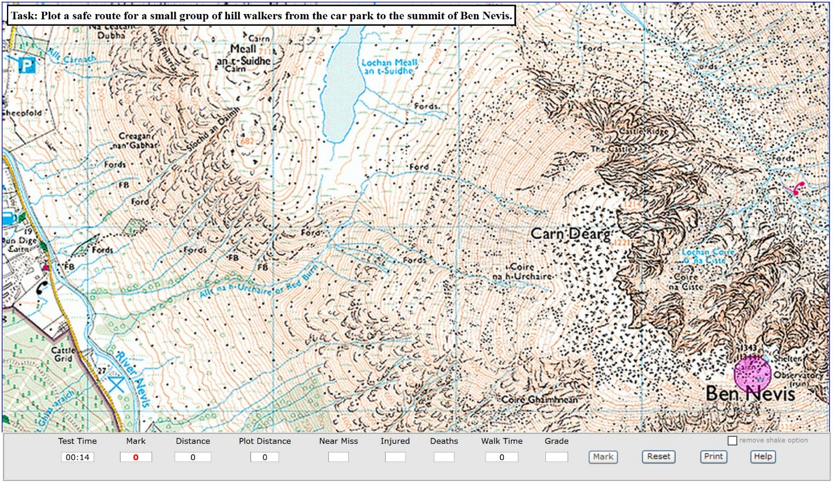

The second application is the Googles map API. I used Google maps API before but ran into issues with obtaining an API key to use it. The one function that I want to use from google maps is the ability to pull in height information from their maps. In the future I might use their API to build a module to teach cross cutting topographic maps. The one issues that I have with google maps API is that I haven’t found a way to hand draw on the map itself.

