

Reuso Estratégico em Linhas de Produto de Software

Enviar esse documento preenchido para o email: rba2@cin.ufpe.br

Nome: Humberto de Sousa Pachêco
Email: hsp@cin.ufpe.br

Tempo de leitura de especificações: 5 min (8:20 -> 8:25)

Cenário de Mudança 01

Hora início: 8:25
Hora fim: 8:33

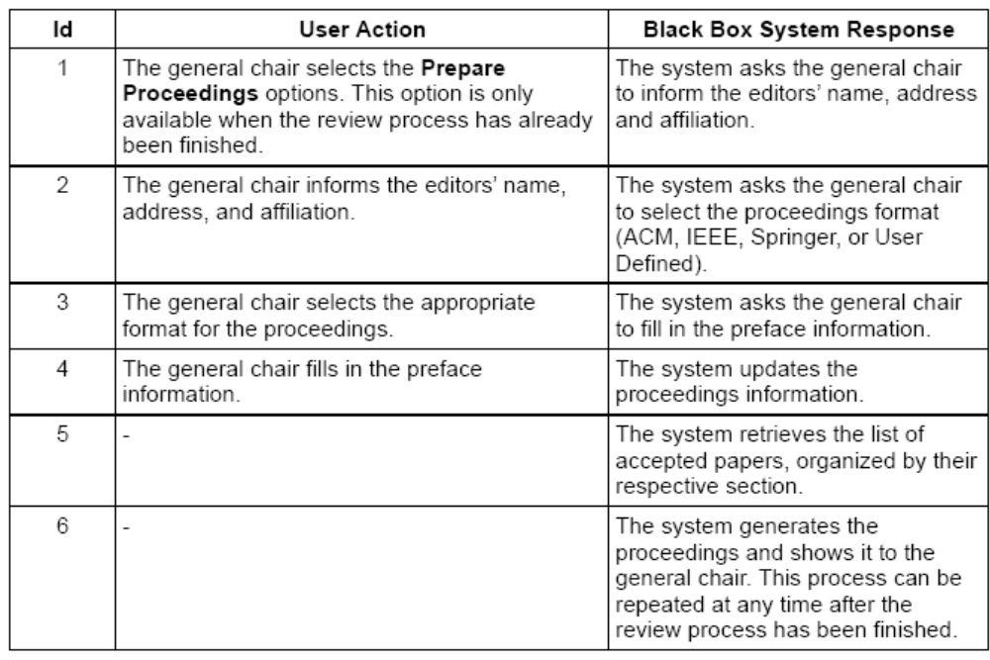

Cenário de Mudança 02

Hora início: 8:35
Hora fim: 8:46

Id | User Action | Black Box System Response
1 | The author selects the Submit Paper option in the main menu. | The system asks the main author to create an authentication profile (that requires an email address and password).
2 | The main author informs the email address and password. | The system creates the author authentication profile, and asks him to inform  - the paper's title, and  - for each author, the name, address and affiliation.  - the related topics of the paper
3 | The main author informs the paper's title, authors' data, and related topics. Selects the Proceed option. | The system updates the paper's submission with the informed title, authors' data, and related topics.
(4)  [Abstract] | - | The system asks the main author to fill in the paper's abstract
(5)  [Abstract] | The main author fills in the paper's abstract and selects the Proceed option. | The system verifies that the abstract does not have the maximum number of characters allowed in the conference.
(6)  [Abstract] | - | The system updates the paper's submission with the informed abstract.
(7)  [Conflicts of Interest] | - | The system asks the main author to inform any conflict of interest with the members of the program committee.
(8)  [Conflicts of Interest] | The main author selects the members of the program committee that have any conflict of interest. | The system updates the paper's submission with conflicts.
9 | - | The system asks the main author to upload the paper in one of the valid formats $FileType$
10 | The main author uploads the file corresponding to the submitted version of the paper. | The system updates the paper's submission with the uploaded file.
(11)  [Auto Validation] | - | The system verifies that:  a) The number of lines and characters of the abstract obey the conference constraints.  b) The numbers of pages and characters of the whole paper adhere to the conference's constraints.
(12)  [Auto Validation] | - | The system verifies that all fonts are embedded in the paper.
(13)  [Auto Validation] |  | The system verifies that that the images obey the conference's restrictions about image format.
(14)  [Auto Validation] |  | The system verifies that the font, spacing, and alignment used in the paper adhere to the conference constraints.
15 | - | The system presents a summary of the submission and sends a message to the paper's authors.

Id | User Action | Black Box System Response
1 | The author selects the Offline Submission option in the main menu. | The system asks the main author to create an authentication profile (that requires an email address and password).
2 | The main author informs the email address and password. | The system creates the author authentication profile, and asks him to upload both electronic form and paper.
3 | The main author uploads the requested files. | The system extracts from the electronic form the submission data.
4 | - | The system creates a conventional submission of the paper.
5  [Auto Validation] | - | The system verifies that:  a) The number of lines and characters of the abstract obey the conference constraints.  b) The numbers of pages and characters of the whole paper adhere to the conference's constraints.
6  [Auto Validation] | - | The system verifies that all fonts are embedded in the paper.
7  [Auto Validation] |  | The system verifies that that the images obey the conference's restrictions about image format.
8  [Auto Validation] |  | The system verifies that the font, spacing, and alignment used in the paper adhere to the conference constraints.
7 | - | The system presents a summary of the submission and sends a message to the paper's authors.

Cenário de Mudança 03

Hora início: 8:47
Hora fim: 9:01

Id | User Action | Black Box System Response
1 | The general chair selects the Assign Papers to Reviewers option in the main menu. | The system retrieves and shows the list of submitted papers. The number of reviewers assign to each paper is shown to the general chair.
2(a)  [Preference Based] | The general chair selects a specific paper. | The system retrieves the reviewers that have previously informed interest in the research topics of the paper. The number of papers that has already been assigned to each reviewer is shown.
2(b)  [Inference Based] | The general chair selects the auto distribution process (available only in products that are configured with the Inference Based distribution process). | The system, automatically generate a distribution of the papers to the reviewers, showing it to the general chair the related topics of each paper.  This process considers:  a) the number of reviewers per paper  b) the number of papers per reviewer, and  c) the reviewer's interest and knowledge in the topics
3  [Inference Based] | The general chair selects on of the options available to automatically assign papers to reviewers. | Based on the chosen criteria, the system automatically generates a distribution of the papers to the reviewers, showing it to the general chair the related topics of each paper. This process considers:  a) The criteria selected by the general chair  b) the number of reviewers per paper  c) the number of papers per reviewer, and  d) the reviewer's interest and knowledge in the topics
4(a)  [Preference Based] | The general chair selects one of the reviewers and click on the Assign option. | The system assigns the paper to the selected reviewer. The process may be repeated until the general chair selects the option check distribution of papers.
4(b)  [Inference Based] | The general chair is able to change the assignment of papers to reviewers. | The system verifies that all constraints are being obeyed. If it this is not true, this process must repeat.
5  [Preference Based] | The general chair selects the Check Distribution of Papers option. | The system verifies that all papers have been assigned to at least three reviewers and that each reviewer have been assigned to a uniformly distribution of papers. If any fault is found, the system will not able the program chair to close the assignment and this process repeat until all constraints have been solved.
6 | The general chair selects the Close Assignment of Papers option. | The system sends the evaluation forms and URLS of assigned papers to each reviewer.
7 |  | The system starts the period of paper evaluation, allowing the members of the program committee to send their revisions.

Cenário de Mudança 04

Hora início: 9:05
Hora fim: 9:10

Id | User Action | Black Box System Response
1 | The author selects the Submit Paper option in the main menu. | The system retrieves and shows the welcome  message.
2 | - | The system asks the main author to create an  authentication profile (that requires an email  address and password) and selects one of the  conference tracks.
 | The main author informs the email address, password and conference track. | The system creates the author authentication  profile, relates it to the track, and asks him to inform  - the paper's title, and  - for each author, the name, address and affiliation.  - the related topics of the paper
3 | The main author informs the paper's title, authors' data, and related topics. Selects the Proceed option. | The system updates the paper's submission with the informed title, authors' data, and related topics.
(4)  [Abstract] | - | The system asks the main author to fill in the paper's abstract
(5)  [Abstract] | The main author fills in the paper's abstract and selects the Proceed option. | The system verifies that the abstract does not have the maximum number of characters allowed in the conference.
(6)  [Abstract] | - | The system updates the paper's submission with the informed abstract.
(7)  [Conflicts of Interest] | - | The system asks the main author to inform any conflict of interest with the members of the program committee.
(8)  [Conflicts of Interest] | The main author selects the members of the program committee that have any conflict of interest. | The system updates the paper's submission with conflicts.
9 | - | The system asks the main author to upload the paper in one of the valid formats $FileType$
10 | The main author uploads the file corresponding to the submitted version of the paper. | The system updates the paper's submission with the uploaded file.
(11)  [Auto Validation] | - | The system verifies that the numbers of pages and characters adhere to the conference's constraints.
(12)  [Auto Validation] | - | The system verifies that all fonts are embedded in the paper and that the images obey the conference's restrictions.
13 | - | The system presents a summary of the submission and sends a message to the paper's authors.

Cenário de Mudança 05

Hora início: 9:10
Hora fim: 9:15

Id | User Action | Black Box System Response
1 | The author selects the Submit Paper option in the main menu. | The system asks the main author to create an authentication profile (that requires an email address and password).
2 | The main author informs the email address and password. | The system creates the author authentication profile, and asks him to inform  - the paper's title, and  - for each author, the name, address and affiliation.  - the related topics of the paper
3 | The main author informs the paper's title, authors' data, and related topics. Selects the Proceed option. | The system updates the paper's submission with the informed title, authors' data, and related topics.
(4)  [Abstract] | - | The system asks the main author to fill in the paper's abstract
(5)  [Abstract] | The main author fills in the paper's abstract and selects the Proceed option. | The system verifies that the abstract does not have the maximum number of characters allowed in the conference.
(6)  [Abstract] | - | The system updates the paper's submission with the informed abstract.
(7)  [Conflicts of Interest] | - | The system asks the main author to inform any conflict of interest with the members of the program committee.
(8)  [Conflicts of Interest] | The main author selects the members of the program committee that have any conflict of interest. | The system updates the paper's submission with conflicts.
9 | - | The system asks the main author to upload the paper in one of the valid formats $FileType$
10 | The main author uploads the file corresponding to the submitted version of the paper. | The system updates the paper's submission with the uploaded file.
(11)  [Auto Validation] | - | The system verifies that the numbers of pages and characters adhere to the conference's constraints.
(12)  [Auto Validation] | - | The system verifies that all fonts are embedded in the paper and that the images obey the conference's restrictions.
13 | - | The system presents a summary of the submission and sends a message to the paper's authors.

Id | User Action | Black Box System Response
1 | The author selects the Offline Submission option in the main menu. | The system asks the main author to create an authentication profile (that requires an email address and password).
2 | The main author informs the email address and password. | The system creates the author authentication profile, and asks him to upload both electronic form and paper.
3 | The main author uploads the requested files. | The system extracts from the electronic form the submission data.
4 | - | The system creates a conventional submission of the paper.
5  [Auto Validation] | - | The system verifies that the numbers of pages and characters adhere to the conference's constraints.
6  [Auto Validation] | - | The system verifies that all fonts are embedded in the paper and that the images obey the conference's restrictions.
7 | - | The system presents a summary of the submission and sends a message to the paper's authors.

Cenário de Mudança 06

Hora início: 9:17
Hora fim: 9:23

