**Mimot PH Inc.**



**Slot Machine**

**Version 1.1.0**

**All work copyright 2020 by MimotPH.**

**All rights reserved**

**Table of content:**

-Version history

-Game overview

-Game play mechanics

-Controls

-Interface sketch

-Screen Description

-Scoring

-Art / Multimedia Index

**Version history:**

This Game design document was made on the 1st week of February 2020 and will be called version 1.1.0 (first edition).

**Game overview:**

Slot Machine is a game where the player place a bet then click on the spin button to start the game. It’s standard features is a screen displaying three or more reels that spin when the game is started. Some of the modern slot machines have different images or design unlike the usual slot machine that’s the same as fruit machine.

**Game play mechanics:**

The player is able to use the mouse to play the game. Player will choose minimum bet which is 1 then maximum bet which is 50. Just click the spin button to play and there is also a reset button once the player doesn’t have any more credits. Just keep on spinning to win and good luck.

**Controls:**



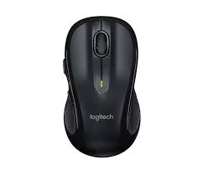



Using a mouse to click the buttons on the slot machine.



**Interface Sketch:**

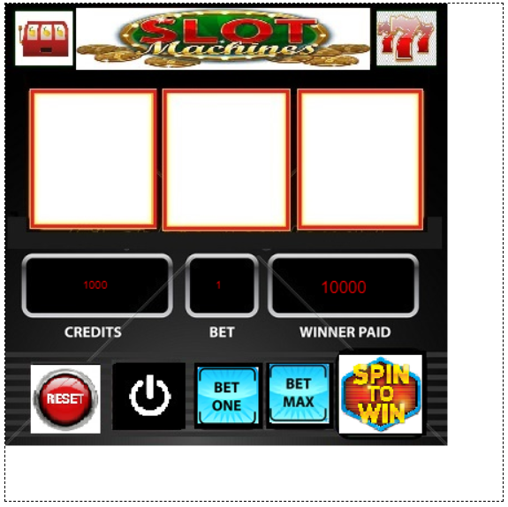

**Screen Descriptions:**

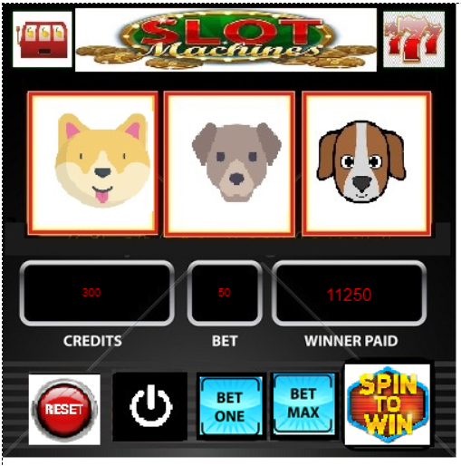

Main screen

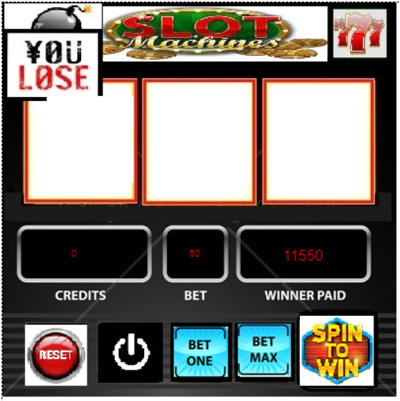

End Screen

**Scoring:**

A score of 1 up to 20 times of amount what the players bet depends on what kind of dog will be the result.

**Art / Multimedia Index:**

