Fuse Bead Designer Tool

Click on the board you would like to design for or enter your own dimensions in the box below.
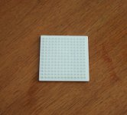
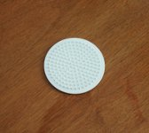
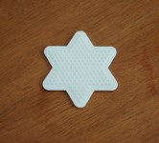
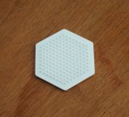


Small Square Small circle Small Star Small Hexagon Small Heart

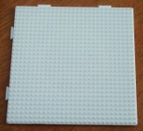
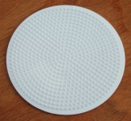

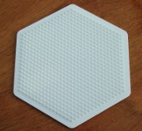


Large Square Large Circle Large Star Large Hexagon Large Heart

Create my board
Define your own rectangular board: Number of pegs wide Number of pegs long

Where can we buy the peg boards? The boards this tool generates are based on the geometric range of midi peg boards produced by hama. If you are in the UK we recommend purchasing them from Tablecraft at http://www.hamabeads.co.uk/ We've found them to be the cheapest and very quick to deliver. We are not affiliated with Hama or Tablecraft.

