Aerofoil v7.0
Plotting and 4-Axis
G-Code generation

This software is available at:
https://github.com/rbp28668/Aerofoils

By R Bruce Porteous
(c) 2020

Change Log
Date | Description | Author
19 May 2020 | Updated for version 6.1 | RBP
14 Oct 2020 | Updated for version 7.0 | RBP

Table of Contents
Change Log 2
Introduction 5
New for Version 7 5
Installation 6
Running 7
Plotting a Wing 9
Set the Plot Size 9
Set a Grid 10
Create the Structure 10
Adding Internal Structure 13
Spars 13
Cutouts 13
Select Sections to Plot 14
Plotting Cores 15
Modifying the Plot 15
Plotting Ellipses 15
Reference Points 16
Editing a Plot 17
Setting Interpolation Position 17
Inverting and Reflecting Items 17
Deleting Sections and Structure 18
Plot Order 18
Printing and Export 20
Printing 20
Export 20
DXF 20
Postscript 20
LaserJet 21
Generating a Cut from a Plot 21
Driving a Cutter 22
Creating a Cutter File 22
Creating Wing Structure 23
Creating Ellipse Structure 26
Creating Point Structure 27
Adding Arbitrary GCode 27
Creating DXF Structure 28
Converting Structure to a Cut 28
Wing Sections 29
Core Type 30
Core Alignment 30
Ellipses 33
Waypoints 34
G-Code Snippets 34
DXF Components 34
Changing Cut Order 34
Home 34
G-Code Output 34
Configuring G-Code 35
Sending G-Code via Network 36
Tool Offset 36
Optimising GCode output 36
Cutter Geometry 37
Previewing a Cut 38
Loading and Saving 40
License and Source Code 41
0. Definitions. 41
1. Source Code. 41
2. Basic Permissions. 42
3. Protecting Users' Legal Rights From Anti-Circumvention Law. 42
4. Conveying Verbatim Copies. 42
5. Conveying Modified Source Versions. 43
6. Conveying Non-Source Forms. 43
7. Additional Terms. 44
8. Termination. 45
9. Acceptance Not Required for Having Copies. 46
10. Automatic Licensing of Downstream Recipients. 46
11. Patents. 46
12. No Surrender of Others' Freedom. 47
13. Use with the GNU Affero General Public License. 47
14. Revised Versions of this License. 47
15. Disclaimer of Warranty. 48
16. Limitation of Liability. 48
17. Interpretation of Sections 15 and 16. 48

Introduction
Now at version 7.0, this program allows you to plot wing sections on paper and to produce G-Code for a separate cutter program. In both cases this includes spars, leading and trailing edges, and skins.

The original It was first written a number of years ago, to run on an early PC-AT with MS-DOS. In this incarnation it's main function was to drive a CNC wing-cutter. When the program was re-written to work under Windows it was extended to include plotting and printing. Now the program has 2 distinct functions – plotting on paper and producing G-Code for a CNC Cutter – in particular the associated Cutter program.

The use of G-Code was introduced in version 6 and now aims to be interoperable with programs such as Jedicut, Profili and Mach3.

Knowledge of the program's provenance is useful when you are using it to plot sections of a wing, a 3 dimensional object, on a 2 dimensional piece of paper. The basic principle is that you define the wing structure, at root and tip (as if you were defining templates for cutting a foam wing) and then plot sections of that structure. This makes tapered wings easy and there is no need for the root and tip sizes or sections to be the same: the program will interpolate between the root and the tip.

In addition to plotting wings it will also plot ellipses or half ellipses for formers. The same principle of defining 2 ends and taking sections along the resultant 3 dimensional object applies as for when you plot wings.

Finally, and this is only really of use when driving a CNC cutter, the program allows you to add waypoints which will guide the cutter between cores.

New for Version 7
Version 7 is primarily around usability and flexibility. It includes:
- Various bug-fixes from 6.1 release.
- Ability to take forward and reverse cuts and separate cutting top and bottom surfaces.
- Revised wing dialog to reduce clicks and show root and tip sections
- Zero length moves filtered out of G-Code
- Cut documents can be created from plot documents and vice versa (useful if you want to plot a few ribs on paper in conjunction with cutting a core).
- Now pays attention to the closed flag in DXF LWPolyLine import.
- Optionally optimises G-Code output when plotting a wing. Results in smaller G-Code files.
- Block (plan) view of cutter and foam block. Useful for visualising tapered/swept wings.
- Tapered wings can now be aligned by leading or trailing edge.

Installation
Simple – copy aerofoil.exe and or cutter.exe into a folder along with the data sub-directory (which contains the aerofoil sections) on to your hard drive. It doesn't matter where the folder is although it is usually a good idea to put it in a folder where all the users of the PC can access it.
Note that it is possible to build both 64 bit and 32 bit versions which have the suffix _x64 and _x86 respectively. Both these versions have been developed and shown to work under Microsoft Windows 10.
If you want to create shortcuts to the program then point them to aerofoil.exe in whichever install folder you decided on.
Un-install is also simple – delete the program and its data files. There is no install or un-install program. If you created any shortcuts, delete them too.

Running
Open up the folder that contains aerofoil.exe and double-click it. The program should start and give you a blank sheet similar to the picture below.

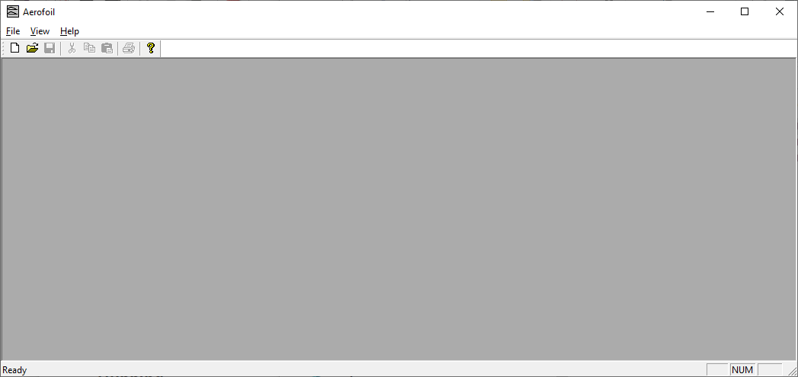
At this point there no plot or cut defined. The File menu can be used to load up a plot file or a cut file or to create a new plot or cut. Plot files are for plotting out on paper (e.g. for making a built-up structure or root or tipe ribs. Cutter files are for driving a CNC cutter. They aren’t interchangeable although you can create the start of a cutter file from a plot and vice-versa.

File/Open will produce the usual Windows file open dialog. Either select Aerofoil Plot Files (*.plt) or Cutter Files (*.cut) from the drop down as needed and chose the plot or cut file to load.

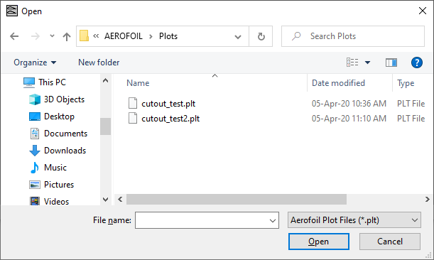
Alternatively, to create a new plot or cut, select File/New. Aerofoil will display the following dialog to ask you whether you want an Aerofoil ( for plotting on paper) or a Cutter for producing CNC output.

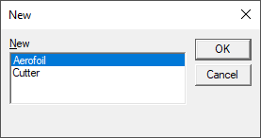
At this point either go to Plotting a Wing or Driving a Cutter.

Plotting a Wing
This is plotting wing sections on paper. If you want to cut a core go to Driving a Cutter later in the document.
On selecting File/New then Aerofoil you should see a blank plot similar to the following.
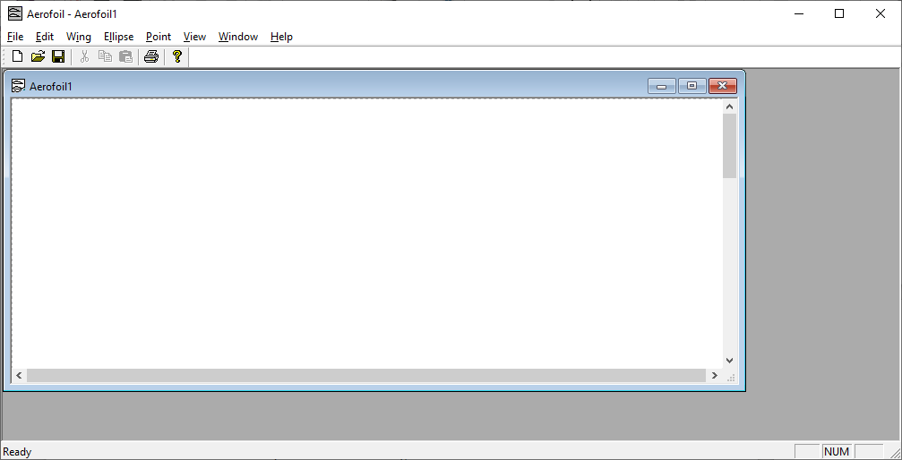

Set the Plot Size
Before doing anything else, it's a good idea to set the plot size that you're working with. Select File/Plot Size and enter the plot size into the dialog shown below.

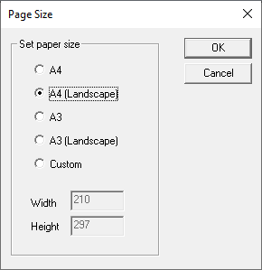
For normal printers, A4 landscape will normally be what you want.

Set a Grid
This step is entirely optional – if you are going to print out the plot and glue it to sheets of balsa for later cutting, it's helpful to have guilde-lines drawn that correspond to the width of the balsa you will be using. To set up these guide-lines select File/Grid. The program will show a dialog similar to the one shown below.

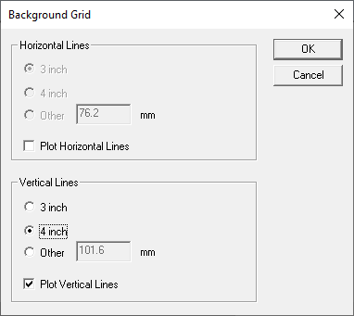
Horizontal or vertical lines will only be plotted if the corresponding checkboxes are ticked. If the box is ticked then you can enter the spacing of the grid. You have 3 options the common 3 or 4 inch size or you can enter another value in mm. Finally click on OK to save the settings. Note that the grid is just a drawing guide and is not saved with the plot.

Create the Structure
To create a new wing, select Wing/New. The program will pop up the standard file-open dialog. This is to allow you to select the root section. Select the data (.DAT) file with the section coordinates for the root. If this is the first time you'll need to navigate to the data folder where all the coordinate files are stored. As soon as you close the first file-open dialog, another one pops up to allow you to enter the tip section.
You should then see the plot of the root section of the wing as shown below.
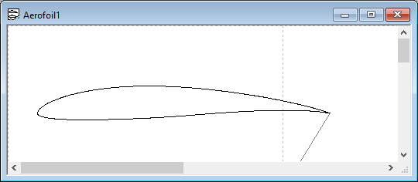

Note that the program in this case has just the root section – modifying this and modifying what is plotted (e.g. chord line, cutting markers, labels etc is covered in Modifying the Plot later.

Now, that the program’s view of the structure probably not what you want. In particular the chord size is almost certainly wrong. To change this you need to edit the basic wing structure. Highlight the section by clicking on it (it should go gray) and either select Wing/Edit or right click and select Edit Wing.

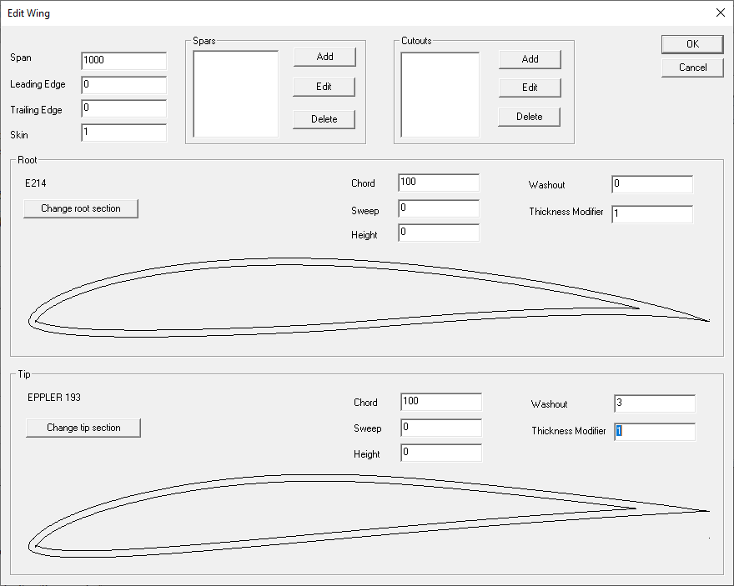

The Edit Wing dialog is shown above. This allows you to edit the basic geometry of the wing, including the (half) span, the size of leading and trailing edges, root and tip section, the size and position of spars and any cutouts in the wing.
The parameters for the root and the tip are shown in this dialog. You can change the sections with the Change root section and Change tip section buttons. Changes in the wing section, size, washout, cutouts, spars etc are shown in the root and tip plots. Span is only really important when cutting a core as it defines the distance between the root and tip sections.

For plotting on paper the Thickness Modifier entry is probably the most useful. This changes the thickness of the section. For example a Thickness Modifier of 1.2 will make a 10% thick section into a 12% thick section.
The other parameters: Sweep, Height and Washout allow the position and angle of the section to be changed. Not so important for plotting on paper but essential if it's driving a CNC cutter.

Adding Internal Structure
So, now that the basic geometry is set up let's add some structure. First we'll add a ¼ inch leading edge and a ¾ inch trailing edge. The program only accepts dimensions in mm so enter 6.3 for the leading edge and 19 for the trailing edge. Let's also define a skin thickness of 1/16 inch or 1.5mm. The next step is to add some spars.

Spars
In the spars box, click on Add. You should see the spar dialog shown below.

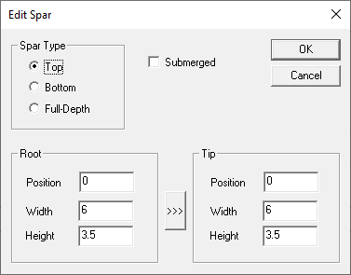
This allows 3 types of spar – top surface, bottom surface or full-depth. “Submerged” determines whether the spar is flush with the surface of the wing or is submerged under the skin. Usually if you've got a balsa skin you'll want a submerged spar. You also need to specify the position and size of the spar at its root and its tip (the position is the distance in mm from the leading edge) A short-cut is to use the “>>>” button to copy the root settings to the tip.
Any number of spars can be entered and they are displayed in a list in the spars dialog.

Cutouts
It’s also possible to enter cutouts in the wing to mark positions for lightening holes or servo leads. In the same way as for spars, cutouts can be added, edited and deleted. If you click Add in the Cutouts box you will see the dialog below.
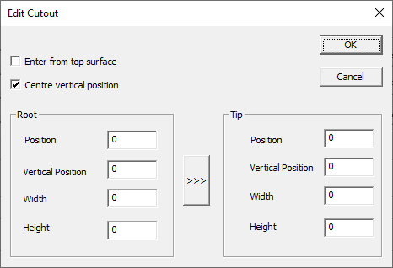

Currently only elliptical cutouts are supported. Position is the position along the chord where you want the centre of the cutout. Vertical Position is relative to the chord line but note the Centre vertical position option which centers the cutout between the upper and lower surfaces. The >>> button will copy the root settings to the tip.
Note that Enter from top surface only applies to generating cuts where the wire has to go into the cutout from one side or other. Normally that would be the lower surface of the wing.

Select Sections to Plot
Once you've set up the wing structure you can plot multiple sections from that wing.
Click on an existing section of the wing to select the wing you want to plot a section of. Then select Wing/New Section from the menu bar. You'll get a dialog asking for the section's position:

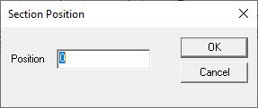
This gives the position, in mm, of this section from the root. One of the parameters of the wing definition is Span. The position, relative to the wing's span parameter determines where the section is interpolated. 0 always plots the wing section – if the wing’s Span is set to 1000 then a Position of 1000 will plot the tip section and 500 will plot a section half way between the root and the tip.
When you click on OK in the Section Position dialog the program will draw another section. You can then click on it's outline to select it and drag it to a new position on the drawing.
Tip: It's useful having a spreadsheet to hand with all the rib positions calculated in mm if you're doing multiple ribs.

Plotting Cores
As well as the full structure of the wing sections the program will also plot templates for foam wings if you don’t have CNC hardware.
Select Wing/New Core from the main menu. The program will draw a core on the drawing, drag it to where you want it. You can change it's position on the span by right clicking it and selecting Position.

Modifying the Plot
Once you've set up a drawing you can modify what's there and how it's drawn. Firstly, anything on the drawing can be moved by dragging with the mouse.
Secondly, there are flags that control exactly what in a wing (or ellipse) is drawn. These affect all the sections of that wing. Select the section of the wing or ellipse and, either right click it and select Wing Flags (for a wing) or, select Wing/Flags from the main menu. You'll get a dialog that specifies a number of options:

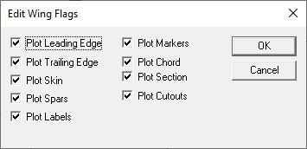
Most of these are fairly obvious. Markers are 10% markers for cutting foam cores by hand. Section determines whether the section is interpolated or both the root and tip are plotted separately.

Plotting Ellipses
The program also allows plotting of elliptical sections for use in creating fuselages etc. The top and bottom heights don’t have to be the same. To add an ellipse, or actually a pair of ellipses as we can interpolate between them much as we do for wing sections, select Ellipse/New from the top menu. You should then see a dialog like the one shown below.
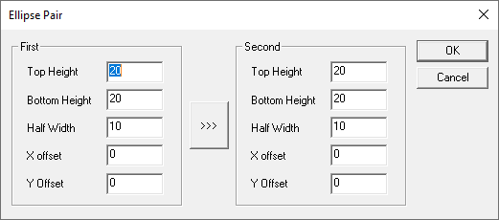

Enter the top and bottom height of the ellipse pair. Half width is the width from the centre to the edge of the ellipse – think radius rather than diameter. As before >>> copies the settings from the first ellipse to the second.

The Flags dialog for an ellipse is simpler than that of a wing:

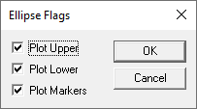
It allows you to specify plotting only the top or bottom halves as well as center markers.

Reference Points
It is possible to add reference points to the plot which are drawn as little “bow-tie” symbols. These can help with alignment over sheets of wood etc.

From the top level menu select Point/New. You should see a dialog like the one below. For a plot there’s no reason to change the values as you can drag its position on the plot anyway.

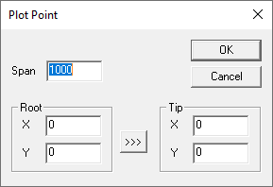

Editing a Plot
Aerofoil sections, ellipses and points can all be dragged around the plot using the mouse. Clicking on an item selects it and you can then able to edit its properties, by :
- Right clicking the item and using the popup menu
- Using the edit menu. Note Edit/Edit Structure is sensitive to the type of object selected.
- Using the Wing/Ellipse or Point menus.

Setting Interpolation Position
All items on the plot are some form of section of a 3 dimensional item which is why even ellipses and points have two ends – first and second or root and tip. Edit/Position will bring up the Section Position dialog shown earlier and below to allow you to interpolate between the two ends.
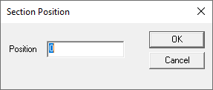

Inverting and Reflecting Items
It’s also possible to invert or reflect the plot of an individual section. Select the section with the mouse and either right click it and select Plot Flags, or, select Edit/Plot Flags from the main menu. You'll see a dialog like the one below:

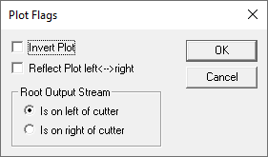

Here, Invert Plot and Reflect Plot left <--> right allow you to flip the section vertically or horizontally respectively. This can be invaluable when trying to cram a set of ribs onto a sheet of balsa.
The Root Output Stream setting is really for a CNC cutter to allow you to switch which end of the cutter cuts the root.

Deleting Sections and Structure
Edit/Delete deletes whichever section is currently selected. That doesn’t delete the underlying structure though. Use Edit/Delete Structure for this which will display a dialog similar to the one below to allow you to select the structure item to delete.

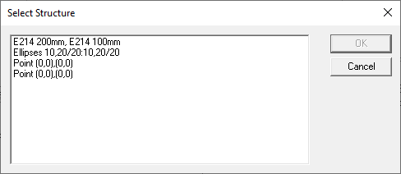
Select the structure item and OK to delete it, Cancel if you didn’t want to delete anything.

Plot Order
Edit/Plot Order allows you to modify the order in which items are plotted. Not normally an issue but this will be reflected in the Postscript or Laserjet (HPGL) output. The Plot Order dialog is shown below. If you select one of the items in the list the buttons to the right allow you to move it to the top or bottom of the list or up and down an entry at a time.
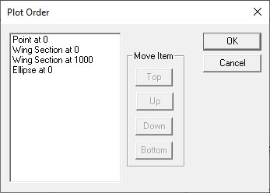

Printing and Export

Printing
It's generally a good idea to set the plot size to match your printer so that you can align objects on the screen to avoid page boundaries.
File/Set Plot Size gives you the dialog shown below.

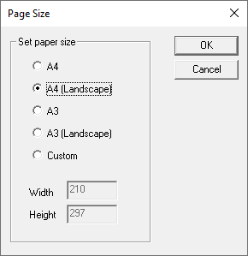
This caters for normal paper sizes and alignments but does allow you to set a custom size as well. The program draws a dotted rectangle around the selected plot size on the screen. Use this as a guide to the printable area – you can drag objects across these lines but they won't get printed.
File/Print and File/Print Preview work as you'd expect with the usual windows dialogs.

Export
As well as printing, Aerofoil can export data in a number of formats: DXF, Laser Jet and Postscript.

DXF
DXF allows you to export sections to be imported into Computer Aided Design (CAD) packages. Aerofoil is itself a CAD program – but a special purpose one. Most general purpose CAD packages will import DXF. To export as DXF select File/DXF Output and enter the name of the file to export to in the Save As dialog that pops up.

Postscript
It may be that you have access to a postscript printer, or want to send a file to someone else who has one. Aerofoil allows export in native postscript. Apart from allowing plot files to be saved and printed later, the postscript asks the printer to generate lines as thin as possible.
To export as Postscript, select File/Postscript Output and enter the name of the file to export in the Save As dialog that pops up.
Note that if you save a postscript file then the usual way to print it is to copy it to the printer device (e.g. PRN: ) not to print it as a text file. Printing it as a text file will make the printer driver encode the Postscript with another layer of Postscript which will waste an awful lot of paper!

LaserJet
In a similar fashion to generating Postscript, Aerofoil will also generate HP-PCL for sending to a Hewlett-Packard laserjet.
To export as HP-PCL, select File/Laser Jet Output and enter the name of the file to export in the Save As dialog that pops up.

Generating a Cut from a Plot
Once a plot has been set up it’s possible to create a cut file from the plot. This copies across the geometry of the underlying structure to provide the basis to build up a set of foam cutting instructions. To do this select File/Create Cutter Document. Note that this is a separate document – changes in the plot will not be reflected in the cut and vice-versa.

Driving a Cutter
Aerofoil provides first class support for generating G-Code to drive a 4-Axis CNC wing cutter. The original program had the ability to directly drive cutter hardware. This has now been moved to a Cutter program which interprets the G-Code and drives the CNC hardware. This has several advantages, not least of which being that the G-Code generated by Aerofoil can be sent to CNC hardware controlled by Mach3 or similar CNC programs.

Creating a Cutter File
After selecting File/New followed by Cutter you should see an empty cut file displayed similar to the one shown below.

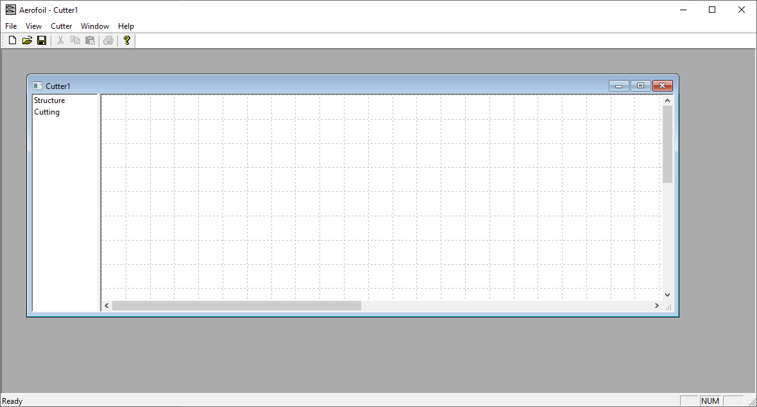
There are 2 areas within the cutter display – a tree view on the left that has (currently empty) Structure and Cutting entries and a display area on the right that shows a graphical display of the current cut file. The separator between the two parts can be dragged left and right to allow more or less display of the tree view.
A tree view is used here as it provides an immediate visual indication of the order in which items will be cut. This is very important when running a CNC system!
The split between the Structure and Cutting entries is a core concept. In Structure you define the “things” you want to cut, in Cutting you define how and where you want them cut. This approach has the obvious advantage when cutting cores – you define the geometry of the wing once then tell the cutter to cut 2 cores, a left and a right one. This can be seen in the image below where a single wing has been defined (Selig S3021) and a mirror pair of cores are configured for cutting, interspersed by cut/move to point to move the wire to the correct position before, between and after cutting the cores.

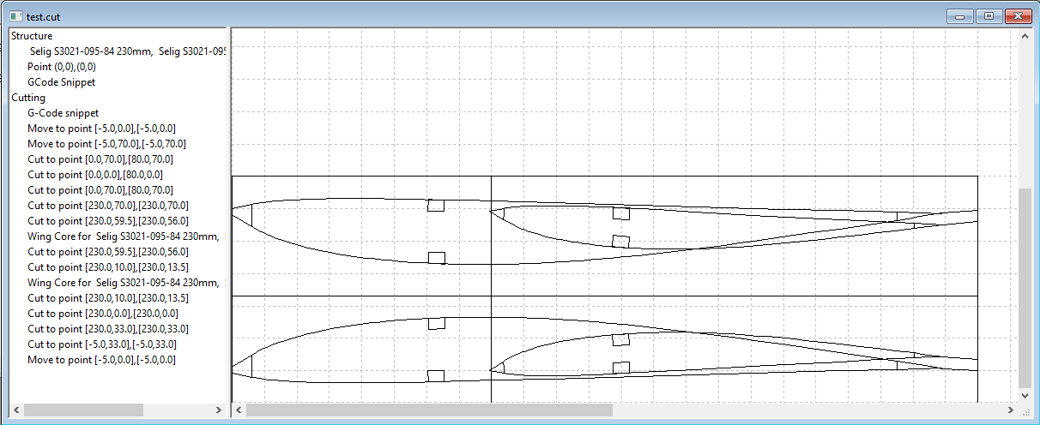

Right clicking on the Structure element in the tree will show a popup menu that allows you to create new structure elements as follows:
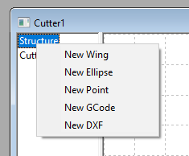

The different types of structure are covered in the following sections.

Creating Wing Structure
Select New Wing from the Structure popup menu. You will then have 2 successive file-open dialogs to select the sections for the root and tip of the wing.
Once you have selected the root and tip sections you’ll see the entry for the wing and can edit it by right clicking the entry and selecting Edit.

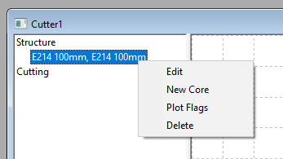
Edit will show the standard Edit Wing dialog shown below and you can change chord, washout, spars, cutouts and leading and trailing edges in the same way as you can creating a plot.

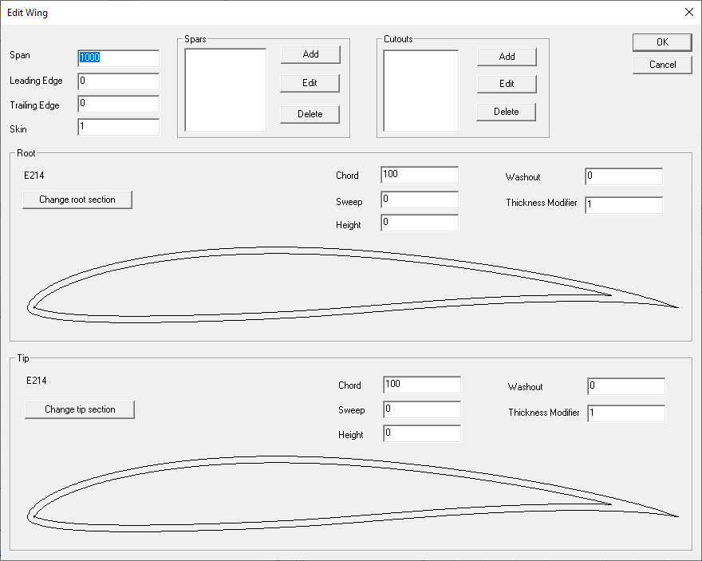
Adding or editing a spar will

Tip: When creating a wing structure usually just leave height at zero and use sweep to set the relative position between the root and tip. Use the transform feature on the actual cut to determine where the cut is positioned on the foam block.

The Edit Spar dialog is shown below. Top, bottom and full depth spars can be defined. Submerged determines whether the spar is submerged under the skin. Note that position is the start of the spar as measured from the leading edge.

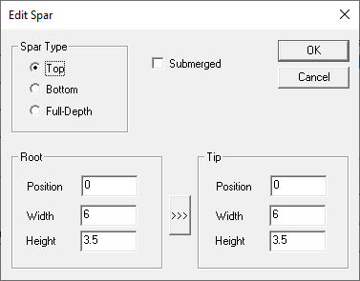
Various variations are shown in the annotated aerofoil picture below:
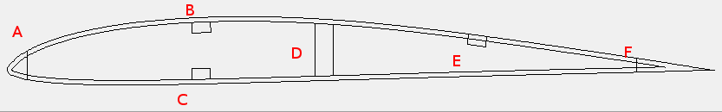
A is the position of the leading edge.
B is a top surface, submerged spar – you can see it’s wholly underneath the skin.
C is a bottom surface, submerged spar.
D is a full depth submerged spar.
E is a top surface spar. It’s not marked as submerged so it is flush with the surface of the wing.
F is the trailing edge cut.

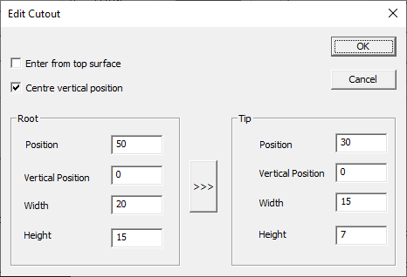
When adding or editing a cutout you will see the Edit Cutout dialog shown below. Cutouts are elliptical. With the cutter the wire must cut through the core to the position of the cutout. By default this cut is on the bottom surface. Selecting Enter from top surface will change this and the cutout will be started on the top surface.

Centre vertical position centres the cutout between the skins – usually this is easier than having to adjust the vertical position.

Selecting Plot Flags from the wing popup menu will display the Edit Wing Flags dialog that controls whether leading edge, trailing edge, spars or cutouts are cut from the core.

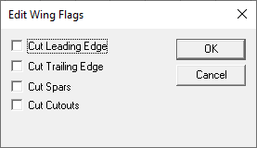

Creating Ellipse Structure
Ellipses can be used for cutting fuselage decking or similar shapes. Select New Ellipse from the Structure popup menu. This will show the Ellipse Pair dialog where you can enter the sizes of the ellipses at both ends. As before the >>> button will copy the contents of the first ellipse to the second.

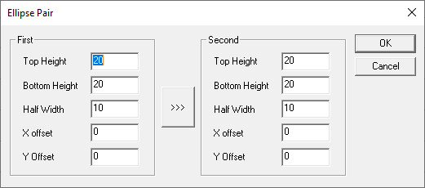

Creating Point Structure
Select New Point from the Structure popup menu. You will see the Plot Point dialog. Note that this defines where the wire of a cutter should go in all 4 axes and so has a position for both root and tip.

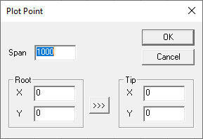
Tip: When setting up the cut path you invariably want the cutter to go via a number of points before it starts cutting the actual foam component. To do this make sure you include a Point at [(0,0)(0,0)] in the structure which will then allow you to create various waypoints before, between and after the actual components.

Adding Arbitrary GCode
You can add snippets of arbitrary GCode in to the list of structures so they can then be included in the cut sequence. Select New G-Code from the Structure popup menu. This will pop up an Edit G-Code dialog where you can add a small snippet of G-Code. See the Cutter manual for more details of G-Code.

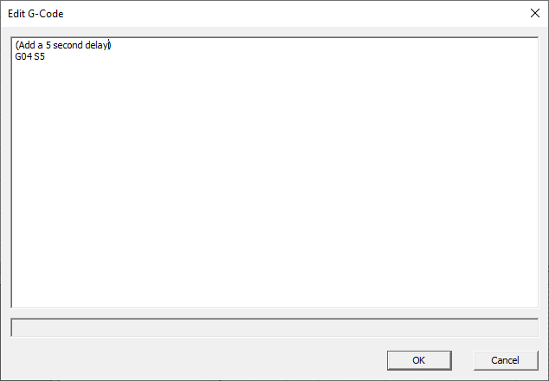

Creating DXF Structure
This allows you to import 2D DXF files into the program. The import has some limitations and currently supports Arc, Circle, Ellipse, Line, LWPolyLine and Point in a DXF file. In practice this is enough to usefully import shapes generated by TurboCad. Note that the full DXF specification is available at https://images.autodesk.com/adsk/files/autocad_2012_pdf_dxf-reference_enu.pdf .
As this is dealing with 2D shapes the same shape is cut through the foam block i.e. the shape effectively becomes an extrusion of that shape.
To import a DXF file, select New DXF from the Structure popup menu. This shows a file open dialog to allow you to select the DXF file to import.

Converting Structure to a Cut
Once the structures that you want to cut are defined you need to set up the cut. Structure specific options are discussed below but there are a few concepts that are worth touching on first:

- All the cuts or cutter actions (bar Home) are produced from corresponding structure item’s right click menus.
- Most cut items can be transformed by reflecting, inverting or setting their position. This includes wings, ellipses, points and DXF imports. G-Code snippets can’t be transformed. Use of transforms is the reason why generally it’s best to leave positions alone in the structure.
- All the cuts can be deleted from their right-click context menu.
- All the cuts can be moved up or down the cutting order using their right-click context menu.
- Deleting a cut doesn’t delete the underlying structure.
- Deleting a structure element deletes all the cuts that rely on it.

Most cuts can be moved in and out, left and right, inverted and reflected using the Transform dialog. This allows you to position a cut in the foam and to make pairs of cores.
The Transform dialog is shown below. Invert Plot and Reflect Plot allow the cut to be inverted (upside down) or reflected left to right (mirror image) respectively. Whilst convention has the root on the left side of the cutter it’s possible to swap sides using the Root Output Stream options.
The Root X and Y offsets and Tip X and Y offsets allow the exact position of the item to be defined in machine space. This is the usual way to position a core, ellipse, cut point etc. Note that the transform does work on a DXF import as well.

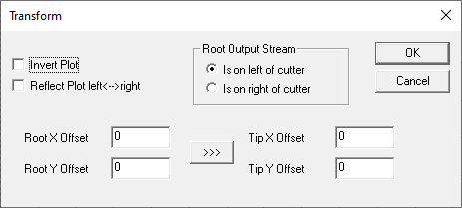

Wing Sections
Right click on the wing structure you want to cut and select New Core from the popup context menu. You should now see a Wing Core entry in the Cutting list. Transform and move up/down the cutting order as needed using its right-click context menu. Note that the right-click popup also has options for modifying the type and alignment of the core as shown below.
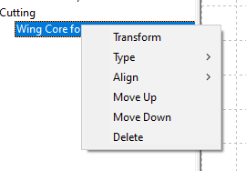
The type and alignment options are discussed in more detail below.

Core Type
Type allows you to select what sort of cut you want and its direction. The options are shown below.
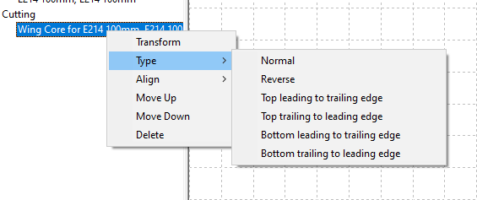
Normal – cut all the way round the wing, starting at the trailing edge and cutting the upper (of the wing) surface first.
Reverse – cut all the way round the wing, starting at the trailing edge and cutting the lower surface first.
Top leading to trailing edge – start at the leading edge and just cut the top surface.
Top trailing to leading edge – start at the trailing edge and just cut the top surface.
Bottom leading to trailing edge – start at the leading edge and just cut the bottom surface.
Bottom trailing to leading edge – start at the trailing edge and just cut the bottom surface.

Cutting the top/bottom separately allows you to cut from the leading edge if needed and to generate lead-in or lead-outs from the core.

Core Alignment
Heavily tapered wings are difficult to cut “as drawn” as they use a lot of foam and may need the cutter to drive outside its limits to produce a cut. This can be seen from the cutter geometry plot shown below.
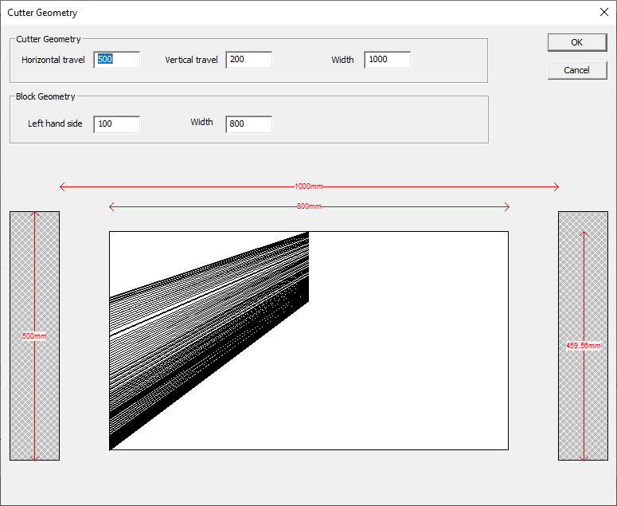
For this wing, the foam fills the cutter bed and, extrapolating the leading and trailing edge lines to the edges, can’t be cut anyway.

As shown below, the Align option on the Wing Core popup menu allows you to align the core either by the leading or the trailing edge.
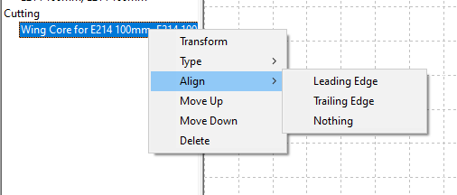
Aligning by Leading Edge does just that as can be seen in the Cutter Geometry dialog shown below.
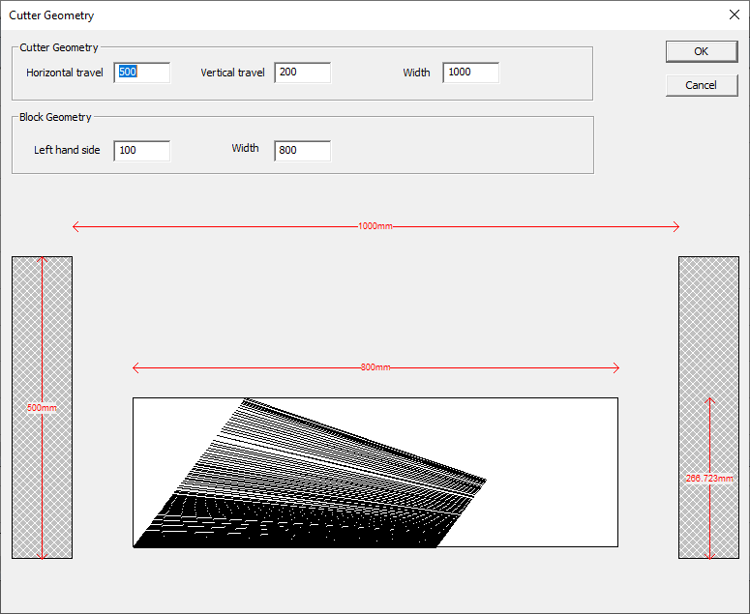
Similarly, Aligning the Trailing Edge aligns the trailing edge with the cutter.

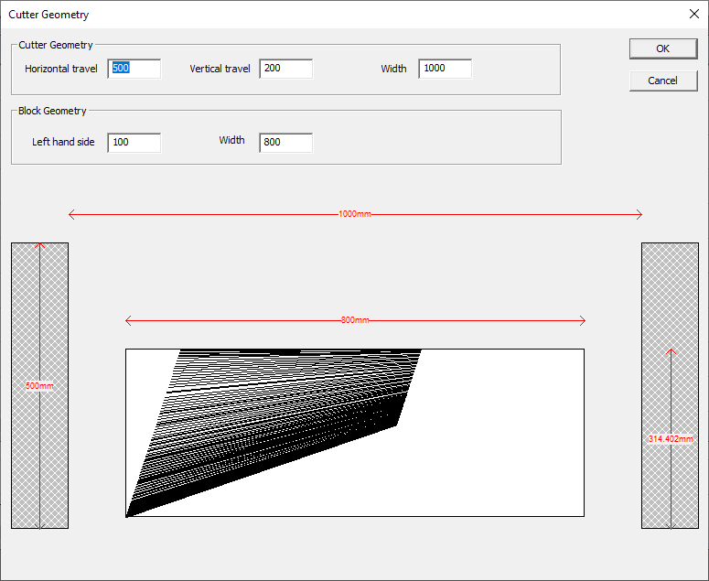
Selecting Nothing in the Align menu cancels any rotation.
Note: that having the span set properly in the wing definition is important here. In effect, all the plotted points are now 3 dimensional. The original x,y locations (along the horizontal axes and up the vertical respectively) have now been joined by a z value which says how far across the cutter the point is. It’s having x,z points that allow the rotation to take place. For rotation, Z on the root is taken to be zero but the Z on the tip is the span value. It’s now this span value that sets the wing size, not the block size.

Ellipses
Right click on the Ellipses structure you want to cut and select New Cut from the popup context menu. You should now see a Wing Core entry in the Cutting list. Transform and move up/down the cutting order as needed using its right-click context menu.

Waypoints
Right click on a Point entry in the structure (if there isn’t one create a new one at 0,0). You now have a choice of New Move or New Cut in the context menu. Moves are for use when the wire it outside the foam block and will go at full speed. Cuts are for when you’re cutting foam during the move and will move at the current feed rate. Your should now see a Move to point or Cut to point entry in the Cutting list. Transform and move up/down the cutting order as needed using its right-click context menu.

G-Code Snippets
Right click on the G-Code Snippet structure entry you want to cut and select New Cut from the popup context menu. You should now see a G-Code Snippet entry in the Cutting list. Move up/down the cutting order as needed using its right-click context menu.

DXF Components
Right click on the DXF Object structure entry you want to cut and select New Cut from the popup context menu. You should now see a DXF Object entry in the Cutting list. Move up/down the cutting order as needed using its right-click context menu.

Changing Cut Order
Each item can be moved up and down the cut order by using its right click menu and selecting Move Up or Move Down as appropriate. Changes to the order should be visible in the display in the right hand pane – hopefully it should be obvious if there’s a move or a cut straight through a part!
Cut items can also be deleted using their right click menus.

Home
The only cut item that can created without structure is the Home command i.e. recalibrate the cutters position against its home or limit switches. To do this right click on the Cutting item in the tree structure and click on Home in the popup as shown below.

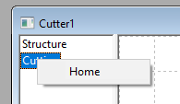

G-Code Output
Aerofoil does not drive a 4-axis cutter directly. Instead it outputs G-Code that the companion Cutter program reads and uses to program the cutter movement. G-Code is a fairly standard way of defining CNC movement. The G-Code that Cutter accepts is defined in the Cutter manual but here are the highlights.
The 4 axes are called X, Y, U, V by default which correspond to left horizontal axis, left vertical axis, right horizontal axis and right vertical axis. 0 positions are at the bottom and closest to the front of the cuter so that +ve movement moves away and up. Axis names are configurable as some systems use X,Y,A,Z.
Default feed rate is set in mm per second but can be over-ridden.
Cutter implements various commands for enabling/disabling the stepper motors, turning the wire on and off and moving the motors. Some of these can be over-ridden.

Configuring G-Code
The emitted G-Code can be configured by selecting Cutter / Configure G-Code Output. The system will display the following dialog which allows various parameters to be set.
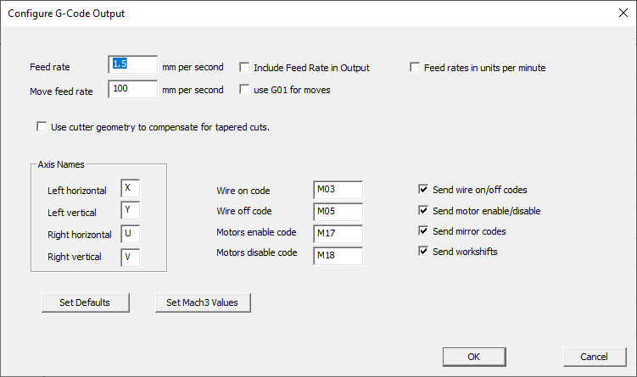

The feed rate can be set in mm per second. It is not included in the output by default (so that the same G-Code program can be used to cut different materials).
Some systems use G01 for fast moves in which case both a Feed rate and a Move feed rate need to be entered and Include Feed Rate In Output, use G01 for moves should be checked. Usually if this is done (for Mach3 for example) then Feed rates in units per minute should also be checked.
The Cutter program is aware of the geometry of the cutter and will compensate for the edges of the foam block not bing right up to the cutter axes when cutting a tapered wing. Aerofoil can also do this calculation for systems that cannot compensate for the taper and the G-Code coordinates will reflect that compensation if Use cutter geometry to compensate for tapered cuts is set.
As stated earlier the 4 axes names can be set using the Axis Names section.

Machine codes for turning the wire on/off and enabling/disabling the motors can be set and optionally written to the G-Code output.
Send mirror codes and Send workshifts allow the commands to reset mirroring and workshifts to be included or excluded from the G-Code preamble.

Sending G-Code via Network
As well as saving a G-Code file to disk that can be read in late, Aerofoil can send G-Code directly to Cutter over a network using TCP-IP. For this to work you need to enter the host (the machine name or IP address) where Cutter is running and the port it is listening on. By default Cutter listens on port 8193. Note that using localhost or 127.0.0.1 as the host will send the data to the machine you’re running Aerofoil on.

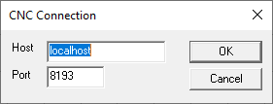
To actually send the data select File/CNC Output. This then streams the data to the given host and port. If you haven’t already setup the CNC connection you’ll see the dialog above before the data is sent and will need to enter a valid host and port.

Tool Offset
Tool offset allows you to compensate for the width of the kerf produced by the hot wire or “melt-back”. Select Cutter/Tool Offset from the top level menu and you will see the following dialog.

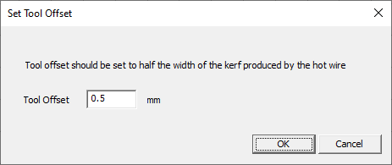
Note that the tool offset is half the width of the kerf - it’s the distance the software needs to move the wire out so that the edge of the cut is in the desired place.

Optimising GCode output
The GCode output consists of a series of straight lines that approximates the curve of the wing. Ideally, where the curvature is small, so should the line segments, but on a flat bottomed wing for example, the straight line can be represented by a single line. Optimising the GCode output takes the resolution of the cutter and minimises the number of lines whilst ensuring that the error between the straight line and the smooth curve is less than the resolution of the cutter.
This is set up by selecting Cutter/Optimise Output. This then displays the Optimise Cut dialog below. This allows you to turn optimisation on or off and to enter the cutter resolution to use.
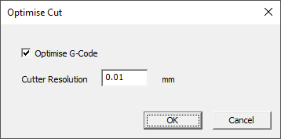

Cutter Geometry
Setting up the cutter geometry allows Aerofoil to do 2 things:
1. It can calculate the correction needed to cut tapered wings, both in simulation and, if selected, when the G-Code is generated.
2. It can scale diagrams correctly to show the available travel.

To set up the cutter geometry select Cutter/Cutter Geometry from the main menu. You will then see a dialog like the one shown below.
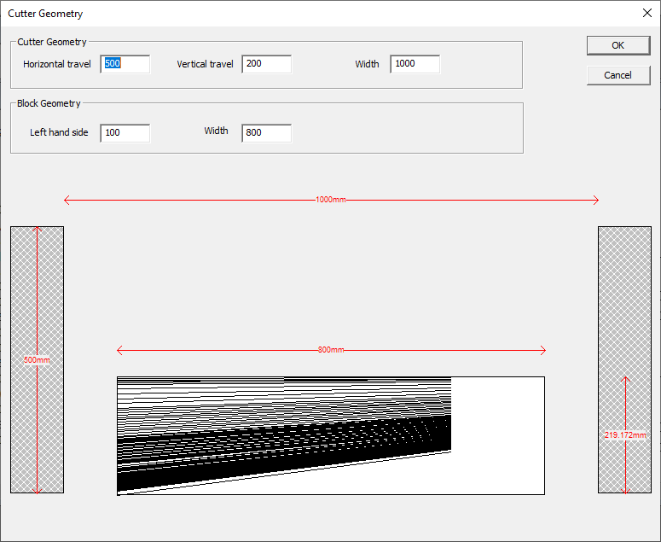

Cutter Geometry allows you to set the horizontal and vertical travel as well as the cutter width. The left hand side of the block and its width then establish the relationship between the block and the cutter. Note that the block’s left hand side and width must be less than the cutter width. All dimensions are in mm.

Previewing a Cut
Before sending the G-Code to the cutter it is worth previewing the cut. To do this select Cutter / Preview Cut Path. You’ll see a dialog similar to the one below displayed and the cutting path will be animated. Note that this is showing the path the actual cutter takes – when cutting tapered wings this will not be the exact shape traced on the edges of the foam block by the wire.

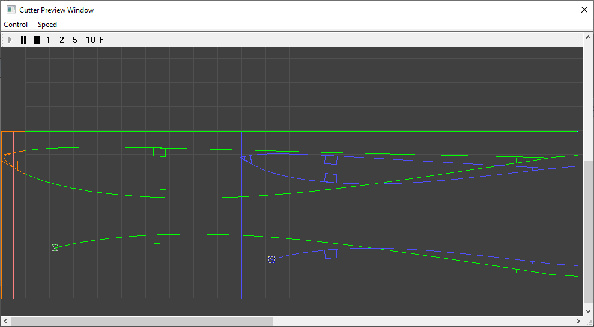
The screenshot above shows the path of the cutter animation – it’s already cut one core and is part way through the top surface of another. Note the colour coding:
- Green is the path taken by the root end of the cutter.
- Blue is the path taken by the tip end of the cutter.
- Cyan (not shown) where both axes are cutting exactly the same point at the same time.
- Red is where one or other path has gone out of limit – less than zero or greater than the cutter travel.
Red is usually the result of faulty programming, in particular cutting a tapered wing where an axis cannot travel far enough to ensure that the wire is in the correct position on the edge of the block.
The simulation can be started, stopped, paused and restarted. The simulation speed can also be changed using the 1-5 and F (full speed) buttons.

Loading and Saving
Drawings can be loaded and saved. On the File menu:
- New creates a new drawing or cut file.
- Open opens an existing (.plt) drawing file (or .cut cutter file).
- Close closes the current drawing.
- Save saves the current drawing to file.
- Save As saves the current drawing to file with a new filename.
It's worth noting that the save format is XML. There is no schema per se, but looking at saved files will give a good guide. These files can be edited by hand if necessary although it's not usually necessary. Once instance where this may be necessary is if the aerofoil data (.dat) files are moved so the saved drawing files no longer reference valid aerofoil files.

License and Source Code
The Aerofoil and Cutter programs are copyright R Bruce Porteous and are licensed under the GNU Public License V3 or later. The GPLv3 license is reproduced below and is also available at http://www.gnu.org/licenses/gpl-3.0.en.html. Source code for Aerofoil can be downloaded from https://github.com/rbp28668/Aerofoils as can this manual and binary releases.

0. Definitions.
“This License” refers to version 3 of the GNU General Public License.
“Copyright” also means copyright-like laws that apply to other kinds of works, such as semiconductor masks.
“The Program” refers to any copyrightable work licensed under this License. Each licensee is addressed as “you”. “Licensees” and “recipients” may be individuals or organizations.
To “modify” a work means to copy from or adapt all or part of the work in a fashion requiring copyright permission, other than the making of an exact copy. The resulting work is called a “modified version” of the earlier work or a work “based on” the earlier work.
A “covered work” means either the unmodified Program or a work based on the Program.
To “propagate” a work means to do anything with it that, without permission, would make you directly or secondarily liable for infringement under applicable copyright law, except executing it on a computer or modifying a private copy. Propagation includes copying, distribution (with or without modification), making available to the public, and in some countries other activities as well.
To “convey” a work means any kind of propagation that enables other parties to make or receive copies. Mere interaction with a user through a computer network, with no transfer of a copy, is not conveying.
An interactive user interface displays “Appropriate Legal Notices” to the extent that it includes a convenient and prominently visible feature that (1) displays an appropriate copyright notice, and (2) tells the user that there is no warranty for the work (except to the extent that warranties are provided), that licensees may convey the work under this License, and how to view a copy of this License. If the interface presents a list of user commands or options, such as a menu, a prominent item in the list meets this criterion.

1. Source Code.
The “source code” for a work means the preferred form of the work for making modifications to it. “Object code” means any non-source form of a work.
A “Standard Interface” means an interface that either is an official standard defined by a recognized standards body, or, in the case of interfaces specified for a particular programming language, one that is widely used among developers working in that language.
The “System Libraries” of an executable work include anything, other than the work as a whole, that (a) is included in the normal form of packaging a Major Component, but which is not part of that Major Component, and (b) serves only to enable use of the work with that Major Component, or to implement a Standard Interface for which an implementation is available to the public in source code form. A “Major Component”, in this context, means a major essential component (kernel, window system, and so on) of the specific operating system (if any) on which the executable work runs, or a compiler used to produce the work, or an object code interpreter used to run it.
The “Corresponding Source” for a work in object code form means all the source code needed to generate, install, and (for an executable work) run the object code and to modify the work, including scripts to control those activities. However, it does not include the work's System Libraries, or general-purpose tools or generally available free programs which are used unmodified in performing those activities but which are not part of the work. For example, Corresponding Source includes interface definition files associated with source files for the work, and the source code for shared libraries and dynamically linked subprograms that the work is specifically designed to require, such as by intimate data communication or control flow between those subprograms and other parts of the work.
The Corresponding Source need not include anything that users can regenerate automatically from other parts of the Corresponding Source.
The Corresponding Source for a work in source code form is that same work.

2. Basic Permissions.
All rights granted under this License are granted for the term of copyright on the Program, and are irrevocable provided the stated conditions are met. This License explicitly affirms your unlimited permission to run the unmodified Program. The output from running a covered work is covered by this License only if the output, given its content, constitutes a covered work. This License acknowledges your rights of fair use or other equivalent, as provided by copyright law.
You may make, run and propagate covered works that you do not convey, without conditions so long as your license otherwise remains in force. You may convey covered works to others for the sole purpose of having them make modifications exclusively for you, or provide you with facilities for running those works, provided that you comply with the terms of this License in conveying all material for which you do not control copyright. Those thus making or running the covered works for you must do so exclusively on your behalf, under your direction and control, on terms that prohibit them from making any copies of your copyrighted material outside their relationship with you.
Conveying under any other circumstances is permitted solely under the conditions stated below. Sublicensing is not allowed; section 10 makes it unnecessary.

3. Protecting Users' Legal Rights From Anti-Circumvention Law.
No covered work shall be deemed part of an effective technological measure under any applicable law fulfilling obligations under article 11 of the WIPO copyright treaty adopted on 20 December 1996, or similar laws prohibiting or restricting circumvention of such measures.
When you convey a covered work, you waive any legal power to forbid circumvention of technological measures to the extent such circumvention is effected by exercising rights under this License with respect to the covered work, and you disclaim any intention to limit operation or modification of the work as a means of enforcing, against the work's users, your or third parties' legal rights to forbid circumvention of technological measures.

4. Conveying Verbatim Copies.
You may convey verbatim copies of the Program's source code as you receive it, in any medium, provided that you conspicuously and appropriately publish on each copy an appropriate copyright notice; keep intact all notices stating that this License and any non-permissive terms added in accord with section 7 apply to the code; keep intact all notices of the absence of any warranty; and give all recipients a copy of this License along with the Program.
You may charge any price or no price for each copy that you convey, and you may offer support or warranty protection for a fee.

5. Conveying Modified Source Versions.
You may convey a work based on the Program, or the modifications to produce it from the Program, in the form of source code under the terms of section 4, provided that you also meet all of these conditions:
- a) The work must carry prominent notices stating that you modified it, and giving a relevant date.
- b) The work must carry prominent notices stating that it is released under this License and any conditions added under section 7. This requirement modifies the requirement in section 4 to “keep intact all notices”.
- c) You must license the entire work, as a whole, under this License to anyone who comes into possession of a copy. This License will therefore apply, along with any applicable section 7 additional terms, to the whole of the work, and all its parts, regardless of how they are packaged. This License gives no permission to license the work in any other way, but it does not invalidate such permission if you have separately received it.
- d) If the work has interactive user interfaces, each must display Appropriate Legal Notices; however, if the Program has interactive interfaces that do not display Appropriate Legal Notices, your work need not make them do so.
A compilation of a covered work with other separate and independent works, which are not by their nature extensions of the covered work, and which are not combined with it such as to form a larger program, in or on a volume of a storage or distribution medium, is called an “aggregate” if the compilation and its resulting copyright are not used to limit the access or legal rights of the compilation's users beyond what the individual works permit. Inclusion of a covered work in an aggregate does not cause this License to apply to the other parts of the aggregate.

6. Conveying Non-Source Forms.
You may convey a covered work in object code form under the terms of sections 4 and 5, provided that you also convey the machine-readable Corresponding Source under the terms of this License, in one of these ways:
- a) Convey the object code in, or embodied in, a physical product (including a physical distribution medium), accompanied by the Corresponding Source fixed on a durable physical medium customarily used for software interchange.
- b) Convey the object code in, or embodied in, a physical product (including a physical distribution medium), accompanied by a written offer, valid for at least three years and valid for as long as you offer spare parts or customer support for that product model, to give anyone who possesses the object code either (1) a copy of the Corresponding Source for all the software in the product that is covered by this License, on a durable physical medium customarily used for software interchange, for a price no more than your reasonable cost of physically performing this conveying of source, or (2) access to copy the Corresponding Source from a network server at no charge.
- c) Convey individual copies of the object code with a copy of the written offer to provide the Corresponding Source. This alternative is allowed only occasionally and noncommercially, and only if you received the object code with such an offer, in accord with subsection 6b.
- d) Convey the object code by offering access from a designated place (gratis or for a charge), and offer equivalent access to the Corresponding Source in the same way through the same place at no further charge. You need not require recipients to copy the Corresponding Source along with the object code. If the place to copy the object code is a network server, the Corresponding Source may be on a different server (operated by you or a third party) that supports equivalent copying facilities, provided you maintain clear directions next to the object code saying where to find the Corresponding Source. Regardless of what server hosts the Corresponding Source, you remain obligated to ensure that it is available for as long as needed to satisfy these requirements.
- e) Convey the object code using peer-to-peer transmission, provided you inform other peers where the object code and Corresponding Source of the work are being offered to the general public at no charge under subsection 6d.
A separable portion of the object code, whose source code is excluded from the Corresponding Source as a System Library, need not be included in conveying the object code work.
A “User Product” is either (1) a “consumer product”, which means any tangible personal property which is normally used for personal, family, or household purposes, or (2) anything designed or sold for incorporation into a dwelling. In determining whether a product is a consumer product, doubtful cases shall be resolved in favor of coverage. For a particular product received by a particular user, “normally used” refers to a typical or common use of that class of product, regardless of the status of the particular user or of the way in which the particular user actually uses, or expects or is expected to use, the product. A product is a consumer product regardless of whether the product has substantial commercial, industrial or non-consumer uses, unless such uses represent the only significant mode of use of the product.
“Installation Information” for a User Product means any methods, procedures, authorization keys, or other information required to install and execute modified versions of a covered work in that User Product from a modified version of its Corresponding Source. The information must suffice to ensure that the continued functioning of the modified object code is in no case prevented or interfered with solely because modification has been made.
If you convey an object code work under this section in, or with, or specifically for use in, a User Product, and the conveying occurs as part of a transaction in which the right of possession and use of the User Product is transferred to the recipient in perpetuity or for a fixed term (regardless of how the transaction is characterized), the Corresponding Source conveyed under this section must be accompanied by the Installation Information. But this requirement does not apply if neither you nor any third party retains the ability to install modified object code on the User Product (for example, the work has been installed in ROM).
The requirement to provide Installation Information does not include a requirement to continue to provide support service, warranty, or updates for a work that has been modified or installed by the recipient, or for the User Product in which it has been modified or installed. Access to a network may be denied when the modification itself materially and adversely affects the operation of the network or violates the rules and protocols for communication across the network.
Corresponding Source conveyed, and Installation Information provided, in accord with this section must be in a format that is publicly documented (and with an implementation available to the public in source code form), and must require no special password or key for unpacking, reading or copying.

7. Additional Terms.
“Additional permissions” are terms that supplement the terms of this License by making exceptions from one or more of its conditions. Additional permissions that are applicable to the entire Program shall be treated as though they were included in this License, to the extent that they are valid under applicable law. If additional permissions apply only to part of the Program, that part may be used separately under those permissions, but the entire Program remains governed by this License without regard to the additional permissions.
When you convey a copy of a covered work, you may at your option remove any additional permissions from that copy, or from any part of it. (Additional permissions may be written to require their own removal in certain cases when you modify the work.) You may place additional permissions on material, added by you to a covered work, for which you have or can give appropriate copyright permission.
Notwithstanding any other provision of this License, for material you add to a covered work, you may (if authorized by the copyright holders of that material) supplement the terms of this License with terms:
- a) Disclaiming warranty or limiting liability differently from the terms of sections 15 and 16 of this License; or
- b) Requiring preservation of specified reasonable legal notices or author attributions in that material or in the Appropriate Legal Notices displayed by works containing it; or
- c) Prohibiting misrepresentation of the origin of that material, or requiring that modified versions of such material be marked in reasonable ways as different from the original version; or
- d) Limiting the use for publicity purposes of names of licensors or authors of the material; or
- e) Declining to grant rights under trademark law for use of some trade names, trademarks, or service marks; or
- f) Requiring indemnification of licensors and authors of that material by anyone who conveys the material (or modified versions of it) with contractual assumptions of liability to the recipient, for any liability that these contractual assumptions directly impose on those licensors and authors.
All other non-permissive additional terms are considered “further restrictions” within the meaning of section 10. If the Program as you received it, or any part of it, contains a notice stating that it is governed by this License along with a term that is a further restriction, you may remove that term. If a license document contains a further restriction but permits relicensing or conveying under this License, you may add to a covered work material governed by the terms of that license document, provided that the further restriction does not survive such relicensing or conveying.
If you add terms to a covered work in accord with this section, you must place, in the relevant source files, a statement of the additional terms that apply to those files, or a notice indicating where to find the applicable terms.
Additional terms, permissive or non-permissive, may be stated in the form of a separately written license, or stated as exceptions; the above requirements apply either way.

8. Termination.
You may not propagate or modify a covered work except as expressly provided under this License. Any attempt otherwise to propagate or modify it is void, and will automatically terminate your rights under this License (including any patent licenses granted under the third paragraph of section 11).
However, if you cease all violation of this License, then your license from a particular copyright holder is reinstated (a) provisionally, unless and until the copyright holder explicitly and finally terminates your license, and (b) permanently, if the copyright holder fails to notify you of the violation by some reasonable means prior to 60 days after the cessation.
Moreover, your license from a particular copyright holder is reinstated permanently if the copyright holder notifies you of the violation by some reasonable means, this is the first time you have received notice of violation of this License (for any work) from that copyright holder, and you cure the violation prior to 30 days after your receipt of the notice.
Termination of your rights under this section does not terminate the licenses of parties who have received copies or rights from you under this License. If your rights have been terminated and not permanently reinstated, you do not qualify to receive new licenses for the same material under section 10.

9. Acceptance Not Required for Having Copies.
You are not required to accept this License in order to receive or run a copy of the Program. Ancillary propagation of a covered work occurring solely as a consequence of using peer-to-peer transmission to receive a copy likewise does not require acceptance. However, nothing other than this License grants you permission to propagate or modify any covered work. These actions infringe copyright if you do not accept this License. Therefore, by modifying or propagating a covered work, you indicate your acceptance of this License to do so.

10. Automatic Licensing of Downstream Recipients.
Each time you convey a covered work, the recipient automatically receives a license from the original licensors, to run, modify and propagate that work, subject to this License. You are not responsible for enforcing compliance by third parties with this License.
An “entity transaction” is a transaction transferring control of an organization, or substantially all assets of one, or subdividing an organization, or merging organizations. If propagation of a covered work results from an entity transaction, each party to that transaction who receives a copy of the work also receives whatever licenses to the work the party's predecessor in interest had or could give under the previous paragraph, plus a right to possession of the Corresponding Source of the work from the predecessor in interest, if the predecessor has it or can get it with reasonable efforts.
You may not impose any further restrictions on the exercise of the rights granted or affirmed under this License. For example, you may not impose a license fee, royalty, or other charge for exercise of rights granted under this License, and you may not initiate litigation (including a cross-claim or counterclaim in a lawsuit) alleging that any patent claim is infringed by making, using, selling, offering for sale, or importing the Program or any portion of it.

11. Patents.
A “contributor” is a copyright holder who authorizes use under this License of the Program or a work on which the Program is based. The work thus licensed is called the contributor's “contributor version”.
A contributor's “essential patent claims” are all patent claims owned or controlled by the contributor, whether already acquired or hereafter acquired, that would be infringed by some manner, permitted by this License, of making, using, or selling its contributor version, but do not include claims that would be infringed only as a consequence of further modification of the contributor version. For purposes of this definition, “control” includes the right to grant patent sublicenses in a manner consistent with the requirements of this License.
Each contributor grants you a non-exclusive, worldwide, royalty-free patent license under the contributor's essential patent claims, to make, use, sell, offer for sale, import and otherwise run, modify and propagate the contents of its contributor version.
In the following three paragraphs, a “patent license” is any express agreement or commitment, however denominated, not to enforce a patent (such as an express permission to practice a patent or covenant not to sue for patent infringement). To “grant” such a patent license to a party means to make such an agreement or commitment not to enforce a patent against the party.
If you convey a covered work, knowingly relying on a patent license, and the Corresponding Source of the work is not available for anyone to copy, free of charge and under the terms of this License, through a publicly available network server or other readily accessible means, then you must either (1) cause the Corresponding Source to be so available, or (2) arrange to deprive yourself of the benefit of the patent license for this particular work, or (3) arrange, in a manner consistent with the requirements of this License, to extend the patent license to downstream recipients. “Knowingly relying” means you have actual knowledge that, but for the patent license, your conveying the covered work in a country, or your recipient's use of the covered work in a country, would infringe one or more identifiable patents in that country that you have reason to believe are valid.
If, pursuant to or in connection with a single transaction or arrangement, you convey, or propagate by procuring conveyance of, a covered work, and grant a patent license to some of the parties receiving the covered work authorizing them to use, propagate, modify or convey a specific copy of the covered work, then the patent license you grant is automatically extended to all recipients of the covered work and works based on it.
A patent license is “discriminatory” if it does not include within the scope of its coverage, prohibits the exercise of, or is conditioned on the non-exercise of one or more of the rights that are specifically granted under this License. You may not convey a covered work if you are a party to an arrangement with a third party that is in the business of distributing software, under which you make payment to the third party based on the extent of your activity of conveying the work, and under which the third party grants, to any of the parties who would receive the covered work from you, a discriminatory patent license (a) in connection with copies of the covered work conveyed by you (or copies made from those copies), or (b) primarily for and in connection with specific products or compilations that contain the covered work, unless you entered into that arrangement, or that patent license was granted, prior to 28 March 2007.
Nothing in this License shall be construed as excluding or limiting any implied license or other defenses to infringement that may otherwise be available to you under applicable patent law.

12. No Surrender of Others' Freedom.
If conditions are imposed on you (whether by court order, agreement or otherwise) that contradict the conditions of this License, they do not excuse you from the conditions of this License. If you cannot convey a covered work so as to satisfy simultaneously your obligations under this License and any other pertinent obligations, then as a consequence you may not convey it at all. For example, if you agree to terms that obligate you to collect a royalty for further conveying from those to whom you convey the Program, the only way you could satisfy both those terms and this License would be to refrain entirely from conveying the Program.

13. Use with the GNU Affero General Public License.
Notwithstanding any other provision of this License, you have permission to link or combine any covered work with a work licensed under version 3 of the GNU Affero General Public License into a single combined work, and to convey the resulting work. The terms of this License will continue to apply to the part which is the covered work, but the special requirements of the GNU Affero General Public License, section 13, concerning interaction through a network will apply to the combination as such.

14. Revised Versions of this License.
The Free Software Foundation may publish revised and/or new versions of the GNU General Public License from time to time. Such new versions will be similar in spirit to the present version, but may differ in detail to address new problems or concerns.
Each version is given a distinguishing version number. If the Program specifies that a certain numbered version of the GNU General Public License “or any later version” applies to it, you have the option of following the terms and conditions either of that numbered version or of any later version published by the Free Software Foundation. If the Program does not specify a version number of the GNU General Public License, you may choose any version ever published by the Free Software Foundation.
If the Program specifies that a proxy can decide which future versions of the GNU General Public License can be used, that proxy's public statement of acceptance of a version permanently authorizes you to choose that version for the Program.
Later license versions may give you additional or different permissions. However, no additional obligations are imposed on any author or copyright holder as a result of your choosing to follow a later version.

15. Disclaimer of Warranty.
THERE IS NO WARRANTY FOR THE PROGRAM, TO THE EXTENT PERMITTED BY APPLICABLE LAW. EXCEPT WHEN OTHERWISE STATED IN WRITING THE COPYRIGHT HOLDERS AND/OR OTHER PARTIES PROVIDE THE PROGRAM “AS IS” WITHOUT WARRANTY OF ANY KIND, EITHER EXPRESSED OR IMPLIED, INCLUDING, BUT NOT LIMITED TO, THE IMPLIED WARRANTIES OF MERCHANTABILITY AND FITNESS FOR A PARTICULAR PURPOSE. THE ENTIRE RISK AS TO THE QUALITY AND PERFORMANCE OF THE PROGRAM IS WITH YOU. SHOULD THE PROGRAM PROVE DEFECTIVE, YOU ASSUME THE COST OF ALL NECESSARY SERVICING, REPAIR OR CORRECTION.

16. Limitation of Liability.
IN NO EVENT UNLESS REQUIRED BY APPLICABLE LAW OR AGREED TO IN WRITING WILL ANY COPYRIGHT HOLDER, OR ANY OTHER PARTY WHO MODIFIES AND/OR CONVEYS THE PROGRAM AS PERMITTED ABOVE, BE LIABLE TO YOU FOR DAMAGES, INCLUDING ANY GENERAL, SPECIAL, INCIDENTAL OR CONSEQUENTIAL DAMAGES ARISING OUT OF THE USE OR INABILITY TO USE THE PROGRAM (INCLUDING BUT NOT LIMITED TO LOSS OF DATA OR DATA BEING RENDERED INACCURATE OR LOSSES SUSTAINED BY YOU OR THIRD PARTIES OR A FAILURE OF THE PROGRAM TO OPERATE WITH ANY OTHER PROGRAMS), EVEN IF SUCH HOLDER OR OTHER PARTY HAS BEEN ADVISED OF THE POSSIBILITY OF SUCH DAMAGES.

17. Interpretation of Sections 15 and 16.
If the disclaimer of warranty and limitation of liability provided above cannot be given local legal effect according to their terms, reviewing courts shall apply local law that most closely approximates an absolute waiver of all civil liability in connection with the Program, unless a warranty or assumption of liability accompanies a copy of the Program in return for a fee.

