Cutter v7.0
G-Code to 4 Axis
Wing Cutter

This software is available at:
https://github.com/rbp28668/Aerofoils

By R Bruce Porteous
(c) 2020

Change Log
Date | Description | Author
19 May 2020 | Updated for version 6.1 | RBP
14 Oct 2020 | Updated for version 7.0 | RBP

Table of Contents
Change Log 2
Introduction 4
Overall Screen Layout 5
Communications 6
G-Code Page 7
Direct G-Code Commands 7
Custom Buttons 9
G-Code Status 9
G-Code Program 10
Hardware Page 11
Sending Line Command 12
Single Step Command 12
Miscellaneous Direct Commands 12
Configuration Page 13
Setting Cutter Geometry 13
Setting Motor Parameters 14
Setting Default Communications Options 15
Defining Custom Buttons 15
Saving Configuration 16
G-Code 17
G-Commands 17
M-Commands 17
Axes and Parameters 17
Writing G-Code 18
Controller Protocol 19
Using PuTTY for Debugging 19
License and Source Code 20
0. Definitions. 20
1. Source Code. 20
2. Basic Permissions. 21
3. Protecting Users' Legal Rights From Anti-Circumvention Law. 21
4. Conveying Verbatim Copies. 22
5. Conveying Modified Source Versions. 22
6. Conveying Non-Source Forms. 22
7. Additional Terms. 24
8. Termination. 25
9. Acceptance Not Required for Having Copies. 25
10. Automatic Licensing of Downstream Recipients. 25
11. Patents. 26
12. No Surrender of Others' Freedom. 27
13. Use with the GNU Affero General Public License. 27
14. Revised Versions of this License. 27
15. Disclaimer of Warranty. 28
16. Limitation of Liability. 28
17. Interpretation of Sections 15 and 16. 28

Introduction

The Cutter program is the companion program to Aerofoil. Whereas Aerofoil is used to design wings and create G-Code, Cutter interprets the G-Code to drive a CNC 4-axis foam cutter. Whilst Cutter is designed to work in parallel with Aerofoil, it can accept G-Code from other sources. To this end it has a degree of flexibility in axis naming and implements several extra G-Code commands.

The core component in Cutter is the G-Code interpreter. It knows how to execute individual or a sequence of G-Code commands. Some of these change the state of the interpreter (such as changing the units from mm to inch), others such as G0 (move) and G1 (cut), send commands to the CNC hardware.

In normal operation you
- Connect to the hardware (see Communications)
- Configure the cutter, especially the block size (see Configuration Page)
- Control the cutter via the G-Code screen (see G-Code Page)
The G-Code screen provides options to directly control the cutter as well as run G-Code programs. These programs can be read from disk or sent directly over the network from Aerofoil.

Overall Screen Layout

The Cutter screens are divided into 3 main sections. There’s a common communications section that deals with communications from the Aerofoil program and to the cutter hardware

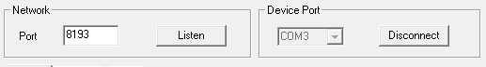
The Cutter software has a central page controlled by tabs. The default page is where you use G-Code to control the cutter. There is a Hardware page for lower level access to the controller and a Config page to set up Cutter’s configuration.

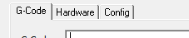
And at the bottom there’s a status area that shows the status of the cutter.

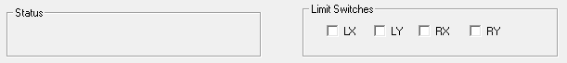

Communications
The communications section controls 2 sets of communications:
- The network port that Cutter listens on to receive G-Code files from the Aerofoil programme.
- The serial port (USB) that connects to the cutter hardware
- .

In Network, when you click Listen the Cutter program is ready to receive G-Code from Aerofoil and the Listen button changes to read Stop Listening. The port is arbitrary but both Aerofoil and Cutter need to be configured with the same port. Note that in the Config page it is possible to define a Default listen port and select Listen automatically in which case Cutter will start to listen for data automatically when it starts up.

In Device Port the system will display all the available serial ports. You need to pick the serial port the cutter hardware is connected to and click on Connect. When connected the dropdown list of ports is greyed out and the button changes to Disconnect as shown above. Note that in the Config page it is possible to define a Default COM Port and select Connect automatically in which case Cutter will connect automatically when it starts up.

Tip: Make sure that Cutter is connected to the hardware before doing anything else. You can tell it’s connected as the COM port dropdown is greyed and the button now reads Disconnect.

G-Code Page
When the program starts up the G-Code page is the default as shown below. Selecting the G-Code tab will bring you back to this page from either the Hardware or Config pages. This is the main page to drive the cutter from – it allows you to send commands to the cutter immediately, shows you the status of the cutter after executing the G-code commands and allows you to load and run a complete G-Code program.
The individual sections are discussed further below.

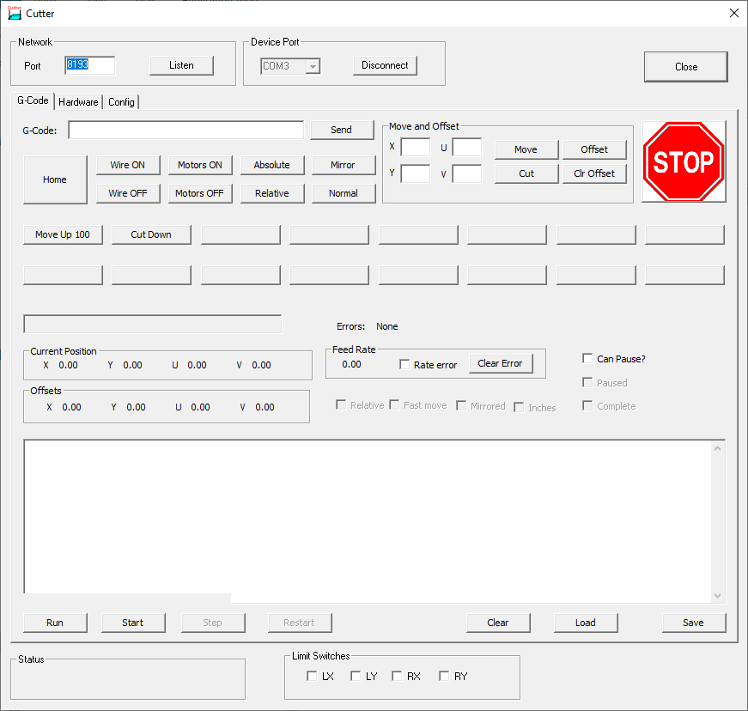

Direct G-Code Commands
This section allows you to send commands directly to the cutter.
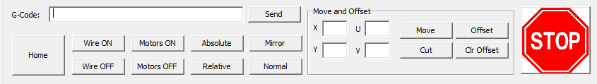
The G-Code edit box allows you to send a line of arbitrary G-Code to the cutter. Pressing Send sends whatever you have typed to the G-Code interpreter. If the command directly affects the cutter the appropriate command will be sent to the cutter, other commands just change the state of the interpreter.
In the Move and Offset box the entries are:
- X,Y ,U,V allow you to specify distances to move in the current units (mm by default).
- Move sends these as a fast move (G0)
- Cut sends these as a slow, feed-rate move (G1)
- Offset sets the offset to the given position. This moves the whole
- Clr Offset clears the offset
The other buttons are:
- Home which tells the cutter to run the home command and move to, and off its limit switches.
- Wire On turns on the hot wire.
- Wire Off turns off the hot wire.
- Motors On enables the motors.
- Motors Off disables the motors.
- Absolute sets absolute positioning – the X,Y,U,V coordinates will be treated as a location to drive to (in the current units).
- Relative sets relative positioning – the X,Y,U,V coordinates will be treated as the amount to move in the current units.
- Mirror mirrors the cut left to right.
- Normal cancels mirroring.
And of course the big red STOP button which should send an immediate stop to the controller (emptying any queues) and stop the interpreter.

Tip: Make sure the motors are enabled before starting a G-Code program. It may be that the program has an M17 command to enable the motors but it may not have.

Custom Buttons
In the Config page it’s possible to configure up to 16 buttons. Each button is given a label and a sequence of G-Code to execute when that button is pressed. Initially these are undefined and in the screenshot below only 2 are configured – one to move the cutter up 100mm and one to Cut down to zero again for trimming foam blocks.
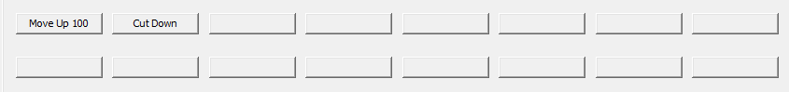
The ability to have small “programs” available from individual buttons is invaluable when trimming foam blocks for example. What each button does is entirely up to you.

G-Code Status
The next part of the screen is all about reporting the status of the G-Code interpreter. Note that this is the status of the interpreter – it’s not necessarily the status of the cutter hardware due to the buffering on the cutter. Usually the interpreter is well ahead of the cutter which has a long list of commands to run.
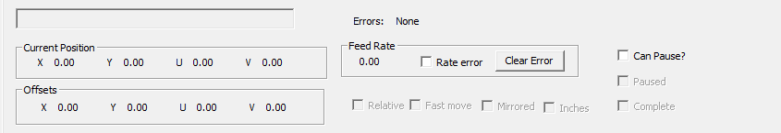
The fields in the status area are as follows:
The unlabled, greyed edit box displays the last command to be executed by the interpreter. Next to it is the error display. When there is an error it will be shown here.
Current Position shows the position of the 4 axes.
Offsets show any current offsets that have been set.
Feed Rate shows the current feed rate, whether there has been a rate error (i.e. the G-Code has asked for a rate the cutter can’t match), and a button to clear feed rate errors.
There are 4 check boxes which show state information from the interpreter. These are:
- Relative – if set shows relative moves are in force, if clear then absolute.
- Fast move – if set shows G0 is in force, if clear G1
- Mirrored – set if the cut is being mirrored left to right, clear if not.
- Inches – set if the current units are inches, clear if mm (the default).
The last 3 check boxes control program operation
- Can Pause enables M01, optional pause.
- Paused is set if the program is paused.
- Complete is set if the program has finished executing.

G-Code Program
This is where you can load, run, modify and save a G-Code program.
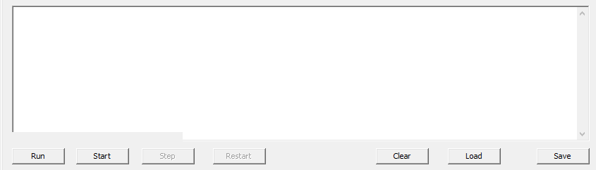
The buttons are as follows:
- Run runs the current G-Code program from the start. If Run is relabled as Continue then it continues running a program at full speed rather than single stepping through it.
- Start starts the program but doesn’t run it. When you click on start the Run button becomes Continue and the Step button is enabled. This allows you to single step through the G-Code.
- Step executes the next line of G-Code when single stepping.
- Restart resets the program to the beginning again so that Run or Start can be used. Note that Restart is only available when the program has completed.
- Clear clears/erases the current program.
- Load pops up a file open dialog to load a new G-Code program from disk.
- Save saves the current G-Code program to disk. It will pop up a file save dialog

Usual operation is to load the program from disk (or send it from Aerofoil) then just press Run, sit back and watch!
Single stepping with Start, Step (and possibly Continue) is useful for debugging G-Code to execute it one line at a time.

Hardware Page
It’s rare that you will need to use this page except when you’re debugging hardware or checking operation of the cutter firmware. The buttons on this page send low level commands directly to the hardware without going via the G-Code interpreter. As such the buttons on this page are a direct one to one match for the commands in the Controller Protocol section on page 19.
Note that the axis names of X,Y, U and V are a concern of the G-Code interpreter and are not used here. Instead the axes are labelled LX (left X or horizontal), LY (left Y or vertical), RX (right X or horizontal) and RY (right Y or vertical).
Note: Be wary of moving the axes with this page when you’re also using G-Code. The G-Code interpreter will be blissfully unaware that you’ve moved the axes behind its back. Usually the only safe option after doing this is to use G-Code to home the axes.
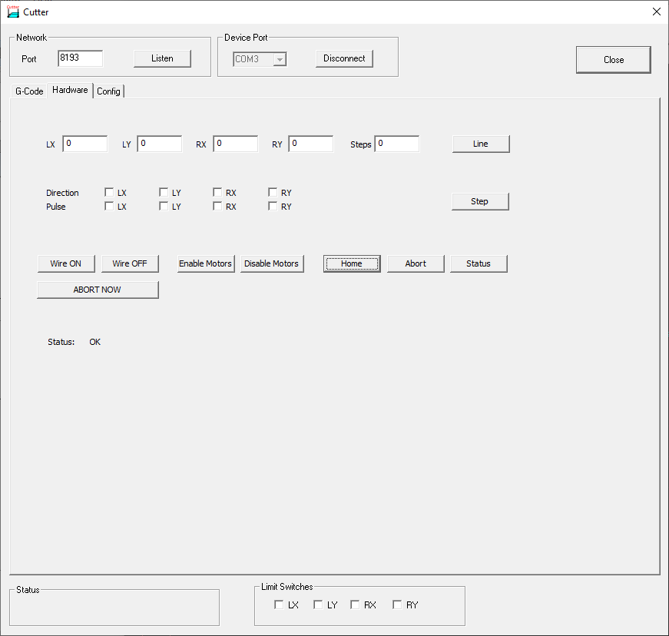

Sending Line Command
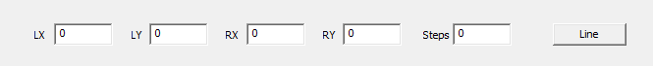
This uses the values of LX, LY, RX, RY and Steps to send a line command to the hardware.
Note that LX,LY,RX and RY are all integer numbers of steps, not mm. Also note that these are inherently relative moves and may be negative.
Steps must be greater than the largest absolute value of LX,LY,RX or RY. Steps determines the total time for the cut in hardware “ticks” (typically multiples of a few hundred microseconds). The current values of LX, LY, RX, RY and Steps are sent to the controller when you click on the Line button.

Single Step Command
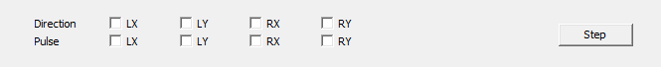
Step sends a command for a single step. Which motor(s) are moved and in which direction is controlled by the direction and pulse check-boxes for the respective axes.

Miscellaneous Direct Commands
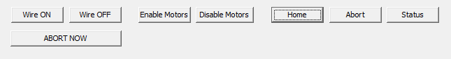
The buttons are used as follows:
- Wire ON turns the hot-wire on.
- Wire OFF turns the hot-wire off.
- Enable Motors enables the stepper motors.
- Disable Motors disables the stepper motors.
- Home runs the cutter’s homing sequence
- Abort disables the steppers, clears the stepper FIFO, clears the command queue and stops any current operation. Note though that this is a queued command so only stops operation when the cutter reaches this command in its buffer.
- Status polls the status of the cutter. It will show if the command queue is full or empty and the status of the limit switches. Status is an immediate command – it’s not queued.
- Abort Now sends an abort now command to the cutter. This clears the command queues, stops the current operation and clears the cutter’s FIFO buffer. This is an immediate command and is not queued so takes affect immediately.

Configuration Page
The configuration page controls the cutter’s view of the hardware, its characteristics and geometry. It also allows you to set default communications and set up the configurable buttons on the G-Code page. The overall Config page is shown below.
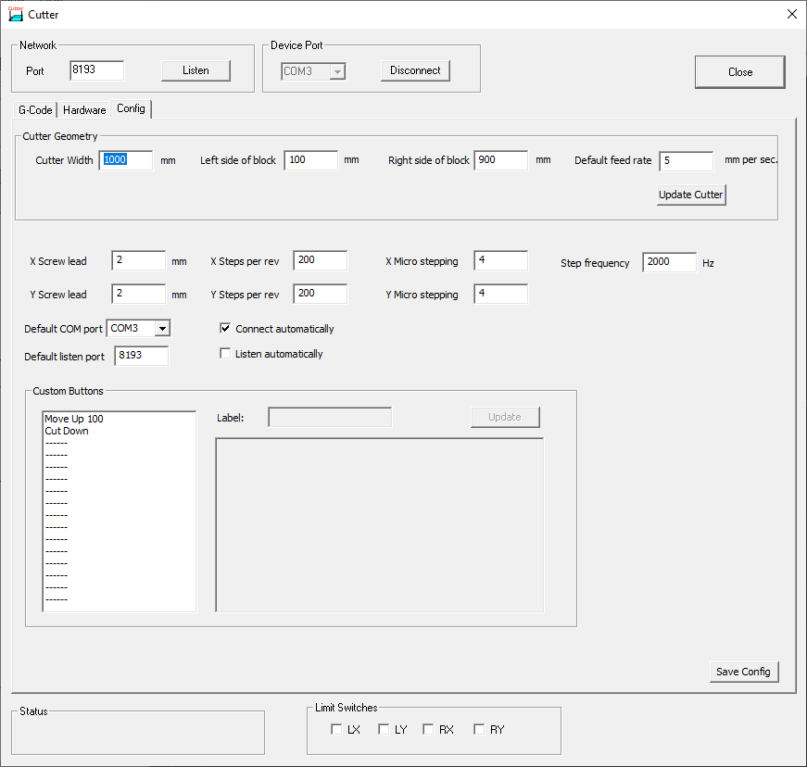

Setting Cutter Geometry
Setting the cutter geometry is important when cutting tapered components as the software can compensate for the edges of the block not being where the wire is supported. Typically the axes have to move further than the dimensions on the block edge or possibly move in the opposite direction to keep one end stationary whilst the other end moves.

Tip: If the G-Code has already been corrected for tapers then set Left side of block to 0 and set Right side of block to equal Cutter Width. Otherwise you will end up with the correction being applied twice – once by the program creating the G-Code, once by Cutter.

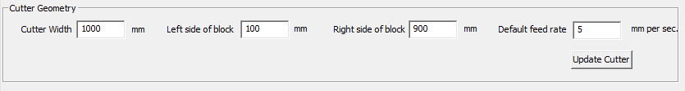
Enter the Cutter Width, the Left side of block and the Right side of block to determine the cutter geometry. All dimensions are in mm and the block positions should be measured from the point where the wire is supported on the left hand side of the cutter as shown in the sketch below.

Drawing 1: Measuring block position
Left
Right

Don’t forget to click on Update Cutter after changing these values.

Setting Motor Parameters
The motor parameters are critical for allowing Cutter to calculate the number of steps for a given distance and feed rate.
The parameters are as follows:
- X Screw lead is the number of mm the carriage moves horizontally for a single turn of the motor.
- Y Screw lead is the number of mm the carriage moves vertically for a single turn of the motor.
- X Steps per rev is the number of steps the horizontal axis motor takes to do a single rotation. For a 1.8 degree stepper this will be 200.
- Y Steps per rev is the same value for the vertical axis.
- X Micro stepping is the number of microsteps for 1 full step of the horizontal axis motor. This is usually a power of two i.e. 2, 4, 8 etc. With a microstepping driver the driver will need steps per rev times micro stepping factor pulses to make a single rotation.
- Ymicro stepping is the same for the vertical axis
- Step frequency is the frequency, in Hz, that the data that’s sent to the steppers is clocked out of the controller FIFO buffer. It’s the reciprocal of the clock period set up in cutter.ino in the driver.
The step frequency is set by this line in cutter.ino:
tickTimer.begin(timerTick, 400);
The numeric value is the time between interrupts in microseconds. 400 microseconds corresponds to a 2500Hz step frequency, 500 microseconds to 2000Hz and so on.

Setting Default Communications Options
Default communication options allow the software to connect to the cutter hardware and to listen for G-Code data automatically.
To automatically connect to the cutter hardware on a given COM port select the appropriate Default COM port value and select Connect automatically.
To automatically listen on a given TCP port enter the port number in Default listen port and select Listen automatically.
Note that if something else (possibly another instance of Cutter) is already connected to the selected COM port or listening on the selected TCP port then Cutter will not start up.

Defining Custom Buttons
The 16 configurable buttons on the G-Code page can be configured using the Custom Buttons group shown below.
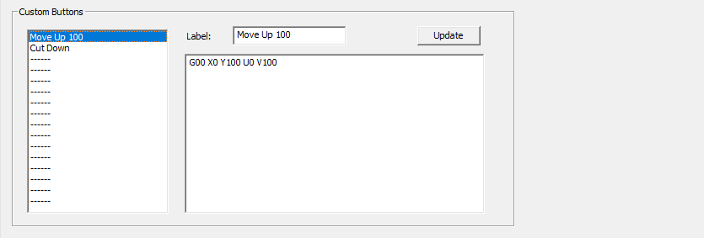
Configuring these are simple. Select one of the 16 values, enter a new Label, type (or paste) the G-Code into the edit box and click on Update. Unused entries are labelled with ----- .

Saving Configuration
After making any changes to the configuration click on the Save Config button. The cutter configuration will be written to a file cutter_config.xml in the current directory. On startup the software will read and initialise itself from this file.

G-Code

The G-Code interpreter is a key part of the Cutter software. The commands it implements are described below.

Note that axes for wing cutter are X,Y (left hand side) and U,V (right hand side). A,Z can be used as aliases for U and V respectively.

G-Commands
G00 - straight line as fast as possible (interpolated)
G01 - straight line at given or active feed rate.
G04 - dwell/pause for given time (P mS or S seconds)
G17 - plane XY: accepted but ignored.
G20 - program coordinates are in inches
G21 - program coordinates are in mm
G28 - return to home position
G38 - mirror imaging “on”
G39 - mirror imaging “off”
G40 - set cutter compensation off: accepted but ignored
G49 - clear existing toolset offset: accepted but ignored
G52 - set local workshift (offsets)
G53 - cancel local workshift
G90 - Absolute programming
G91 - Incremental programming
G94 - Feed rate is units (mm or inch) per minute.

M-Commands
M00 - program stop (restartable)
M01 - optional program stop (restartable)
M02 - end of program
M03 - wire on
M05 - wire off
M17 - Enable/Power all stepper motors
M18 - Disable all stepper motors
M30 - End program and reset to beginning

Axes and Parameters
F - feedrate
X - Left X position
Y - Left Y position
U - Right X position
V - Right Y position
A - Alternative Right X Position
Z - Alternative Right Y Position
N - line number
P - dwell time in mS
S - dwell time in S

Writing G-Code
G-Code has one or more commands per line. Movement commands are modal, for example, say a code begins with a linear rapid move at X1 Y1 (G00 X1 Y1). If the next function is another linear rapid move, it is not necessary to write G00 again. All that is needed on the next line of code is the new position (say, X2 Y2) because the modal condition is the same. Then, to change the function to a linear feed (G01), programming G01 on the following line would deactivate the linear rapid move and activate the linear feed.

Comments can be placed in parentheses i.e. ( this is a comment ).

Controller Protocol

The commands implemented by the stepper controller are shown below. Note that the number of digits in each (hex) number is important – where SSSSSSSS is specified that means exactly 8 hex digits. Line takes 2s complement numbers so minus numbers will typically start F….

The commands are as follows:

? - show this message
P - ping, show queue state
A - abort now and clear queues
Z - Abort current operation and clear queues
S - Single step - DB where D is 4 bits of direction, P are pulse bits (1 to pulse), both hex digits
L - Line in 4 dimensions SSSSSSSSAAAAAAAABBBBBBBBCCCCCCCCDDDDDDDD where S gives total number of steps and A-D are axes. All in hex, 2s complement
H - Drives the steppers to their home positions
E - Enable motors
D - Disable motors
W - Turn on hot wire
X - Turn off hot wire

After each command it returns a 4 byte status:

Y or N which says if the command was interpreted correctly (Y) or not (N).
F or - has F if the command queue is full.
E or - has E if the command queue is empty.
a hex digit that encodes the status of all 4 limit switches.

Using PuTTY for Debugging
If you connect a serial terminal (such as by using the PuTTY program) it should be possible to drive the controller using the commands shown above. For the line a calculator capable of converting decimal to 8 digit HEX values in invaluable! This can sometimes be useful for debugging purposes if you’re not sure that the correct commands are reaching the controller. At the very least, entering “?” and getting back the description of the allowable commands tells you the cutter hardware is connected to the port you think it is!

License and Source Code
The Aerofoil and Cutter programs are copyright R Bruce Porteous and are licensed under the GNU Public License V3 or later. The GPLv3 license is reproduced below and is also available at http://www.gnu.org/licenses/gpl-3.0.en.html. Source code for Aerofoil can be downloaded from https://github.com/rbp28668/Aerofoils as can this manual and binary releases.

0. Definitions.
“This License” refers to version 3 of the GNU General Public License.
“Copyright” also means copyright-like laws that apply to other kinds of works, such as semiconductor masks.
“The Program” refers to any copyrightable work licensed under this License. Each licensee is addressed as “you”. “Licensees” and “recipients” may be individuals or organizations.
To “modify” a work means to copy from or adapt all or part of the work in a fashion requiring copyright permission, other than the making of an exact copy. The resulting work is called a “modified version” of the earlier work or a work “based on” the earlier work.
A “covered work” means either the unmodified Program or a work based on the Program.
To “propagate” a work means to do anything with it that, without permission, would make you directly or secondarily liable for infringement under applicable copyright law, except executing it on a computer or modifying a private copy. Propagation includes copying, distribution (with or without modification), making available to the public, and in some countries other activities as well.
To “convey” a work means any kind of propagation that enables other parties to make or receive copies. Mere interaction with a user through a computer network, with no transfer of a copy, is not conveying.
An interactive user interface displays “Appropriate Legal Notices” to the extent that it includes a convenient and prominently visible feature that (1) displays an appropriate copyright notice, and (2) tells the user that there is no warranty for the work (except to the extent that warranties are provided), that licensees may convey the work under this License, and how to view a copy of this License. If the interface presents a list of user commands or options, such as a menu, a prominent item in the list meets this criterion.

1. Source Code.
The “source code” for a work means the preferred form of the work for making modifications to it. “Object code” means any non-source form of a work.
A “Standard Interface” means an interface that either is an official standard defined by a recognized standards body, or, in the case of interfaces specified for a particular programming language, one that is widely used among developers working in that language.
The “System Libraries” of an executable work include anything, other than the work as a whole, that (a) is included in the normal form of packaging a Major Component, but which is not part of that Major Component, and (b) serves only to enable use of the work with that Major Component, or to implement a Standard Interface for which an implementation is available to the public in source code form. A “Major Component”, in this context, means a major essential component (kernel, window system, and so on) of the specific operating system (if any) on which the executable work runs, or a compiler used to produce the work, or an object code interpreter used to run it.
The “Corresponding Source” for a work in object code form means all the source code needed to generate, install, and (for an executable work) run the object code and to modify the work, including scripts to control those activities. However, it does not include the work's System Libraries, or general-purpose tools or generally available free programs which are used unmodified in performing those activities but which are not part of the work. For example, Corresponding Source includes interface definition files associated with source files for the work, and the source code for shared libraries and dynamically linked subprograms that the work is specifically designed to require, such as by intimate data communication or control flow between those subprograms and other parts of the work.
The Corresponding Source need not include anything that users can regenerate automatically from other parts of the Corresponding Source.
The Corresponding Source for a work in source code form is that same work.

2. Basic Permissions.
All rights granted under this License are granted for the term of copyright on the Program, and are irrevocable provided the stated conditions are met. This License explicitly affirms your unlimited permission to run the unmodified Program. The output from running a covered work is covered by this License only if the output, given its content, constitutes a covered work. This License acknowledges your rights of fair use or other equivalent, as provided by copyright law.
You may make, run and propagate covered works that you do not convey, without conditions so long as your license otherwise remains in force. You may convey covered works to others for the sole purpose of having them make modifications exclusively for you, or provide you with facilities for running those works, provided that you comply with the terms of this License in conveying all material for which you do not control copyright. Those thus making or running the covered works for you must do so exclusively on your behalf, under your direction and control, on terms that prohibit them from making any copies of your copyrighted material outside their relationship with you.
Conveying under any other circumstances is permitted solely under the conditions stated below. Sublicensing is not allowed; section 10 makes it unnecessary.

3. Protecting Users' Legal Rights From Anti-Circumvention Law.
No covered work shall be deemed part of an effective technological measure under any applicable law fulfilling obligations under article 11 of the WIPO copyright treaty adopted on 20 December 1996, or similar laws prohibiting or restricting circumvention of such measures.
When you convey a covered work, you waive any legal power to forbid circumvention of technological measures to the extent such circumvention is effected by exercising rights under this License with respect to the covered work, and you disclaim any intention to limit operation or modification of the work as a means of enforcing, against the work's users, your or third parties' legal rights to forbid circumvention of technological measures.

4. Conveying Verbatim Copies.
You may convey verbatim copies of the Program's source code as you receive it, in any medium, provided that you conspicuously and appropriately publish on each copy an appropriate copyright notice; keep intact all notices stating that this License and any non-permissive terms added in accord with section 7 apply to the code; keep intact all notices of the absence of any warranty; and give all recipients a copy of this License along with the Program.
You may charge any price or no price for each copy that you convey, and you may offer support or warranty protection for a fee.

5. Conveying Modified Source Versions.
You may convey a work based on the Program, or the modifications to produce it from the Program, in the form of source code under the terms of section 4, provided that you also meet all of these conditions:
- a) The work must carry prominent notices stating that you modified it, and giving a relevant date.
- b) The work must carry prominent notices stating that it is released under this License and any conditions added under section 7. This requirement modifies the requirement in section 4 to “keep intact all notices”.
- c) You must license the entire work, as a whole, under this License to anyone who comes into possession of a copy. This License will therefore apply, along with any applicable section 7 additional terms, to the whole of the work, and all its parts, regardless of how they are packaged. This License gives no permission to license the work in any other way, but it does not invalidate such permission if you have separately received it.
- d) If the work has interactive user interfaces, each must display Appropriate Legal Notices; however, if the Program has interactive interfaces that do not display Appropriate Legal Notices, your work need not make them do so.
A compilation of a covered work with other separate and independent works, which are not by their nature extensions of the covered work, and which are not combined with it such as to form a larger program, in or on a volume of a storage or distribution medium, is called an “aggregate” if the compilation and its resulting copyright are not used to limit the access or legal rights of the compilation's users beyond what the individual works permit. Inclusion of a covered work in an aggregate does not cause this License to apply to the other parts of the aggregate.

6. Conveying Non-Source Forms.
You may convey a covered work in object code form under the terms of sections 4 and 5, provided that you also convey the machine-readable Corresponding Source under the terms of this License, in one of these ways:
- a) Convey the object code in, or embodied in, a physical product (including a physical distribution medium), accompanied by the Corresponding Source fixed on a durable physical medium customarily used for software interchange.
- b) Convey the object code in, or embodied in, a physical product (including a physical distribution medium), accompanied by a written offer, valid for at least three years and valid for as long as you offer spare parts or customer support for that product model, to give anyone who possesses the object code either (1) a copy of the Corresponding Source for all the software in the product that is covered by this License, on a durable physical medium customarily used for software interchange, for a price no more than your reasonable cost of physically performing this conveying of source, or (2) access to copy the Corresponding Source from a network server at no charge.
- c) Convey individual copies of the object code with a copy of the written offer to provide the Corresponding Source. This alternative is allowed only occasionally and noncommercially, and only if you received the object code with such an offer, in accord with subsection 6b.
- d) Convey the object code by offering access from a designated place (gratis or for a charge), and offer equivalent access to the Corresponding Source in the same way through the same place at no further charge. You need not require recipients to copy the Corresponding Source along with the object code. If the place to copy the object code is a network server, the Corresponding Source may be on a different server (operated by you or a third party) that supports equivalent copying facilities, provided you maintain clear directions next to the object code saying where to find the Corresponding Source. Regardless of what server hosts the Corresponding Source, you remain obligated to ensure that it is available for as long as needed to satisfy these requirements.
- e) Convey the object code using peer-to-peer transmission, provided you inform other peers where the object code and Corresponding Source of the work are being offered to the general public at no charge under subsection 6d.
A separable portion of the object code, whose source code is excluded from the Corresponding Source as a System Library, need not be included in conveying the object code work.
A “User Product” is either (1) a “consumer product”, which means any tangible personal property which is normally used for personal, family, or household purposes, or (2) anything designed or sold for incorporation into a dwelling. In determining whether a product is a consumer product, doubtful cases shall be resolved in favor of coverage. For a particular product received by a particular user, “normally used” refers to a typical or common use of that class of product, regardless of the status of the particular user or of the way in which the particular user actually uses, or expects or is expected to use, the product. A product is a consumer product regardless of whether the product has substantial commercial, industrial or non-consumer uses, unless such uses represent the only significant mode of use of the product.
“Installation Information” for a User Product means any methods, procedures, authorization keys, or other information required to install and execute modified versions of a covered work in that User Product from a modified version of its Corresponding Source. The information must suffice to ensure that the continued functioning of the modified object code is in no case prevented or interfered with solely because modification has been made.
If you convey an object code work under this section in, or with, or specifically for use in, a User Product, and the conveying occurs as part of a transaction in which the right of possession and use of the User Product is transferred to the recipient in perpetuity or for a fixed term (regardless of how the transaction is characterized), the Corresponding Source conveyed under this section must be accompanied by the Installation Information. But this requirement does not apply if neither you nor any third party retains the ability to install modified object code on the User Product (for example, the work has been installed in ROM).
The requirement to provide Installation Information does not include a requirement to continue to provide support service, warranty, or updates for a work that has been modified or installed by the recipient, or for the User Product in which it has been modified or installed. Access to a network may be denied when the modification itself materially and adversely affects the operation of the network or violates the rules and protocols for communication across the network.
Corresponding Source conveyed, and Installation Information provided, in accord with this section must be in a format that is publicly documented (and with an implementation available to the public in source code form), and must require no special password or key for unpacking, reading or copying.

7. Additional Terms.
“Additional permissions” are terms that supplement the terms of this License by making exceptions from one or more of its conditions. Additional permissions that are applicable to the entire Program shall be treated as though they were included in this License, to the extent that they are valid under applicable law. If additional permissions apply only to part of the Program, that part may be used separately under those permissions, but the entire Program remains governed by this License without regard to the additional permissions.
When you convey a copy of a covered work, you may at your option remove any additional permissions from that copy, or from any part of it. (Additional permissions may be written to require their own removal in certain cases when you modify the work.) You may place additional permissions on material, added by you to a covered work, for which you have or can give appropriate copyright permission.
Notwithstanding any other provision of this License, for material you add to a covered work, you may (if authorized by the copyright holders of that material) supplement the terms of this License with terms:
- a) Disclaiming warranty or limiting liability differently from the terms of sections 15 and 16 of this License; or
- b) Requiring preservation of specified reasonable legal notices or author attributions in that material or in the Appropriate Legal Notices displayed by works containing it; or
- c) Prohibiting misrepresentation of the origin of that material, or requiring that modified versions of such material be marked in reasonable ways as different from the original version; or
- d) Limiting the use for publicity purposes of names of licensors or authors of the material; or
- e) Declining to grant rights under trademark law for use of some trade names, trademarks, or service marks; or
- f) Requiring indemnification of licensors and authors of that material by anyone who conveys the material (or modified versions of it) with contractual assumptions of liability to the recipient, for any liability that these contractual assumptions directly impose on those licensors and authors.
All other non-permissive additional terms are considered “further restrictions” within the meaning of section 10. If the Program as you received it, or any part of it, contains a notice stating that it is governed by this License along with a term that is a further restriction, you may remove that term. If a license document contains a further restriction but permits relicensing or conveying under this License, you may add to a covered work material governed by the terms of that license document, provided that the further restriction does not survive such relicensing or conveying.
If you add terms to a covered work in accord with this section, you must place, in the relevant source files, a statement of the additional terms that apply to those files, or a notice indicating where to find the applicable terms.
Additional terms, permissive or non-permissive, may be stated in the form of a separately written license, or stated as exceptions; the above requirements apply either way.

8. Termination.
You may not propagate or modify a covered work except as expressly provided under this License. Any attempt otherwise to propagate or modify it is void, and will automatically terminate your rights under this License (including any patent licenses granted under the third paragraph of section 11).
However, if you cease all violation of this License, then your license from a particular copyright holder is reinstated (a) provisionally, unless and until the copyright holder explicitly and finally terminates your license, and (b) permanently, if the copyright holder fails to notify you of the violation by some reasonable means prior to 60 days after the cessation.
Moreover, your license from a particular copyright holder is reinstated permanently if the copyright holder notifies you of the violation by some reasonable means, this is the first time you have received notice of violation of this License (for any work) from that copyright holder, and you cure the violation prior to 30 days after your receipt of the notice.
Termination of your rights under this section does not terminate the licenses of parties who have received copies or rights from you under this License. If your rights have been terminated and not permanently reinstated, you do not qualify to receive new licenses for the same material under section 10.

9. Acceptance Not Required for Having Copies.
You are not required to accept this License in order to receive or run a copy of the Program. Ancillary propagation of a covered work occurring solely as a consequence of using peer-to-peer transmission to receive a copy likewise does not require acceptance. However, nothing other than this License grants you permission to propagate or modify any covered work. These actions infringe copyright if you do not accept this License. Therefore, by modifying or propagating a covered work, you indicate your acceptance of this License to do so.

10. Automatic Licensing of Downstream Recipients.
Each time you convey a covered work, the recipient automatically receives a license from the original licensors, to run, modify and propagate that work, subject to this License. You are not responsible for enforcing compliance by third parties with this License.
An “entity transaction” is a transaction transferring control of an organization, or substantially all assets of one, or subdividing an organization, or merging organizations. If propagation of a covered work results from an entity transaction, each party to that transaction who receives a copy of the work also receives whatever licenses to the work the party's predecessor in interest had or could give under the previous paragraph, plus a right to possession of the Corresponding Source of the work from the predecessor in interest, if the predecessor has it or can get it with reasonable efforts.
You may not impose any further restrictions on the exercise of the rights granted or affirmed under this License. For example, you may not impose a license fee, royalty, or other charge for exercise of rights granted under this License, and you may not initiate litigation (including a cross-claim or counterclaim in a lawsuit) alleging that any patent claim is infringed by making, using, selling, offering for sale, or importing the Program or any portion of it.

11. Patents.
A “contributor” is a copyright holder who authorizes use under this License of the Program or a work on which the Program is based. The work thus licensed is called the contributor's “contributor version”.
A contributor's “essential patent claims” are all patent claims owned or controlled by the contributor, whether already acquired or hereafter acquired, that would be infringed by some manner, permitted by this License, of making, using, or selling its contributor version, but do not include claims that would be infringed only as a consequence of further modification of the contributor version. For purposes of this definition, “control” includes the right to grant patent sublicenses in a manner consistent with the requirements of this License.
Each contributor grants you a non-exclusive, worldwide, royalty-free patent license under the contributor's essential patent claims, to make, use, sell, offer for sale, import and otherwise run, modify and propagate the contents of its contributor version.
In the following three paragraphs, a “patent license” is any express agreement or commitment, however denominated, not to enforce a patent (such as an express permission to practice a patent or covenant not to sue for patent infringement). To “grant” such a patent license to a party means to make such an agreement or commitment not to enforce a patent against the party.
If you convey a covered work, knowingly relying on a patent license, and the Corresponding Source of the work is not available for anyone to copy, free of charge and under the terms of this License, through a publicly available network server or other readily accessible means, then you must either (1) cause the Corresponding Source to be so available, or (2) arrange to deprive yourself of the benefit of the patent license for this particular work, or (3) arrange, in a manner consistent with the requirements of this License, to extend the patent license to downstream recipients. “Knowingly relying” means you have actual knowledge that, but for the patent license, your conveying the covered work in a country, or your recipient's use of the covered work in a country, would infringe one or more identifiable patents in that country that you have reason to believe are valid.
If, pursuant to or in connection with a single transaction or arrangement, you convey, or propagate by procuring conveyance of, a covered work, and grant a patent license to some of the parties receiving the covered work authorizing them to use, propagate, modify or convey a specific copy of the covered work, then the patent license you grant is automatically extended to all recipients of the covered work and works based on it.
A patent license is “discriminatory” if it does not include within the scope of its coverage, prohibits the exercise of, or is conditioned on the non-exercise of one or more of the rights that are specifically granted under this License. You may not convey a covered work if you are a party to an arrangement with a third party that is in the business of distributing software, under which you make payment to the third party based on the extent of your activity of conveying the work, and under which the third party grants, to any of the parties who would receive the covered work from you, a discriminatory patent license (a) in connection with copies of the covered work conveyed by you (or copies made from those copies), or (b) primarily for and in connection with specific products or compilations that contain the covered work, unless you entered into that arrangement, or that patent license was granted, prior to 28 March 2007.
Nothing in this License shall be construed as excluding or limiting any implied license or other defenses to infringement that may otherwise be available to you under applicable patent law.

12. No Surrender of Others' Freedom.
If conditions are imposed on you (whether by court order, agreement or otherwise) that contradict the conditions of this License, they do not excuse you from the conditions of this License. If you cannot convey a covered work so as to satisfy simultaneously your obligations under this License and any other pertinent obligations, then as a consequence you may not convey it at all. For example, if you agree to terms that obligate you to collect a royalty for further conveying from those to whom you convey the Program, the only way you could satisfy both those terms and this License would be to refrain entirely from conveying the Program.

13. Use with the GNU Affero General Public License.
Notwithstanding any other provision of this License, you have permission to link or combine any covered work with a work licensed under version 3 of the GNU Affero General Public License into a single combined work, and to convey the resulting work. The terms of this License will continue to apply to the part which is the covered work, but the special requirements of the GNU Affero General Public License, section 13, concerning interaction through a network will apply to the combination as such.

14. Revised Versions of this License.
The Free Software Foundation may publish revised and/or new versions of the GNU General Public License from time to time. Such new versions will be similar in spirit to the present version, but may differ in detail to address new problems or concerns.
Each version is given a distinguishing version number. If the Program specifies that a certain numbered version of the GNU General Public License “or any later version” applies to it, you have the option of following the terms and conditions either of that numbered version or of any later version published by the Free Software Foundation. If the Program does not specify a version number of the GNU General Public License, you may choose any version ever published by the Free Software Foundation.
If the Program specifies that a proxy can decide which future versions of the GNU General Public License can be used, that proxy's public statement of acceptance of a version permanently authorizes you to choose that version for the Program.
Later license versions may give you additional or different permissions. However, no additional obligations are imposed on any author or copyright holder as a result of your choosing to follow a later version.

15. Disclaimer of Warranty.
THERE IS NO WARRANTY FOR THE PROGRAM, TO THE EXTENT PERMITTED BY APPLICABLE LAW. EXCEPT WHEN OTHERWISE STATED IN WRITING THE COPYRIGHT HOLDERS AND/OR OTHER PARTIES PROVIDE THE PROGRAM “AS IS” WITHOUT WARRANTY OF ANY KIND, EITHER EXPRESSED OR IMPLIED, INCLUDING, BUT NOT LIMITED TO, THE IMPLIED WARRANTIES OF MERCHANTABILITY AND FITNESS FOR A PARTICULAR PURPOSE. THE ENTIRE RISK AS TO THE QUALITY AND PERFORMANCE OF THE PROGRAM IS WITH YOU. SHOULD THE PROGRAM PROVE DEFECTIVE, YOU ASSUME THE COST OF ALL NECESSARY SERVICING, REPAIR OR CORRECTION.

16. Limitation of Liability.
IN NO EVENT UNLESS REQUIRED BY APPLICABLE LAW OR AGREED TO IN WRITING WILL ANY COPYRIGHT HOLDER, OR ANY OTHER PARTY WHO MODIFIES AND/OR CONVEYS THE PROGRAM AS PERMITTED ABOVE, BE LIABLE TO YOU FOR DAMAGES, INCLUDING ANY GENERAL, SPECIAL, INCIDENTAL OR CONSEQUENTIAL DAMAGES ARISING OUT OF THE USE OR INABILITY TO USE THE PROGRAM (INCLUDING BUT NOT LIMITED TO LOSS OF DATA OR DATA BEING RENDERED INACCURATE OR LOSSES SUSTAINED BY YOU OR THIRD PARTIES OR A FAILURE OF THE PROGRAM TO OPERATE WITH ANY OTHER PROGRAMS), EVEN IF SUCH HOLDER OR OTHER PARTY HAS BEEN ADVISED OF THE POSSIBILITY OF SUCH DAMAGES.

17. Interpretation of Sections 15 and 16.
If the disclaimer of warranty and limitation of liability provided above cannot be given local legal effect according to their terms, reviewing courts shall apply local law that most closely approximates an absolute waiver of all civil liability in connection with the Program, unless a warranty or assumption of liability accompanies a copy of the Program in return for a fee.

