4-Axis CNC
Wing Cutter
Hardware

Associated software is available at:
https://github.com/rbp28668/Aerofoils

By R Bruce Porteous
(c) 2020

Table of Contents
Introduction 3
Mark 1 3
Mark 2 4
Layout 4
Steppers 6
Stepper Drivers 6
Limit Switches 7
Controller Board 8

Introduction
A companion document to the software manuals for Aerofoil and Cutter this describes the hardware that I’ve built for 4 axis CNC cutters. This is really just a set of notes and there are plenty of references on the internet. Both these approaches have worked. There are others.

Mark 1
The initial version was built around 1995, mainly of MDF with metal used for key items and metal inserts for sliding bearings. Electronics were entirely home made with surplus steppers.

Shown below cutting some cores.

Basically, the hardware needs 4 steppers and interfacing electronics. If you want to cut tapered wings the wire needs to be able to slide – the Mk 1 cutter used gimbals and a sliding bearing at one end to achieve this.

Mark 2
25 years later quite a few things have changed:
- Stepper motors are cheap with reasonable quality NEMA17 motors for around £10.
- Quite sophisticated switching, microstepping, isolated stepper drivers are readily available at low cost.
- Lead-screws, linear slides and bearings are all available (mainly from China) at ridiculously low prices.
- 32 bit USB capable microcontrollers are available (e.g. Teensy 3.2), again at low cost (£20).
- High current switching power supplies are also easy to obtain.

It’s therefore not that hard or expensive to build a capable hardware and electronics package for a CNC cutter.

Layout
Rough layout can be seen from the drawing below. 2 carriage running on 2 guide rails a side with a couple of uprights holding a vertical plate. Vertical motor on top.
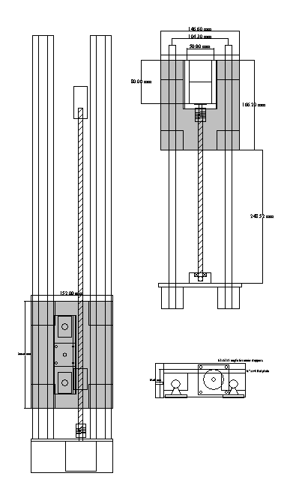

The general layout may be move obvious after looking at the photograph below. Note that the vertical steppers are just out of shot at the top of the towers.
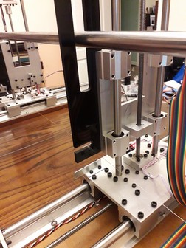

The electronics are in a box constructed from sheet and 20mm extrusion. There are:
- 1 power supply 0-40V for the steppers
- 1 power supply, 24V for the hot wire
- One control board
- One relay board for the hot wire
- 2 fans
- Out of shot but on the top – a constant current/voltage module to accurately control the wire current.
- Various plugs and sockets.

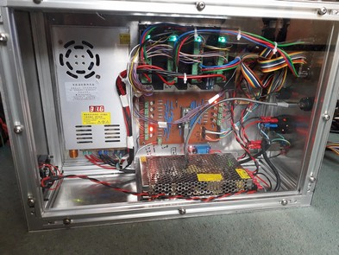

Steppers
These days there’s no reason not to use a bipolar stepper with an appropriate high voltage driver to get maximum torque and speed. Steppers basically have 2 windings, usually referred to as A and B and by varying the current through each winding the motor moves from step to step. Luckily the correct current pattern is dealt with by an off the shelf stepper driver. Worth noting that if the motor rotates in the wrong direction, swap the connections on one of the two windings.
There are 2 sizes of steppers that are of interest: NEMA 17 (smaller) and NEMA 23 (larger) A typical NEMA17 motor is shown below.
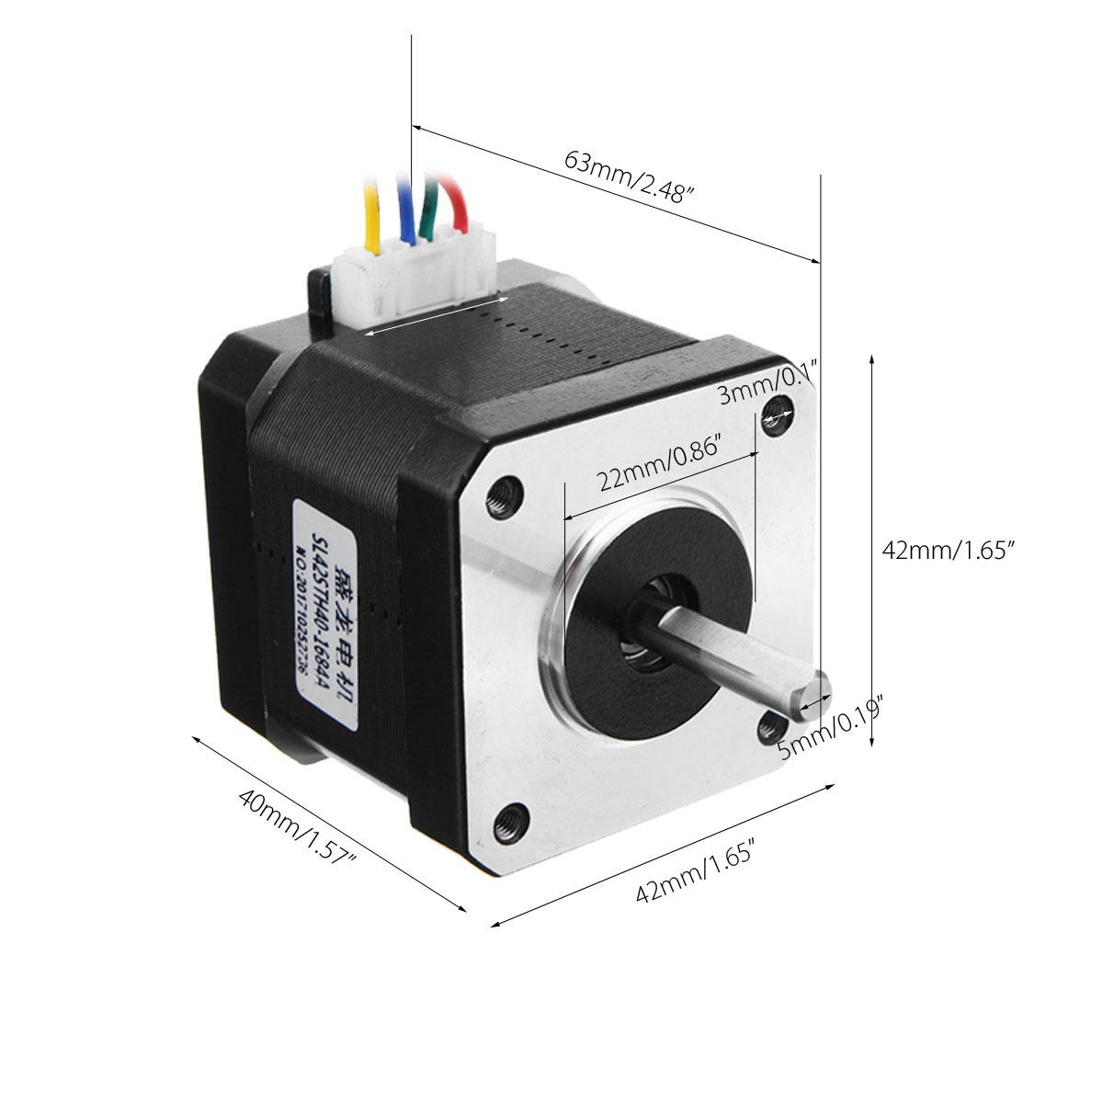

Stepper Drivers

StepSticks i.e. DRV8825 are a bit weedy for the larger motors. They’re not large enough to have enough PCB to cool the driver properly so they’re only really ok up to about 1 amp.
TBA6600 (or similar) based drivers much more robust. They’re ok but may benefit from a low impedance power supply with short leads and/or a large capacitor across the power supply.
Still under £10 each (there are better more expensive ones about)
Opto-isolated modules needs:
- Direction
- Pulse
- Enable
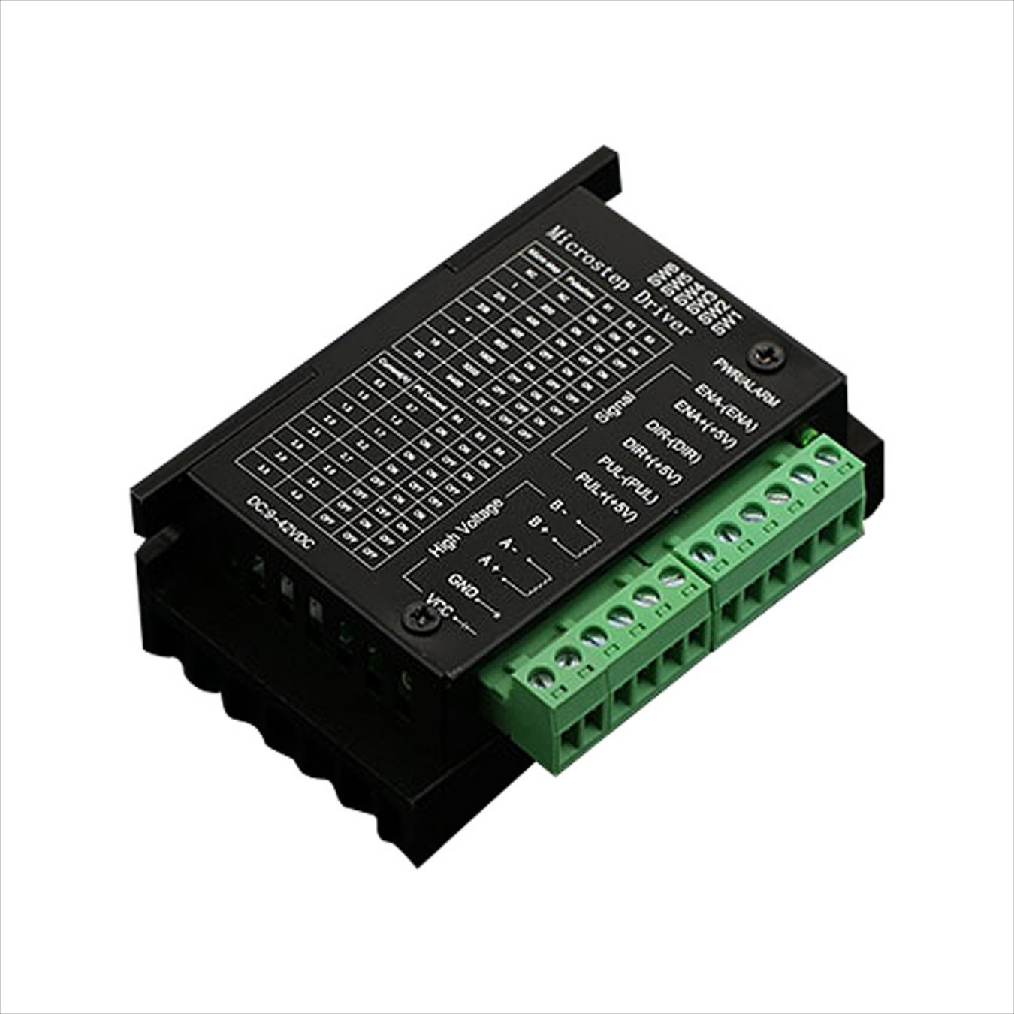

Limit Switches

Opto switches such as the Vishay example shown below are readily available ready wired for use as limit switches in 3D printers etc. Sold as “Optical Endstop with Cable Control Limit Switch” they are simple to use.
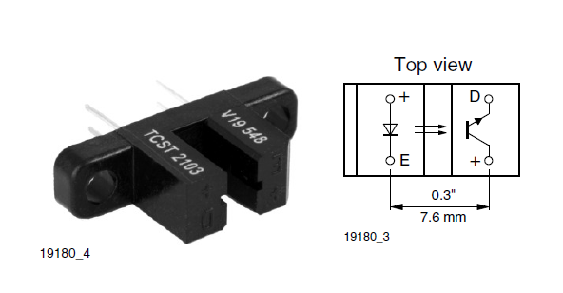
Note that when these are built into a module they come with a LED to show operation and a pull down resistor. As such, when not interrupted the output is logic 1. When an opaque blade is inserted into the slot to break the beam, the resistor pulls the output down to logic 0.
The cutter needs at least one limit switch on each axis to home to. It’s sensible to have them on both ends and they can then be combined with a NAND gate (74HC00) – if neither sensor is interrupted then both will be outputting logic 1 and the NAND output will 0. If either is interrupted it will output 0 so the NAND output will go to logic 1.

Controller Board
Veroboard layout for the controller board is shown below. Note that all the outputs are buffered by (BC547) transistors. This is partly to protect the microcontroller but primarily to ensure that there’s plenty of drive current to the stepper driver’s opto isolated inputs and to allow driving a LED for each output so that you can easily see what’s happening.
The microcontroller is a PJRC Teensy 3.2.
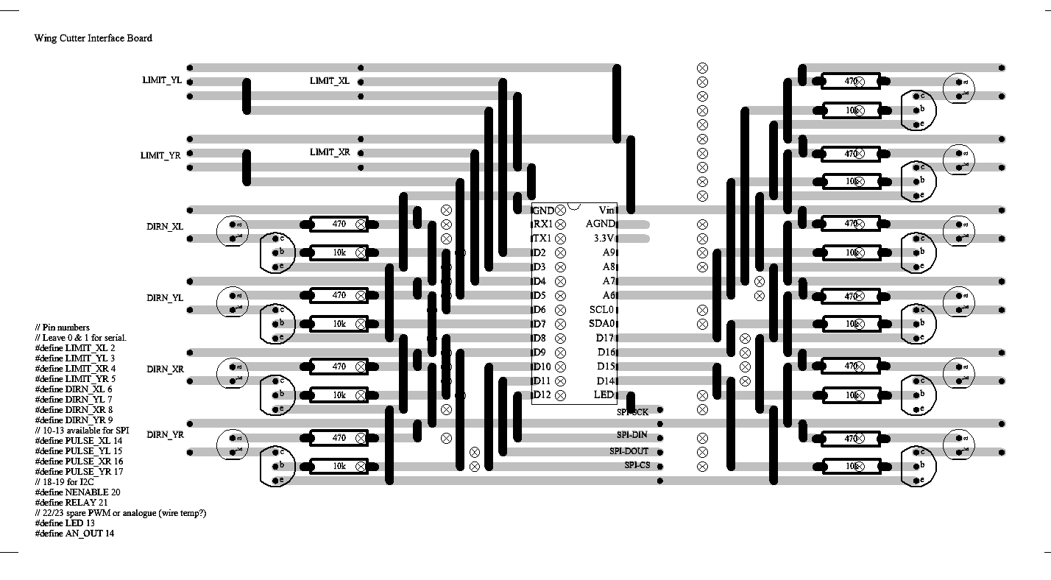
Note that for expansion the SPI port is made available, serial port RX1/TX1 is also not used and there are a few spare pins. If you want to fit 2 limit switches per axes there’s probably enough room in the top left of the board to re-work the layout and fit a 74HC700 and associated resistors.

